Pharmacy layout design

M.PHIL PHARMACEUTICS (2020-2022)

1ST SEMESTER

Learning outcomes:
By the end of the session,the participants will be able to understand:

- Pharmacy layout design
- Characteristics of a good pharmacy layout
- Ideas to improve the layout
- Objectives of layout design
- Success of a community pharmacy
- Types of community pharmacy
- Pharmaceutical centre
- The super Drug store
- Traditional pharmacy
- Prescription oriented pharmacy
- community pharmacy layout design
- Legal requirements for a Drug store
- Types of layout design
- Personal service
- Self selection
- Self service
- Style of layout design
- Grid layout
- Free flow layout

Pharmacy layout design

What is pharmacy?
A pharmacy (also called "drugstore" in American English or "community pharmacy" or "chemist's" in Common wealth English) is a retail shop which provides prescription drugs, among other products. At the pharmacy, a pharmacist oversees the fulfilment of medical prescriptions and is available to give advice on their offerings of over-the-counter drugs. A typical pharmacy would be in the commercial area of a community.

Characteristics of a good pharmacy:
The American Association of Colleges of Pharmacy recommends that consumers choose a pharmacy at which they can have a consulting relationship with the pharmacist.
Anyone using drugs benefits when they have easier access to a pharmacist.
Being timely includes both processing the request quickly and having drug stock available to fill the prescription.
Some consumers need drugs delivered to their home, perhaps by mail, and may select a pharmacy which offers that service.
Different pharmacies may charge different prices for the same drugs, so shopping for lower prices may identify a pharmacy offering better value.
In addition to fulfilling prescriptions, a pharmacy might offer preventive healthcare services like vaccinations.
Up-to-date technology at a pharmacy can assist a patient with prescription reminders and alerts about potential negative drug interactions, thereby reducing medical errors.
Pharmacy layout design:
“A layout primarily refers to the floor plan and the arrangement of fixtures in your front end, which reflects how you want to flow your space and present your merchandise”. Your pharmacy layout influences your customer experience, for better or for worse.

How can you improve your pharmacy layout
While no single layout will suit every pharmacy, there are certain layout and design concepts that should apply to most retail pharmacies. Here are ten tips for improving your pharmacy layout and design:

1. Layout and Design. These two functions are often misinterpreted as one in the same. Not true. Layout relates to the arrangement and placement of everything within the space; Design relates to aesthetics such as color and visual effects. Your customers and staff are influenced by the layout but do not see it while the design is much more obvious. Layout is much more essential than design and should never be sacrificed in order to create a unique appearance.

2. Use a grid layout style. Displays and counters positioned in straight, parallel lines will maximise the use of space. Angled island displays and curved counters can waste up to one third of the space without making any contributions while the higher cost is never justified.

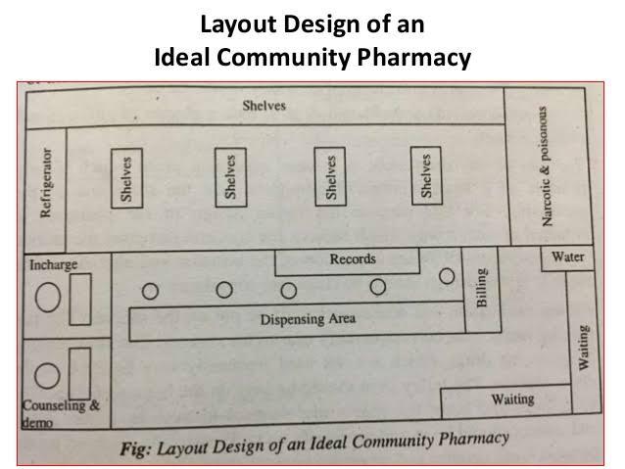
3. Modular cabinetry combined with custom casework. Adjustments are inevitable as the pharmacy grows and trends change; modular fixtures make changes a lot easier and less costly. Each layout should provide versatility so that changes can be made with minimal interruption.

4. Use metal shelves in most areas. Metal shelving has many advantages over wood and glass. Metal shelves are more adjustable, easier to maintain, cost less and look better much longer. Further, they have built-in label channels for price tags and scanner labels while others do not. Again, wood shelving that is used to make your pharmacy look different is a waste of money.

5. Adjust lighting levels in the pharmacy. The prescription department generally requires more lighting than the sales area. A valance separating the work area from the customer area makes the ceiling and lighting configuration less noticeable. A misconception is that you need less lighting during daylight than at night.

6. Choose colours wisely. Most non-selling areas such as the walls and floors should be a neutral color; darker colours may be used for accents, service counters, vertical panels, and signage that can emanate individual personality. Lighter colours make the pharmacy appear more spacious, and the colourful merchandise becomes the attention getter. Avoid Retail Pharmacy Layout Designs on the floor covering that cause the space to look smaller and attract attention.

7. Dispensing area. The dispensing department should have adequate work counter space and shelving. Again, modular counters and shelving make adjustments and expansions much simpler. The area should not be crowded so that personnel can move about with ease. Work flow is a major component in the dispensing area.

8. Display similar categories together. For customer convenience, place similar merchandise and service departments adjacent to each other. That may also lead to an additional purchase.

9. Differentiate your business. Provide departments and services not offered by your competition. Compounding, MTM, and custom patient services are examples. It is much more significant to be unique than to look unique. Some pharmacy designers like to use lots of custom applications that draw more attention to the décor than to the merchandise.

10. Security. Place departments that are more susceptible to pilferage in view of personnel and service counters. Have as much of the sales area viewable at personnel stations as possible. Having one entrance rather than two or more improves security. Installation of cameras and other security measures will discourage criminals from targeting your pharmacy.

Design of pharmacy:
a.Exterior Design:
The uniqueness of the store front and the creative use of entrance display windows and distinctive outdoor signs can help create favourable pharmacy image.
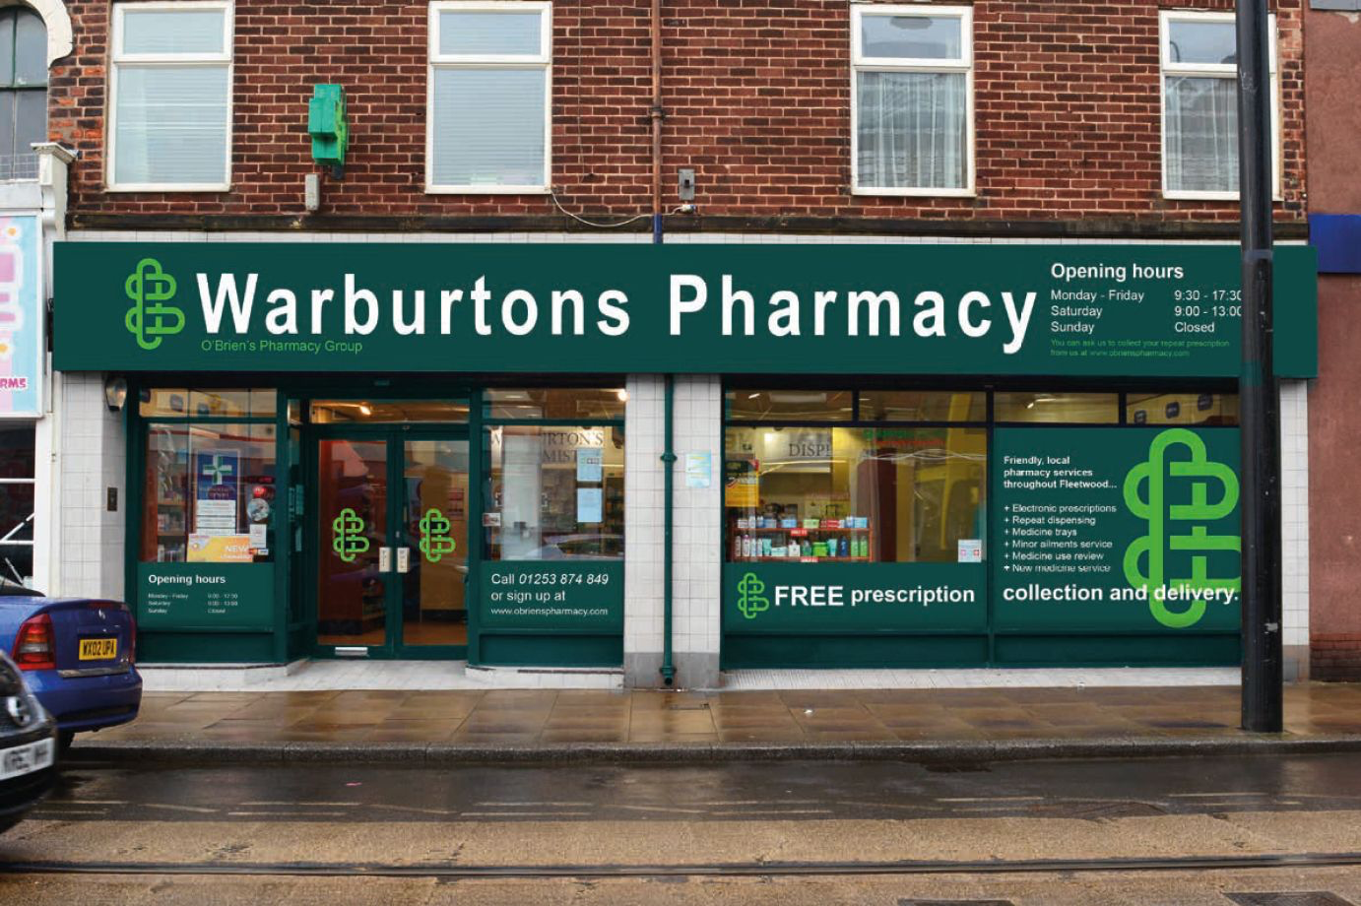

b.Interior Design:
Interior elements that serve as attention attractors include
- Fixtures
- Lightning
- Flooring
- Colours
- Scents and sounds
- Temperature
- Width of aisles
- Cleanliness
- Modernisation
- Merchandise assortment
- Display of prices, and personnel.

(2) Store layout:
Involves
- Planning the internal arrangement of departments
- Allocating the amount of space for each department
- Arrangement of drugs in each department
Before a pharmacist under takes to design a layout or modernise the pharmacy
He should consider the,
- Objectives of the various designs
- The type of community pharmacy
- Types of layout design
- Style of layout design

Objective of layout Design
The major objective in the design of exterior of pharmacy is,
- To attract more patrons into the pharmacy.
- To increase the amount of the total purchases of each person who enters the pharmacy.
- To enhance the general appearance of the pharmacy and to project a professional image.
- To control payroll expenses through convenience and efficiency of the layout.
- To improve patrons satisfaction and convenience.
- To maximise the utilisation of space.
- To disperse and control the traffic pattern within the pharmacy.
- To provide surveillance and reduce pilferage.
- To minimise the movement of customers within the premises of drug store.
Community pharmacy:
A retail pharmacy practice that services prescription directly to the public and over the counter products(OTC).
OR
Community pharmacy can be defined as an area or place under the supervision of pharmacist where pharmacy practice occur and prescription are compounded and dispensed other than limited service pharmacy.It is unique hybrid of business and professionalism.
Success of community pharmacy:
The factors on which the success of community pharmacy depends are:
- Location
- Physical environment
- Sufficient Finance
- Staff experience, sincerity and behaviour
Layout of community pharmacy:
Before designing a layout one must consider the following:
- Objective of the design
- Type of community pharmacy
- Type of layout design
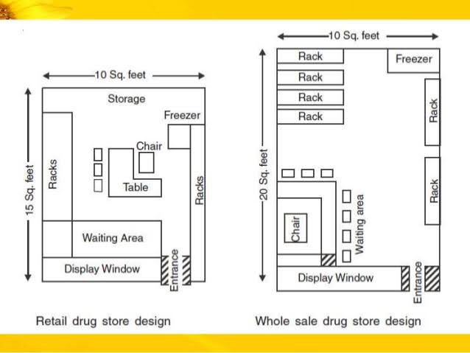
- Style of layout design
The first step involved in layout design of community pharmacy is
Selection of Location:
Following factors must be considered for the selection of location:
- Sufficient finance must be available
- Such area shall be selected that has dense population and need medicines
- Pharmacy site shall be such that it is centre of population and is accessible and convenient to the customers.
- Pharmacy site shall have proper parking area.
- Surrounding area of pharmacy site shall have hospital and doctors around it.
- Other drugs stores around the pharmacy site.
- Flow of traffic,
Legal Requirements for Drug Store:
Minimum Qualification:
- A person who is interested to start a retail sale drug store must be registered pharmacist with State Pharmacy Council.
- A person without diploma or degree can also start pharmacy but he/she shall a employ registered pharmacist because license will be granted to the registered pharmacist employed for the purpose.
- Minimum space:
The space for the premises of a pharmacy shall not be less then 140 sq.feet with minimum breath of 8 feet in the front and height of 8feet.In case of medical store 96 sq.ft. with minimum breadth of 08ft.in front and height of 08ft.

Display of SignBoard:
The pharmacy and medical store shall display a sign board of minimum length of 5feet and 2.5 width on the outside wall with displaying word ‘pharmacy’ in white writing on a green coloured signboard in case of pharmacy while the word ‘Medical Store’ in white on a blue coloured signboard in case of medical store.

Facility Requirements:
The premises has proper and adequate facility for storage of drugs and for their protection from direct sunlight, dust or dirt,including refrigeration facility.
Application for the grant of License:
A person who is interested in starting a pharmacy must submit application for the grant of licence to the licensing authority.
Physical Environment:
Physical environment is yet another factor along with the location, sufficient capital and management that plays an important role in success of pharmacy.physical environment and its characteristics help to develop and maintain the image of pharmacy along with drawing customers.
Types of community pharmacy:
Community pharmacy has four major types that must be consider to choose the type of retail to adopted
- Pharmaceutical Centre:
Pharmaceutical centre sell medicine, surgical and orthopaedic appliances and convenience articles.No product of any kind is displayed and the décor and the organised floor space are its hallmarks.
- Prescription oriented pharmacy:
Prescription oriented pharmacies occupy a space of 1000 to 2000 sq.feet.They have comfortable waiting area for the customers so that they can wait while the prescription is being processed Drugs health related items and prescription accessories are displayed in its vicinity while a separate room is used to keep surgical and orthopaedic appliances.
- Traditional pharmacy:
Traditional pharmacy also known as conventional pharmacy occupies a space of 2000 to 5000 sq, feet.The entire pharmacy is expose to the customer.It must have pleasing appearance and environment for both the customers and the employees and have capabilities of giving maximum sale with minimum expenses.
- The Super Drug Store:
The super drug store occupy a space of 5000 to 10000 sq.feet.The entire super drug store is exposed to the customers where they can handle and select articles by themselves which self-service pattern except for the prescription department.
Types of Layout Design:

- Clerkship or personal services:
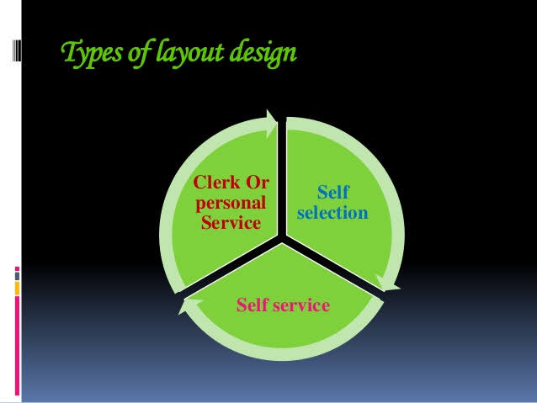
The clerk service layout is the old traditional design that is still in most pharmacies.It consist entirely of complete assistant service except a small part of the products exposed for customers to handle.This is one of the compulsion for prescription products where there is no selection of the customers at retail level.There is no self service or self selection in this setup.The pharmacy staff supplies drugs to the customers it enables maximum interchange between staff and customers.

- Self selection:
Self selection provides personal service in a more efficient manner and as a result more competitive with larger super drug stores.Many independent pharmacies are now trying to use the self selection layout design.In this type of layout design clerk service is maintained at all service oriented sections such as cosmetics, photo supplies, prescription and selected non prescription drugs, surgical and orthopaedic appliances and supplies, and veterinary sections.However other products are displayed so that the customers can see, handle and select themselves but prescription item have no possibility of self selection.
- Self service:
Self service is restricted for layout utilising a minimum of clerk service and exposes the maximum of customers to handle.
- It is not possible to have 100% self service in pharmacy because of the prescription drugs and item.
- This type of layout is most often used in super drug store but for the non-drug items and commodities such as cosmetics and nutritional supplements.

Styles of layout Design:
1)Grid layout
Here the product are displayed in parallel lines.
Advantage
- More product exposure
- Increase self-service possibility
- Maximise the use of available space
- Familiarity with products that cN be needed in future.
2)Free flow layout
Here the fixture are arranged in irregular shaped circles or triangles.
- Advantages:
- Flexibility and visual appeal
- Maximise impulse purchases
- Disadvantage:
- Costly
- Waste of floor space
Selection of the site,location and layout of community pharmacy:
- Located at needy town city.
- Select suitable site that provide easy access to majority of customers
- Should be equipped with free parking facilities
Physical facilities:
- Administration section
- Storage for bulk items
- Impatient department
- Outpatient department in case of hospital pharmacy
- Emergency medicine storage
- Medicine information resource centre
- Narcotics and other dangerous drug locker
- Manufacturing and repacking

Mini mum requirement for pharmacy:

Premises:
- The word pharmacy shall be displaced on green colour sign board in white writing with minimum of 5feet length and 2.5feet width.
- The premises shall be well, ventilated and built dry and shall be suitably arranged and have sufficient dimensions to allow goods such as drugs and poisons to be kept visible.
- The area for dispensing department shall not be less then 6sq.meter for each additional person.
- Height shall be at least 2.5 sq.meter.
- Floor shall be smooth and washable
- Walls shall be oil painted, titled and plastered to avoid cracks, holes, and ,maintain smooth, washable surface.
- Separation shall be made In dispensing department to avoid public entry.

References:
1:Drug store and business Management by A.K Gupta.
2:Principles And Methods of pharmacy Management by,Harry A.Smith
3: Copyright © 2020 American Society of Health-System Pharmacists
4:Store environment An Environmental psychology approach journal of retailing.
5:pharmaceutical Management and Marketing by,Dr.Mahmood Ahmad and Nadeem irfan.

