2. Sample Preparation
Sample preparation can be performed by simple dilution, or with heating for pre-concentration or partial or total dissolution. However to achieve most sample preparations, it is necessary to add reagents to the sample and to apply enough energy to break some bonds and the crystalline structure of solids. If necessary, it is possible to use complementary reagents to obtain the analytes in solution. Two basic procedures are normally used for sample preparation: dry and wet decomposition.^{2,6,9,10}
2.1. Dry dissolution
2.1.1. Fusion and dry ashing. Dry decomposition by fluxes (fusion processes) is normally used for silicates, refractory materials, some mineral oxides and iron alloys. The sample is mixed with a flux and then fused to form products that can be dissolved in water or dilute acid. The temperature required is high (300 to 1000 ºC), and it is achieved by flame, conductive or microwave assisted heating. Some examples of fluxes are presented in Table 2.⁶ The disadvantages of this method are the impurities in the fluxes, the high content of electrolytes in the resulting solution, especially in the case of some analytical spectroscopic techniques, risk of contamination and losses by volatilization.^{2,6,7,10-16}
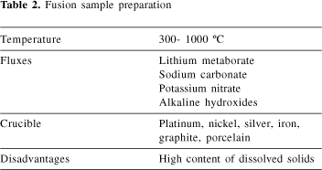
Dry ashing^{2,3,6,7,17} is used for the elimination or minimization of organic materials, prior to mineral element determination, and consists of the ignition of the organic compound in air or in a stream of oxygen. To avoid losses of volatile elements such as As, Cd, Hg and Pb, additives can be used. Some examples are presented in Table 3.^{6,17}
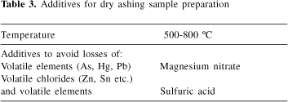
2.2. Wet dissolution
For wet decomposition, oxidizing agents are used to decompose the organic samples prior to metal content determination or to extract metals from inorganic matrices, allowing their determination. Normally concentrated acid plus heating is used, and the important aspects to consider are the strength of the acid, its oxidizing and complexing power, its boiling point, the solubility of the resulting salts, safety in manipulation, and purity.^{2-8,18,19} For open vessel decomposition, the boiling point of the acid controls the maximum temperature to be used in order to avoid high acid consumption and possible losses of the volatile elements.^{2,6,7} Nitric acid, hydrochloric acid, sulfuric acid, phosphoric acid, hydrofluoric acid and hydrogen peroxide, as well as mixtures of such reagents, are used for organic samples, metallic alloys, common minerals, soils, rocks, clays and silicates.
Special care must be taken when hydrofluoric or perchloric acids are used. For hydrofluoric acid, PTFE or other plastic materials must be used and it must be emphasized that contact of HF with skin results in serious damage and should be avoided. Perchloric acid should never be more concentrated than 72%, in the presence of organic matter due to the risk of explosion. Additional details can be found in references 6 and 7.
Wet procedures can be performed using different forms of energy: thermal, ultrasonic and radiant (infrared, ultraviolet and microwave).
2.2.1. Wet decomposition-thermal energy. Open vessel decomposition can be performed using heat from a Bunsen burner, hot plate, digestion block, oven or muffle.^{2,3,6,14,17-19} The main problems to consider are: time consumption (hours), the use of large amounts of reagents, contamination from the environment, pre-concentration of reagent impurities, the use of strong oxidizing agents, such as hydrogen peroxide, and the need of constant supervision. The analyst also should be well prepared. For some refractory materials, such methods are not adequate. Even so, for many cases, reliable results can be achieved.^{3,6,8,10,17-19} Examples are presented in Table 4.⁶
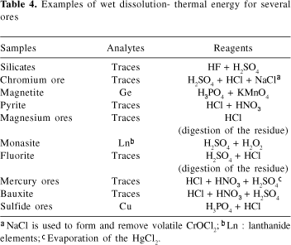
Wet decomposition performed in a pressure decomposition container, in order to avoid contamination and loss of volatile elements, was first tested by Carius (1860), ^{4,6,18} using a thick-walled glass tube, where the sample and reagents were combined and the tube was then sealed. It should be mentioned that during heating, explosions could occur. Samples are held at 250-300 ºC for 3-6 h in most procedures. Tölg and coworkers²⁰ and Bernas²¹ proposed the use of pressurized PTFE bombs, small masses of sample (200 to 500 mg) plus acid or a mixture of acids, and pointed out that increasing temperatures speed up the decomposition. Tölg's bombs are used especially in trace element analysis with organic, biological and inorganic samples, alloys, metals, and minerals. An adapted pressure decomposition Tölg's bomb is shown in Figure 1^{6,18,20} as employed nowadays. It is constituted of: pressure valve, screw-cap, pressure spring, metal lid, PTFE lid, PTFE insert and a pressure vessel (lined with stainless steel and thermal insulation). It rests in an aluminum heating block with a thermal probe, a cold water connection and a heating current connection with an over-heating fuse. During the decomposition in the PTFE vessel, the temperature limit is about 170 ºC and the sample contain up to 100 mg of carbon for the 35 mL vessel.
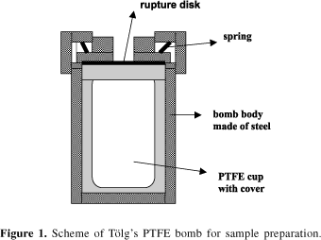
More recently, Knapp presented a high-pressure asher²² that makes possible to perform decompositions at 180 to 300 ºC, generating practically carbon-free solutions. By adding an external pressure of 10 MPa for 300 ºC, the vapor and gas pressure, generated during the decomposition, are compensated. The autoclave with the heating element contains an autoclave lid and lock ring. The heating block insert contains the quartz decomposition vessel with its own lid, and this vessel contains the sample to be decomposed, along with the acid (nitric acid as a rule). The quartz decomposition device is closed using a thin PTFE foil and a quartz lid (Figure 2). Analytes (chemical species) are present in inorganic forms in the decomposition solution. The amount of biological sample can contain up to 100 mg C for a 30 mL vessel and up to 230 mg C for a 70 mL vessel when treated at 300 ºC and up to 350 mg C for a 30 mL vessel and 800 mg C for a 70 mL vessel if treated at 180 ºC. Typical decomposition times using Tölg's bomb and high-pressure asher vary from 1 to 3 h.¹⁸
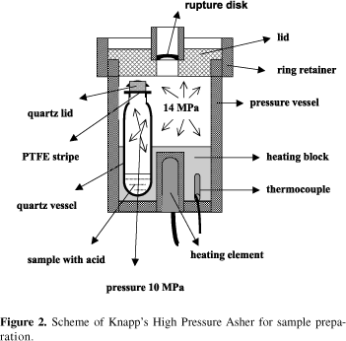
2.2.2. Wet decomposition/extraction-ultrasonic energy. A few years ago, ultrasound-assisted metal extraction was proposed as a simple and inexpensive alternative for sample preparation for biological and inorganic matrices. The extraction effect is considered as being caused by acoustic cavitation, that is, bubble formation and subsequent disruptive action. The collapse of bubbles, created by sonication of solutions, results in the generation of extremely high local temperature (ca. 5000 K) and pressure (ca.10 GPa) gradients, which help sample preparation.^{18,23}
A diluted acid medium is normally used, thus decreasing blank values and reducing both reagent and time consumption, as compared to traditional wet digestion using conductive or microwave-assisted heating. Also a smaller sample amount is used.^{18, 23} This method, using a bath system, allows the preparation of several samples directly in the sample container, preventing sample losses and minimizing contamination, and is mainly used for extraction of the analytes. Ultrasound probes are generally employed for decomposition of organic compounds in environmental samples. Examples are presented in the literature for sample pretreatment²⁴⁻²⁶ and also for synthesis.²⁷
2.2.3. Wet decomposition- radiant energy- infrared radiation. Infrared-assisted element extraction has been employed for organic and biological samples.²⁸⁻³¹ Infrared radiation (1.2x10⁻¹⁴ to 6.0x10⁻¹² Hz) causes an increase in molecular vibration and variation in molecular rotation, generating heat and also its propagation.
Usually, a small amount of biological sample, ca. 200 mg, plus 2 mL of nitric acid in a small glass flask (ca. 4 mL) is placed in the focus of three IR lamps. After applying 10 V during 120 to 180 s, 1 mL of hydrogen peroxide is then added, followed by application of 10 V for 60 s. Analytes are analyzed directly in the same tube, avoiding contamination of the solution.³¹ Other applications are, for example, the heating of liquid and solid samples for determination of volatile analytes,²⁸ and for the preparation of sub-boiling acids.³²
2.2.4. Wet Dissolution- radiant energy-ultraviolet radiation. Ultraviolet radiation decomposition devices are used for complete removal of organic materials, normally when polarography or voltametry is used for subsequent elemental determination.^{18,33-35} Examples are heavy metal determination in waste-waters or liquid foodstuffs such as beer and wine.¹⁸ Ultraviolet radiation decomposition requires the addition of a small amount of acid plus hydrogen peroxide to the sample, without a significant increase in the temperature. This allows low contamination levels from reagents and avoids losses of volatile elements. Highly reactive chemical radicals are produced by UV radiation and ozone is generated which can be drawn away using a laboratory hood. In secondary reactions, organic substances, which bind to heavy metals, are degraded. Several quartz tubes containing sample and reagents can be arranged around a UV emitter placed in the center.¹⁸
Cavicchioli and Gutz described an in-line sample photo-digestion of organic matter in aqueous solution for voltammetric flow analysis of heavy metals in water samples.³³
2.2.5. Wet decomposition- radiant energy-microwave radiation. Microwave-assisted sample preparation is now used for a wide range of applications, including decomposition of inorganic and organic materials.^{4-9,18,19,34-37} The interaction of microwave radiation (2450 MHz, 12.2 cm) with sample and reagents causes both ionic migration and dipole rotation, resulting in fast heating of the mixture with consequent decomposition.
The advantages of this strategy are the short time needed (minutes) to perform decomposition of the sample, direct heating of samples and reagents (the vessels are only indirectly heated by the hot solution), minimal contamination and no loss of volatile elements. The use of small amounts of reagents decreases the blank signal.
Both a focused microwave oven (a wave-guided type microwave digestion system) and a conventional microwave oven (a cavity microwave digestion system) are presented in Figure 3. Both are available commercially.^{7,18,37}
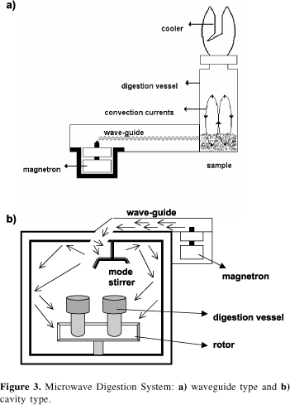
The focused microwave oven operates at atmospheric pressure, can be used for sample masses up to 10 g, and is adequate for samples with high concentrations of organic materials. It allows control of temperature vs. time or power vs. time (with simultaneous temperature measurement). The tubes are made of glass, quartz or PTFE, when hydrofluoric acid is used, and are transparent to microwave radiation. Temperature control should be programmed according to the boiling points of the acid or acid mixture used (Table 5).⁴
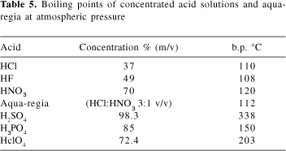
Usually, a mixture containing nitric acid plus hydrogen peroxide is used for botanic, biological and food (cereals, algae, pasta, etc.) samples. Sulfuric acid plus hydrogen peroxide is used for lubrication oils, PVC chips, polypropylene, polyamide, polyester and food (cornstarch, spinach, peanut butter etc.) samples.^{6,7,35-37} Acid mixtures (nitric plus hydrochloric acid etc.) are recommended for inorganic materials, such as some metals, alloys, minerals, and for metal extraction from soils and sediments.^{6, 7,35-37}
The conventional microwave oven operates at high pressures, which depend on the type of digestion flask, for the decomposition of samples using nitric and other mineral acids. Sealed PTFE vessels have pressures up to 7 MPa and quartz tubes up to 12 MPa (especially when sulfuric acid is used). Vessels and microwave ovens present different security devices, depending on the manufacturer. The details have been described.^{6,7,28,37}
The heating program can control pressure vs. time or temperature vs. time or power vs. time. It should be emphasized that the temperature to be used should be based on the boiling point of the acid or mixture used, as shown in Table 6.⁴ The relationship between pressure and sample amount is presented in Table 7.^{4,7,35-37} Thus, applications include practically all inorganic and organic samples to be submitted to complete or partial decomposition, especially for refractory materials and for foods with high contents of carbohydrates, proteins and lipids. Examples are presented in the literature.^{4-7,28,35-37}
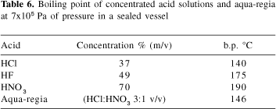
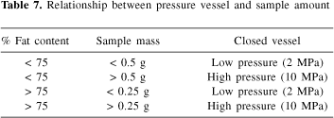
The advantages of using microwave ovens are the security of the commercially available equipment, the short time required for decomposition (minutes) and the accuracy of the results, as a consequence of minimal contamination from the environment and from reagents (lesser amounts are required), with no loss of volatile elements.⁴
Microwave assisted flow digestion can be performed in continuous flow systems, stopped flow systems, ambient pressure systems or pressurized systems; several examples have been presented in the literature.^{18,34-41} These systems save time and reagents and have broad applications. By accelerating the reaction through rapid heating, such systems make it feasible to generate reaction products quickly and in larger quantities.³⁸ In addition to these favorable characteristics, fume production during wet digestion, contamination and loss of volatile elements can be avoided or minimized when microwave-assisted flow digestion systems are used. Generally a flow system is incorporated into a microwave oven, and the digested sample is collected in flasks, opened for subsequent analysis by some appropriate analytical technique or transported directly to a detector coupled in line with the microwave oven.³⁴
3. Present and Future Trends
Present and future trends can be summarized by emphasizing the minimal manipulation of samples. In this sense, the analysis of slurries, determinations in situ and on line, and the principle of single flask and automation/robotics have also been employed for sample decomposition.⁴²⁻⁶⁷
3.1. Strategies to perform microwave-assisted decomposition
As pointed out by Nóbrega et al.,⁴³ focused-microwave-assisted sample preparation is a suitable strategy when dealing with high masses of organic samples. However, the high acid concentration of the digestates may result in difficult routine analytical measurements when using spectroscopic techniques. Acids must be evaporated, but this step may be slow, even when using microwave-assisted heating and requires a scrubber system for acid vapor collection and neutralization.
Two procedures can be used to decrease the acid concentration of digestates. The first is based on acid vapor phase digestion of samples contained in PTFE devices inserted into the microwave flask. The acid solution is heated by absorption of microwave radiation, then the acid vapor partially condenses in the upper part of the reaction flask being partially collected in each sample container. Calcium, iron, magnesium, manganese and zinc were quantitatively recovered in samples of animal and vegetable tissues⁴⁴ using the system presented in Figure 4.
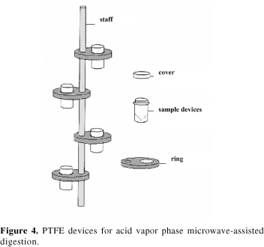
The second procedure is based on the gradual addition of liquid samples to a previously heated acid digestion mixture. This procedure was successfully applied for digestion of milk, fruit juices, and red wine.⁴³
Based on the first strategy, and using the principle of a single flask⁴⁵ for the entire analytical protocol, Tan et al.⁴⁶ developed a device using 4 flasks (4 mL) or 5 flasks (2 mL), placed inside the glass tube of a focused microwave oven (Figure 5), for pretreatment and determination of some metals in hair samples. Owing to the reduced content in hair samples, Cu, Fe and Zn (60 mg of sample for each of 4 flasks) were determined by flame atomic absorption and Mn and Se (30 mg of sample for each of 5 flasks) by electrothermal atomic absorption spectrometry.
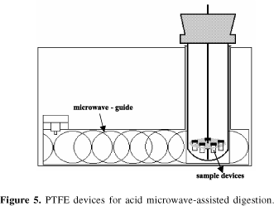
Flores⁴⁵ applied the principle of a single flask to biological samples. The sample (15 mg of hair or bovine liver) plus 50 mL of sulfuric acid and 150 mL of nitric acid were placed in 2 mL mini-polypropylene flasks. The mixture was heated in a conduction oven for 20 h at 70 ºC or in a conventional microwave oven for 7 min for As determination in hair samples. After cooling, the volume was made up to 1.5 mL and the analytes were determined by electrothermal atomic absorption spectrometry.
The main difficulty in such methodologies is caused by the lack of homogeneity of the samples, because only a few mg were used in all examples reported.^{18,44}
3.2. On-line sample decomposition
On-line sample preparation can be performed using microwave-assisted procedures⁴⁸⁻⁴⁹ or by partial chemical decomposition.⁴⁸ On-line partial chemical decomposition using a flow injection system coupled to an ICP-OES was developed for Cr, Mn and Ni determinations in stainless steel.⁴⁷ An extractor solution consisting of 7.0 mol L⁻¹ HNO₃ and 6.0 mol L⁻¹ HCl, was pumped through a glass reaction chamber (ca.. 5 cm), that contains the samples (as chips) and fiberfill as filters at both extremities, to avoid having particles reach the nebulizer of the spectrometer. Water passed out of the system and was discarded. After commutation, the water flow passed through the reaction chamber, the reaction ceased and the system was cleaned, the reaction chamber plus sample was changed, while the extractor solution was pumped to the spectrometer. Commuting again, a new sample can be analyzed. The analytical frequency was 20 samples per hour.
Focused microwave-assisted on-line sample dissolution, as shown in Figure 6, was applied to orange juice⁴⁸ and wine⁴⁹ samples for determination of nutrients and contaminating elements, applying inductively coupled plasma-optical emission spectrometry. The reactor coil was a PTFE tube (4.0 m long and 1.6 mm i.d.), positioned in the commercial glass tube of the focused microwave oven. A volume of 500 mL orange juice sample was mixed at the confluence point with 1000 mL of reagent (80% v/v HNO₃) and transported to the reaction coil by an air carrier. With this on-line digestion system it was possible to analyze 12 samples per hour, minimizing contamination and saving both sample and reagents.⁴
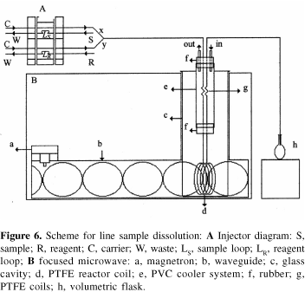
Burgra and Burgra⁴⁰ have presented a review on microwave-assisted sample preparation using flow systems. In addition, other publications are available.^{50, 51}
3.3. Solid samples and slurry analysis
In situ sample preparation is also employed to prevent contamination, when only a small amount of sample is available. For blood samples, direct introduction of sample into a graphite furnace, together with the reagent, results in minimization of the matrix effects and allows simultaneous determination of Mn and Se⁵² or Cu, Fe and Zn⁵³ by simultaneous electrothermal atomic absorption spectrometry.
The direct sample introduction, as a slurry, has been used as a sample pretreatment and presents the advantage of avoiding the use of reagents and dilutions that can introduce contaminants. No losses of volatile elements, safety of operation, and the small amount of sample are attractive characteristics of this method.^{9,18, 44,54-60}
Direct solid sampling electrothermal atomic absorption spectrometry (SS-ETAAS) is applicable to trace and ultra-trace element determination in technological, biological and environmental samples.^{55,61} Reduced sample requirements, the possibility of performing the sample decomposition inside the graphite furnace, operational simplicity and high detectability are the main attributes of SS-ETAAS. The sample is directly weighed into a boat-type platform using a micro-balance, and the platform is inserted into the furnace using a manual or automatic solid sampler. Thus, there is no sample pretreatment and only heat, in the presence of an appropriate modifier, is used for minimization of the matrix effect.
Slurry and solid sample analyses require the characterization of a number of variables, such as homogeneity, grinding and sieving, addition of stabilizing or wetting agents and particle size.^{18,26,44,62}
3.4. Microwave plus ultraviolet radiation/automation and robotics
A microwave-assisted high temperature UV digestion for accelerated decomposition of dissolved organic compounds or slurries was developed by Florian and Knapp.⁶³ Ultraviolet radiation is generated by an immersed electrodeless Cd discharge lamp (228 nm), activated by the microwave field in the oven cavity, providing temperatures up to 250-280 ºC. This system is ideal for very low trace analyses, due to low blank values and low acid concentrations (ca. 0.1 mL HNO₃, 5 mL H₂O and 1 mL H₂O₂ for digesting 0.1 g of powdered organic matrices).
Automation and robotics are already used in sample preparation.^{34,51,63-67} A review about mechanization for sample pretreatment has been published by Arruda and Santelli.³⁴
Han et al.⁶⁴ presented a microwave system that allows the decomposition of the sample and the evaporation of the digestates for trace element determination in silica-based materials.
Norris et al.⁶⁵ presented a robotic system that is able to weigh the sample, perform the addition of acids, process the digestion in a microwave oven, dilute and transfer the solution to a recipient for analysis, and clean the system. The analytical frequency was around 3 samples per hour.
Torres et al.⁶⁶ described the determination of Fe, Cu and Zn in soil samples using a robotic system.
Kingston et al.⁶⁷ reported on automated analysis, with sub mg g⁻¹ detection limits and the trend toward speciation, rather than just elemental analysis. They described new instrumentation, which integrated sample preparation and analysis, to enable on-line near real-time analyses.
3.5. Quality assurance
The operations undertaken in the course of sample preparation, plus the sampling and methodology validation steps, must be considered in order to develop quality assurance in the analytical protocol. Only recently has Eurachem published a preliminary document on these issues.⁶⁸ Both traceability and measurement uncertainty in sample pretreatment must be considered in order to represent correctly the original status of analyzed samples.

