What is Narrative Structure in Filmmaking?
Four Different Types of Writing Styles: Expository, Descriptive, Persuasive, and Narrative.
Narrative structure is about two things: the content of a story and the form used to tell the story. Two common ways to describe these two parts of narrative structure are story and plot.
Story refers to the raw materials of dramatic action as they might be described in chronological order. Plot refers to how the story is told — the form of storytelling, or the structure, that the story follows.
If we want to analyze narrative structure, we can use “who,” “what,” and “where” questions to look at the story or content of a movie. “How” and “when” questions are used to examine plot structure.
Conventionally, both story and plot are described in terms of how a character’s life is disrupted by an event or change in his/her situation; this causes a series of conflicts that the character(s) must face, including the major conflict that is eventually resolved at the end of the film. “Conflict” in this model can take many forms, be it emotional, interpersonal, or even between the character and his/her physical environment.

To describe story in a film, we would need to answer the following questions:
• Where is the story set?
• What event starts the story?
• Who are the main characters?
• What conflict(s) do they face? What is at stake?
• What happens to the characters as they face this conflict?
• What is the outcome of this conflict?
• What is the ultimate impact on the characters?

So here they are, the eight narrative elements of film:
- Character. ...
- Plot. ...
- Conflict. ...
- Resolution. ...
- Structure. ...
- Scenes. ...
- Dialogue. ...
- Visuals.

To describe the plot structure of the movie, we would need to answer these questions:
• How and when is the major conflict in the story set up?
• How and when are the main characters introduced?
• How is the story moved along so that the characters must face the central conflict?
• How and when is the major conflict set up to propel the film to its conclusion?
• How and when does the film resolve most of the major conflicts set up at the outset?

In each case, story and plot are slightly different ways of analyzing a movie.
From the audience’s perspective, story and plot refer to the different ways movie narratives construct meaning for spectators. Story is about trying to determine the key conflicts, main characters, setting and events. Plot is about how, and at what stages, the key conflicts are set up and resolved. What’s interesting about most of the movies made in Hollywood is that, while the stories may change, the fundamental plot structure is virtually identical.

Graphical Presentation of Narratives in Filmmaking:

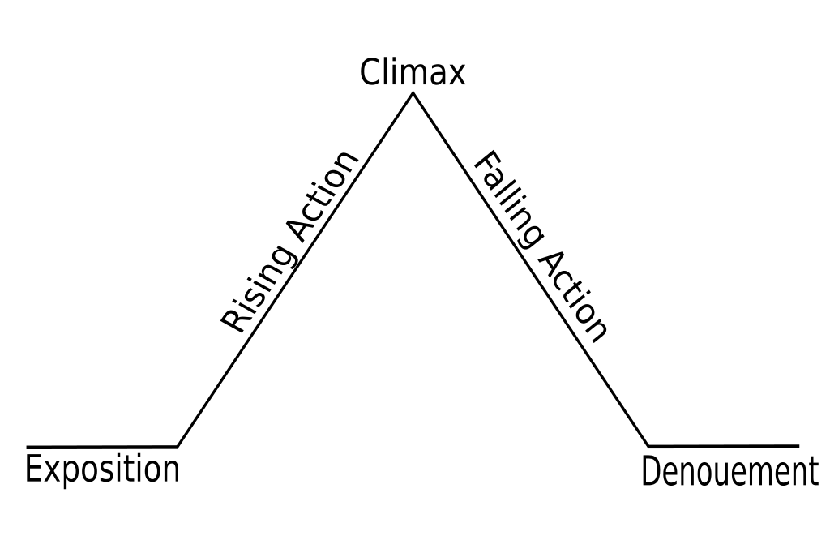

Types/Styles of Narratives in Filmmaking:
- Linear narrative.
Linear Narrative is when the scenes in a film are in chronological order throughout the film. Linear Narrative is about to explain your story in one tone from its ‘A to Z’. Flashbacks are often confused with true narratives which are not linear, but the concept is fundamentally linear.

- Nonlinear narrative.
Nonlinear Narrative is when the scenes are not in order and the story can switch between different points in time. Cinema can only provide the illusion through broken narrative, a famous example of this being the 1994 film Pulp Fiction....

- Interactive Narrative:
An Interactive Narrative is one which is composed with a branching structure where a single starting point may lead to multiple developments and outcomes. The principle of all such games is that, at each step of the narrative, the user makes choices that advance the story, leading to new series of choices. Authoring non-linear narrative or dialogue thus implies imagining an indefinite number of parallel stories.

- Single Strand Narrative:
A single strand Narrative is where there is no main character as the focus is the story. There is only one plot that follows the main character but there will usually be some surrounding characters that the story doesn’t really focus much on and the audience won’t care about as much.

- Multi Strand Narrative:
A Multi Strand Narrative is where there is no central characters and will have multiple plots. The audience will care about more than just one character and not all of the focus is on one character at a time. As in Harry Potter, through Harry can be classed as the main character at a time, the story does focus on other characters and the audience does build a strong relationship with the likes of Ron and Hermione as they do Harry.

