Phrase Examples
A phrase is a group of words that express a concept and is used as a unit within a sentence. Eight common types of phrases are: noun, verb, gerund, infinitive, appositive, participial, prepositional, and absolute. Take a look at our selection of phrase examples below.
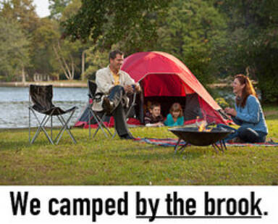

Noun Phrases
A noun phrase consists of a noun and all its modifiers.
Here are examples:
- The bewildered tourist was lost.
- The lost puppy was a wet and stinky dog.
- The flu clinic had seen many cases of infectious disease.
- It was a story as old as time.
- The sports car drove the long and winding road.
- Saturday became a cool, wet afternoon.

Verb Phrases
A verb phrase consists of a verb and all its modifiers.
Here are examples:
- He was waiting for the rain to stop.
- She was upset when it didn't boil.
- You have been sleeping for a long time.
- You might enjoy a massage.
- He was eager to eat dinner.

Gerund Phrases
A gerund phrase is simply a noun phrase that starts with a gerund.
Examples include:
- Taking my dog for a walk is fun.
- Walking in the rain can be difficult.
- Strolling along a beach at sunset is romantic.
- Getting a promotion is exciting.
- Signing autographs takes time.
- Going for ice cream is a real treat.
- Singing for his supper was how he earned his keep.
- Getting a sore back was the result of the golf game.
- Pulling an all-nighter did not improve his test scores.
- Sailing into the sunset was the perfect end to the book.

Infinitive Phrases
An infinitive phrase is a noun phrase that begins with an infinitive verb.
Here are some examples:
- To make lemonade, you have to start with lemons.
- I tried to see the stage, but I was too short.
- She organized a boycott to make a statement.
- To see Niagara Falls is mind-boggling.
- He really needs to get his priorities in order.
- The company decided to reduce hours for everyone.
- To donate time or money is an honorable thing.
- I went to Spain to study the language and culture.

Appositive Phrases
An appositive phrase restates and defines a noun. It consists of one or more words.
Examples are:
- My favorite pastime, needlepoint, surprises some people.
- Her horse, an Arabian, was her pride and joy.
- My wife, the love of my life, is also my best friend.
- A cheetah, the fastest land animal, can run 70 miles an hour.
- My idea, a recycling bin for the office, was accepted by the boss.
- The Florida panther, the state animal of Florida, is an endangered species.

Participial Phrases
A participial phrase begins with a past or present participle.
Examples are:
- Washed with my clothes, my cell phone no longer worked.
- Knowing what I know now, I wish I had never come here.
- I am really excited, considering all the people that will be there.
- We are looking forward to the movie, having seen the trailer last week.
- Grinning from ear to ear, she accepted her award.
- The happy dog ran the entire length of the park, pausing only to sniff the dandelions.
- Painted a brilliant white, the small room appeared bigger.
- The lake, frozen over all winter, was finally thawing.

Prepositional Phrases
A prepositional phrase begins with a preposition and can act as a noun, an adjective or an adverb.
Examples are:
- The book was on the table.
- We camped by the brook.
- He knew it was over the rainbow.
- She was lost in the dark of night.
- He was between a rock and a hard place.
- I waited for a while.
- She smelled of strawberries and cream.
- He won the challenge against all odds.

Absolute Phrases
An absolute phrase has a subject, but not an action verb, so it cannot stand alone as a complete sentence. It modifies the whole sentence, not just a noun.
Examples are:
- His tail between his legs, the dog walked out the door.
- Picnic basket in hand, she set off for her date.
- The guys attacked the pile of nachos, their fingers getting the last bit of cheese off the plate.
- Their heads hanging down, the whole group apologized.
- The entire team, their uniforms muddy and stained, shouted for joy.
These are just a few examples of the eight different kinds of phrases.

