FOOD CONSTITUENTS-3
Inorganic materials regarded as minerals or mineral elements are those that are present in ash content of food. These minerals are present in all living tissues. They have two general functions in the body – building and regulating.
Building function involve in skeleton and all soft tissues like muscles. Regulatory functions are associated with heartbeat, clotting of blood, maintenance of internal fluid pressure of the body and transportation.
Inorganic materials are essential but required in small amount. They are classified as:

Macro or major minerals | Micro or trace minerals
Those which are present in appreciable amount in body. | Those which found in minute or trace quantity.
Example; calcium, magnesium, potassium, chlorine, sodium, Sulphur etc. | Example; iron, iodine, cobalt, zinc, copper etc.
These are required in milligram.

Major minerals

Minerals | Sources | Functions
Calcium | Milk, milk products, leafy vegetables and legumes. | 1-helps to clot blood.2-formation and development of bones and teeth.3- deficiency causes rickets and osteomalcia
Sodium | Main constituent of table salt | 1-regulation of water and other body fluids.2-aid in carbon dioxide transport.
Phosphorus | Milk, meat, eggs, fish, cabbage, cereals. | 1-involve in formation of phospholipids.2- integral part of cell structure.
Chlorine | Exist in the form of common salt. | 1-helps in formation of HCl essential for gastric juice that is involve in digestion.
Potassium | Found in fruits and vegetables | 1-regulate osmotic pressure.2-its deficiency leads to paralysis and muscles weakness.
Magnesium | Present in plants sources i.e pulses, cereals, nuts etc. | - It’s a part of enzymes acts as activator.2- deficiency causes depression, weakness and convulsions.

Minor inorganic materials

Minerals | Sources | Functions
Iron | Lean meat, egg yolk, oysters, dry beans, pulses, green leafy vegetables, dried fruits. | 1-it’s a part of haemoglobin.2-deficiency cause anemia.
Iodine | Sea fish, fish oils, iodized salt. | 1-it’s an integral part of thyroxine hormone.2- deficiency cause goiter.
Zinc | Kidney, liver, oysters. | 1-it is an essential for growth, reproduction, and production of insulin.

Experiment # 3
DETERMINATION OF ASH CONTENT OF A FOOD SAMPLE
Purpose:
To determine the inorganic residues (minerals) remaining after incineration of organic matter in the food sample.
Procedure:
- Remove seeds, stones and other inedible parts from the sample (fruit, vegetable, meat, fish, cereals, nuts etc.)
- Prepare a homogenous and representative sample as explained in experiment 1.
- Place the sample in a weighed crucible and weigh.
- Place the crucible on heat at 100ºC until water is expelled from the sample.
- Char the sample gently over a low direct flame.
- Place the crucible in muffle furnace set at 525ºC and leaves until white ash is obtained.
- Moist ash with distilled water, dry on hot plate.
- Re-ash in muffle furnace at 525ºC to constant weight.
Calculations:
Ash (%) = Weight of sample after ashing × 100
Weight of sample

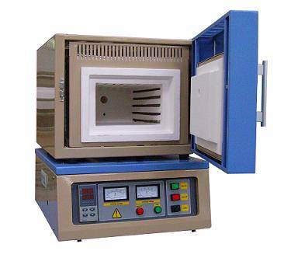MUFFLE FURNACE

