Topic: Law of independent Assortment
Definition:
The principle, originated by George Mendel , stating that when two or more
characteristics are inherited, individual hereditary factor assort independently during gamet production, giving different traits on equal opportunity of occuring to gather.

History of Mendelian inheritance:
The principle of Mendelian inheritance were named for and first derived by Gregor Johann Mendel a ninteenth century Moravian monk who formulated his idea after conducting simple hybridization experiment with pea plants ( pisum sativum). He had planted in the garden of his monastery and tested some 5000 plants. From these experiment he induced two generalization which later become principle of hereditary or Mendelian inheritance. Mendels results were largely ignored by vast majority of biologists.
Key points:
Mendels law of independent Assortment states that gene don’t influence each other with regard to the sorting of allele into gamets , every possible combination of allele for every gene is equally likely to occur.
The calculation of any particular genotypic combination of more then one gene is therefore , the probability of desired genotype at first locus multiplied by the probability of desired genotype at their loci.
The forked line method can be used to calculate the chances of all possible genotypic combination from a cross , while the probability method can be used to calculate the chances of any one particular genotype that might result from that cross.
Independent assortment separate gene for separate trait are passed independently of one another from parents to offspring.
Indeprndent Assortment:
Mendels law of independent Assortment states that gene don’t influence each other with regard to the sorting of allele into gamets every possible combination of allele for every gene is equally likely to occur. The independent Assortment of gene can be illustrated by dihybrid cross:a cross between two true breeding parents that express different traits for two characteristics.
Experiment:
Consider the characteristics of seed color and seed texture for two pea plants. One that has green ,wrinkled seed (YYrr) and other has yellow ,round seed (YYRR). Because each parent is homozygous the law of segregation indicate that the gamets , for the green/wrinkled plants all are yr, while the gametes for yellow/round plant are all YR. Thus for F1 generation of offspring all are YyRr.
For F2 generation the law of segregation requires that each gamete receives either R allele or r allele along with either Y or y allele. The law of independent Assortment states that a gamete into which allele sorted would be equally like to contain either Y or y allele. Thus these are four equally liked gamete that can be formed when the YyRr heterozygote is self _ crossed as follow
YR, Yr, yR, yr
Arranging these along top and left of punnete square gives us 16 equally liked genotypic combination. From these genotype we infer a phenotypic ratio of
9 round /yellow : 3 round /green : 3 wrinkled/yellow :1 wrinkled /green

These are offspring ratio we would , expect , assuming we performed the crossing with a large enough size.
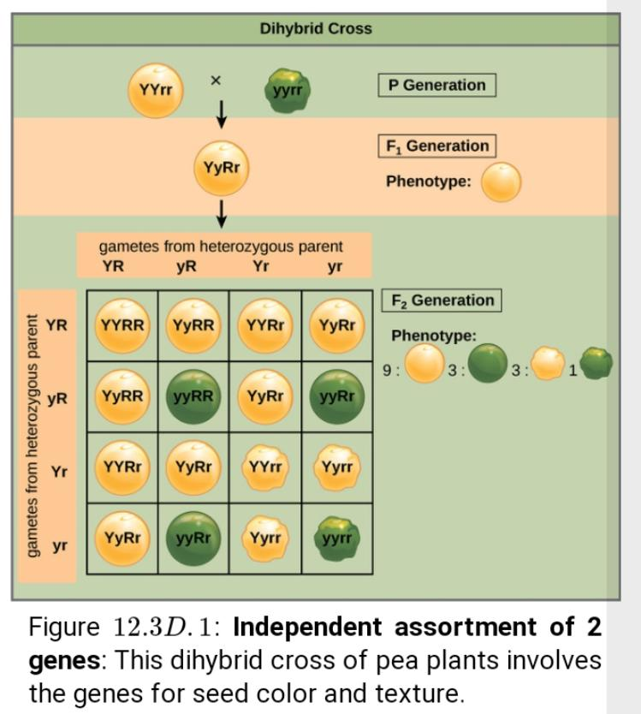

Because of independent Assortment and dominance , the ratio 9:3:3:1 dihybrid phenotype ratio can be collapsed into two 3:1 ratio, characteristics of any monohybrid cross that follows a dominant and recessive pattern ignoring seed color and considering only seed texture in the above dihybrid cross , we would expect that three quarters of F2 generation offspring would be round and one quarter would be wrinkled.similarliy isolating only seed color we would assume that three quarters of F2 generation offspring would be yellow and one quarter would be green. The sorting of allele for texture and color are independent events , so we can apply the product rule. Therefore the proportion of round and yellow F2 offspring is expected to be:
(3/4)×(3/4)=9/16
And the proportion of wrinkled and green is expected to be
(1/4)×(1/4)=1/16
The proportion are identical to those obtained using a punnete square.
Other method can also be used to calculate genotypic combination like:
1: Fork_line method
2: Probability method
Fork- line method:
When more then two gene are being considered, the punnett square method become unwisely. For instance, examing a cross involving four gene would require a 16×16 grid contained 256 boxes. It would be extremely cumbersome to manually enter each genotype . For more complex crosses, the fork line and probability methods are preffered.
To prepare a forked line diagram for a cross between F1 hetrozyote resulting from a cross between AABBCC and aabbcc parents, we first creat reo equal to number of genes being considered and the segregate the allele in each row on forked line according to the probabilities for individual monohybrid crosses and then multiply the values along fork pathway to obtain the F2 offspring probabilities.
Note that this process is a diagrammatic version of product rule. The values along each forked pathway can be multiplied because each gene assort independently. For trihybrid cross the F2 phenotypic ratio is 27:9:9:9:3:3:3:1.

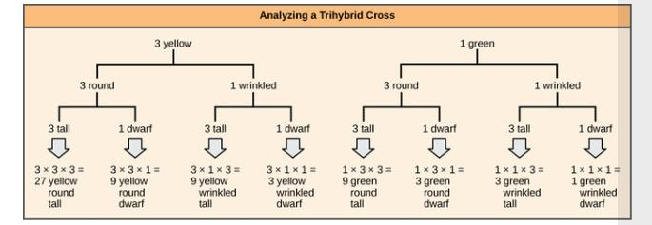
Probability method:
While the fork line method is diagrammatic approach to keeping track of probabilities in cross, the probability method give the proportion of offspring expected to exhibit each phenotype or genotype without added.
To fully demonstrate the power of the probability method, however , we can consider specific genetic calculation, For instance for a tetrahybrid cross between individual that are heterozygote for all four gene are sorting independently in a dominant and recessive pattern . What proportion of the offspring will be expected to be homozygous recessive for all four allele? Rather then writing out every possible genotype, we can use the probability method.
We know that for each gene fraction of homozygous recessive offspring will be ¼. Therefore, multiplying this fraction for each of four genes,
¼×1/4×1/4×1/4
We determine that 1/256 of offspring will be homozygous recessive .
When does independent Assortment occurs?
Independent assortment occurs during the process of mieosis. Meiosis is similar to mitosis , only the finally product is gamete cell. Gamete cell have half the DNA of regular, diploid cells and we considered haploid
This is necessary part of sexual reproduction which allow two gametes cell to then fuse together to create a diploid zygote, containing all the DNA necessary to creat a new organism.
To understand when independent Assortment occur you must also understand the law of segregation. This law states that during mieosis, the two different gameye cell . This law of independent Assortment , on the other hand, deals with the maternal and parental sources of DNA being separated at random.
We know that this independent Assortment of gene occur during meiosis in eukaryotes. Meiosis is a type of the cell division that reduce the number of the chromosome on a parent cell by half to produce four reproductive cells called gametes.
In humans diploid cell contain 46 chromosome with 23 chromosome inherited from the mother and the second similar set of 23 chromosome from father.paors of similar chromosome are called homologous chromosome. During meiosis , the pair of homologous chromosome are divided in half to form haploid cell, and this separation or Assortment of homologous chromosome is random. This means that all of the maternal chromosome will not be separated in one cell while the all the parents chromosome are separated into an other. Instead of the meiosis occur , each haploid cell contain a mixture of gene from the organism mother and father.
Independent assortment in mieosis:
As a basic example , let us consider a hypothetical population of bunny rabbit that only have two visible traits.Fur color ( black or white) eye color (green or red)
The black color fur allele (B) is dominant over white (b) while the green eye (G) is dominant over red (g).in this hypothetical example , two hybrid rabbits are mixed .
What does it’s means is that both rabbits look black with green eyes, but are really they have a heterozygous genotype. Both rabbits have genotype BbGg . In this population of two rabbits all the individual have same mixture of characteristics . In other words they are all black with green eyes.
Before breeding , each rabbit will have to produce gameye. During this process , not only all the alles are separated but each copy of each chromosome is randomly assigned ta a different gamete. This means regardless of the parental phenotype ( black with green eyes)the babies can inherit different combinations of these traits. For instance one baby would receive the bbgg genotype, giving it white fur and red eyes . Alternatively a baby rabbit could also receive the genotype, Bbgg ,giving it black fur and red eyes . This is the law of independent Assortment.
Explanation:
Mendels law of independent Assortment explain the inheritance of two traits of a plants to gather.The can be explained by taking the example of inheritance of height and color of flower together in pea plants . This type of cross is termed as dihybrid Cross.
A pure tall plants bearing red flower is crossed with pure dwarf plant bearing which hiflower . The plant produce as a result of this cross are all tall plants bearing red flower constituting the first filial generation or F1 generation of the offspring.
Plants of F1 generation are allowed to interbreeded freely among themselves to get F2 generation . The plants of F2 generation have 4 different phenotype tall red , tall white, dwarf red, dwarf white in the ratio of 9:3:3:1 . This is termed as dihybrid phenotypic ratio.
These result obtained in dihybrid cross could be explained by assuming that segregation of the gene of two traits height and color of flower occur independently of each other. In other words , the segregation of the gene of one trait don’t affect the segregation of the other trait.
A homozygous tall and homozygous red plants (TRTR) is crossed to homozygous dwarf and homozygous white plant (trtr). The plant of F1 generation are heterozygous tall and heterozygous red(TRtr).
On crossing plants D1 the gametes produced by two plants will have 4 genotype , if we assume that the segregation of gene of two traits is independent of each other.4 type of gameye formed will have genotype , TR, TR, tR, tr . Each of four type of gameye formed by one plants has equally chances of fusing with each other 4 type of gameye formed by other plants.
The possible permutation and combination of these gametes will produce red , tall white, dwarf red and dwarf white plants in ratio of 9:3:3:1 as is actually observed that the actual result observed in dihybrid cross were the same as calculated results, on the basis of assumption that the segregation of gene of 2 trait is independent of each other . He thus proposed the law of independent Assortment, which states that the segregation of gene of trait is independent of each other.
Multiple choice questions:
1: Experiment on plants hybridization was written by:
Sutten
Mendel
Darwin
De varis
2:word gene was used by:
Sutten
Mendel
Best on
De varis
3: The cross in which two characters are followed at the same is called:
Monohybrid cross
Reciprocal cross
Dihybrid Cross
Hybrid cross
4: when round wrinkle were cross it gave all round thus:
P1 generation
F1 generation
F2 generation
FA generation
5:when tall is crossed with dwarf F1 give tall it is:
Recessive
Hybrid
Dominant
None
6:The law of segregation give proportion of F2 generation:
2:1
4:1
3:1
1:2:1
7: In F3 cross the round produce only round were:
V
1/3
V2
None
8:If test cross give all dominant character it means parents is:
Homozygous recessive
Heterozygous
Homozygous dominant
Heterozygous dominant
9: The gamete of F1 are formed in ratio:
1:2
1:1:1:1
9:3:3:1
1:1
10:The gene linkage minimize the chance of
Cross over
Segregation
Genetic recombination
Independent assortment
11: There are 80% parental and 20% recombination in a cross. It recombinant frequency is:
10%
20%
30%
40%

