Basic Essay and Paragraph Format
A basic essay consists of three main parts: introduction, body, and conclusion. Following this format will help you write and organize an essay. However, flexibility is important. While keeping this basic essay format in mind, let the topic and specific assignment guide the writing and organization.

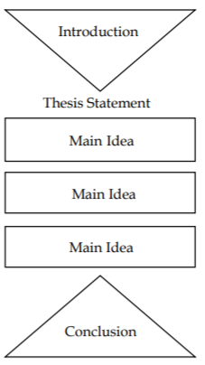
Parts of an Essay
Introduction
The introduction guides your reader into the paper by introducing the topic. It should begin with a hook that catches the reader’s interest. This hook could be a quote, an analogy, a question, etc. After getting the reader’s attention, the introduction should give some background information on the topic. The ideas within the introduction should be general enough for the reader to understand the main claim and gradually become more specific to lead into the thesis statement. (See the Introductions handout for further information.)
Thesis Statement
The thesis statement concisely states the main idea or argument of the essay, sets limits on the topic, and can indicate the organization of the essay. The thesis works as a road map for the entire essay, showing the readers what you have to say and which main points you will use to support your ideas. (See the Thesis Statements handout.)
Body
The body of the essay supports the main points presented in the thesis. Each point is developed by one or more paragraphs and supported with specific details. These details can include support from research and experiences, depending on the assignment. In addition to this support, the author’s own analysis and discussion of the topic ties ideas together and draws conclusions that support the thesis. Refer to “Parts of a Paragraph” below for further information on writing effective body paragraphs. Transitions Transitions connect paragraphs to each other and to the thesis. They are used within and between paragraphs to help the paper flow from one topic to the next. These transitions can be one or two words (“first,” “next,” “in addition,” etc.) or one or two sentences that bring the reader to the next main point. The topic sentence of a paragraph often serves as a transition. (See the Transitions handout for further information.)
Conclusion
The conclusion brings together all the main points of the essay. It refers back to the thesis statement and leaves readers with a final thought and sense of closure by resolving any ideas brought up in the essay. It may also address the implications of the argument. In the conclusion, new topics or ideas that were not developed in the paper should not be introduced. (See the Conclusions handout for further information.)
Citations
If your paper incorporates research, be sure to give credit to each source using in-text citations and a Works Cited/References/Bibliography page. Refer to the MLA Format, APA Format, or Turabian Format handout for help with this.
Parts of a Paragraph
In an essay, a paragraph discusses one idea in detail that supports the thesis of the essay. Each paragraph in the body of the paper should include a topic sentence, supporting details to support the topic sentence, and a concluding sentence. The paragraph’s purpose and scope will determine its length, but most paragraphs contain at least two complete sentences. For more information on this topic, see the Basic Paragraph Format handout.
Topic Sentence
The main idea of each paragraph is stated in a topic sentence that shows how the idea relates to the thesis. Generally, the topic sentence is placed at the beginning of a paragraph, but the location and placement may vary according to individual organization and audience expectation. Topic sentences often serve as transitions between paragraphs.

Supporting Details
Supporting details elaborate upon the topic sentences and thesis. Supporting details should be drawn from a variety of sources determined by the assignment guidelines and genre, and should include the writer’s own analysis.
- Expert Opinion
- Facts and Statistics
- Personal Experiences
- Others’ Experiences
- Brief Stories
- Research Studies
- Your Own Analysis
- Interviews

Concluding Sentence
Each paragraph should end with a final statement that brings together the ideas brought up in the paragraph. Sometimes, it can serve as a transition to the next paragraph.

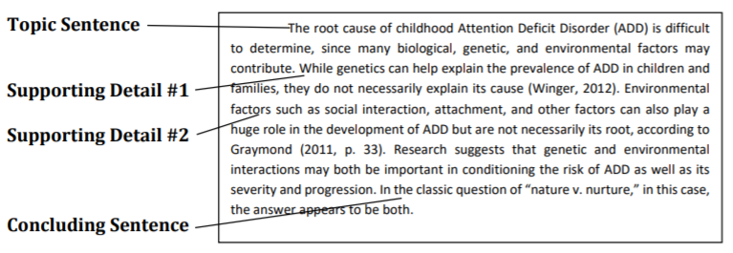
Unity and Coherence Proper essay and paragraph format not only helps to achieve unity and coherence but also enhances the reader’s understanding. Well-worded topic sentences and concluding sentences will also help maintain unity throughout the essay.
- Unity is the continuity of a single idea (the thesis) throughout the essay. Each detail and example should develop logically and refer back to the original focus.
- Coherence means that each point should be linked to the previous and following points to help the essay flow and progress logically and clearly. An easy way to link paragraphs together is through transitions in each paragraph’s topic sentence.

PARAGRAPH AND ESSAY-WRITING PARAGRAPHS
A paragraph is the fundamental unit of an essay. A paragraph consists of several sentences that are grouped together. This group of sentences together discusses one point, idea or opinion – one main subject or topic.
Topic sentences
Your topic sentence is the sentence whose main idea controls the rest of the paragraph. The topic sentence consists of a topic (the main idea of the paragraph) and the controlling idea (what you are going to say about the main idea. The controlling idea gives the focus of the paragraph and usually the opinion of the author.
A topic sentence has several important functions: it unifies the content of a paragraph and directs the order of the sentences. It advises the reader of the subject to be discussed and how the paragraph will discuss it. Readers generally look to the first few sentences in a paragraph to determine the subject and perspective of the paragraph. That is why it is often best to put the topic sentence at the very beginning of the paragraph.
How to write a good paragraph
To write a paragraph, there needs to be a structure which has to be adhered to. A paragraph has three parts/sections. These are the introduction (explained in Steps 1 and 2 below), the body (explained in Steps 3 and 4) and the conclusion (clarified in Step 5). The following is a brief guide on how to draft, refine and explain your ideas so that you write clear, well-developed paragraphs:
Step 1: Decide on the topic of your paragraph before you begin writing. You need to know what you are writing about first before you set about writing the paragraph.
Step 2: Once you know what you are going to write about, develop the topic sentence before writing a paragraph. It is important to think about the topic first and then what you want to say about the topic. Often the topic is easy, but the question focuses on what you want to say about the topic (the controlling idea).
Step 3: After stating your topic sentence, you need to provide information to prove, illustrate, clarify and support the point you want to make as expressed in the topic sentence. This is the body of the paragraph.
Step 4: Give your paragraph meaning after you have given the reader enough information to see and understand your point. You need to explain why this information is relevant, meaningful or interesting.
Step 5: Conclude after illustrating your point with relevant information. Add a concluding sentence. Concluding sentences link one paragraph to the next (if you are writing an essay).
Step 6: Look over and proofread The last step in good paragraph-writing is proofreading and revision. Before you submit your writing, look over your work at least one more time. Try reading your paragraph out aloud to make sure it makes sense. Also, ask yourself these questions:
- Does my paragraph answer the prompt and support my topic sentence? • Does it make sense?
- Does it use the appropriate academic voice?

ESSAYS
An essay is a piece of writing, usually from the author’s point of view. It is often non-fiction where presentation is often based on facts. It can also be based on hypotheses (researched or educated opinions which include a certain number of facts) or it can be subjective (based on opinions), in the view of the language, perception and experiences as well as the interpretations of the world. Writing an essay is no more difficult than writing a paragraph except that an essay is longer. The principles of organisation are the same for both, so if you can write a good paragraph, you can also write a good essay.
When writing an essay, you should always consider:
Your purpose (your reason for writing)
Your audience (to whom you are writing), who will read it, think about it and respond to it.
The person for whom you are writing will influence the way you write as well as the vocabulary you choose. Your purpose should be scholarly, for entertainment or educational. Each of those purposes will change the way you write.
Parts of an Essay
A good essay has three parts: The introduction is the first paragraph of the essay. It should capture the reader’s attention and create the desire to read the essay and develop the basic ideas of what you will cover. It should start with a general discussion of your subject to provide background information. These are called general statements. The general statements should lead to the specific statement of your main idea or thesis. This is called the thesis statement. It should be the last sentence of the introduction and is usually only one sentence. It is made up of the topic, focus and three main points of the essay.
Each body paragraph should start with a transition — either a word or phrase, like “first”, or “another important point is”, for example. Then, the first sentence should continue with your topic sentence. The topic sentence tells your reader what the paragraph is about, like a smaller-level thesis statement. The rest of the paragraph will be made of supporting sentences. These sentences, at least four of them, will explain your topic sentence to your reader.
The conclusion is the last paragraph of the essay. This paragraph brings the essay to a close, reminds the reader of the basic ideas from the essay and restates the thesis statement. It can also contain words of advice or recommendation. The conclusion should not contain new ideas as it is the end of the content of the essay.

