Molecular Exclusion Chromatography
In molecular exclusion chromatography (also called size exclusion or gel filtration or gel permeation chromatography), molecules are separated according to size. Small molecules penetrate the pores in the stationary phase, but large molecules do not. Because small molecules must pass through an effectively larger volume, large molecules are eluted first. This technique is widely used in biochemistry to purify macromolecules.

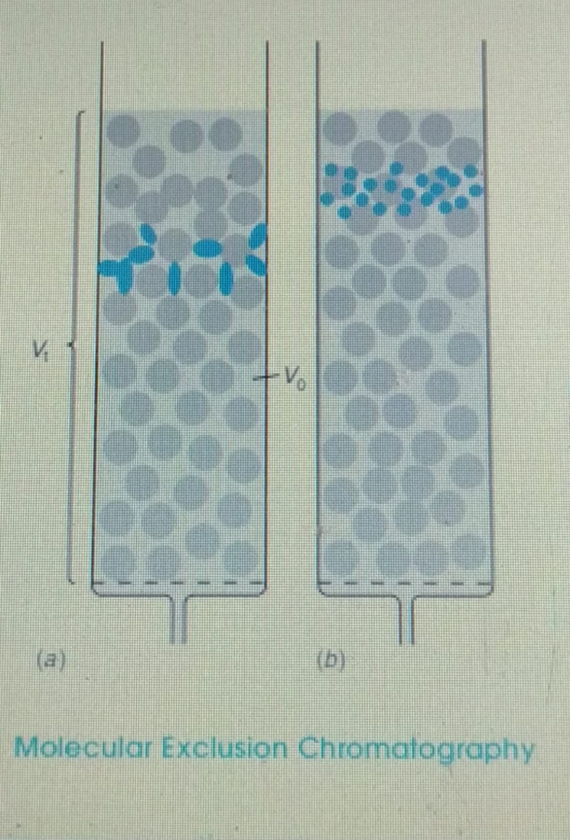
Large molecules by gel filtration because the large molecules are eluted first. This technique, called desalting, is useful for changing the buffer composition of a macromolecule solution.
The Elution Equation
The total volume of mobile phase in a chromatography column is , which includes solvent inside and outside the gel particles. The volume of mobile phase outside the gel particles is called the void volume,( Vo) . The volume of solvent inside the gel is therefore . The quantity (read “K average”) is defined as where is the retention volume for a solute. For a large molecule that does not penetrate the gel, , and . For a small molecule that freely penetrates the gel, , and . Molecules of intermediate size penetrate some gel pores, but not others, so is between 0 and 1. Ideally, gel penetration is the only mechanism by which molecules are retained in this type of chromatography. In fact, there is always some adsorption, so can be greater than 1.
Stationary Phase
Gels for open column, preparative-scale molecular exclusion include Sephadex and Bio-Gel P, which is a polyacrylamide crosslinked by. The smallest pore sizes in highly cross linked gels exclude molecules with a molecular mass , whereas the largest pore sizes exclude molecules with molecular mass . The finer the particle size of the gel, the greater the resolution (efficiency) and the slower the flow rate of the column.
Molecular Mass Determination
Gel filtration is used mainly to separate molecules of significantly different molecular size For each stationary phase, we construct a calibration curve, which is a graph of log(molecular mass) versus elution volume. We estimate the molecular mass of an unknown by comparing its elution volume with those of standards. We must exercise caution in interpreting results, however, because molecules with the same molecular mass but different shapes exhibit different elution characteristics.
For proteins, it is important to u9se an ionic strength high enough to eliminate electrostatic adsorption of solute by occasional charged sites on the gel. Nanoparticles can be separated by molecular exclusion chromatography just as proteins are separated.
Affinity chromatography
Affinity chromatography is used to isolate a single compound from a complex mixture. The technique is based on specific binding of that one compound to the stationary phase.When sample is passed through the column, only one solute is bound. After everything else has washed through, the one adhering solute is eluted by changing a condition such as pH or ionic strength to weaken its binding. Affinity chromatography is especially applicable in biochemistry and is based on specific interactions between enzymes and substrates, antibodies and antigens, or receptors and hormones.
The isolation of the protein immunoglobulin G (IgG) by affinity chromatography on a column containing covalently bound protein A. Protein A binds to one specific region of IgG at . When a crude(impure) mixture containing IgG and other proteins was passed through the column at pH 7.6, everything except IgG was eluted within 0.3 min. At 1 min, the eluent pH was lowered to 2.6 and IgG was cleanly eluted at 1.3 min.
Optical isomers of a drug can have completely different therapeutic effects. Affinity chromatography can be used to isolate individual optical isomers for drug testing.. Antibodies are produced by B cells in the spleen. One B cell produces only one kind of antibody. By isolating individual B cells, it is possible to isolate the gene for the antibody to each of the stereoisomers. The gene can be transplanted into E. coli cells for mass production of a single kind of antibody, called a monoclonal antibody. When the mixture of stereoisomers is passed through a column to which just one kind of antibody is attached, only one of the four stereoisomers is retained. By lowering the pH, the retained isomer is eluted in pure form. Box 26-2 shows how molecularly imprinted polymers can be used as affinity media. Aptamers are another class of chromatographically useful compounds with high affinity for a selected target.

