TABLE OF CONTENTS
- Definition Of Vegetation
- Classification Of Vegetation
- Dynamics Of Vegetation
- Major Vegetation Zones
- Local Vegetation Of Pakistan
- Importance Of Vegetation

DEFINITION OF VEGETATION:
Vegetation is an assemblage of plant species and the ground cover they provide. It is a general term, without specific reference to particular taxa, life forms, structure, spatial extent, or any other specific botanical or geographic characteristics. It is broader than the term flora which refers to species composition. Perhaps the closest synonym is plant community, but vegetation can, and often does, refer to a wider range of spatial scales than that term does, including scales as large as the global. Primeval redwood forests, coastal mangrove stands, sphagnum bogs, desert soil crusts, roadside weed patches, wheat fields, cultivated gardens and lawns; all are encompassed by the term vegetation. The distinction between vegetation (the general appearance of a community) and flora (the taxonomic composition of a community) was first made by Jules Thurmann (1849). Prior to this, the two terms (vegetation and flora) were used indiscriminately.
Augustin de Candolle (1820) also made a similar distinction, but he used the terms "station" (habitat type) and "habitation" (botanical region).Later, the concept of vegetation would influence theusage of the term biome, with the inclusion of the animal element.
Other concepts similar to vegetation are "physiognomy of vegetation" (Humboldt, 1805, 1807) and "formation" (Grisebach, 1838, derived from "Vegetation form", Martius, 1824).
Departing from Linnean taxonomy, Humboldt established a new science, dividing plant geography between taxonomists who studied plants as taxa and geographers who studied plants as vegetation.[13] The physiognomic approach in the study of vegetation is common among bio geographers working on vegetation on a world scale, or when there is a lack of taxonomic knowledge of someplace (e.g., in the tropics, where biodiversity is commonly high).
The concept of "vegetation type" is more ambiguous. The definition of a specific vegetation type may include not only physiognomy but also floristic and habitat aspects.The phytosociological approach in the study of vegetation relies upon a fundamental unit, the plant association, which is defined upon flora.
CLASSIFICATION OF VEGETATION:
There are many approaches for the classification of vegetation (physiognomy, flora, ecology, etc.).Much of the work on vegetation classification comes from European and North American ecologists, and they have fundamentally different approaches. In North America, vegetation types are based on a combination of the following criteria: climate pattern, plant habit, phenology and/or growth form, and dominant species. In the current US standard (adopted by the Federal Geographic Data Committee (FGDC), and originally developed by UNESCO and The Nature Conservancy), the classification is hierarchical and incorporates the non-floristic criteria into the upper (most general) five levels and limited floristic criteria only into the lower (most specific) two levels. In Europe, classification often relies much more heavily, sometimes entirely, on floristic (species) composition alone, without explicit reference to climate,
phenology or growth forms. It often emphasizes indicator or diagnostic species which may distinguish one classification from another.
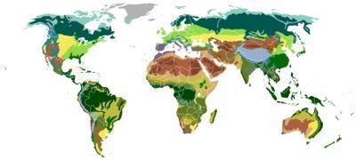
In the FGDC standard, the hierarchy levels, from most general to most specific, are: system, class, subclass, group, formation, alliance, and association. The lowest level, or association, is thus the most precisely defined, and incorporates the names of the dominant one to three (usually two) species of a type. An example of a vegetation type defined at the level of class might be "Forest, canopy cover > 60%"; at the level of a formation as "Winter-rain, broad-leaved, evergreen, sclerophyllous, closed-canopy forest"; at the level of alliance as "Arbutus menziesii forest"; and at the level of association as "Arbutus menziesii-Lithocarpus dense flora forest", referring to Pacific madrone-tanoak forests which occur in California and Oregon, USA. In practice, the levels of the alliance and/or an association are the most often used, particularly in vegetation mapping, just as the Latin binomial is most often used in discussing particular species
in taxonomy and in general communicat
ion.

Biomes classified by vegetation

undr
a
T

a
aig
T

T
emperate broadleaf and mixed fores
t

T
emperate grassland
s

t
S
ubtropical moist fores

n
M
editerranea

M
onsoon fores
t

Deser
t

Xeric shrublan
d

D
ry stepp
e

i
em
S
-
d
eser
t

G
rass savann
a

T
ree savann
a

DYNAMICS:

Dynamism in vegetation is defined primarily as changes in species composition and/or vegetation structure.

Temporal dynamics

Vegetation types at the time of Last Glacial Maximum
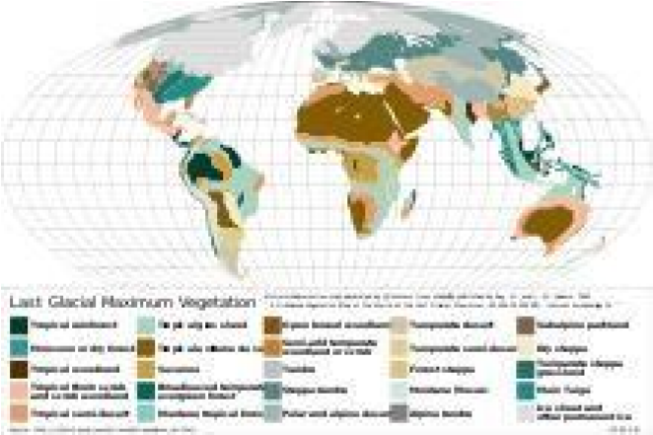
Temporally, a large number of processes or events can cause change, but for sake of simplicity, they can be categorized roughly as either abrupt or gradual. Abrupt changes are generally referred to as disturbances; these include things like wildfires, high winds, landslides, floods, avalanches and the like. Their causes are usually external (exogenous) to the community—they are natural processes occurring (mostly) independently of the natural processes of the community (such as germination, growth, death, etc.). Such events can change vegetation structure and composition very quickly and for long time periods, and they can do so over large areas. Very few ecosystems are without some type of disturbance as a regular and recurring part of the long term system dynamic. Fire and wind disturbances are particularly common throughout many vegetation types worldwide. Fire is particularly potent because of its ability to destroy not only living plants, but also the seeds, spores, and living meristems representing the potential next generation, and because of fire's impact on fauna populations, soil characteristics and other ecosystem elements and processes (for further discussion of this topic see fire ecology).
Temporal change at a slower pace is ubiquitous; it comprises the field of ecological succession. Succession is the relatively gradual change in structure and taxonomic composition that arises as the vegetation itself modifies various environmental variables over time, including light, water and nutrient levels. These modifications change the suite of species most adapted to grow, survive and reproduce in an area, causing floristic changes. These floristic changes contribute to structural changes that are inherent in plant growth even in the absence of species changes (especially where plants have a large maximum size, i.e. trees), causing slow and broadly predictable changes in the vegetation. Succession can be interrupted at any time by disturbance, setting the system either back to a previous state, or off on another trajectory altogether. Because of this, successional processes may or may not lead to some static, final state. Moreover, accurately predicting the characteristics of such a state, even if it does arise, is not always possible. In short, vegetative communities are subject to many variables that together set limits on the predictability of future conditions.

Spatial dynamics:

As a general rule, the larger an area under consideration, the more likely the vegetation will be heterogeneous across it. Two main factors are at work. First, the temporal dynamics of disturbance and succession are increasingly unlikely to be in synchrony across any area as the size of that area increases. That is, different areas will be at different developmental stages due to different local histories, particularly their times since last major disturbance. This fact interacts with inherent environmental variability (e.g. in soils, climate, topography, etc.), which is also a function of area. Environmental variability constrains the suite of species that can occupy a given area, and the two factors together interact to create a mosaic of vegetation conditions across the landscape. Only in agricultural or horticultural systems does vegetation ever approach perfect uniformity. In natural systems, there is always heterogeneity, although its scale and intensity will vary widely.

MAJOR VEGETATION ZONES:
As a general rule, the larger an area under consideration, the more likely the vegetation will be heterogeneous across it. Two main factors are at work. First, the temporal dynamics of disturbance and succession are increasingly unlikely to be in synchrony across any area as the size of that area increases. That is, different areas will be at different developmental stages due to different local histories, particularly their times since last major disturbance. This fact interacts with inherent environmental variability (e.g. in soils, climate, topography, etc.), which is also a function of area. Environmental variability constrains the suite of species that can occupy a given area, and the two factors together interact to create a mosaic of vegetation conditions across the landscape. Only in agricultural or horticultural systems does vegetation ever approach perfect uniformity. In natural systems, there is always heterogeneity, although its scale and intensity will vary widely. One way to classify different types of forests is by the type of trees a forest has. Deciduous forests have trees with green leaves that change color in the fall and drop altogether in the winter. Trees that are common in deciduous forests are oak and maple. The northeastern United States is covered in deciduous forest, and tourists flock to the area every autumn to experience the orange, yellow, and red leaves blanketing the region.

Evergreen forests:
Trees with leaves that stay green all year long. One of the places evergreen forests can be found is on the opposite side of the North American continent—in the Pacific Northwest, which includes the Canadian province of British Columbia and the U.S. states of Washington and Oregon. The Pacific Northwest is full of evergreen trees like fir.

Sometimes forests are classified by the type of leaves on their trees. Trees in broad-leaved forests have wide, flat leaves. Tropical rain forests are a type of broad-leaved forest. Tropical rain forests, such as Brazil’s Amazon Basin rain forest, are found near the Equator. They contain more than half of the world’s biodiversity, or variety of plant and animal species.

Coniferous forests have trees with cones and needles instead of leaves. Coniferous forests have the tallest (coast redwood), largest (giant sequoia), and oldest (bristlecone pine) trees in the world.
Many forests are mixed, meaning they have both broadleaf and coniferous trees. The eucalyptus forests of Australia are mixed forests, for instance. The evergreen eucalyptus trees are mixed with deciduous trees like beech.
Grassland:

Grasslands are, as their name suggests, flat and open areas where grasses are the dominant type of vegetation. Grasslands can be found on every continent except Antarctica.

Climate plays a role in the type of grassland you get. In cool, mild climates, like northwest Europe, grasslands are dominated by tough vegetation, such as oats, that thrives all year. Some of these grasses are so tough and hardy that they are considered weeds.

In warmer climates, seasonal vegetation survives better. Temperate grasslands exist where there are seasonal variations in temperature over the course of the year: hot summers and cold winters. Different grasses thrive in different temperatures here. Temperate grasslands exist from the prairies of North America to the veld, or rural grassland, of South Africa.
Tropical grasslands are called savannas. They do well in weather that is warm year-round and usually pretty dry. The most famous savannas are in Africa. Serengeti National Park, in Tanzania, has three distinct types of savanna grassland: long grass, intermediate grass, and short grass. This part of the Serengeti is known as the Serengeti Plains, and it supports wildlife from aardvarks to zebras.

Grasslands are important for milk and dairy production; dairy cows are happiest, and most productive, in areas in which they can munch on grass all day.

Tundra:

Tundra is an area where tree growth is difficult because of cold temperatures and short seasons. Vegetation in tundra is limited to a few shrubs, grasses, and mosses. Scientists estimate roughly 1,700 different species live in the tundra, which isn’t much compared to forests and grasslands. The ground is often too cold for plants to set down roots, and without plants, few animal species can survive.

There are two types of tundra: alpine tundra and arctic tundra. Alpine tundra is separated from a forest vegetation region by the tree line, the area beyond which conditions are too harsh or cold for tree growth. The weather in alpine tundra’s is cold, snowy, and windy. Most of the Tibetan
Plateau, the so-called “roof of the world” located in Tibet, China, and India, is alpine tundra. Animals like mountain goats live in this vegetation region.

Arctic tundra occurs in the far-northern hemisphere of the Earth. It has a bare landscape and is frozen for much of the year. Here, the tundra can include permafrost, or soil that is permanently frozen. Russia and Canada have huge areas of arctic tundra. During the summer, the permafrost thaws just a bit, allowing some plants to grow in the wet, marshy ground. You won’t find many mammals in the arctic tundra, but thousands of insects and birds show up every year and enjoy the marshes before they freeze. Among the few mammals that actually thrive in the arctic tundra are caribou and polar bears.

Desert:

Deserts have almost no precipitation, or rainfall. In fact, deserts are specifically defined as areas with an average annual precipitation of less than 10 inches per year. Deserts usually have really high daytime temperatures, low nighttime temperatures, and very low humidity.

Desert soil is often sandy, rocky, or gravely. Plant life is highly specialized to adapt to these coarse, dry conditions, with long roots, small leaves, stems that store water, and prickly spines that discourage animals from touching or eating them. Cactuses, which are native to deserts in North and South America, are an example of this kind of plant. Despite the barren look of hot deserts, they are full of animal life. Most desert animals, such as lizards or snakes, are nocturnal, meaning they are active at night. Nocturnal animals take advantage of the cooler nighttime temperatures of the hot desert.

Not all deserts are hot and sandy, however. The largest desert in the world is the Antarctic Desert, which takes up most of the continent of Antarctica. In the Antarctic Desert, ice sheets cover barren rock. Few animals can live in the Antarctic Desert. Those that do are often microscopic, such as lice.

Ice Sheet:

The interesting thing about the ice sheet “vegetation region” is that there really isn’t any vegetation there at all! An ice sheet is a large stretch of glacier ice that covers the land all around it for more than 50,000 square kilometers (20,000 square miles). Currently, the only ice sheets are in Antarctica and Greenland. Don’t confuse the ice sheets, called polar ice caps, with other ice shelves or glaciers; an ice sheet is much, much bigger.

Ice sheets are important research sites for scientists. The Antarctic ice sheet is a record of Earth’s atmospheric changes. By looking at layers in the ice, scientists can keep track of different levels of pollution or volcanic gases in the atmosphere. The 1883 eruption of the Indonesian island volcano of Krakatoa can be located and dated by the distinct air bubbles in the Antarctic ice sheet, for instance.

Scientists are also studying ice sheets to measure the rate of melting ice. Parts of the Greenland ice sheet were once thought to be permanent, but they are now melting at a fast pace.

LOCAL VEGETATION OF PAKISTAN:
The vegetation in Pakistan is divided into five categories on the basis of climate, altitude and plant types. These are:
- Dry tropical forest vegetation
- Dry sub-tropical sub-mountainous vegetation
- Dry Temperate forests vegetation
- Moist temperature forest vegetation
- Sub –Alpine and Alpine vegetation

1) Dry Tropical Forest Vegetation
Greater part of Pakistan has tropical conditions. The dry tropical forests are distributed in the tropical coastal area, Indus plan, and Low hills of Baluchistan and Sind. Their vegetation chiefly consists of xerophytes. Biotic communities are developed on large tract of land. This land is used for agriculture. Dry tropical forests are classified as follows:
(a)Dry Tropical Thorn Forest Vegetation (Indus plain and hills): They are distributed in Indus basin plains of Punjab. Sind, and coastal region of Pakistan. The hills are scattered throughout the Indus plain. Some of plants are Prosopis julillord Prosnpis cineraria Acacia Mimic° (kikar) and Acacia Senegal.
(b)Vegetation of Riverian Tract and Indus Delta: The area present around the river is called riverain tract. Some of plants found in this area are Saccharum numja (sarkanda), Taunt
Inc//ca etc. The tract where rive enters into sea is called delta. The delta has forests of mangroves.
- Vegetation of Sandy Tracts: Sandy tract includes Thal, Cholisten and coastal tract of Makran and Sind. The average rain fall in these regions is 6 -12 inches. Some of the plants in these regions are Salvadora, Acacia and Euphorbia.
- Vegetation of Irrigated Plantation: Canal system is developed in the Indus basin region of Pakistan. This area was included in Tropical rain forests. These forests have been cleared and its land is used for agriculture.
2) Dry sub-tropical sub-mountainous vegetation
This vegetation includes trees and shrubs. The trees may show dense growth. The trees and shrubs are thorny. The average rain fall in this region is 10 – 36 inches. Humidity is low. The annual mean humidity is 50%. Temperature rises to 40°C in summer. This area includes Siwalik Hills and Baluchistan Plateau.
2. Dry Temperate forests vegetation

Vegetation of Siwalik Hills: Siwa;ik Hills include Potohar plateau, salt range and hills of the NWFI’. Some of plants found in this regions are Acacia modems, (Rea cuspidate, Dalbergia sissy etc.
(b) Vegetation of Baluchistan Plateau: This area is distributed in dry hills, sand dunes and coamost of this area is a zone of winter rain and snow. Some of the genera found in this region are Juniperous, Frarinus. Prunus, Stipa, Dodonoea FFagraria Minn, Ephcdra and Rumex.

4. Moist Temperate Forest
These are found along the Himalayan Mountains. They are located in Kashmir, Murree -Hazara hill tract, Swat, Dir, Gilgit and Baltistan districts.
These mountains receive heavy monsoon rain fall during July to September. Annual rain 30 to 60 inches. Most of precipitation takes place in the form of snow. Snow fall may reaches up to 15 feet.
The melting of snow provides adequate moisture. Average humidity is 57%. Temperature ranges between -25 to 30’t.

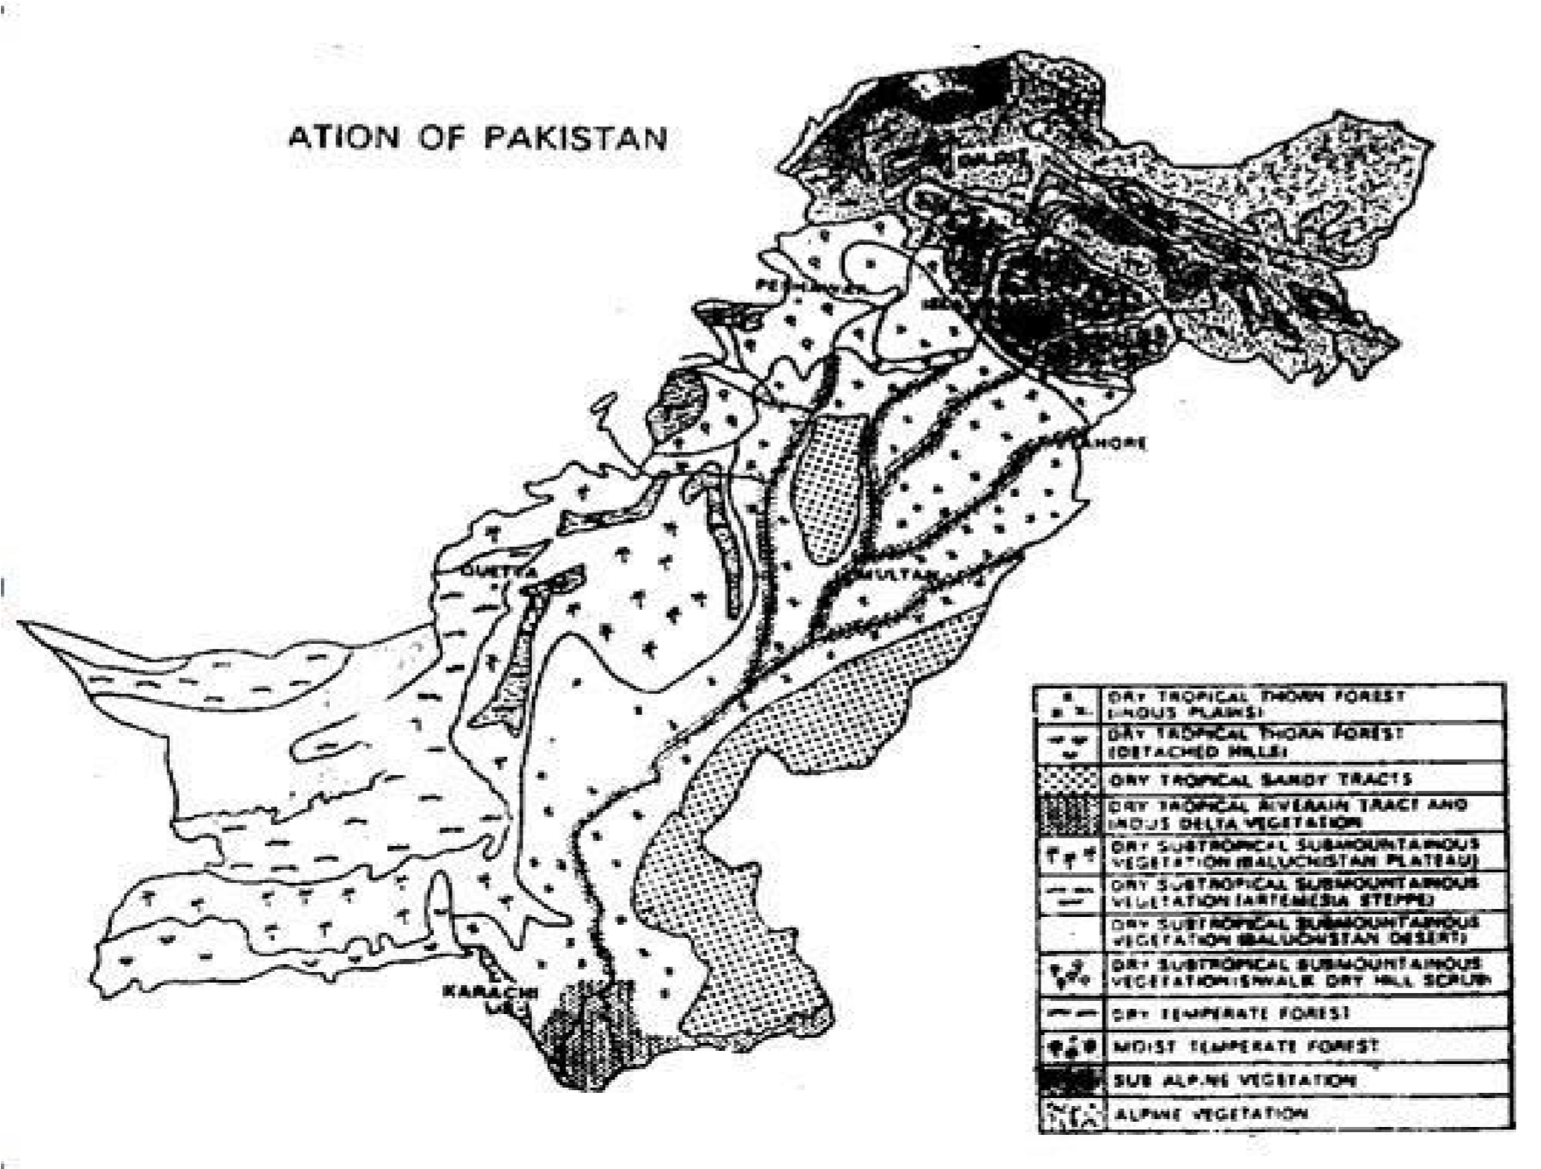

Cedrus deodara etc. Some broad leave plants are also present there. These are apple, Almond, Apricot etc.
There is heavy grazing and trampling in these forests. Therefore, most of the moist forests have been destroyed. These forests are replaced by small grasses, some legumes and some members of Liliaceae. These flat grassy grounds are called parklands. They are mostly found in Murree. Kaghan valley and upper Swat.
5. Sub alpine and Alpine vegetation
The vegetation zone above the moist temperate coniferous forest is called sub-alpine and alpine region. It is found in Himalayan Mountains of Kaghan. Swat, lialtistan. Gilgit AgenL.), Chitral, Dir and Kurram Agency.
The growing season is short in these zones. They had deep snow and cold wind. So they have xerophytic habitat tor plants. These zones are away from the monsoon region. Therefore,Annual rain fall is very low.

IMPORTANCE OF VEGETATION:
Vegetation serves several critical functions in the biosphere, at all possible spatial scales.First, vegetation regulates the flow of numerous biogeochemical cycles, most critically those of water , carbon, and nitrogen; it is also of great importance in local and global energy balances.
- Vegetation is a key component of an ecosystem and, as such, is involved in the regulation of various biogeochemical cycles, e.g., water, carbon, nitrogen.
- Vegetation converts solar energy into biomass and forms the base of all food chains.
- Vegetation influences the energy balance at the earth’s surface and within the atmospheric boundary layer, often mitigating extremes of local climate.
- Vegetation releases oxygen and sequesters carbon.
- Vegetation affects soil development over time, generally contributing to a more productive soil.
- Vegetation provides wildlife habitat and food.
- Vegetation provides direct (e.g., timber) and indirect (e.g., watershed protection) socioeconomic products and services for humans.
- Vegetation gives spiritual and cultural experiences to some people.
- Vegetation can be easily described and mapped, and therefore can be used to: monitor changes in cover, composition, and structure due to natural or humaninfluenced events. Set conservation and habitat management goals.

