TOPIC:LIGHT,TEMPERATUREANDQUALITYOFLIGHT Light:
Lightisakindofenergythattravelintheformofwavesaswellasparticles.
Lightwave:
Lightwaveistransverseelectro-magneticinwhichelectricandmagneticfieldtravelin thedirectionofpropagationofwaveandit90°withrespecttoeachother.
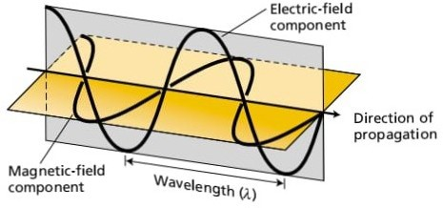
Lightwavehasspecificwavelengthandfrequency.Thefrequencyoflightisinversely proportionatetothewavelengthoflight.
v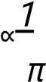
v=^{c} π
c=πv
WhereCisconstantcalledspeedlightanditsvalueis3×10m/s.
ParticleNature:
LightisalsoaparticlewhichwecallPhoton.Photoncontainanamountofenergythatiscalled quantum(p1.Quanta),thesequantanotincontinuousformbuttravelina discretepacketwhichdependuponthefrequencyoflight.
E=hv
Wherehisplank’sconstantanditsvalueis6.626×10⁻³⁴js.
RoleofLightinPhoto-synthesis:
Sunisthebasicsourceoflight.Sunlightislikearainofphotonsofdifferentfrequencies.Someour eyesaresensitivetosmallportionoflightcalledvisiblelight.Whenthesevisiblelightpass fromtheprismtheygivesevencolorsofdifferentfrequencywavelength.
700nm_{R}
O
I
Y
G
B
V
400nm
Thelightbelow400nmofwavelengthcalledultravioletlightwhichareharmfulforanimal andplant.
Thelightabove700nmofwavelengthcalledIRradiationwhicharenoeffectonplantand arereflectinupperatmosphere.
AbsorptionSpectra:
Thepartoflightusuallyabsorbbyphoto-syntheticpigmentofplantsiscalledAbsorptionSpectra.
Theabsorptionspectrumforaparticularsubstanceinanon-absorbingsolventcanbe determinedbyaspectrophotometer.
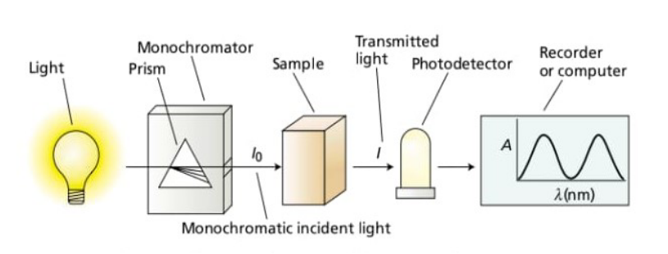
Spectrophotometryisatechniqueusedtomeasuretheabsorptionoflight.
Chlorophyllabsorbhavecertainwavelengthoflightwithinthevisiblerangeofthe moreeffectivelightabsorbedbychlorophyllisredandblue.Thegreenpartofthevisible lightusuallyreflectthatiswhychlorophyllappeargreen.
Whenchlorophyllmoleculeabsorbslight,theyexcitedfromgroundstatetohighenergystate.
chl+hv=chl^{x}
Absorptionofbluelightexcitechlorophylltohigherenergystatethanabsorptionofred lightbecausetheenergyofphotonishigherwhentheirwavelengthisshorter.
Theabsorptionspectraofchlorophyllandcarotenoidasshowninthefollowingfigure.
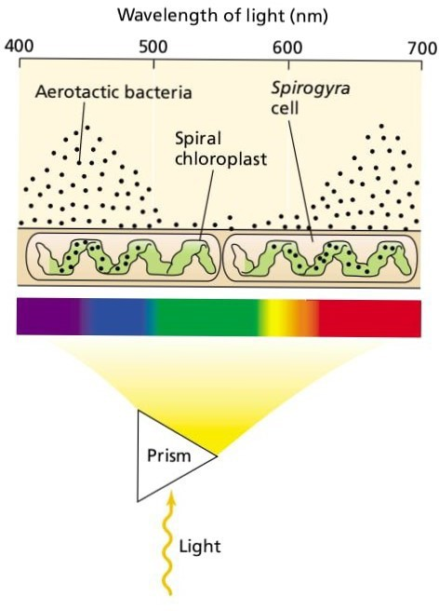
ActionSpectra:
Thepartoftheabsorblightspectratodriveprocessofphotosynthesis.
OR
Theabilityofdifferentwavelengthoflighttodrivetheprocessofphotosynthesis.

OR
Comparativeabilityofdifferentwavelengthoflighttodrivephotosynthesis.
Theactionspectrumshowsthemagnitudeofaresponseofabiologicalsystemtolight,asa functionofwave.Forexample,anactionspectrumcanbeconstitutedformeasurementof oxygenevaluationatdifferentwavelength.
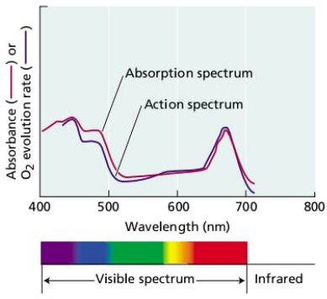
Intheabovefigureactionspectrumdrawb/wo₂evaluationresponseandwavelength.The actionspectraofoxygen(o₂)evaluationmatchtheabsorptionspectraofintackchloroplast quitwell,indicatingthatlightabsorptionbythechlorophyll’smediateoxygenevaluation.
ActionspectraweremeasuredbyT.WEngelmannin1800s.Engelmannusedaprismtodisperse sunlightintoarainbowthatwasallowedtofallonanaquaticalgalfilament.Apopulationofo₂
(oxygen)seekingbacteriawasintroducedintothesystem.Thebacteriacongregatedinthe regionofthefilamentthatevaluedthemostoxygen.Theseweretheregionilluminatedbyblue lightandredlightwhicharestronglyabsorbbychlorophyll.
LightRoles:
Inlightreactionofphotosynthesislighthastworoles:
1.Photo-excitation
2.Photo-lysis
1)Photo-excitation:
Whenlightfallonantennacomplexofchlorophyllbofphoto-systemIIand chlorophyllaofphotosystemI,thesefigmentsabsorbitandbecomeactivated.It releasesanelectron,theelectronbecomeexcitedtoahighenergylevelwhicharecapturedby primaryelectronacceptor.
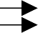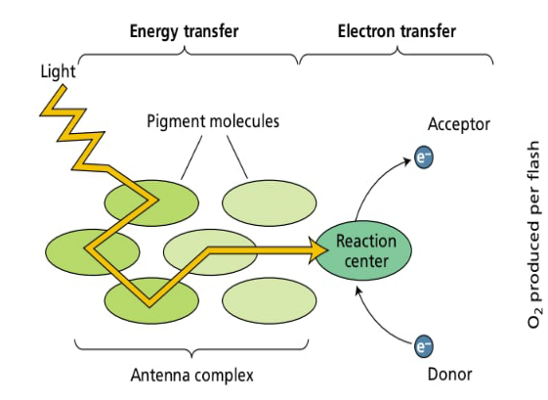
2
e
P
=
I
I
2)Photo-lysis:
Whenwaterfallonphoto-system,thewatermoleculesbreakupintotwo componenthydrogenandoxygen.
4HO→4H+4OH
2 4OH→2HO+O
2 2
TheHydrogencombinewithNADP,formNADP^{H}₂.
QualityofLight:
Thequalityoflightisalsoimportantforplant.Onthebasisofplantlightperiod(Quantity) plantweredividedintothreecategories:
` 1.Short-DayPlant
2.Long-DayPlant 3.Day-NeutralPlant
1.Short-DayPlant:
Theplantwhichproducedfloweriflightisprovidedbelowthecriticalvalue.
e.g.Tobacco,Soyabean,SugarCane,Potato,Riceetc.Shortdayplantalsocalledlong nightplantbecausetheirdarkperiodislongerthancriticalvalue.
2.LongDayPlant:
Theplantwhichproducefloweriflightisprovidedabovethecriticalvalue. ExampleofLongDayPlantisWheat,Oat,Spinach,Radish.
3.DayNeutralPlant:
Plantswhichindependentondaylength.DayNeutralPlantproduceflowerafteraperiod ofvegetativegrowth.
ExampleisTomato,Sunflower,Litton,Cucumberetc.
Notonlyquantityoflightisimportantforplantbutqualityoflightisalsoveryimportantforplant. Borthwickin1954performanexperimentandproofthatqualityoflightandquantityoflightboth importantforplant.
Borthwicktaketwoplant,oneplantwasshortdayplantandtheotherplantwas longdayplantandperformtheflowingexperimenttoprovetheimportanceoflightforplant.
1.Hetakeshortdayplantandfexposedtoshortdayperiodoflight.They produceshortflowerthenheexposeddayplanttodayperiodoflighttheyremain
vegetative.
Short-Day LongDay
White Black flowering White Black
9/1 9/1
5 ShortDayPlant 5 Vegetative
2.Borthwicktakelongdayfirstlyheexposedtoshortdayperiodoflight.They remainvegetativeandcannotproducedflower.Thenheexposedtolongdayperiod,theplant produceflower.
Short-Day | LongDay
White
Black
9/1  5 Vegetative | 9/15  flowering
3.Hetakeshortdayplantandexposedtoshortdayperiodoflightbutbreaktheirdark periodthroughredlight.So,duetowhichtheirdarkperiodiseffect,sotheyremainvegetative. Thenheexposedtolongdayperiodbutgiveredlightduringnight,sotheyproducedflower.
Red LongDay Red
ShortDayPlant
Vegetative
Flowering
9/1
5
4.Hegive1Rlighttolongdayplantduringshortdayperiod,theyproducedandhegive1R lightduringlongdayperiodtheyremainvegetativeandcannotproducedflower.
Long-DayPlant
1 1
S.D
9/1 9/15
5
5.ThenhetakeshortdayplantandexposedtoshortdayperiodbuthegiveRed then1Rlight,sotheplantproducedflower.Inlongdaytheplantcannotproducedflowerand remainvegetative.
Red1R Red1R
S.D WhiteBlackflowering L.D
WhiteBlack
6.Finally,hetakeslongdayplantandexposedtoredlightthen1Rlightinshortdayperiod theplantremainsvegetativeduringlongdayperiodtheplantproducedflower.
1RR 1RR
White | Black
White | Black
S.D Vegetative L.D
Flowering
Borthwickconcludedthatonlyquantityoflightisimportantbutqualityalsoimportant.
Temperature:
Thedegreeofheatpresentinasubstanceespeciallyexpressedbyacomparativescaleona thermometer.
Temperatureisanabioticfactorwhichwedefinedas“Thenegativeimpactofnonlivingfactoronlivingorganisminaspecificenvironment.”
EffectofTemperatureonPlant:
Theoptimumtemperatureforplantgrowthis25-30°c.Ifthetemperatureincreasefrom theoptimalvaluetheyhavenegativeeffectonplantandalsoiftemperaturedecrease fromnormalvalueeffecttheplant. HighTemperatureEffect:
1.Highmaycauseinjurytochloroplastby:
i.DisturbingThyloKoidstructure
ii.Swellingofgrana
iii.Effectgranastockingability.
2.Hightemperatureincreasefluidityoflipidduetowhichkineticenergyof membraneincreaseandthemoleculerandomlymove.
3.Hightemperaturealsodecreaseshydrogenbondingandelectro-static interactionb/wpolargroupsofproteinwithintheaqueousphaseofthe membrane.
4.Hightemperaturemodifiesmembranecompositionandstructureandcauseleakage ofions.
5.Photo-Synthesisandrespirationarebotheffectedbyhightemperature.
6.Chloroplastenzymesbecomeunstablebyhightemperatureandbeganto denatureandloseactivity.Becauseenzymesareproteininnatureandinthehigh temperature,theylosetheirthree-dimensionalstructure.
TolerancetohighTemperature:
Whentemperatureishightheplantdevelopssomemethodtoprotectitselffromhightemperature.
1.Highexpressionofanti-oxidantenzymelikecatalyze,peroxidase,glutathione,reductase.
2.Plantproduceanti-oxidantmetabolitelikeascorbatecaroteneetc.
3.Expressionofheatshockprotein(heatshockproteinsareafamilyofprotein thatareproducedbycellsinresponsetoexposuretostressfulcondition.)
PreventiontohighTemperature:
1.Whentemperatureishighthenstomataautomaticallyclosedtoconservewater.
2.Xylemtransportlittlewatertoconservewaterwhentemperatureishigh.
3.Walycuticlealsopreventswaterlossathightemperaturethisisthe adaptationwhichovercomethehightemperature.
4.Rollingofleafbladderwherevertheyusedrollingofleafbladderthereisless surfaceforthereductionofwater.
LowTemperature:
1.ChillingStressTemperature0-15°ccausechillingstress(whenplantexposed toalowtemperatureabovethe0°cthisiscalledchillingstress).
2.FreezingStressWhenplantisexposedtoalowtemperaturebelowzerodegree causefreezingstress.
Thesetwoconditionsareshownbytheplantoftropicalarea.
EffectofColdTemperatureonPlant:
1.Discolorationofleaves:Whentemperatureislowtheleaveshaschanged colorintothewhitish,yellowishorbronzeandalsoprematureleaffallalsooccur. Thisdiscolorationalsooccursduetothedeficiencyofnutrient.
2.Delayedtransitionoffloweringandplantgrowth.
3.PollenSterility:Pollensterilityisalsocausedbylowtemperature.
“Pollensterilitymeanthefailureofplanttoproducepollenormalegametes”
4.Waterpotentialinsidethecellalsoeffectedbylowtemperaturebecauseatlow temperaturewaterconvertintoicewhicheffectenzymesandionschannel. AdaptationtoLowTemperature:
1.NeedlelikeleafstructurewhichpresentfreezingandtranspirationofH₂Oduetolow surfacearea.Theyalsohaveterpenesandalcoholwhichareanti-freezingfactor.
2.Terminationofgrowthactivityduringwinter.
3.Coldareaplantsanti-freezingproteinwhichintheRyeplant.

