Topic
NATURAL RESOURCES AND RESERVES
Natural Resources
A natural resource is what people can use which comes from the natural environment.
Examples of natural resources are air, water, wood, oil, wind energy, natural gas, iron, and coal.
Reserves
Reserves are that subgroup of a resource that have been discovered, have a known size, and can be extracted at a profit.
Reserve resources are those resources which we know their use and how to use them but we have kept them for future use. For example, USA has plenty of oil and gas reserves but it imports oil and gas and has kept its own reserves for future use
Introduction to natural resources (NR)
Ever since the earth was inhabited, humans and other life forms have depended on things that exist freely in nature to survive. These things include water (seas and fresh water), land, soils, rocks, forests (vegetation), animals (including fish), fossil fuels and minerals. They are called Natural Resources and are the basis of life on earth.
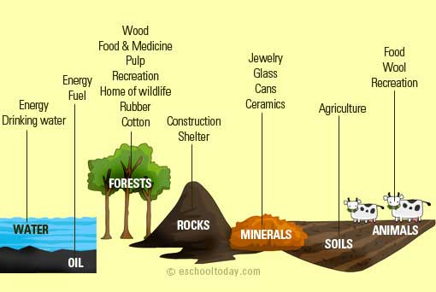
All these mentioned above are natural, and they exist in nature. No human created them. We tap into their supply to survive and also to function properly. Natural resources are all connected in a way. Therefore if one is taken away, it will affect the supply or quality of all others. For example, if water is eliminated from an area, the vegetation, soils, animals and even the air in that area will be affected negatively.
Below is a simple illustration of some great things that we get from some natural resources.
Natural resources can be consumed directly or indirectly. For instance, humans depend directly on forests for food, biomass, health, recreation and increased living comfort. Indirectly forests act as climate control, flood control, storm protection and nutrient cycling.
Raw materials
Sometimes, natural resources can be used as raw materials to produce something. For instance, we can use a tree from the forest to produce timber. The timber is then used to produce wood for furniture or pulp for paper and paper products. In this scenario, the tree is the raw material.
Every item in your home was made from a raw material that came from a natural resource. The tea mug, electricity at home, bread, clothes, you name them: each of them came from a natural resource
Natural resources come in many forms. It may be a solid, liquid or gas. It may also be organic or inorganic. It may also be metallic or non-metallic. It may be renewable or non-renewable. Click next to see what each category is made up of.

Types of Natural Resources
All Natural Resources fall under two main categories:
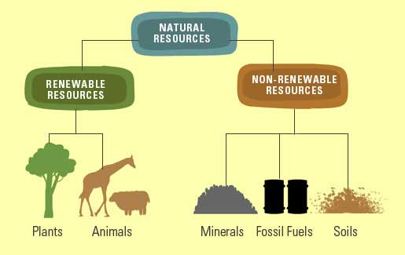
Renewable and Non-renewable Resources.
Renewable resources
Renewable resources are those that are constantly available (like water) or can be reasonably replaced or recovered, like vegetative lands. Animals are also renewable because with a bit of care, they can reproduce offsprings to replace adult animals. Even though some renewable resources can be replaced, they may take many years and that does not make them renewable.
If renewable resources come from living things, (such as trees and animals) they can be called organic renewable resources.
If renewable resources come from non-living things, (such as water, sun and wind) they can be called inorganic renewable resources.
Non-renewable resources
Non-renewable resources are those that cannot easily be replaced once they are destroyed. Examples include fossil fuels. Minerals are also non-renewable because even though they form naturally in a process called the rock cycle, it can take thousands of years, making it non-renewable. Some animals can also be considered non-renewable, because if people hunt for a particular species without ensuring their reproduction, they will be extinct. This is why we must ensure that we protect resources that are endangered.
Non-renewable resources can be called inorganic resources if they come from non-living things. Examples include include, minerals, wind, land, soil and rocks.
Some non-renewable resources come from living things — such as fossil fuels. They can be called organic non-renewable resources.
Metallic and Non-metallic Resources
Inorganic resources may be metallic or non-metallic. Metallic minerals are those that have metals in them. They are harder, shiny, and can be melted to form new products. Examples are iron, copper and tin. Non-metallic minerals have no metals in them. They are softer and do not shine. Examples include clay and coal.

Why are Natural Resources so important?
Natural resources are available to sustain the very complex interaction between living things and non-living things. Humans also benefit immensely from this interaction. All over the world, people consume resources directly or indirectly. Developed countries consume resources more than under-developed countries
The world economy uses around 60 billion tonnes of resources each year to produce the goods and services which we all consume. On the average, a person in Europe consumes about 36kg of resources per day; a person in North America consumes about 90kg per day, a person in Asia consumes about 14kg and a person in Africa consumes about 10kg of resources per day.
In what form do people consume natural resources? The three major forms include Food and drink, Housing and infrastructure, and Mobility. These three make up more than 60% of resource use.
Food and drink:
This includes agricultural products as well as naturally occurring foods such as game, fish from fresh water and seas, seeds and nuts, medicines, herbs and plants. They also include drinking water, as well as water for sanitation and household use. Think of ceramic plates, silverware (spoons, forks and knives), cans, milk packages, paper and plastic cups — they are all made from raw materials which come from our natural resources.
Mobility:
This includes automobiles, trains, water vessels, airplanes, together with all the fuel that powers them. Can you imagine where all the raw materials used in their production came from?
Housing and infrastructure:
Think about all the houses, public places, roads and constructed objects you have in your city or town. Think about all the energy for heating and cooling that we consume in our homes — can you imagine where all the wood, metals, plastic, stone and other materials came from?
Beyond these three major areas of resource consumption, we consume much more resources from our environment on a daily basis. The role of natural resources in sustaining life on earth is extremely important and we must ensure that we protect the environment and also make it easy for it to
replenish itself naturally.
Distribution of Natural Resources
Natural resources are not evenly distributed all over the world. Some places are more endowed that others — for instance, some regions have lots of water (and access to ocean and seas). Others have lots of minerals and forestlands. Others have metallic rocks, wildlife, fossil fuels and so on.
For example, The US has the world's largest coal reserves with 491 billion short tons accounting for 27% of the world's total. Australia is the world's largest net exporter of coal accounting for 29% of global coal exports
China remains the largest producer of gold with a 14% share of the global production.
The United States, Russia, and Canada are the leading producers of timber and pulp. Annual exports of primary and secondary wood products from tropical forests have exceeded US$ 20 billion in recent years and further increases are anticipated.
Many countries have developed their economies by using their natural resources. Some also get a lot of income from their resources in the form of tourism and recreation. Brazil and Peru for example, make a lot of money from The Amazon Forests, which is super diverse in trees and animals.
Crude oil is another important natural resource. From Crude oil, we get many petroleum products such as petrol, diesel and gas. We use these to fuel our cars and provide energy to warm and cool our homes. But Crude oil is not evenly distributed all over the world. Below is an illustration of how much each region of the world produces.
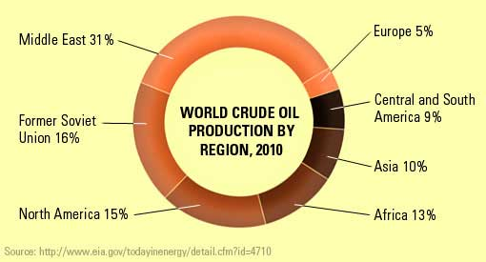
International and local trade has its roots in the fact that resources are not evenly distributed on the earth’s surface. Regions with crude oil can drill oil and sell to regions without oil, and also buy resources such as timber and precious metals (gold, diamonds and silver) from other regions that have them in abundance.
The uneven distribution is also the root of power and greed in many regions. Some countries use their wealth in resources to control and manipulate regions with fewer resources. Some countries and regions have even gone to war over the management, ownership, allocation, use and protection of natural resources and related ecosystems.
Threats to Natural Resources
A. Overpopulation
This is probably the most significant, single threat that natural resources face. The world’s population is increasing at a very fast rate. In the USA, a baby is born every 8 seconds, and a person dies every 13 seconds The increase in populations mean there will be pressure on almost all natural resources. How?
Land Use: With more mouths to feed and people to house, more land will need to be cultivated and developed for housing. More farming chemicals will be applied to increase food production. Many forest or vegetative lands will be converted to settlements for people, roads and farms. These have serious repercussions on natural resources.
Forests: Demand for wood (timber), food, roads and forest products will be more. People will therefore use more forest resources than they can naturally recover.
Fishing: Fresh water and sea food will face problems too as we will continue to depend heavily on them. Bigger fishing companies are going deeper into sea to catch fish in even larger quantities. Some of the fishing methods they use are not sustainable, thereby destroying much more fish and sea creatures in the process.
Need for more: Human's demand for a comfortable life means more items (communication, transport, education, entertainment and recreation) will need to be produced. This means more industrial processes and more need for raw materials and natural resources.
B. Climate Change
The alteration in climate patterns as a result of excessive anthropogenic is hurting biodiversity and many other abiotic natural resources. Species that have acclimatized to their environments may perish and others will have to move to more favorable conditions to survive.
C. Environmental Pollution
Land, water and air pollution directly affect the health of the environments in which they occur. Pollution affects the chemical make-up of soils, rocks, lands, ocean water, freshwater and underground water, and other natural phenomena. This often has catastrophic consequences

Problems associated with Natural Resources
Even though natural resources are the basic support structures of life, too much or too little of it can come with a lot of trouble and conflict.
Too little natural resources:
In many regions of the world a mix of limited resources, overpopulation and environmental degradation has produced extreme poverty and income inequality. This has in turn has fuelled grievances, rebellion and conflict in society.
Too much natural resources:
This problem is even bigger in regions with excess natural resources. Greed, corruption, and conflict from revenue distribution, resource ownership, decision making, management, and access has fuelled local and international conflict.
For example, in Papua New Guinea, The Panguna Copper Mine, once the largest open pit mine in the world was the centre of violent conflict. Developed in the 1960’s, locals were angry about the unfair salaries between local and foreign workers. They were also angry that the government did not give the community a fair share of revenues from the mine. They also had problems with foreign firms exploiting the community’s resources. This conflict continued even after the mine was closed.
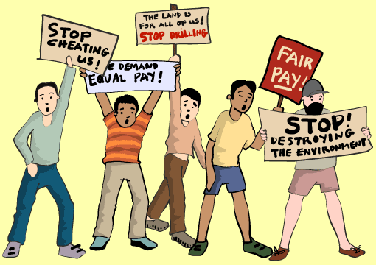

Conflict does not occur only in local communities. Third parties (including advanced nations) also have extreme interest in wealth from natural resources in other regions. This often results in tensions between regions and countries, as well as foster or engage in civil conflicts.
For example, civil war in Democratic Republic of Congo (DRC) was partly fostered by neighboring states seeking raw materials. It is also believed that the actions of a French Oil Corporation (Elf) escalated the conflict in DRC.
What kind of natural resources are in your country and do you think some nations are interfering with your country's resources? What can your leaders do to ensure that there is no conflict from this scenario.

Resource Recovery
In recent years, waste has been viewed as a potential resource and not something that must end up in the landfill. From paper, plastics, wood, metals and even wastewater, experts believe that each component of waste can be tapped and turned into something very useful.
Fossil fuel use by the pulp and paper industry in the United States of America declined by more than 50% between 1972 and 2002, largely through energy efficiency measures, power recovery through co-generation and increased use of biomass.
Resource recovery is the separation of certain materials from the waste we produce, with the aim of using them again or turning them into new raw materials for use again.
It involves composting and recycling of materials that are heading to the landfill. Here is an example: Wet organic waste such as food and agricultural waste is considered waste after food consumption or after an agricultural activity. Traditionally, we collect them and send them to a landfill. In Resource Recovery, we collect and divert to composting or anaerobic digestion to produce biome thane. We can also recover nutrients through regulator-approved use of residuals.
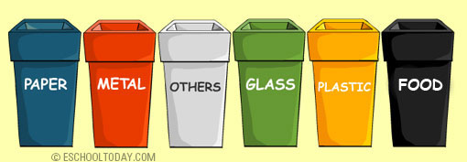
The concept can be applied in household settings too. Many communities have places that residents can drop off waste that they have already sorted in their homes. This makes it easy for waste recovery organizations to pick them up for further processing.
Recovering waste is not an easy task. It involves good planning, education, community participation, and use of technology. But it has huge environmental and economic benefits and must be seriously considered.
Resource recovery benefits us because it reduces our need to tap into new raw materials, thereby saving the environment. For example, by separating and collecting all paper products from the waste we create, we can recycle them to reduce the need for new pulp which comes from timber. Less energy is also used in recycling old materials than new raw materials.
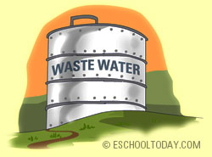
Think of wastewater and storm water as another example. The demand for potable water can be greatly reduced if we can divert all wastewater and storm water for treatment and re-use. We can use it for gardening, agriculture, sanitation (cleaning) and even heating by energy producers.
In Victoria, Australia, reclaimed water is used to irrigate vineyards, tomatoes, potatoes, and other crops in addition to traditional landscape irrigation.
In Mexico City, nearly 46 million gallons (174 million liters) per day of reclaimed water is used for irrigation of green areas, recharge of recreational lakes and agriculture.
Conservation of Natural Resources
To have an environmentally sustainable secure future where we can still enjoy natural resources, we urgently need to transform the way we use resources, by completely changing the way we produce and consume goods and services.
The case of high resource consumption occurs primarily in the bigger cities of the world.
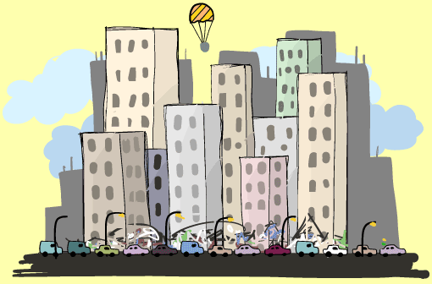
Cities worldwide are responsible for 60-80% of global energy consumption and 75% of carbon emissions, consuming more than 75% of the world’s natural resources.
To turn this unfortunate way of life around, we all have to play a role.
Education and Public Awareness
All stakeholders must aim to provide information and raise public awareness about the wonderful natural resources we have and the need to ensure its health. Even though there is a lot of information in the public domain, campaigners must try to use less scientific terms, and avoid complex terminology to send the message across. Once people understand how useful our natural resources are, they will be better placed to preserve it.
Individuals, organizations and nations
People and organizations in developed nations with high resource consumption rates must be aware of the issues of natural resources. People should understand that it is OK to enjoy all the items and gadgets at home, but also, give back to the environment by way of reducing waste, recycling waste and becoming a part of the solution. We can achieve this in our homes and workplaces by reducing waste and also by recycling the waste we create.
Governments and Policy
Governments must enforce policies that protect the environment.
They must ensure that businesses and industries play fair and are accountable to all people. Incentives must be given to businesses that use recycled raw materials and hefty fines to those that still tap from raw natural resources. Businesses must return a portion of their profits to activities that aim at restoring what they have taken out of the environment.
Did you know...
Population growth means more need for natural resources
The world population is expected to increase to 10.2 billion by 2050, with two thirds of the population living in cities. More than half of this anticipated growth is expected to occur in Africa (+1.3 billion), with Asia (+0.75 billion) expected to be the second largest contributor to future population growth. Global demand for agricultural and energy production (mainly food and electricity), both of which are water-intensive, is expected to increase by roughly 60% and 80% respectively by 2025*.
*WWAP (United Nations World Water Assessment Programmed)/UN-Water. 2018. The United Nations World Water Development Report 2018: Nature-Based Solutions for Water. Paris, UNESCO. Page 10, ISBN 978-92-3-100264-9
Natural Resources Consumption:
People in rich countries consume up to 10 times more natural resources than those in the poorest countries. On average, an inhabitant of North America consumes around 90 kilograms (kg) of resources each day. In Europe, consumption is around 45 kg per day, while in Africa people consume only around 10 kg per day.
Which society consumes more?
Before industrial times, people lived by hunting and gathering. They consumed only renewable natural resources such as wood and sun. Wood was basically used for basic shelter and carving hunting weapons. One person consumed only about 3kg of natural resources per day.
In agrarian communities, more natural resources were used to power the farms, feed animals and transport produce and meats. The average consumption per person in this community is 11kg per day.
In an industrial society, more energy, particularly fossil fuels is used to power production plants. Construction, infrastructure, transport, storage, marketing and distribution, all depend on energy and other natural resources. This is why industrialized nations consume so much resource. The average consumption per person is 44kg per day.
Waste Recovery is real:
Before the mid 1970, waste in Connecticut (a state in the USA) was sent to landfill. The state recognized the environmental hazards of it, and made some policy changes. By 2010, about 92% of Municipal Solid Waste (MSW) is saved from the landfill. Of this amount, one this is recycled and two thirds is combusted to energy. The energy is enough to power 100,000 homes

