Topic: Enzymes

Content:
Chemistry
Classification
Mechanism of Enzyme Action
Enzyme Kinetics
Inhibition
Activation
Specificity
Introduction:
Enzymes are biological catalysts that speed
up the rate of the biochemical reaction.
Most enzymes are three-dimensional globular proteins (tertiary and quaternary structure).

EARLY NATURE OF ENZYME

The living cell is the site of tremendous biochemical activity called metabolism. This is the process of chemical and physical change which goes on continually in the living organism. Build-up of new tissue, replacement of old tissue, conversion of food to energy, disposal of waste materials, reproduction - all the activities that we characterize as "life." This building up and tearing down takes place in the face of an apparent paradox. The greatest majority of these biochemical reactions do not take place spontaneously. The phenomenon of catalysis makes possible biochemical reactions necessary for all life processes. Catalysis is defined as the acceleration of a chemical reaction by some substance which itself undergoes no permanent chemical change. The catalysts of biochemical reactions are enzymes and are responsible for bringing about almost all of the chemical reactions in living organisms. Without enzymes, these reactions take place at a rate far too slow for the pace of metabolism. The oxidation of a fatty acid to carbon dioxide and water is not a gentle process in a test tube - extremes of pH, high temperatures and corrosive chemicals are required. Yet in the body such a reaction takes place smoothly and rapidly within a narrow range of pH and temperature. In the laboratory, the average protein must be boiled for about 24 hours in a 20% HCl solution to achieve a complete breakdown. In the body, the breakdown takes place
in four hours or less under conditions of mild physiological temperature and pH. It is through attempts at understanding more about enzyme catalysts - what they are, what they do, and how they do it - that many advances in medicine and the life sciences have been brought about.
Early Enzyme Discoveries
The existence of enzymes has been known for well over a century. Some of the earliest studies were performed in 1835 by the Swedish chemist Jon Jakob Berzelius who termed their chemical action catalytic. It was not until 1926, however, that the first enzyme was obtained in pure form, a feat accomplished by James B. Sumner of Cornell University. Sumner was able to isolate and crystallize the enzyme urease from the jack bean. His work was to earn him the 1947 Nobel Prize. John H. Northrop and Wendell M. Stanley of the Rockefeller Institute for Medical Research shared the 1947 Nobel Prize with Sumner. They discovered a complex procedure for isolating pepsin. This precipitation technique devised by Northrop and Stanley has been used to crystallize several enzymes.

Structure of enzyme;
The active site of an enzyme is the region that binds substrates, co-factors and prosthetic groups and contains residue that helps to hold the substrate.
Active sites generally occupy less than 5% of the total surface area of enzyme.
Active site has a specific shape due to tertiary structure of protein.
A change in the shape of protein affects the shape of active site and function of the enzyme.
- Active site:
Active site can be further divided into:
Binding Site:
It chooses the substrate and binds it to active site.
Catalytic Site:
It performs the catalytic action of enzyme.
- Cofactors
Co-factor is the non protein molecule which carries out chemical reactions that cannot be performed by standard 20 amino acids.
Co-factors are of two types:
Organic co-factors
Inorganic cofactors.
- Inorganic Co. Factors
These are the inorganic molecules required for the proper
activity of enzymes.
Examples:
Enzyme carbonic anhydrase requires Zn for it‟s activity.
Hexokinase has co-factor Mg++.
- ORGANIC CO-FACTORS
o These are the organic molecules required for the proper activity of enzymes.
Example:
Glycogen phosphorylase requires the small organic molecule pyridoxal phosphate.
TYPES OF ORGANIC CO-FACTORS;
Prosthetic Group Coenzyme
o A prosthetic group is a o A coenzyme is loosely tightly bound organic co- bound organic co-facto+r. factor e.g. Flavins, heme E.g. NAD+
groups and biotin.
An enzyme with it‟s co-factor removed is designated as
apoenzyme.
The complete complex of a protein with all necessary small organic molecules, metal ions and other components is termed as holoenzyme of holoprotein.
- Substrate:
The reactant in biochemical reaction is termed as substrate.
When a substrate binds to an enzyme it forms an enzyme- substrate complex.
SITES OF ENZYME SYNTHESIS:
Enzymes are synthesized by ribosomes which are attached to the rough endoplasmic reticulum.
Information for the synthesis of enzyme is carried by DNA.
Amino acids are bonded together to form specific enzyme
according to the DNA‟s codes.
INTRACELLULAR AND EXTRACELLULAR ENZYMESP:
Intracellular enzymes are synthesized and retained in the cell for the use of cell itself.
They are found in the cytoplasm, nucleus, mitochondria and
chloroplast.
Example:
Oxydoreductase catalyses biological oxidation.
Enzymes involved in reduction in the mitochondria.
o Extracellular enzymes are synthesized in cell but secreted from the cell to work externally.
Example:
Digestive enzyme produced by the pancreas, are not used by the cells in the pancreas but are transported to the duodenum.
CHARACTERISTICS:
Enzymes speed up the reaction by lowering the activation energy of the reaction.
Their presence does not affect the nature and properties of
end product.
They are highly specific in their action that is each enzyme
can catalyze one kind of substrate.
Small number of enzymes can accelerate chemical reactions.
Enzymes are sensitive to change in pH, temperature and substrate concentration.
Turnover number is defined as the number of substrate molecules transformed per minute by one enzyme molecule.
NOMENCLATURE OF ENZYMES
An enzyme is named according to the name of the substrate its catalysis.
Some enzymes were named before a systematic way of
naming enzyme was formed.
Example: pepsin, trypsin and rennin
By adding suffix -ase at the end of the name of the
substrate, enzymes are named.
Enzyme for catalyzing the hydrolysis is termed as hydrolase.
Example:
Lactose, maltose, glucose….
Classification:
A systematic classification of enzymes has been developed by
International Enzyme Commission.
This classification is based on the type of reactions catalyzed by enzymes.
There are six major classes.
Each class is further divided into sub classes, sub sub-classes and so on, to describe the huge number of different enzyme- catalyzed reactions.
Mechanism of enzyme action:
The catalytic efficiency of enzymes is explained by two
perspectives:
Thermodynamic changes
Processes at the active site
THERMODYNAMIC CHANGES: All chemical reactions have energy barriers between reactants and products.
The difference in transitional state and substrate is called
activational barrier.
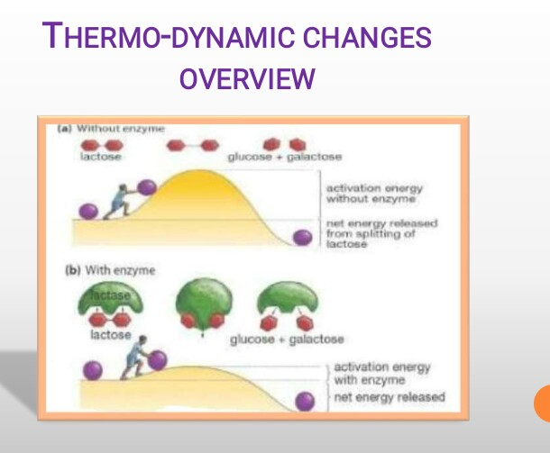
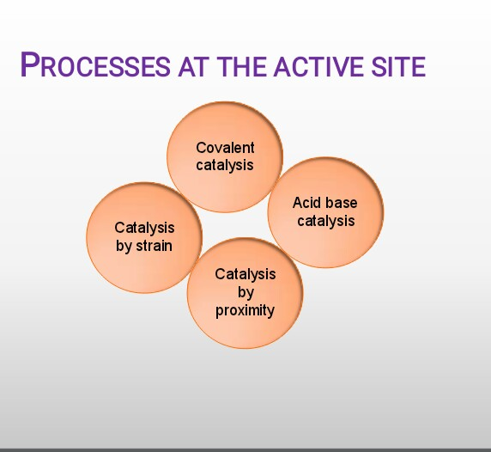
Only a few substances cross the activation barrier and change into products.
That is why rate of uncatalyzed reactions is much slow.
Enzymes provide an alternate pathway for conversion of substrate into products.
Enzymes accelerate reaction rates by forming transitional
state having low activational energy.
Hence, the reaction rate is increased many folds in the presence of enzymes.
The total energy of the system remains the same and equilibrium state is not disturbed.
COVALENT CATALYSIS:
Enzymes form covalent linkages with substrate forming transient enzyme-substrate complex with very low activation energy.
Enzyme is released unaltered after completion of reaction.
ACID-BASE CATALYSIS:
Mostly undertaken by oxido- reductases enzyme.
Mostly at the active site, histdine is present which act as both proton donor and proton acceptor.
CATALYSIS BY PROXIMITY:
In this catalysis molecules must come in bond Forming distance.
When enzyme binds:
A region of high substrate concentration is produced at active site.
This will orient substrate molecules especially in a position
ideal for them.
CATALYSIS BY BOND STRAIN:
Mostly undertaken by lyases.
The enzyme-substrate binding causes reorientation of the structure of site due to in a strain condition.
Thus, transitional state is required and here bond is unstable and eventually broken.
In this way bond between substrate is broken and converted
into products.
LOCK AND KEY MODEL;
Proposed by EMIL FISCHER in 1894.
Lock and key hypothesis assume the active site of an enzymes are rigid in its shape.
There is no change in the active site before and after a chemical reaction.
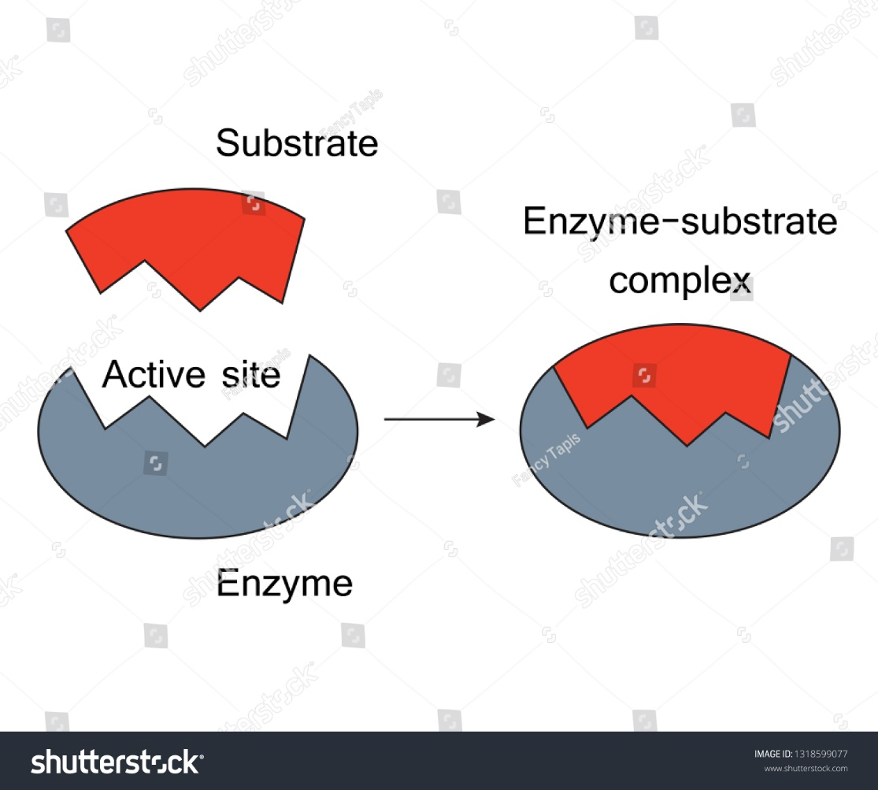

INDUCED FIT MODEL:
More recent studies have revealed that the process is much more likely to involve an induced fit model (proposed by DANIAL KOSH LAND in 1958).
According to this exposure of an enzyme to substrate cause a change in enzyme, which causes the active site to change its shape to allow enzyme and substrate to bind.

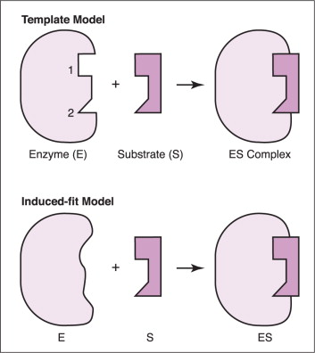

ENZYMES KINETICS
INTRODUCTION
“It is a branch of biochemistry in which we study the rate of enzyme catalyzed reactions.”
Kinetic analysis reveals the number and order of the individual steps by which enzymes transform substrate into products
Studying an enzyme's kinetics in this way can reveal the catalytic mechanism of that enzyme, its role in metabolism, how its activity is controlled, and how a drug or an agonist might inhibit the enzyme
RATES OF REACTION AND THEIR DEPENDENCE ON ACTIVATION ENERGY:
Activation Energy (Ea):
“The least amount of energy needed for a chemical reaction to
take place.”
Enzyme (as a catalyst) acts on substrate in such a way that they lower the activation energy by changing the route of the reaction.
The reduction of activation energy (Ea) increases the amount of reactant molecules that achieve a sufficient level of energy, so that they reach the activation energy and form the product.
Example:
Carbonic anhydrase catalyses the hydration of 10⁶ CO₂ molecules per second which is 10⁷x faster than spontaneous hydration.
KINETICS OF ENZYMES CATALYSIS:
Enzymes catalysis:
“It is an increase in the rate of reaction with the help of
enzyme (as catalyst).”
Catalysis by that proceed mechanism, typically occurs when the transition intermediate forms a covalent bond with the enzyme (covalent catalysis).
During the process of catalysis enzymes always emerge unchanged at the completion of the reaction.
FACTORS AFFECTING RATE OF ENZYME CATALYZED REACTIONS:
Temperature
Hydrogen ion concentration(pH)
Substrate concentration
EFFECT OF TEMPERATURE;
Raising the temperature increases the rate of enzyme catalyzed reaction by increasing kinetic energy of reacting molecules.
Enzymes work maximum over a particular temperature known as optimum temperature. Enzymes for humans generally exhibit stability temperature up to 35-45 ᵒ C.
The temperature coefficient is a factor Q₁₀ by which the rate of biological processes increases for a 10 ᵒ C increase in temperature.
For most biological processes Q₁₀ = 2.
However, sometimes heat energy can also increase kinetic energy to a point that exceed the energy barrier which results in denaturing of enzymes.
EFFECT OF PH:
Rate of almost all enzymes catalyzed reactions depends on pH
Most enzymes exhibit optimal activity at pH value between 5
and 9
High or low pH value than optimum value will cause ionization of enzyme which result in denaturation of enzyme
MICHAELIS-MENTEN MODEL & EFFECTS OF SUBSTRATE CONCENTRATION
Michaelis-Menten Model:
“According to this model the enzyme reversibly combines with
substrate to form an ES complex that subsequently yields
product, regenerating the free enzyme.”
E + S = ES =E + P
where:
S is the substrate E is the enzyme
ES-is the enzyme substrate complex
P is the product
K1, K-1 and K2 are rate constants
MICHAELIS-MENTEN EQUATION:
“It is an equation which describes how reaction velocity varies
with substrate concentration.”
Vmax [S]
Vo=
Km+[S]
Where
Vo is the initial reaction velocity.
Vmax is the maximum velocity.
Km is the Michaelis constant = (k₋₁+k₂)/k₁.
[S] is the substrate concentration.
ASSUMPTIONS FOR MICHAELIS-MENTEN EQUATION: Following assumptions are made in deriving the Michaelis- Menten equation:
Relative concentrations of E and S.
Steady-State assumptions
Initial Velocity
PHARMACEUTICAL IMPORTANCE:
Enzymes are virtually involved in all physiological processes which makes them the targets of choice for drugs that cure or ameliorate human disease.
Applied enzyme kinetics represents the principal tool by which scientist identify and characterize therapeutic agents that selectively inhibit the rates of specific enzymes catalyzed processes.
Enzymes kinetics thus play a critical role in drug discovery as well as elaborating the mode of action of drugs.
INHIBITION: o the prevention of an enzyme process as a result of interaction of inhibitor with enzyme.
INHIBITORS:
Any substance that can diminish the velocity of an enzyme catalyzed reaction is called an inhibitor.
REVERSIBLE INHIBITION:
It is an inhibition of enzyme activity in which the inhibiting molecular entity can associate and dissociate from the protein’s binding site.
TYPES OF REVERSIBLE INHIBITION
There are four types:
Competitive inhibition.
Uncompetitive inhibition.
Mixed inhibition.
Non-competitive inhibition.
COMPETITIVE INHIBITION: In this type of inhibition, the inhibitors compete with the substrate for the active site. Formation of E.S complex is reduced while a new E.I complex is formed.
EXAMPLES OF COMPETITIVE INHIBITION:
Statin Drug as Example of Competitive Inhibition:
Statin drugs such as lipitor compete with HMG-CoA(substrate) and inhibit the active site of HMG CoA-REDUCTASE (that bring about the catalysis of cholesterol synthesis).
UNCOMPETITIVE INHIBITION:
In this type of inhibition, inhibitor does not compete with the substrate for the active site of enzyme instead it binds to another site known as allosteric site.
EXAMPLES OF UNCOMPETITIVE INHIBITION:
Drugs to treat cases of poisoning by methanol or ethylene glycol act as uncompetitive inhibitors.
Tetramethylene sulfoxide and 3- butylthiolene 1-oxide are uncompetitive inhibitors of liver alcohaldehydrogenase.
MIXED INHIBITION:
In this type of inhibition both E.I and E.S. I complex are formed.
Both complexes are catalytically inactive.
NON-COMPETITIVE INHIBITION
It is a special case of inhibition.
In this inhibitor has the same affinity for either enzyme E or the E.S complex.
IRREVERSIBLE INHIBITION:
This type of inhibition involves the covalent attachment of the inhibitor to the enzyme.
The catalytic activity of enzyme is completely lost.
It can only be restored only by synthesizing molecules.
EXAMPLES OF IRREVERSIBLE INHIBITION:
Aspirin which targets and covalently modifies a key enzyme involved in inflammation is an irreversible inhibitor.
SUICIDE INHIBITION:
It is an unusual type of irreversible inhibition where the enzyme converts the inhibitor into a reactive form in its active site.
ACTIVATION:
Activation is defined as the conversion of an inactive form of an enzyme to active form which processes the metabolic activity.
TYPES OF ACTIVATION: Activation by co-factors.
Conversion of an enzyme precursor.
ACTIVATION BY CO FACTORS:
Many enzymes are activated by co-factors.
Examples:
DNA polymerase is a holoenzyme that catalyzes the polymerization of de -oxyribonucleotide into a DNA strand. It uses Mg- ion for catalytic activity.
Horse liver dehydrogenase uses Zn- ion for it‟s activation.
CONVERSION OF AN ENZYME PRECURSOR:
Specific proteolysis is a common method of activating enzymes and other proteins in biological system.
Example:
The generation of trypsin from trypsinogen leads to the activation of other zymogens.
ENZYME SPECIFICITY:
Enzymes are highly specific in nature, interacting with one or few substrates and catalyzing only one type of chemical reaction.
Substrate specificity is due to complete fitting of active site and substrate.
Example:
Oxydoreductase do not catalyze hydrolase reactions and hydrolase do not catalyze reaction involving oxidation and reduction.
TYPES OF ENZYME SPECIFICITY:
Enzymes show different degrees of specificity:
Bond specificity.
Group specificity.
Absolute specificity.
Optical or stereo-specificity.
Dual specificity.
BOND SPECIFICITY
In this type, enzyme acts on substrates that are similar in structure and contain the same type of bond.
Example:
Amylase which acts on α-1-4 glycosidic , bond in starch dextrin and glycogen, shows bond specificity.
GROUP SPECIFICITY:
In this type of specificity, the enzyme is specific not only to the type of bond but also to the structure surrounding it.
Example:
Pepsin is an endopeptidase enzyme, that hydrolyzes central peptide bonds in which the amino group belongs to aromatic amino acids e. g phenyl alanine, tyrosine and tryptophan.
SUBSTRATE SPECIFICITY:
In this type of specificity , the enzymes act only on one
substrate
Example:
Uricase , which acts only on uric acid, shows substrate specificity.
Maltase , which acts only on maltose, shows substrate specificity.
OPTICAL / STEREO-SPECIFICITY:
In this type of specificity , the enzyme is not specific to substrate but also to its optical configuration
Example: D amino acid oxidase acts only on D amino acids.
L amino acid oxidase acts only on L amino acids.
DUAL SPECIFICITY:
There are two types of dual specificity.
Enzyme may act on one substrate by two different types of reaction.
Isocitrate dehydrogenase enzyme acts on isocitrate (one substrate) by oxidation followed by decarboxylation (two different reaction types).
The enzyme may act on two substrates by one reaction type
Example:
Xanthine oxidase enzyme acts on xanthine and hypoxanthine (two substrates) by oxidation (one reaction type)
SUMMARY:

Enzymes are very efficient catalysts for biochemical reactions. They speed up reactions by providing an alternative pathway of lower activation energy. In this lab, an investigation was brought forward to discover the factors that can affect the enzyme during catalytic activity; the following conclusions were made from conducting the lab. Increasing the enzyme concentration would increase the rate of reaction and improving the performance of catalase enzyme activity, but only to a certain degree before observing a steep drop off, as there is a higher concentration of enzymes and not enough substrate to bind to the enzyme’s active site. Enzymes work best at a specific PH and anything higher or lower than the desired pH would not affect the rate of reaction in a beneficial matter. Just like pH, enzymes perform at their best in a small range of temperature. These biological catalysts increase the rate of reaction when exposed to the optimum temperature and would underperform when temperatures lower and or higher than the optimal temperature are introduced. The rate of an enzyme-catalyzed reaction depends on the concentration of both the enzyme and the substrate. For a given enzyme concentration, the rate of the reaction.

