Topic:-
Genetic Code :-
Definition :-
The genetic code connects groups of nucleotides in an mRNA to amino acids in a protein. Start codons, stop codons, reading frames .
OR .
The genetic code is used by living cells to translate information encoded within genetic. material (or codons) into protein.

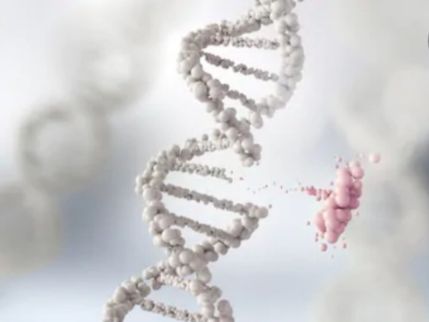

Discovery of genetic Code :-
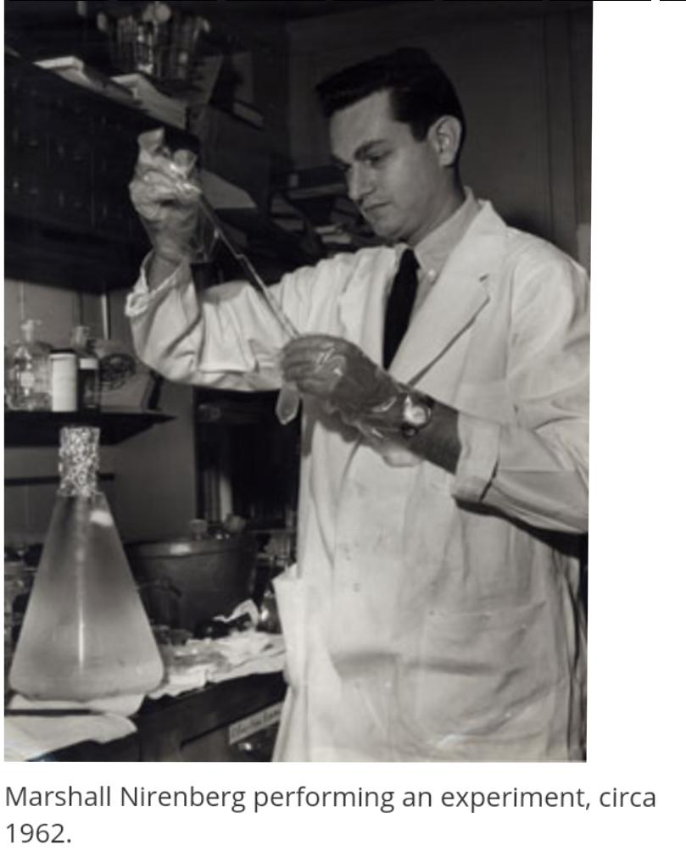
In 1961, Francis Crick and colleagues introduced the idea of the codon. However in 1964, it was Marshall Nirenberg and co-workers who discovered a way to determine the sequence of letters in each triplet word for amino acids .They showed that four nucleotide bases – A (adenine), U (uracil), G (guanine) and C (cytosine) ─ form codons of different base combinations that code for all 20 amino acids during protein synthesis.

Introduction :-
Have you ever written a secret message to your friends? You may have used a hidden words or a code to keep the message hidden. For example, you may have replaced the letters of the word with numbers or symbols or any other thing, following a specific set of rules. In order for your friend to pick the message, they would need to know the code or specific words and apply the same set of rules, in reverse, to decode it.
Decoding messages is also an important step in gene expression, in which information from a gene is read out to build a protein. In genetic code , code allows DNA and RNA sequences to be ‘ decoded ‘ into amino acids for forming of a protein.

Background ( Making a protein ) :-
Genes that provide information for proteins are expressed in a two-step process.
- In transcription, particular segment of DNA ( informative strand ) is copied into mRNA by an enzyme ( RNA polymerase ) .
- In translation , the strand of mRNA that has been copied from informative strand of DNA synthesizes protein.

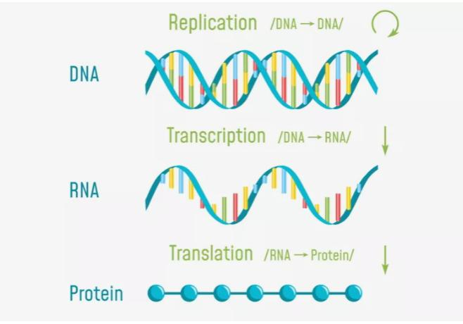

Explanation of genetic code :-
The genetic code is the set of specified rules used by living cells to translate given information encoded within genetic material (DNA or mRNA sequences of nucleotide triplets, or codons) into proteins. Translation is accomplished by the ribosome ,which connects amino acids in an order specified by messenger RNA (mRNA), using transfer
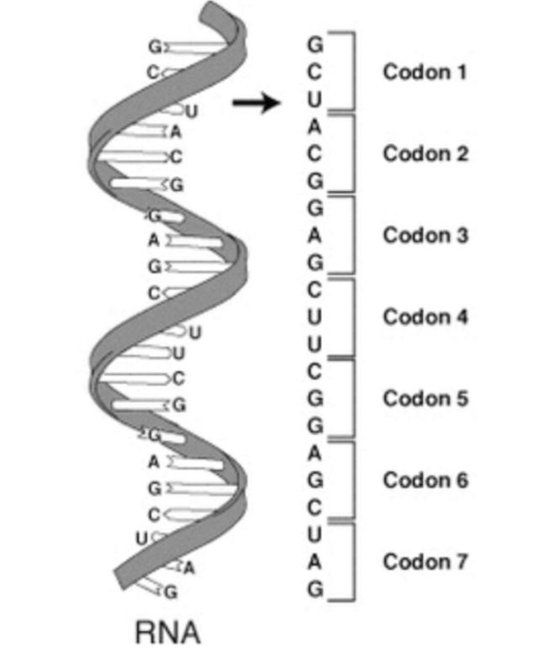
RNA (tRNA) molecules to carry amino acids and to read the three nucleotides at a time. The code defines how codons specify the amino acids and which amino acid will be added next during protein synthesis. With some exceptions, a three-nucleotide codon in a nucleic acid sequence specifies a single amino acid. The majority of genes are encoded with a single scheme. Genetic code is the term we use for the way that the four bases of DNA--the A, C, G, and T--are together in any amino acid sequence in a way that the cellular machinery, the ribosome, can understand them and change them into a protein. In the genetic code, each three nucleotides in a single row count as a triplet and code for a single amino acid. So each sequence of three codes for an amino acid. And frequently proteins are made up of hundreds of amino acids. So the code that would make one protein could have hundreds, sometimes even thousands, of triplets contained in it.

Genetic code Table :-
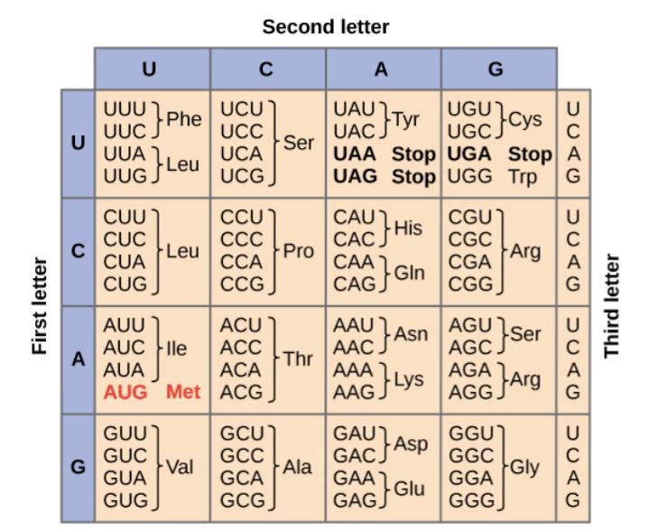
The full set of relationships between codons and amino acids (or stop signals) is called the genetic code. The genetic code is often briefly explained in a table.
Notice that many amino acids are represented in the table by more than one codon. For example, there are six different ways to "write" leucine in the language of mRNA ( messenger RNA ).
An important point about the genetic code is that it's universal. With minor exceptions, virtually all species (from bacteria to you!) use the genetic code shown above for protein synthesis. The arrangement of the coding table shows the structure of the code. There are sixteen “blocks” of codons, each specified by the first and second nucleotides of the codons within the block, e.g., the “AC*” block that corresponds to the amino acid threonine (Thr). Some blocks are divided into a pyrimidine half, in which the codon ends with U or C, and a purine half, in which the codon ends with A or G. Some amino acids get a whole block of four codons, like alanine (Ala), threonine (Thr) and proline (Pro). Some get the pyrimidine half of their block, like histidine (His) and asparagine (Asn). Others get the purine half of their block, like glutamate (Glu) and lysine (Lys). Note that some amino acids get a block and a half-block for a total of six codons.

Types of Code System :-
The nitrogen base and amino acids form different types of code by their combined functions . Three types of codes are as follows :
- Single code system
- Double code system
- Triple code system

Single code system :-
When only one nitrogen base works for one amino acid , then only four types of genetic codes are formed .

Double code system :-
When two nitrogen bases work for one amino acid , then 16 possible combinations of genetic codes are formed .
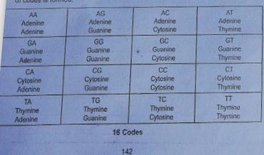
Triple code system :-
When three nitrogen bases work for one amino acid , then 64 genetic codes are formed.
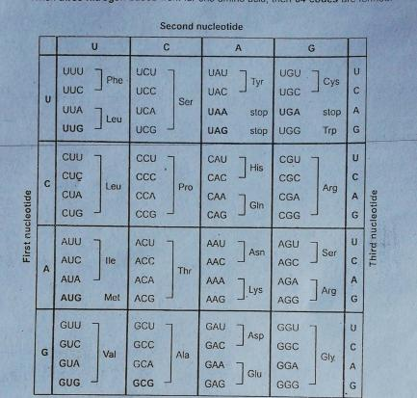

Codons :-
Cells decode mRNAs by reading their nucleotides groups that consists of 3 nucleotides called codons.
A codon is a trinucleotide sequence of DNA or RNA that corresponds to a specific amino acid. The genetic code describes the relationship between the sequence of DNA bases (A, C, G, and T) in a gene and the corresponding protein sequence that it encodes. The cell understands the sequence of the gene in groups of three bases. There are 64 different codons: 61 specify amino acids while the remaining three are specify as stop signals. Codon is the name we give a group of the three nucleotides, you know, one of A, C, G, or T, three of which in a row, that code for a specific amino acid, and so the genetic code is made up of units called codons where you have three nucleotides that code for a specific amino acid next to another three nucleotides, another three nucleotides, and another three nucleotides. And the cellular machinery, again the ribosome, that comes through and reads that genetic code, plugs in the correct amino acid that corresponds to each of the triplet code that's in the codon.

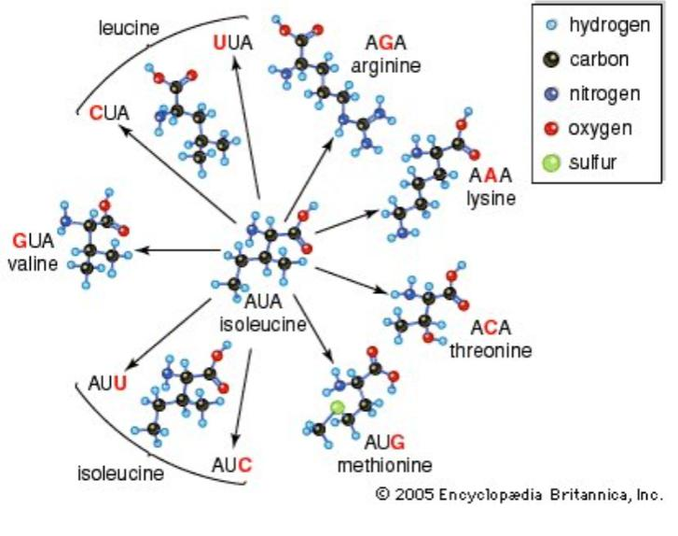

Degeneracy :-
Many amino acids are specified by more than one codon, a phenomenon known as codon “degeneracy.” Degeneracy is believed to be a cellular mechanism to reduce the negative impact of random mutations. Codons that specify the same amino acid typically only differ by one nucleotide. In addition, amino acids with chemically similar side chains are encoded by similar codons. For example, aspartate (Asp) and glutamate (Glu), which occupy the GA* block, are both negatively charged. This nuance of the genetic code ensures that a single-nucleotide substitution mutation might specify the same amino acid but have no effect or specify a similar amino acid, preventing the protein from being rendered completely nonfunctional.
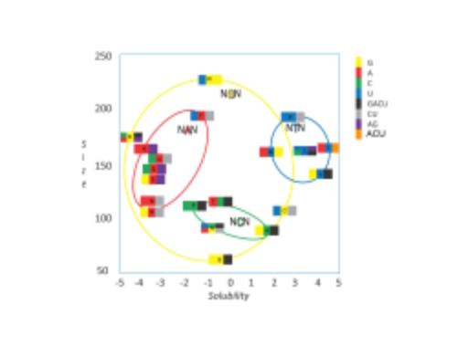

Anticodons :-
Definition :-
Anticodons are sequences of nucleotides that are complementary to codons. They are found in tRNA, and allow the tRNAs to bring the correct amino acid in line with an mRNA during protein production.

Explanation :-
During protein production, amino acids are bound together into a string, much like beads on a necklace. It’s important that the correct amino acids be used in the correct places, because amino acids have different properties. Putting the wrong one in a spot can render a protein useless, or even dangerous to the cell. All goes well, only the tRNAs with the correct anticodons will bind successfully to the exposed mRNA, so only the correct amino acids will be added: tRNAs are responsible for bringing the correct amino acids to be added to the protein, according to the mRNA’s instructions. Their anticodons, which pair-bond with codons on mRNA, allow them to perform this function.
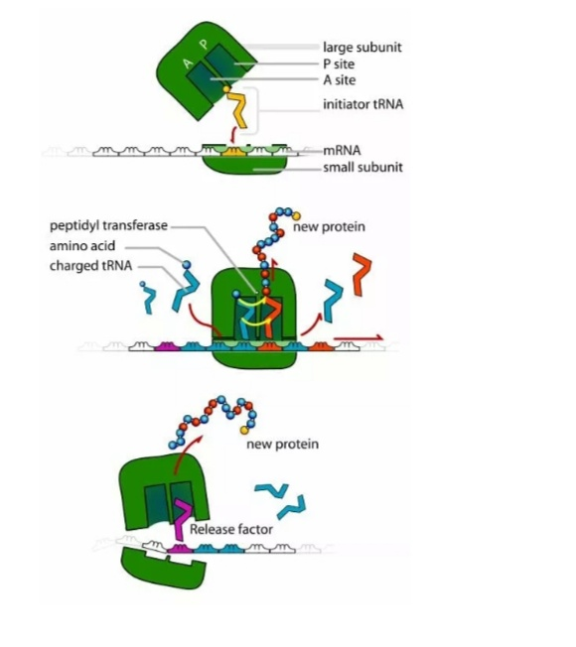

Example :-
For example the anticodon for Glycine is CCC that binds to the codon (which is GGG) of mRNA.

Function of Anticodons :-
The function of anticodons is to bring together the correct amino acids to create a protein, based on the instructions carried in mRNA each . RNA carries one amino acid, and has one anticodon. When the anticodon successfully pairs up with an mRNA codon, the cellular machinery knows that the correct amino acid is in place to be added to the growing protein. Anticodons are important to complete the process of turning the information stored in DNA into functional proteins that a cell can use to carry out its life functions.

Start and Stop codons :-
Start codon marks the site at which translation begins for protein synthesis. Stop codons marks the site at which translation ends .
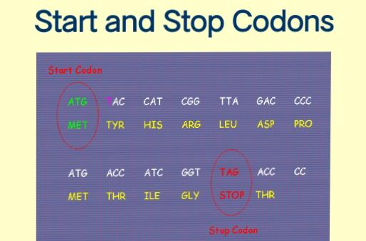

Start codon :-
The start codon is the first codon of a messenger RNA (mRNA) transcript translated from a parent DNA strand. The start codon always codes for methionine in most eukaryotes and Archaea and a ubiquitin lysine in protists, bacteria, mitochondria and plastids. The most common start codon is AUG (i.e., ATG in the corresponding DNA sequence). An alternative start codon sequence, such as GUG or UUG, may commence translation sequence if the AUG codon is unavailable.

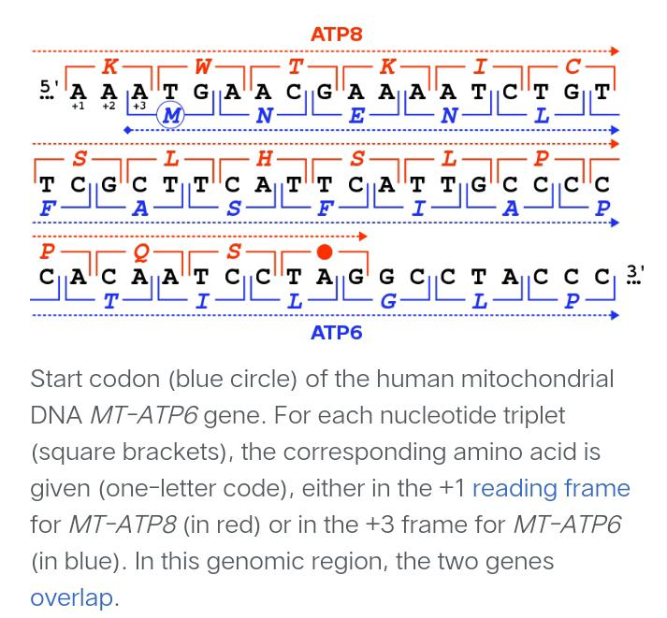

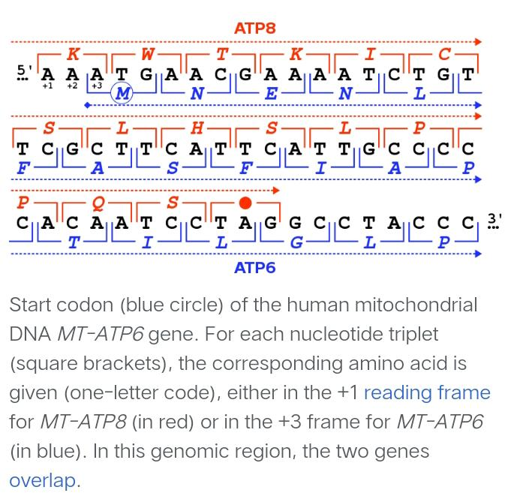
The start codon is often preceded by a 3' untranslated polyadenylated (polyA) region (3' UTR). In prokaryotes this includes the ribosome binding site. Top of Form

Bottom of Form

Stop codons :-
In molecular biology (specifically protein biosynthesis), a stop codon (or termination codon) is a codon (nucleotide triplet within messenger RNA) that signals the termination of the translation process of the current protein. Most codons in messenger RNA correspond to the addition of an amino acid to a growing polypeptide chain, which may ultimately become a protein; stop codons signal the termination of this process by binding release factors, which cause the ribosomal subunits to disassociate, releasing the amino acid chain. While start codons need nearby sequences or initiation factors to start translation, a stop codon alone is sufficient to initiate termination.

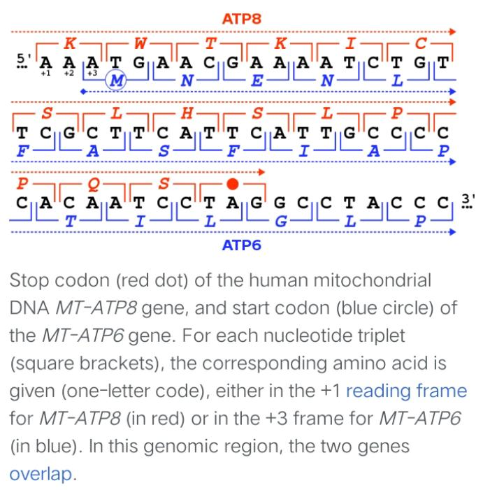

Reading frames :-
The genetic code can be read in various ways depending on where the reading starts. For example, if the base sequence is GGGAAACCC, reading could start from the first letter, G and there will be 3 codons - GGG, AAA, and CCC. If reading starts at G in the second position, the string will have two codons - GGA and AAC. If reading starts at the third base G, 2 codons will again result - GAA and ACC. Thus, there are 3 ways of reading the code of every strand of genetic material. These different ways of reading a nucleotide sequence is called as the reading frame. Each reading frame will produce a different sequence of amino acids and then proteins. Thus, in double stranded DNA, there are 6 possible reading frames.
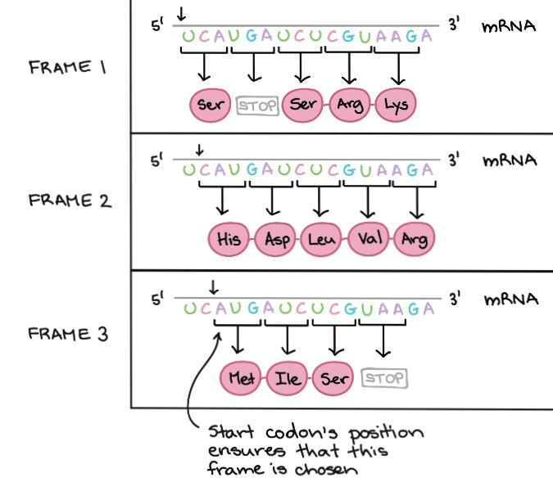

Reading frame determines how the mRNA sequence is divided up into codons during translation. That's a pretty clear concept, so let's look at an example to understand it better. The mRNA below can encode three totally different proteins, depending on the frame in which it's read:
So, how does a cell know which of these protein to make? The start codon is the key signal. Because translation begins at the start codon and continues in successive groups of three, the position of the start codon ensures that the mRNA is read in the correct frame (in the example above, in Frame 3).
Mutations (changes in DNA) that insert or delete one or two nucleotides can change the reading frame, causing an incorrect protein to be produced.
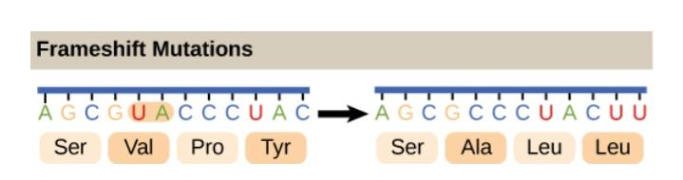

Characteristics of genetic code :-
The genetic code has a number of important characteristics.
- Genetic code is universal :-
The genetic code is universal. All known living organisms use the same genetic code. This shows that all organisms share the common evolutionary history.
- Genetic code is unambiguous :-

The genetic code is unambiguous. Each codon codes for just one amino acid (or start or stop).
- Genetic code is redundant :-
The genetic code is redundant. Most amino acids are encoded for one amino acid .
- The code is degenerate :-

The occurrence of more than one codon for a single amino acid is referred to as degenerate. A review of genetic code dictionary will show that t most of the amino acids have more than one codon. Out of 61 functional codons, AUG and UGG code to one amino acid each. But remaining 18 amino acids are coded by 59 codons.
- The Code is Non-overlapping:-
In a non-overlapping code, the same letter {i.e., base) is not used in the formation of more than one codon.

- The code is comma less :-
A comma less code means that no nucleotide or comma (or punctuation) is present in between two codons. Therefore, code is continuous and comma less and no letter is wasted between two words or codons.

Co-linearity:-
DNA is a linear polynucleotide chain and a protein is a linear polypeptide chain. The sequence of amino acids in a polypeptide chain corresponds to the sequence of nucleotide bases in the gene (DNA) that codes for it. Change in a specific codon in DNA produces a change of amino acid in the corresponding position in the polypeptide. The gene and the polypeptide it codes for are said to be co-linear.

- Code is triplet :-
The coding units or codons for amino acids comprise three letter words, 4 x 4 x 4 or 4³ = 64. 64 codons are quite adequate to specify 20 proteinous amino acids.

Summary :-

    - The genetic code consists of the sequence of bases in DNA or RNA. It was discovered by Nierenberg .
    - Genetic codes are arranged in table and there are three different ways of coding system .
    - Groups of three bases form codons, and each codon stands for one amino acid (or start or stop).
    - The codons are read in sequence following the start codon until a stop codon is reached.
    - The genetic code is universal, unambiguous, and redundant.

Multiple Choice Questions :-

Question No:- 01
How many nucleotides in one codon ?
a)1
b)2
c)3
d)4
Answer :-
c)3

Question No :- 02

Who gave the idea of codon ?
- Nierenberg
- Francis crick
- Alexander
- Graham
Answer :-
b)Francis crick

Question No :-03
The full set of relationships between codons and amino acids (or stop signals) is called the :-
- genetic code
- genetic code table
- Reading frame
- Start codons
Answer :-
a)genetic code

Question No :-04
Which one is not characteristics of genetic code ?
- triplet
- Universal
- Co-linear
- Over lapping

Answer :-
d)over lapping (because genetic code is non-overlapping ).

Question No :-05
When three nitrogen bases work for one amino acid, then 64 genetic codes are formed . Which type of code system is it ?
- Single Code System
- Double code system
- Triple code System
- None of these
Answer :-
c)triple codon System

Question No :-06
How many types of code system ?
a)2
b)5
c)3
d)6
Answer :-
c) 3

Question No :- 07
What is codon degeneracy ?
- many amino acids are encoded by only one codon
- One amino acid is encoded by many codons
- Both a and b
- None of these
Answer :-
- many amino acids are encoded by only one amino acid

Question No :- 08
What is complimentary to codons ?
- Amino acids
- Nucleotides
- Anti codons
- Both a and c

Answer :-
c)Anti codons

Question No :-09

Start codon marks the site at which translation. For protein synthesis.
- begins
- Ends
- In middle
- None of these

Answer :-
- begins

Question No :- 10

In non-overlapping , which letter is not used in formation of more than one codon ?
- same letter
- Different letter
- Both a and b
- None of these
Answer :-
a)Same letter

