ABSTRACT:

The objective of this chapter is to familiarize the students with the grammar of films and to enable them to read signs and codes of films and to make them able to how to play with semiotics and how to communicate through symbols as a Filmmaker. This refers to the way an audience receives texts by organizing all experiences into a binary patters: good/bad; master/slave; hero/villain; true/false. This helps in our understanding of what the filmic text means.

WHAT IS FILM?

Filming is an absolute Art as Film is a combination of pictures so, it is also termed as the Motion pictures. Film is all about to do a lot of artificiality to just show a real feel. Film is a process of communication through which you convey your idea, you spread your information as well as you portray the way you look for the same stuff to your audience. Film is a major part of Broadcast Communication process through which you convey your message.

MEANINGS OF FILM:

Meanings of Film is all based upon two major portions:
- Your Film Story
- Your Film Narratives

Your story in a film is a main and the most important part. If you are not up with a story you can’t go for the film production process. And your film narratives tell you, when and how you have to explain your story. When you go through these two basics of film then your film will be up with some proper meanings and then your film can communicate with your viewers. Your film’s meanings based upon the relationship of semiology, you used in your Film and the audience have in its culture.

SEMIOLOGY:
Semiology is a term derived from a Greek word Semiotic that means “Signs” So, the term Semiology means “the study of Signs”. It includes the study of signs and sign processes, indication, designation, likeness, symbolism, signification, and communication. It is not to be confused with the tradition called semiology, which is a subset of semiotics. The semiotic tradition explores the study of signs and symbols as a significant part of communications.

SEMIOTICS OF CULTURE:
Semiotics of culture is a research field within semiotics that attempts to define culture from semiotic perspective and as a type of human symbolic activity, creation of signs and a way of giving meaning to everything around. Therefore, here culture is understood as a system of symbols or meaningful signs. Because the main sign system is the linguistic system, the field is usually referred to as semiotics of culture and language. Under this field of study symbols are analyzed and categorized in certain class within the hierarchal system with postmodernity, metanarratives are no longer thus categorizing these symbols in this postmodern age is more difficult and rather critical.

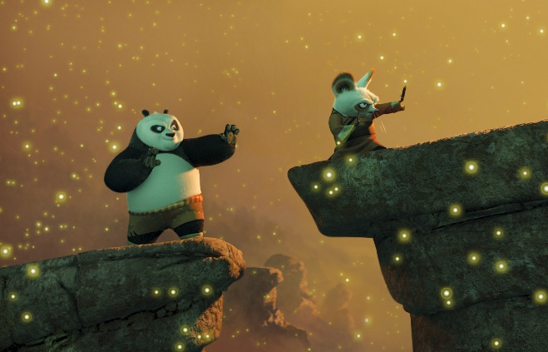 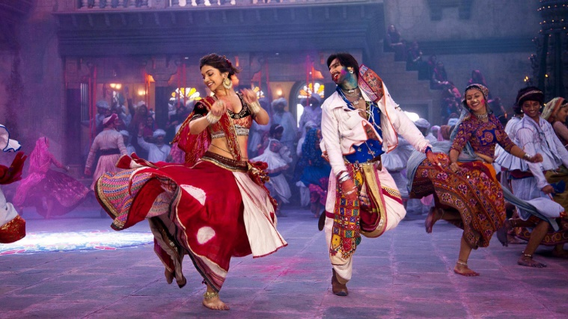
CHINA INDIA
HOLLYWOOD PAKISTAN

SEMIOLOGY OF CINEMA:
Film is the art of visual abbreviation. Cinema is about synesthetic, sensational or sense experience.
The basic tenet of semiotics is that a sign has two parts: one is Signifier that is physical, or the sign-as-object and the other is Signified the psychological, or the sign as concept. Filmmakers show and we understand visual signs such as smiles, scars, guns, badges, hairstyle etc. At this point, an important term you should be familiar with is Synecdoche, that is, relationship of a part to a whole (the crown represents the king or the queen, the Oval office stands for the President, the badge symbolizes law and order). It is the little things that fill our everyday lives with meaning, and the same holds true for films. Film images are signs, look at any film poster and you will notice how posters and publicity materials send signals that tell you about the genre of the film.

FILM SEMIOTICS:
Here are five main directions where semiotics works in film;
Production House (Logo/Belongings) Film Poster

Film DVDs and CDs cover

- Film visuals
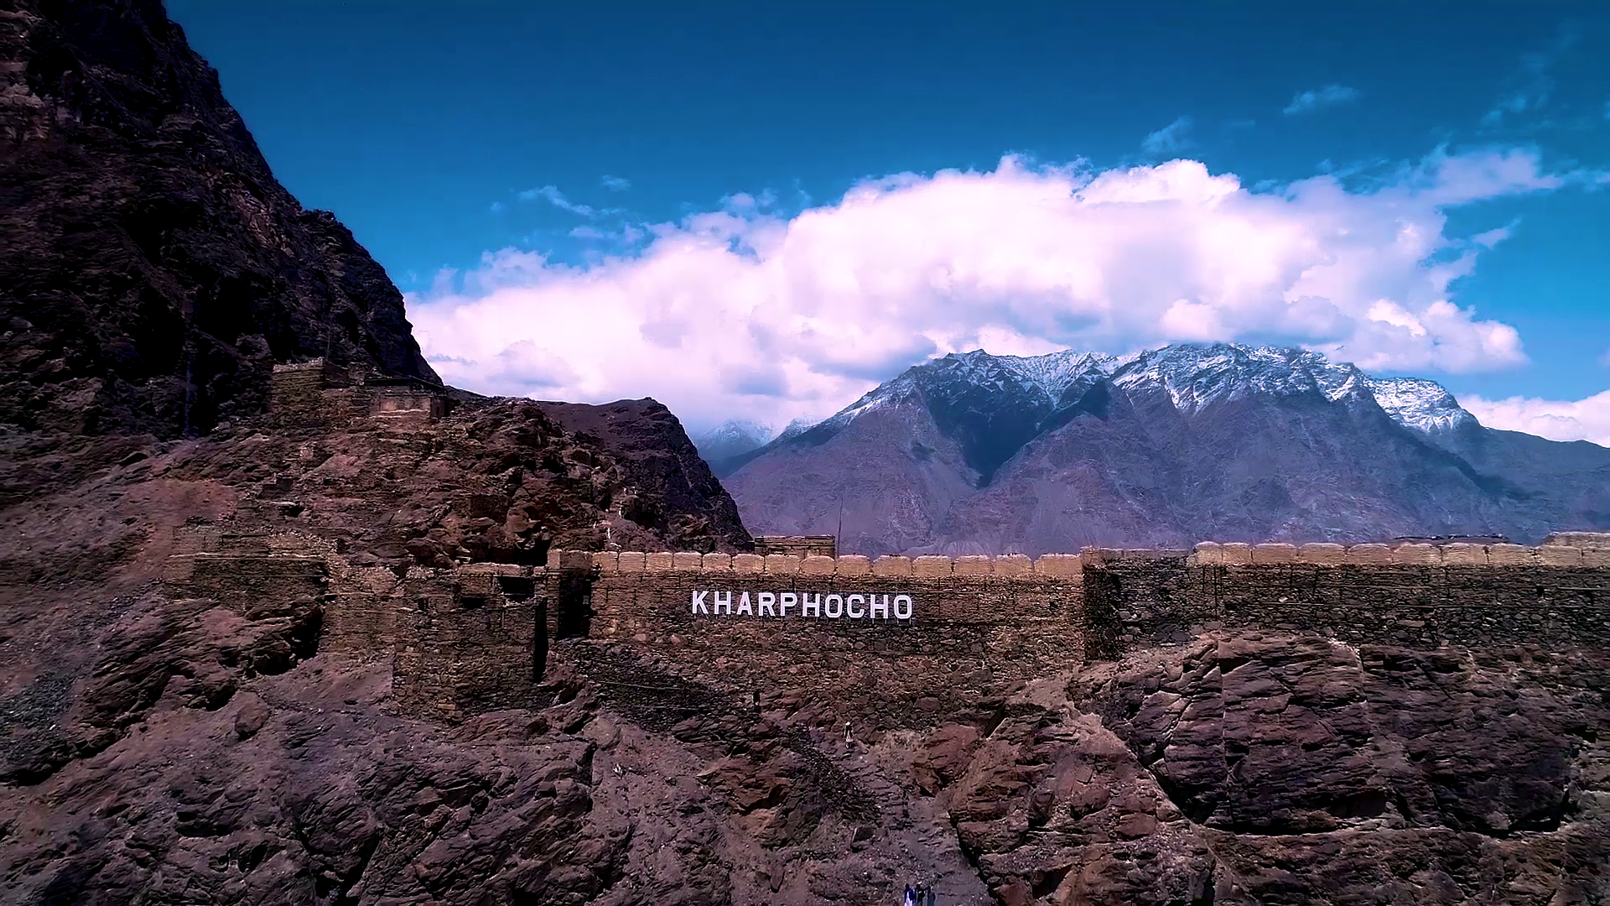

and Film Sound.
Here are a lot of more Film Semiotics in the Film Visuals and Film Sound. Means how you are showing and presenting your visual objects on screen and their moves and which type of language and music you are using in your Film.

SEMIOLOGY OF CINEMA IN USA:
USA Cinema’s Semiotics are:
- Technology
- Fantasy
- Sexuality
- Advancement
- Their Cultural Signs

SEMIOLOGY OF CINEMA IN CHINA:
Chinese Cinema’s Semiotics are:
- Focus
- Peace
- Kung Fu
- Their Cultural Signs

SEMIOLOGY OF CINEMA IN INDIA:
Indian Cinema’s Semiotics are:
- Copy to Hollywood Cinema
- Religious Believes
- Item Songs
- Their Cultural Signs

SEMIOLOGY OF CINEMA IN PAKISTAN:
Pakistani Cinema’s Semiotics are:
- Humanity
- Diversity of Cultures
- Patriotism
- Cultural Values
- Their Cultural Signs

