TABLE OF CONTENTS
PRE-PARTITION CONSTITUTIONAL HISTORY 3
AFTER THE BIRTH OF A NATION 6
CONSTITUTIONAL DEVELOPMENT 1947 TO 1956 6
CONSTITUTION OF 1956 11
FIRST MARTIAL LAW 13
BASIC DEMOCRACIES 13
CONSTITUTIONAL COMMISSION 13
CONSTITUTION OF 1962 13
THE DECADE OF DEVELOPMENT 13
AYUB KHAN STEPS DOWN 13
YAHYA KHAN 13
OUTBREAK OF THE 1971 WAR 13
CONSTITUTION MAKING 13
1973 CONSTITUTION 13
LIST OF AMENDMENTS TO THE CONSTITUTION OF PAKISTAN 13
MOST IMPORTANT AMENDMENTS: 13
CONCLUSION 14
REFERENCES 14

PRE-PARTITION CONSTITUTIONAL HISTORY
THE GOVERNMENT OF INDIA ACT, 1858:
It was a constitutional colonial India. Under this act, the territories under the control and administration of the Company were transferred to and vested in the Crown. The Secretary of State, who was to sit in parliament, was empowered to exercise powers that were previously exercised by the Company or the Board of Control. A Council, consisting of 15 members was established under the Act. The Secretary of State could override the opinion of the majority of the Council but had to record reasons for doing so. The expenditure of the revenues of India was made subject to the control of the Secretary of State and the Council. The accounts for each financial year were to be laid before the British Parliament. The Secretary of State could sue or be sued in India, as well as, in England in the name of the Secretary of State in Council as body corporate. The Secretary of State and Members of the Council were indemnified against any personal liability regarding the performance of their official duties and all liabilities, cost, and damages in respect thereof were to be paid of the revenues of India.
The Government of India Act, 1858 was amended in 1859 and the Governor-General of India, Governors and certain officers (authorized by the Secretary of State and the Council) were empowered to sell and dispose of all real and personal estate in India which was vested in the Crown and to execute any contracts in this behalf.
THE INDIAN COUNCILS ACT, 1861:
The Indian Councils Act 1861 was an Act of the Parliament of the United Kingdom that transformed the Viceroy of India's executive council into a cabinet run on the portfolio system. This cabinet had six "ordinary members", who each took charge of a separate department in Calcutta's government: home, revenue, military, law, finance, and (after 1874) public works. The military Commander-in-Chief sat in with the council as an extraordinary member. The Executive Council was enlarged by addition of fifth member. The Viceroy was allowed, under the provisions of the Act, to overrule the council on affairs if he deemed it necessary, as was the case in 1879, during the tenure of Lord Lytton.
The Viceroy was allowed to issue ordinances lasting six months if the Legislative Council is not in session in an emergency.
The Secretary of State for India, Sir Charles Wood, believed that the Act was of immense importance: "the act is a great experiment. That everything is changing in India is obvious enough and that the old autocratic government cannot stand unmodified is indisputable.

THE INDIAN COUNCILS ACT, 1892:
It was enacted to amend the Indian Councils Act, 1861. The number of additional members of Governor-General’s Council was raised from six to twelve, to ten to twenty. This Act opened the way for the appointment of Indian residents as additional members of the Councils of the Governor-General, governors of the presidencies, or lieutenant-governors of the provinces. The local legislature of any province was empowered to repeal or amend any law or regulation as to that province.
THE INDIAN COUNCILS ACT 1909:
This Act enlarged the size of Legislative Councils of the Governor-General and the Governors of various Provinces, which included the nominated as well as elected members. Indians became entitled to nomination or election as members of these Legislative Councils, subject to conditions laid down in the regulations made by the Governor-General with the approval of the Secretary of State.
The Functions of the Legislative Councils were increased and individual members in the Imperial Legislative Council could move resolutions relating to alteration in taxation. Matters of general public interest could also be discussed in the Legislative Councils and members could ask questions and supplementary questions.
In the rules framed under this Act, official majority was given up in the Provincial Legislative Councils, though working majorities were maintained. Official majority was, however, maintained in the Central Legislature. In the provinces, university senators, landlords, district boards, municipalities and Chambers of Commerce were to elect members of the Legislative Councils. Muslims were given separate representation and Muslim members of the legislature were to be elected by Muslims alone. The demand for a separate electorate was thus accepted.

THE GOVERNMENT OF INDIA ACT, 1915:
The Government of India Act 1915 was an act of the Parliament of the United Kingdom, which consolidated prior Acts of Parliament concerning British India into a single act. It was passed in July 1915 and went into effect on 1 January 1916 (5 & 6 Geo. V, c. 61).
The act repealed 47 prior acts of Parliament, starting with an act of 1770, and replaced them with a single act containing 135 sections and five schedules. It was introduced first to the House of Lords, where it was referred to a joint committee of Parliament chaired by Lord Loreburn. The committee removed several provisions which went beyond the simple consolidation of existing law.
A supplemental act, mostly technical in nature and including several of the provisions struck out of the consolidation act, was introduced and passed in 1916, becoming the "Government of India (Amendment) Act, 1916" (6 & 7 Geo. V, c. 37).
The Government of India Act 1915 and its supplemental act the following year "made the English statute law relating to India easier to understand, and therefore easier to amend."
THE GOVERNMENT OF INDIA ACT, 1919:
The Government of India Act, 1919 made substantial changes to the law.
Salient features of the Act were as follows:
- This Act had a separate Preamble which declared that Objective of the British Government is the gradual introduction of responsible Government in India.
- Diarchy was introduced as Provincial Level. Diarchy means a dual set of governments one is accountable another is not accountable. The provincial subjects were divided into two groups: One was reserved and another was transferred. The reserved subjects were kept with the Governor and transferred subjects were kept with the Indian Ministers. This division of subjects was basically what they meant by introducing the Diarchy.
- The Government of India Act of 1919, made a provision for classification of the central and provincial subjects. The Act kept the Income Tax as source of revenue to the Central Government. However, for Bengal and Bombay for which, to meet their objections, a provision to assign them 25% of the Income tax was made.
- No bill of the legislature could be deemed to have been passed unless assented to by the governor general. The later could however enact a Bill without the assent of the legislature.
- This Act made the central legislature bicameral. The lower house was the Legislative Assembly, with 145 members serving three year terms (the model for today's Lok Sabha); the upper house was the Council of States with 60 members serving five year terms (the model for today's Rajya Sabha)
- The Act provided for the establishment of a Public Service Commission in India for the first time.
- This act also made a provision that a statutory commission would be set up at the end of 10 years after the act was passed which shall inquire into the working into the system of the government. The Simon commission of 1927 was an outcome of this provision.
- The communal representation was extended and Sikhs, Europeans and Anglo Indians were included. The Franchise (Right of voting) was granted to the limited number of only those who paid certain minimum “Tax” to the government.
- The seats were distributed among the provinces not upon the basis of the population but upon the basis of their importance in the eyes of the government, on the basis of communities, and property was one of the main basis to determine a franchisee. Those people who had a property, taxable income & paid land revenue of Rs. 3000 were entitled to vote.
- The financial powers of the central legislature were also very much limited. The budget was to be divided into two categories, votable and non-votable. The votable items covered only one third of the total expenditure. Even in this sphere the Governor-General was empowered to restore any grant refused or reduced by the legislature, if in his opinion the demand was essential for the discharge of his responsibilities. Thus the Government of India Act provided for partial transfer of Power to the electorate through the system of diarchy. It also prepared the ground for the Indian Federalism, as it identified the provinces as units of fiscal and general administration.
THE GOVERNMENT OF INDIA ACT, 1935:
In March 1933, the British government announced its proposals for how India should be governed. These were published in a ‘White Paper’ (a discussion document issued before a Bill is presented at the British Parliament). After discussions by British politicians, and consultation with the ‘safe’ Indian delegates, nominated by the government to take part in talks, a Bill was introduced before the British Parliament in December 1934. In August 1935 the Government of India Act became law. This was the last major legislation that the British government passed before independence was granted. Its main terms were:
- the grant of a large measure of autonomy to the provinces of British India (ending the system of diarchy introduced by the Government of Indian Act 1919
- provision for the establishment of a "Federation of India", to be made up of both British India and some or all of the "princely states"
- the introduction of direct elections, thus increasing the franchise from seven million to thirty-five million people
- a partial reorganization of the provinces:
  - Sindh was separated from Bombay
  - Bihar and Orissa was split into separate provinces of Bihar and Orissa
  - Burma was completely separated from India
  - Aden was also detached from India, and established as a separate Crown colony
- membership of the provincial assemblies was altered so as to include any number of elected Indian representatives, who were now able to form majorities and be appointed to form governments
- the establishment of a Federal Court
However, the degree of autonomy introduced at the provincial level was subject to important limitations: the provincial Governors retained important reserve powers, and the British authorities also retained a right to suspend responsible government.
The parts of the Act intended to establish the Federation of India never came into operation, due to opposition from rulers of the princely states. The remaining parts of the Act came into force in 1937, when the first elections under the act were also held.

THE INDEPENDENCE ACT:
On 15th July 1947 the Indian Independence Act was passed. The Act stated that from 15th August, British India would be partitioned into two dominion states – India and Pakistan. Each state would have complete freedom to pass any law it wished. The Government of India Act 1935 would be the provisional constitution until the states devised their own.
On 14th August 1947, a new country came into being – PAKISTAN!
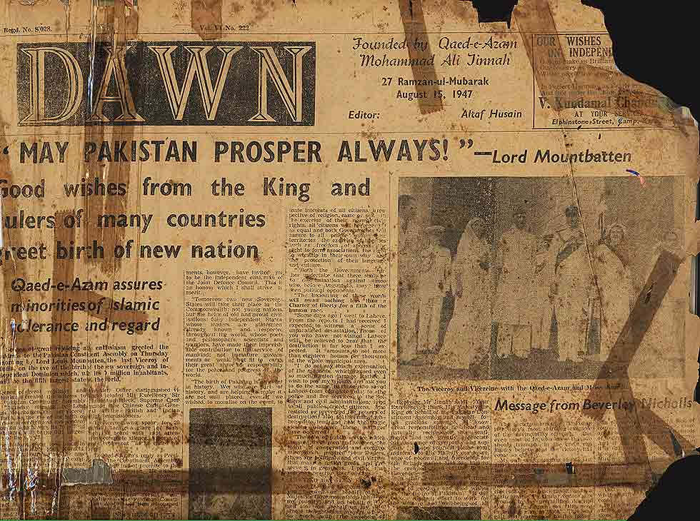

Courtesy: Dawn, 1947

AFTER THE BIRTH OF A NATION

CONSTITUTIONAL DEVELOPMENT 1947 TO 1956
The modified Government of India Act (1935) became the Interim Constitution of Pakistan in 1947. The Constituent Assembly was given the task of framing the Constitution of Pakistan.
THE CONSTITUENT ASSEMBLY:
Pakistan's first Constituent Assembly came into being on 26th July 1947 and its inaugural session was held on 10th August 1947. On 12th March 1949, the Constituent Assembly assumed the future Constitution had to be formulated. The Assembly also appointed Objectives Resolution, enumerating the ideals on which the on the same date a Basic Principle Committee had to work out the principles on which the Constitution was to be drafted.
OBJECTIVES RESOLUTION:
The Objectives Resolution was a resolution adopted on 12th March 1949 by the Constituent Assembly of Pakistan. The resolution proposed by the Prime Minister Liaquat Ali Khan proclaimed that the future constitution of Pakistan would not be modeled entirely on a European pattern, but on the ideology and democratic faith of Islam.
It declared:
- The constitution should observe the principle of democracy, freedom, equality, tolerance, and social justice as laid down by Islam.
- Muslims would be able to lead their lives according to Islamic principles.
- Other religious groups should be able to practice their religion freely.
- Minorities and the poor would be legally protected from social injustice.
- All fundamental human rights should be guaranteed.
- The legal system should be independent of government.
It was targeted by much criticism:
- East Pakistan had a much larger population than West Pakistan and resented the idea of equal representation in the National Assembly. The East Pakistanis also resented having Urdu as the official language, at the expense of Bengali.
- Provincial politicians objected to the power being given to the Head of State and to the Federal Government.
- Religious groups complained that the constitution was not sufficiently Islamic. Religious Scholar Maulana Maududi was disappointed with the fact that it did not produce any positive results. According to him, it was such a rain which was neither preceded by a gathering of clouds, nor was it followed by vegetation. Prime Minister Liaquat Ali Khan decided that since there was so much criticism of the proposals they should be given further consideration. His untimely death meant that constitutional change had to wait until a new leader was found and had time to settle in.
CONSTITUTIONAL MATTERS:
The Basic Principles Committee (BPC) consisting of 24 members was made to work for the constitution. The various sub-committees on Federal and provincial duties, Franchise, Judiciary, and Fundamental Rights started working. Board of Talimat-e-Islamia was also set to look for advice on the religious matters.
BASIC PRINCIPLES COMMITTEE (FIRST DRAFT) – 28TH SEPTEMBER 1950:
The Objectives Resolution was to be built-in in the Constitution as the order principles. Bicameral Legislature would be set up. The Upper House: (House of Units) would have equal representation for the units, consisting of 100 members. The Lower House: (House of People) will be on the basis of Population, consisting of 400 members. Both Houses will enjoy equal powers. The Head of State would be elected by joint session for five years (two times only). President had the powers of emergency proclamation, official appointments. The President was not responsible to give answers to anyone. He could be a Muslim or a Non-Muslim. He would be assisted by the Prime Minister (PM) and Cabinet. Parliament can change him by 2/3 majority. Nevertheless, he was given the power to break the constitution if need be. The Cabinet was answerable to both the Houses. Urdu would be the national language.
This report was severely criticized. The religious group objects that the report contained nothing related to Islam. This report was also criticized strongly by S.C. Chattopadyaya and East Pakistan: the crux of criticism was related to underrepresentation in the central legislature and the proposal for a strong center with vast powers on financial matters; East Pakistan was given equal number of seats in Upper House, the same as West Pakistan. Thus it reduced the principle of majority and turned East Pakistan into a minority. Moreover, the interim report was preposterous for the East Pakistan since it had Urdu as national language and Bengali was nowhere in the constitutional arena.
BASIC PRINCIPLES COMMITTEE REPORT (SECOND DRAFT) – 22 DECEMBER 1952 (Date According to Nigel Kelly):
This revised Report suggested:
- The Head of State must be Muslim.
- There should be a House of Units with 60 members from East Pakistan and 60 from West Pakistan. The House of People should have 400 members with 200 elected from each wing.
- Religious minorities would have representatives at National and Provincial levels.
- The Cabinet was to be responsible to the National Assembly, not the Head of State.
- The Head of State would choose a committee of Islamic specialists to ensure that all legislation conformed to Islamic law.
- The official language should be settled by the Assembly.
Like the first report this was also criticized, but this time criticism arose from Punjab which considered the federal formula to be defective. They demanded equal representation for various units in lower house and equal power for both Houses. The Punjab members in the Basic Principles Committee and the Federal Cabinet disliked the formula because they felt East Pakistan would easily dominate West Pakistan which had been divided into nine units. As yet, Pakistan had no official language, although Urdu had been suggested under the Quaid and had much government support.
Due to the political crisis, on 17th April 1953 (date according to Nigel Kelly) Ghulam Muhammad dismissed Khawaja Nazimuddin and three other members of the Cabinet. Ghulam Muhammad said that:
‘I have been driven to the conclusion that the Cabinet of Khawaja Nazimuddin has proved entirely inadequate to grapple with the difficulties facing the country.’
BOGRA FORMULA:
Mohammad Ali Bogra presented his package popularly known as the 'Bogra Formula'. The Bogra Formula was discussed in detail and was approved by the Assembly. On 21st September 1954, while Ghulam Muhammad was out of country, Bogra persuaded the Assembly to pass laws limiting the powers of the Governor-General by saying:
- That all his ministers, including the Prime Minister, must be member of the Assembly.
- That the Assembly had to approve the Cabinet,
- That the Governor-General had to take the advice of the ministers.
But before it could be written down in the form of constitution, the Constituent Assembly was dissolved by the then Governor-General, Ghulam Muhammad, on 24th October 1954.
CONSTITUENT ASSEMBLY DISSOLUTION:
On 24th October 1954, Governor-General dissolved the Constituent Assembly that was challenged in the Sindh High Court by Maulvi Tamizuddin. Sindh High court declared the dissolution illegal but the Federal Court upheld the Governor-General action and asked for setting up an elected Constituent Assembly. Quoting from a speech by Ghulam Muhammad on 24th October 1945 when he dissolved the Assembly, “The constitutional machinery has broken down… The Constituent Assembly has lost the confidence of the people and can no longer function.” Part of the decision made by the Sindh High Court in February 1955 was, “The Constituent Assembly is a sovereign body. The Governor-General has no power of any kind to dissolve it.”
SECOND CONSTITUENT ASSEMBLY, JUNE-JULY 1955:
Ghulam Muhammad called a Convention on 10th May 1955. All its members were to be elected indirectly (by the provincial assemblies). In this way, the 2nd Constituent Assembly came into existence during the months of June-July, 1955.
ONE UNIT SCHEME, OCTOBER 1955:
The presence of different provinces in the West Pakistan had complicated the issue of the West Pakistan’s representation in the Constituent Assembly. In November 1954, Bogra had proposed that the four provinces and 10 princely states within Pakistan should be joined together to form West Pakistan. On 5th October 1955 (date according to Nigel Kelly), Iskander Mirza passed an order unifying all of West Pakistan in what became known as the ‘One Unit Scheme’. Now both the parts had become two units and could be addressed equally.
THE CONSTITUTION MAKING:
One Unit scheme helped the task of constitution making to achieve successfully. The previous committee’s work helped the new Assembly that completed its work and presented it in the 2nd Constituent Assembly on 9th January 1956. With certain amendments, it was approved on January 29, 1956
On March 23, 1956, it was promulgated as Constitution of Pakistan. With this, Pakistan had finally become an Islamic Republic.

CONSTITUTION OF 1956
The main points of this constitution are as follows:
- Pakistan was to be federal republic based on Islamic Ideology.
- A detailed and comprehensive list of fundamental rights with an Independent Judiciary was provided in the constitution.
- The system of the parliamentary form of government was adopted both at the Centre and in the provinces.
- There was distribution of powers between the Centre and the provinces.
- The constitution provided for Pakistan, wherein equality between East and West wings had been maintained.
- For the distribution of subjects between the centre and the provinces, three lists of subject had been drawn up.
- There was a special procedure to be adopted for the amendment of the constitution, yet it was the least rigid constitution. It was reasonably flexible.
- It had provided for two National languages Urdu for the West Pakistan and Bengali for the East Pakistan.
- Instead of double citizenship, one citizenship system was provided for the Federation of Pakistan.
- The constitution was silent as to be method of conducting elections both for the Central and the Provincial legislatures.
- And finally, there were the Islamic characters of the constitution. The Islamic Provisions are as following:
- The name of the country will be Islamic republic of Pakistan.
- The preamble of the constitution embodied the sovereignty of God Almighty.
- The Head of the State shall be a Muslim.
- Islamic Advisory Council shall be set up.
- No Law detrimental to Islam shall be enacted.
Second Constituent Assembly passed the Constitution based on arbitrarily made compromises. Hence, the Constitution could not ensure stability. The most adverse implication was its decision to vest extra-ordinary powers in the President despite the claim of the Constitution to be a parliamentary one. The Constitution also could not resolve the issue of the electorate.
Moreover, it created an artificial parity between East and West Pakistan by merging the provinces, states and others administrative units of the western wing of the country into One Unit, in order to neutralize the numerical majority of East Pakistan. These aspects of the Constitution paved the way for subsequent crises and swift changes in the governments with four prime ministers coming to office between 1956-1958.

RIGHTS GUARANTEED BY THE CONSTITUTION:
- Free speech and assembly
- Right to vote
- Right to form political parties
- Right to criticize
- Freedom from unlawful arrest
- Freedom of religion
- Equality as a citizen
- Freedom of culture
- Right to security
- Right to marry
- Right to education
- Right to own property
- Right to choose trade and profession
- Right t practice that profession

1956 CONSTITUTION – GOVERNMENT STRUCTURES
FEDERAL and PROVINCIAL COURTS

Powers: Chooses Prime Minister, can impose emergency, can dissolve the National Assembly

Restrictions: Muslim, over 40, PM must be from National Assembly, dissolving of NA only on advice of PM

PRESIDENT
a

CABINET
PRIME MINISTER
Powers: Advises President
Restrictions: Advises only
Powers: Chooses Cabinet
Restrictions: Cabinet must be from National Assembly
Islamic Committee now + right of veto on legislation
NATIONAL ASSEMBLY
One house of parliament, with 300 members elected by adults over 21 years.

PROVINCIAL ASSEMBLY
A body for East Pakistan.
A single ‘one unit’ body for the 4 provinces of West Pakistan Elected as before

FIRST MARTIAL LAW
On October 07, 1958, President Iskander Mirza imposed Martial Law in the country and abrogated the Constitution. He appointed General Ayub Khan as the Chief Martial Law Administrator. Twenty days later on 27th October 1958, Ayub Khan overthrew Mirza and assumed the office of the President as well.

BASIC DEMOCRACIES
A year later on 26th October 1959 (date according to Nigel Kelly), Ayub Khan introduced the Basic Democracies Order creating 80,000 Basic Democracies member who had to serve as the Electoral College later. Through this Electoral College, Ayub got elected as President in a referendum on 14th February 1960.
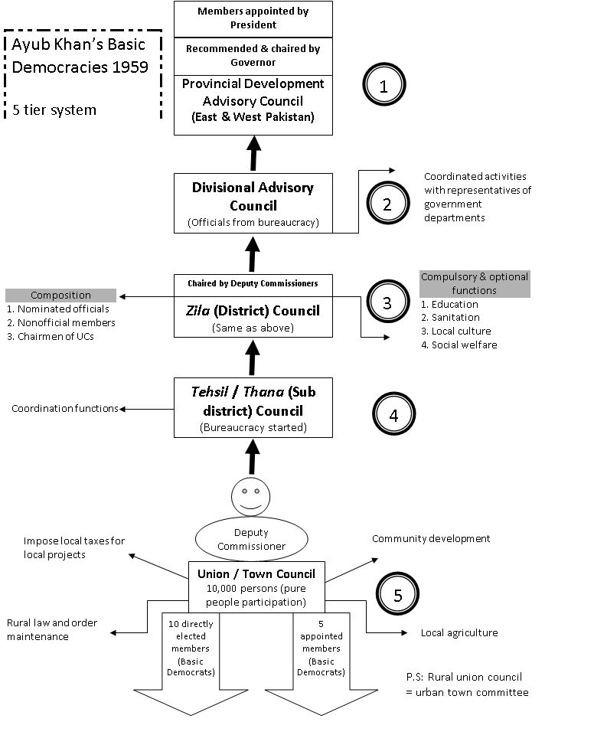Courtesy: khalidriazblog, wordpress.com

CONSTITUTIONAL COMMISSION
After taking over President Ayub Khan set up a constitutional commission under Justice Shahab-ud-Din to suggest recommendations for the new constitution of the country. The commission after through and lengthy discussion submitted its report on 6th March 1961. The report was examined by president. In its report the commission highlighted the reasons of the failure of parliamentary democracy in Pakistan:
- It fixed the responsibility for the debacle of democracy on the lack of dedicated leadership.
- Absence of well-organized political parties
- And the self-aggrandizement of the greedy politicians
In the view of the recommendation of the commission a new constitution was not framed by a constitutional body which was elected, nor did it enjoy popular support. The constitution was thrust upon the people in an undemocratic and authoritarian manner. (Dr. Tahir Jamil’s presentation)

CONSTITUTION OF 1962
The new constitution was announced on 1st March 1962. Although Ayub described it as combining ‘democracy with discipline’, in reality it set up a presidential form of government. Salient Features of the Constitution were:
- Title of the State will be Islamic Republic of Pakistan.
- A Powerful President who was responsible for administration and affairs of the state. He should be a Muslim, no less than 40 years of age, should be capable to be a member of NA. He would be elected through not direct elections for a time of five years. If he has held office for more than 8 years, he could look for reelection with the support of the NA and the PAs.
- National Assembly was given the power to charge the president, however it was difficult to achieve.
- President could dissolve the NA but in that case he must seek re-election.
- President was the central point of all the Executive, Legislative and Judicial powers. Cabinet was responsible to him. All key appointments were to be made by President. He could issue Ordinances. He could also announce State of Emergency in the country.
- NA was consisted of one house on the basis of principle of parity between two wings of the country. There were 150 seats plus 6 seats were reserved for women. All were elected indirectly. For the membership minimum age limit was 25 years.
- NA had all the powers of law making but law was to be finally ratified by the president. President could sign, reject or return the bill.
- Financial Powers of NA were limited. Only new expenses could be voted. NA could not reject join Fund List and Recurring Expenditure.
- There were two provinces of the federation: East Pakistan and West Pakistan. Only one list of subjects, i.e. the Central list was given in the constitution.
- Governors were head of the provinces and govern the province with his cabinet. Provincial governments were directly under the control of President. There was a strong center with a Powerful President. He had enough powers to manage provincial affairs. In case of emergency powers Central government could take direct control of the province.

PRINCIPLE POLICIES:
- National solidarity would be observed.
- Interests of backward people would be looked after.
- Opportunities for participation in national life
- Education and well-being of people
- Islam would be implemented in day to day life.
- Fundamental Rights were provided in the constitution.
- Originally Political Parties were not allowed. Political Parties Act was introduced in 1962.
- Objectives Resolution was the Preamble of the Constitution. Other Islamic provisions were a part of Principles of Policy and not the constitution.
- An Advisory Council for Islamic Ideology was made in the constitution having 5-12 members. It was a recommendatory body. It was designed for the Research and instructions in Islam for assisting the reconstruction of Muslim society on truly Islamic lines.
Ayub Khan provided a second Constitution to the country. Discarding the parliamentary system, the Constitution adopted the presidential form of government, but it was void of the system of checks and balances which is enshrined in democratic Presidential systems in other countries. Moreover, the Constitution gave overwhelming powers to the President, allowing him to dominate the entire constitutional system.

THE DECADE OF DEVELOPMENT
AGRICULTURE REFORMS:
Ayub’s advisors wanted to bring reforms in the field of agriculture and make it more productive. They said that many small, subsistence holdings could never be efficient. A law was passed saying that no farm could be smaller than 12.5 acres or larger than 500 acres (irrigated) or 1000 acres (not irrigated). This meant that many smaller farms found their land was redistributed. However, the resulting larger farms did produce a steady rise in food output. Big land owners were forced to find tenants for parts of their lands and this, too, raised productivity as the tenants and smaller farms were often more efficient than the larger, poorly run farms. Three major dams were built to help irrigation. Farmers were also loaned money to build wells to reduce the need for canal irrigation.

INDUSTRIAL REFORMS:
Ayub’s advisors pressed for more industrial development. This was carried out with the help of loans from more industrialized western countries, particularly the USA, Germany and the UK. In 1962, an oil refinery was established in Karachi and a Mineral Cooperation set up for the exploration of mineral deposits. In 1964, an economic union was formed with Iran and Turkey, the Regional Cooperation for Development in which three countries agreed to develop ties and trade, commerce and industry. An Export Bonus Scheme was set up offering incentives to industrialist who increased exports.

SOCIAL AND EDUCATIONAL REFORMS:
Ayub’s advisors drew up new curricula for schools and suggested that new textbooks should be published. The government began an extensive literacy program, building new schools and colleges. There was also an attempt to deal with shelter less people. In some cities, especially Karachi, refugees from the partition era had still not been able to find permanent homes.
Ayub’s government also tried to control population growth and set up the Family Planning Programme, funding largely by American loans. The government used radio, cinema, newspapers, posters and leaflets to persuade Pakistanis to limit the size of their families. The Programme, however, was not particularly successful.
Medical facilities were also improved. More medical and nursing training schools were set up to increase the number of doctors and nurses.

A NEW CAPTIAL
Since partition, the capital had been Karachi. Ayub’s government decided to build a new capital. In 1959, the site of Islamabad was chosen to replace Karachi as the new capital of Pakistan.

AYUB KHAN STEPS DOWN
Ayub's Constitution lasted as long as he survived in office. With his departure, his system was also folded. In fact, Ayub himself renounced the imposition of Martial Law on 25th March 1969 as he had realized that he had barely any support to sustain. But he did not call for new elections to choose another President. Instead he handed over power to the army and for the second time in its short history, Pakistan experienced a Martial Law.

YAHYA KHAN
New Chief Martial Law Administrator General Yahya Khan, soon after the taking-over announced that he would hold elections for the constituent assembly at an appropriate time. Before the elections that were held in December 1970, General Yahya dissolved One Unit and restored the former provinces along with the creation of the Province of Baluchistan in the western part of the country. He also announced the Legal Framework Order (LFO).
The LFO brought an end to parity between East and West Pakistan, accepting the numerical majority of the eastern wing. It also gave up the indirect elections as had been introduced by Ayub Khan. The 1970 elections, thus, were the first general elections in the country to be held on the basis of adult franchise.
However, the election results that brought Sheikh Mujib-ur -Rehman's provincial autonomist Awami League as the majority party in the National Assembly could not be reconciled by the military regime. The failure of dialogue between the regime, the Awami League and the Pakistan People's Party which had emerged as the majority party in two provinces of West Pakistan - the Punjab and Sindh- paved the way for a crisis which the military regime tried to resolve by force.

OUTBREAK OF THE 1971 WAR
There was first an outbreak of a civil war in Pakistan as a consequence of Yahya sending an army into East Pakistan to ‘keep order’ and the Awami League was banned. Yahya claimed that Mujib (leader of Awami League) was claiming to declare independence, and although this was unlikely, fears increased when on 26th March (date according to Nigel Kelly), Sovereign People’s Republic of Bangladesh was announced in a secret radio broadcast from Dhaka.
Problems aroused when a war broke out with India as a result of a mistake. On 3rd December Pakistani Air Force launched attacks, not on East Pakistan, but on Northern India. Mrs. Gandhi, the Indian leader, reacted immediately. This led to the war between India and Pakistan in 1971. India assisted East Pakistan – or what, by this stage, was Bangladesh, in gaining independence. In this war, Pakistan army decided to surrender although it was positive to defeat India and punish East Pakistan for rebelling. It was due to the fact that East Pakistanis were determined to fight against West Pakistan to attain freedom and now had India’s support, while Pakistan could expect very little from its allies in arbitration and pacification of this outbreak.
The military regime's failure in crisis management led to its intensification and culminated in the separation of East Pakistan on December 16, 1971. On 21st December 1971, the Republic of Bangladesh was officially declared.
Defeat in the war brought disgrace for Yahya and for the army. On 20th December, Yahya resigned as President and was replaced by Z.A. Bhutto; hence, Bhutto uplifted the second Martial Law. He got the approval of the Opposition for his interim Constitution to govern the country as long as the permanent Constitution was not made. National Assembly approved a temporary Constitution, which was imposed on April 21, 1972.

CONSTITUTION MAKING
Constitutional Committee comprising National Assembly members from all parties was set up in April 1972. Law Minister was the Chairman of this Committee. All parties agreed on the future political system in October 1972. The Committee reported on December 31, 1972. After long deliberations and compromises, final draft was approved commonly on April 10, 1973.

1973 CONSTITUTION
The new Constitution was adopted on August 14, 1973. The Constitution functioned since then with two gaps. It remained operational during following periods:
1973-77: Operational
1977-1985: Suspended
1985-1999: Operational after changes
1999-2002: Suspended
2002 onwards Operational after changes (Next Section)
Following are the features of the 1973 constitution:
Parliamentary System: It was a parliamentary constitution having powerful Prime Minister (PM) as head of government with a very weak President. President must act on the advice of PM. All his orders were to be countersigned by PM. Prime Minister to be elected by the NA. PM exercised all executive authority.
An important aspect of the Constitution of 1973 was the sustainability of the National Assembly, which was elected for the duration of five years and could be dissolved by the President only on the advice of the Prime Minister. This was a normal parliamentary practice that was incorporated in the Constitution.
In order to strengthen the parliament, it was laid down that a Prime Minister against whom a resolution for a vote of no-confidence had been moved in the National Assembly, but had not been yet voted upon, or against whom such a resolution had been passed, or who was continuing in office after his resignation, could not recommend the dissolution of the National Assembly to the President.
PM was answerable to the NA. In 1985, powers of the President were increased. He enjoyed some discretion in appointments of PM. He had power to break up the NA. He had the powers of appointment of caretaker PM. He gives his assent to bills passed by the parliament or returns these.
President: Must be at least 45 years of age, Muslim, qualified to become member of the NA. He is elected by the Parliament and the Provincial Assemblies for 5 years.
Parliament with two houses: Upper House is called Senate. In this house equal representation is given to Provinces. Seats are reserved for the tribal areas, women and technocrats. Its original strength was 63, which was later raised to 87 and then to 100. Senate is elected indirectly. It’s a permanent House as half of its members are elected after three years.
Lower House is called the National Assembly. NA is elected on population basis. Its original strength was 210 but now it is 342. It is elected for five years through direct elections. Voting age for the franchise is lowered from 21 to 18. Parliament under 1973 constitution is a powerful legislative body that enjoys all legislative powers. It has control of the executive through questions, resolutions, parliamentary committees, etc. National Assembly is more powerful than the Senate. Budget is presented before NA. Cabinet is answerable to National Assembly.
Federal System: Federation of Pakistan has four provinces and federally administered areas. Two lists are given in the constitution: Federal list and Concurrent list. Residuary powers belong to provinces.
Provincial Governors are appointed by the President on the advice of the PM. Elected Chief Minister exercises executive powers. Parliamentary system is there in the provinces. Size of the provincial assemblies varied but in 2002, Punjab had 371; Sindh had 168; NWFP (later renamed as Khyber Pakhtunkhwa) 124; Balochistan had 65. Enough provincial independence is guaranteed and the tradition of strong center continued. Centre has emergency powers. Governor’s rule can be forced if the government cannot function in the provinces. Provinces are dependent on center for Finances.
Principles of Policy: Islamic provisions are provided in Principles of Policy.
Fundamental Rights: Fundamental Rights are protected in the constitution and are implemented through the highest court.
Islamic Provisions: Title of the state is Islamic Republic of Pakistan. The objectives resolution was the Preamble in the initial constitution but through article 2-A of 8th amendment it was inserted in the constitution in 1985. Islam was declared the State Religion of Pakistan. Definition of Muslim was included by an amendment. Principles of Policy also carry some Islamic clauses. Council for Islamic Ideology is recognized under the constitution. Federal Shariat Court was added in 1981.
National Language: Urdu is declared National Language, however English may be used for official purposes until preparations would be made for its replacement by Urdu. Provincial Assembly may prescribe measures for teaching, promotion and use of a provincial language in addition to the national language.
National Security Council: National Security Council was added in 2002 in advisory capacity.
Judiciary: An independent judiciary is given under the constitution. Supreme Court of Pakistan is the highest court. One High Court is established in each province and one in Azad Kashmir. A chain of lower courts is there under the high courts.

LIST OF AMENDMENTS TO THE CONSTITUTION OF PAKISTAN
1. | Redefined the boundaries of Pakistan and removed references to East Pakistan. | Passed on May 4, 1974
2. | Defined a Muslim and declared the status of Ahmadis as minority and 'non-Muslim'. | Passed on September 7, 1974
3. | Extended the period of preventive detention. | Passed on February 18, 1975
4. | Decreed additional seats for minorities, it also deprived courts of the power to grant bail to any person detained under any preventive detention. | Passed on  November 21, 1975
5. | Widened the scope of restriction on the High Courts. | Passed on September 5, 1976
6. | Provided that Chief Justice of Supreme Court will be retired at the age of 65 and High Court judges at age 62. | Passed on December 22, 1976
7. | Enables the Prime Minister to obtain a vote of confidence of the people of Pakistan. | Passed on May 16, 1977
8. | Changed Pakistan's government from a Parliamentary system to a Semi-presidential system by giving the President a number of additional powers. | Passed on November 11, 1985
9. | Bill to impose Shariah law as the supreme law of land. The bill was passed by Senate but could never be passed by National Assembly owing to the latter's dissolution. | Not Passed
10. | Fixed the interval period between sessions of the National Assembly to not exceed 130 days. | Passed on March 29, 1987
11. | Revision of the reserved seats for women in the National and the provincial assemblies. The bill was withdrawn in 1992 | Not Passed
12. | Created Speedy Trial Court for 3 years. | Passed in 1991
13. | Stripped the President of Pakistan of his reserve power to dissolve the National Assembly of Pakistan, and thereby triggering new elections and dismissing the Prime Minister. | Passed in 1997
14. | Allowed members of parliament to be dismissed if they defect. | Passed on July 3, 1997
15. | Bill to impose Shariah law as supreme law of land. Was never passed. | Not Passed
16. | Increased the term appointed for quota system as per 1973 Constitution from 20 to 40 years. | Passed in 1999
17. | Made changes dealing with the office of the President and the reversal of the effects of the Thirteenth Amendment. | Passed in 2003
18. | Removed the power of President of Pakistan to dissolve the Parliament unilaterally. | Passed on April 8, 2010
19. | Provided for the appointment of the Judges of the Supreme Court of Pakistan and made amendments in the number of members of the parliamentary committee for the appointment of Chief Electoral Officers at Election Commission of Pakistan. | Passed on  December 22, 2010
20. | For Free and Fair Elections. | Passed on  February 14, 2012
21. | For Speedy Trial Military Courts to deal with terrorism. | Passed on  January 7, 2015
22. | ECP powers deputed to Chief Election Commissioner. | Passed on June 8, 2016
23. | The 23rd Amendment was passed to re-establish the military courts for further two years till 6th January 2019.^{[3]} In 2015, National Assembly passed the 21st Amendment and created the military courts for the period of 2 years. The period of two years was expired on 6th January 2017 hence this 23rd Amendment was passed to re-establish the military courts for further two years till 6th January 2019. At the end of this period all the amendments will be expired/removed automatically. | Passed on January 7, 2017
24. | Reallocation of National Assembly seats among federating units and allowing election authorities to update boundaries of constituencies based on provisional results of 2017 Census of Pakistan. | Passed on December 22, 2017
25. | Merges Federally Administered Tribal Areas with Khyber Pakhtunkhwa | Passed on May 31, 2018

MOST IMPORTANT AMENDMENTS:
8TH AMENDMENT (58-2b):
The Eighth Constitutional Amendment added a clause to the Article 58 giving to the President the power to dissolve the National Assembly in his discretion where, in his opinion, an appeal to the electorate was necessary. .
This clause had far reaching implications not only in making the assembly dependent and subservient to the President, but also drastically changing the parliamentary character of the Constitution, tilting it towards a presidential one.
After being inducted in the Constitution, this clause was invoked by the President on four occasions in a short span of nine years between 1988 and 1996. This clause was repealed in the Thirteenth Constitutional Amendment passed on April 04,1997 (Nawaz Sharif govt). The Eighth Amendment had given similar power to the governors with respect to the provincial assemblies.
13TH AMENDMENT:
The parliamentary character of the Constitution was restored as a result of the Thirteenth Amendment (1997) which also accompanied the restoration of the prime ministerial advice as being binding for the President with respect to the appointment of governors and taking away of the discretionary powers of the President to appoint the three chiefs of the armed forces.
17TH AMENDMENT:
However, the Seventeenth Amendment (was an amendment to the Constitution of Pakistan passed in December 2003, after over a year of political wrangling between supporters and opponents of Pakistani President Pervez Musharraf) once again shifted the pendulum to the side of the President. The President can now once again dissolve the National Assembly at his discretion.
18TH AMENDMENT:
It was passed by the National Assembly of Pakistan on April 8, 2010, removing the power of the President of Pakistan to dissolve the Parliament unilaterally, turning Pakistan from a semi-presidential to a parliamentary republic.
Highlights of the 18th Constitutional Amendment:
Amendment to Article 6 seeks to pre-empt military coups in future. Article 58(2b) to be repealed, substituted with ‘Dissolution of National Assembly’. President may dissolve NA in case no confidence vote passed against PM. Total strength of cabinet should not exceed 11% of total membership of parliament.
Governor should be a resident and registered voter of his/her province, he/she would be appointed by president on prime minister’s advice. Provinces required by law to establish local government systems, devolve political, administrative and financial responsibility and authority to elected representatives. PM to be the chairperson of CCI; members to include CMs; 3 members from federal government. Amendment to Article 157 says federal government must consult provincial government before installing hydroelectric power stations in any province.
PM to forward three names for office of CEC, in consultation with opposition leader in National Assembly, to a parliamentary committee for confirmation. Committee proposes insertion of Article 175(a) to deal with appointment of judges to Supreme Court, high courts, Federal Shariah Court. Committee proposes substitution of Article 243, says federal government ‘shall have control and command of armed forces, supreme command of armed forces shall [rest with] … president.
President to appoint Joint Chiefs of Staff Committee chairman, Chief of Army Staff, Chief of Naval Staff, Chief of Air Staff. NWFP will be renamed ‘Khyber Pakhtunkhwah’. State will provide free, compulsory education to children aged between 5 and 16 years.
Amendments to Clause 1 seek substitution of ‘Baluchistan’ with ‘Balochistan’, ‘Sind’ with ‘Sindh’. Insertion of clause sought to bar persons acquiring citizenship of foreign country from contesting elections to parliament. All elections will be held under constitution, other than those of PM and CM, to be by secret ballot.

CONCLUSION
The constitutional history of Pakistan reflects the social, economic and political dynamics of the state, exhibiting the clashes between the vital interests of the main social groups in Pakistan. The struggle over most constitutional issues (the state language, from of elections, division of powers between the Federation and the Provinces, etc.) went on for years altogether, often time to an extreme extent under adverse political exploitation.
The present Constitution of Pakistan is characterized by such fundamental principles as a parliamentary republican system, federal state structure, and proclamation of democracy, freedom, equality, tolerance and other bourgeois-democratic freedoms, and the attainment of social justice as the supreme aim of the state. (Dr. Tahir Jamil presentation) After the huge turnout of 2018 elections, the society unanimously has taken democratic values of the state in their hands to make Pakistan as peaceful and tolerant of a society as the global arena today yearns for. Pakistan has and will continue to stand in the face of extremism, terrorism, intolerance and corruption, and now Pakistanis show a profound political sense to take responsibility of the state reputation and the sanctity of her constitution.

REFERENCES
- Jamil, Tahir. Constitutional Development in Pakistan. (Presentation). Retrieved from: LinkedIn
- Kelly, Nigel. (2004). The History and Culture of Pakistan, 2010 Edition. London, England. PEAK PUBLISHING.
- Khan, Hamid. (2001). CONSTITUTIONAL AND POLITICAL HISTORY OF PAKISTAN, 3RD Edition 2017. Karachi, Sindh. Oxford.
Note: All dates are according to this book, if not mentioned otherwise.
- https://en.wikipedia.org/wiki/Amendments_to_the_Constitution_of_Pakistan
- https://en.wikipedia.org/wiki/Government_of_India_Act,_1915
- https://en.wikipedia.org/wiki/Government_of_India_Act_1919
- https://en.wikipedia.org/wiki/Government_of_India_Act_1935
- https://en.wikipedia.org/wiki/Indian_Councils_Act_1861

