BULK-POPULATION

In the bulk-population procedure, seeds harvested in the F2 and succeeding generations are bulked and grown, with selection delayed until an advanced generation, commonly the F5 or the F6, at which time the segregation will have virtually ceased (Fig). An example of the bulk-population procedure follows:

Crossing generation. Cross cultivar A × cultivar B.

F1 generation. Grow 50 to 100 F1 plants. Before harvest, eliminate plants that may have arisen from self-pollination. Harvest en masse and bulk seed.

F2 generation. Grow 2000 to 3000 F2 plants. Harvest en masse and bulk seed from all plants.

F3 to F4 generations. Grow 1/50- to 1/100-hectare plots with bulked seed harvested from the preceding generation.

F5 generation. Space plant 3000 to 5000 seeds. Select and harvest 300 to 500 superior plants keeping seed separate from each plant.

F6 generation. Grow progeny rows of selected plants; harvest 30 to 50 progenies in which plants exhibit the desired characteristics of the parents.

F7 generation. Grow superior progenies harvested in the F6 in a preliminary yield trial.

F8 to F10 generations. Yield trials are continued in multiple locations as in the pedigree-selection procedure.

F11 and F12 generations. Increase seed of a superior line and distribute as a new cultivar.

PROs: The bulk-population method of breeding is simple, convenient, requires less labor, and is less expensive to conduct during the early segregating generations than the pedigree-selection procedure. It is necessary to grow large populations of spaced plants in the selection generation to have a reasonable chance of finding desirable segregates.The bulk-population method is suited to crops normally planted in thick spacing, like small grains, in which it is difficult to separate and identify individual plants.
CONS: In contrast to the pedigree-selection method, no information is obtained during the early generations on inheritance of specific traits or performance of specific lines. During the segregating generations some desirable genotypes may be lost from the population, for example, tall and late plants may suppress short and early plants.

The bulk-population selection procedure may be modified by selecting in the F3 or the F4 and starting yield trials even though the lines are still segregating. Superior yielding lines may be reselected while yield testing continues
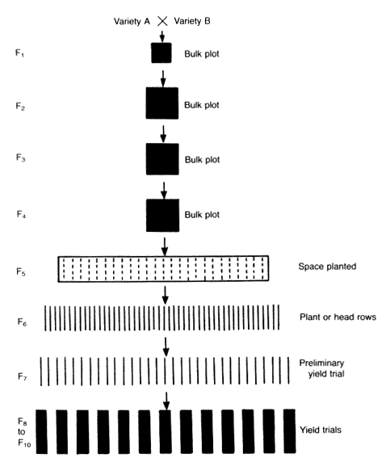

Fig.
Bulk-population method of selection. The progeny of the cross is grown in a bulk planting through the F4 generation. In F5 the progeny is space planted.
Plant or head selections are made and grown in plant or head rows in F6. Superior
rows are selected and grown in a preliminary yield trial in F7. Superior strains are
grown in yield trials in F8 to F10. Various modifications of this procedure may be
made. For example, selection may start as early as F3 or F4, with lines having a
superior yield being purified in later generations, or bulk plots may be replicated
and harvested for yield and entire crosses discarded on the basis of the yield
of the bulk plots.

