REPORT OF
GROUP NO 5
UOS BHAKKAR CAMPUS
Name of Student:……USAMA MUSHTAQ………….....Roll No:..……….BMTF19BM002

Name of Student:……SANA ULLAH…………………...Roll No:..……….BMTF19BM051

Name of Student:……GHULAM MUSTAFA……………Roll No:..……….BMTF19BM015

Name of Student:……MUHAMMAD ASIM …………….Roll No:..……….BMTF19BM033
Name of Student:……Syed Muhammad Mhedi Shah……Roll No…………BMTF19BM047

Program:…………….BS MATHEMATICS….……Session:………..………2019-2023

The Report
As our project is about giving awareness relating COVID-19 and we have done it very nicely. Our group members including me went out in our village and we placed many advertisements on different wall and especially on those areas where there is great gathering like mosques. As this virus is increasing rapidly in our beloved country that’s why there is need to aware civilians about this virus and protecting techniques from this fatal virus. We made some pictures while doing this project.
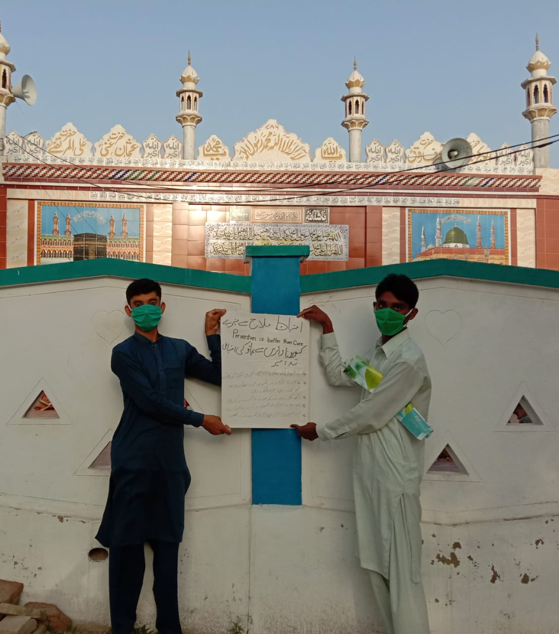
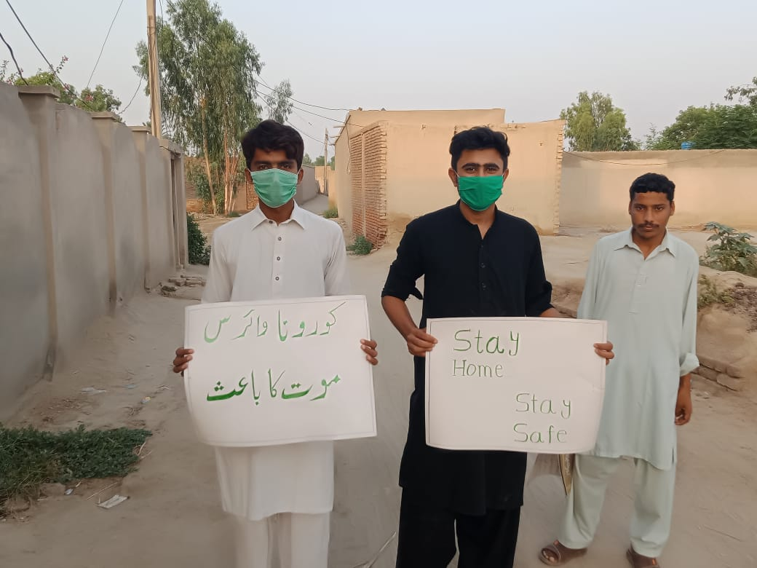
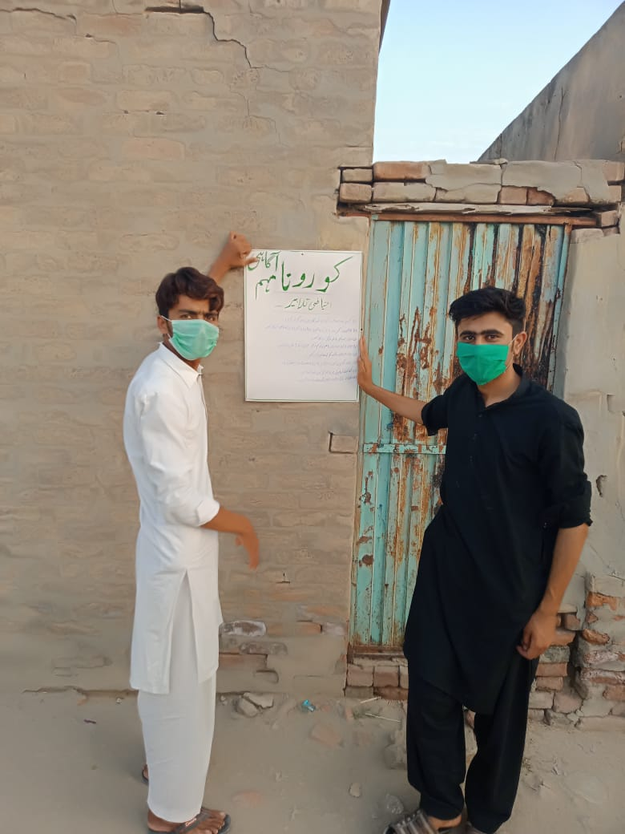
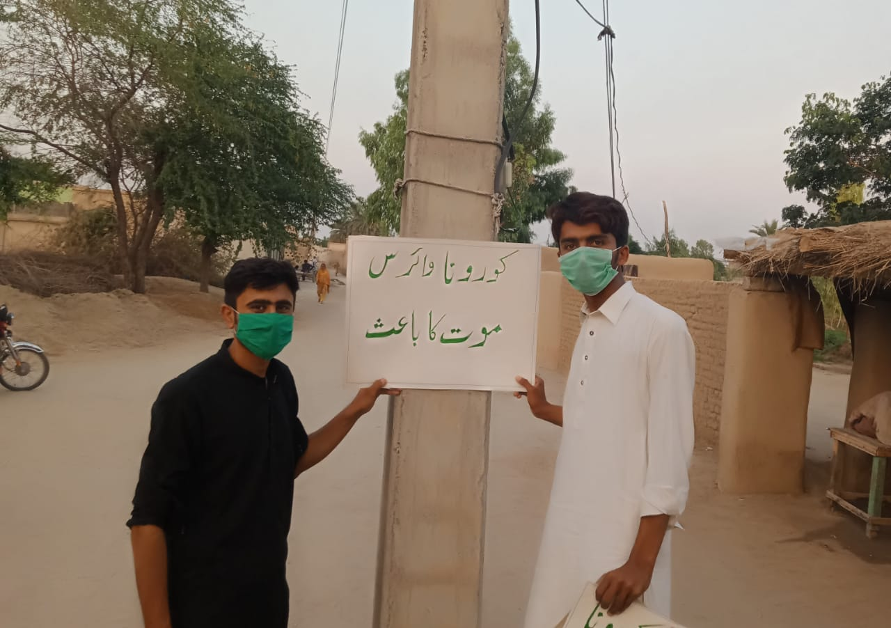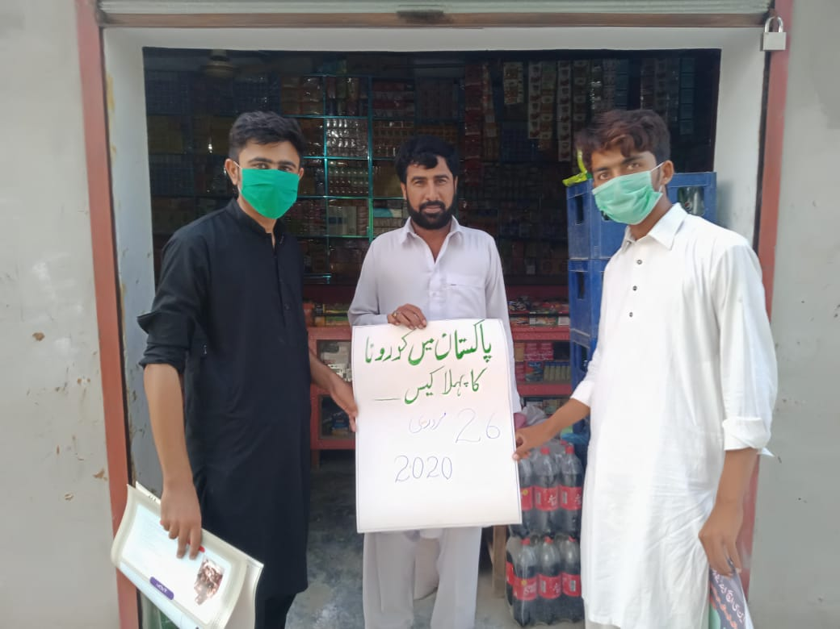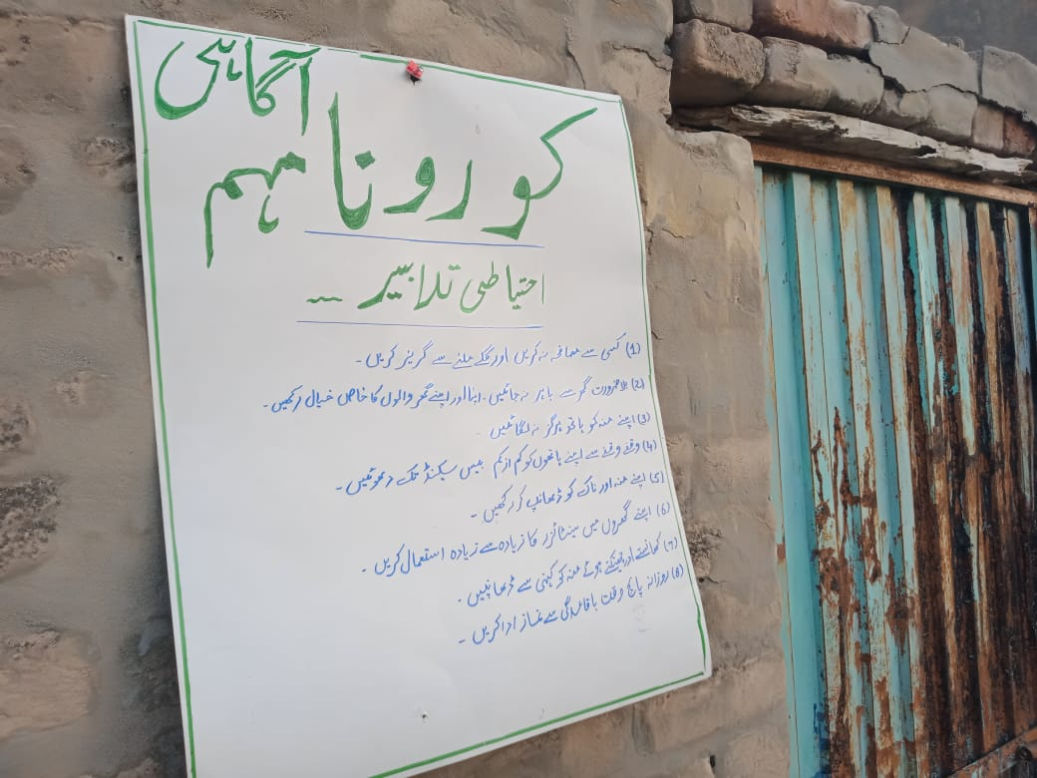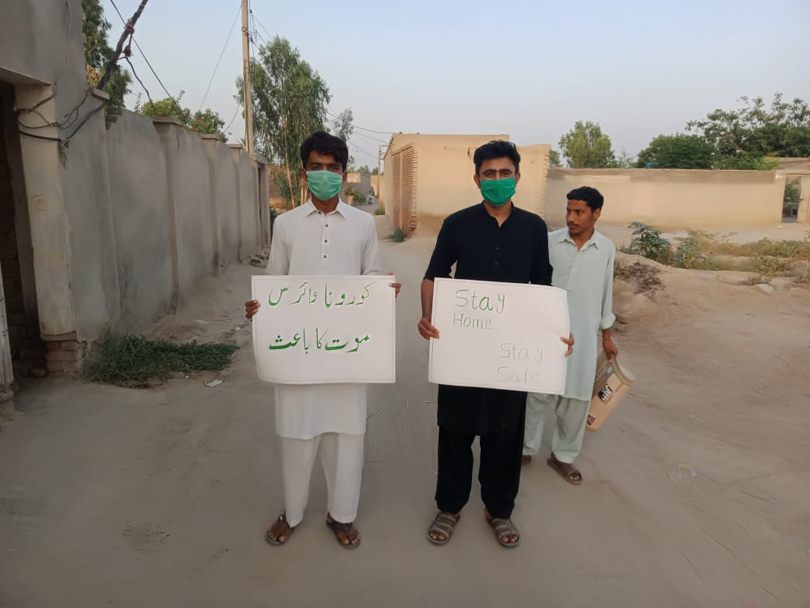
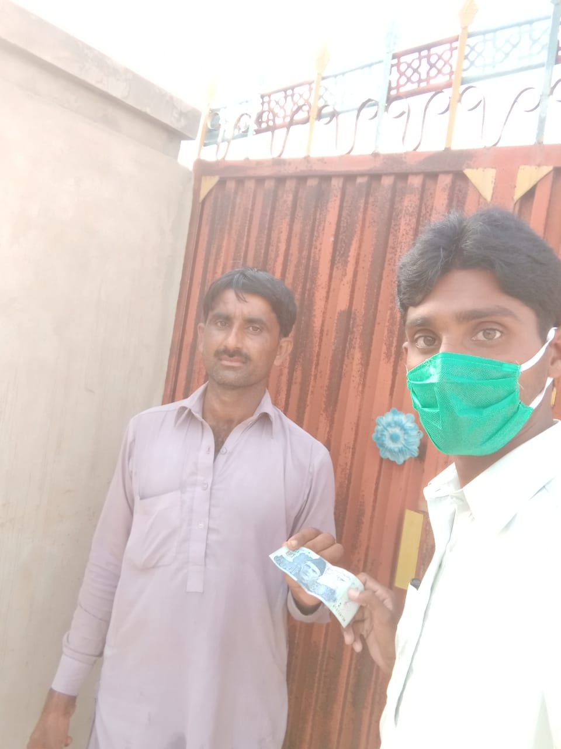
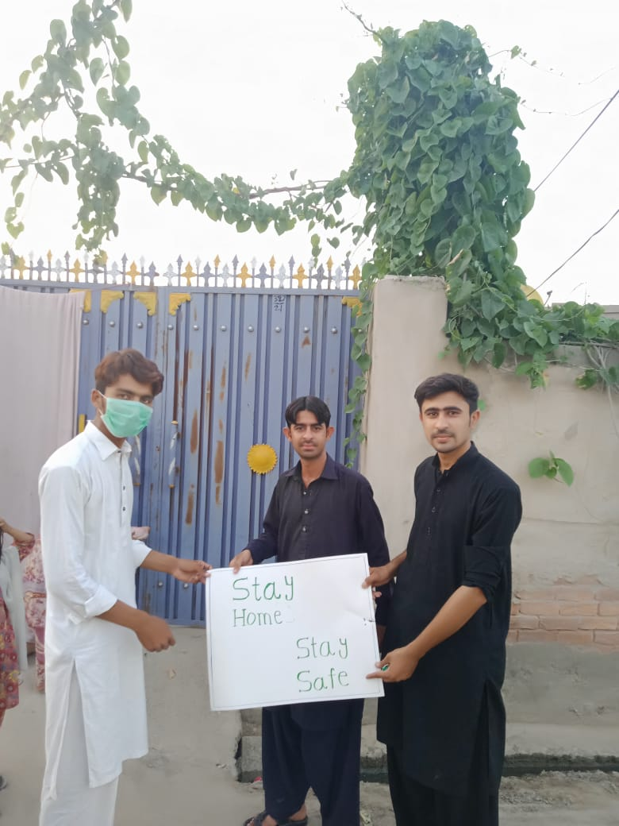(MUHAMMAD ASIM)
As in this crisis when every country and every city has been locked down many laborers and many poor people have stuck in their homes. In lock down they cannot go out side to earn and that’s why they are consuming their saving which is not sufficient for them in this long lock down. Therefore, we made this project to help those poor people financially so that they do not go outside. Because this virus more spread out by shaking hand and other activities like this. The government of all the countries has said people to remain at their home so that they can keep safe themselves and other lives. We helped many people and also, we got some pictures.
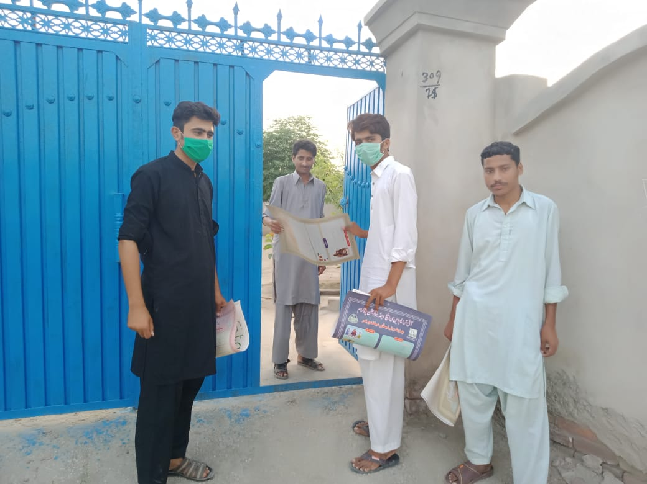
of them.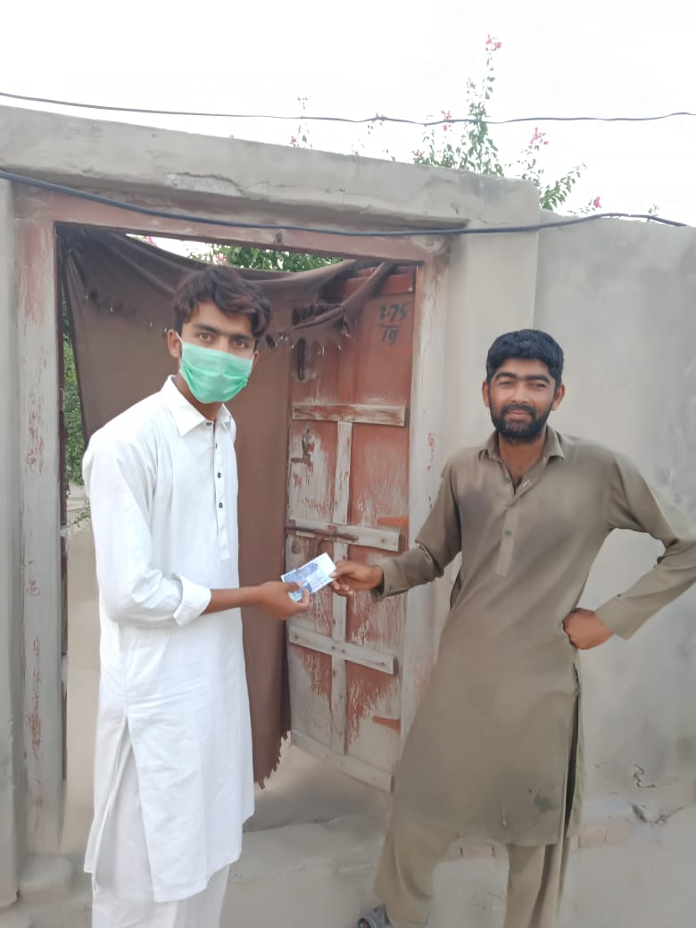
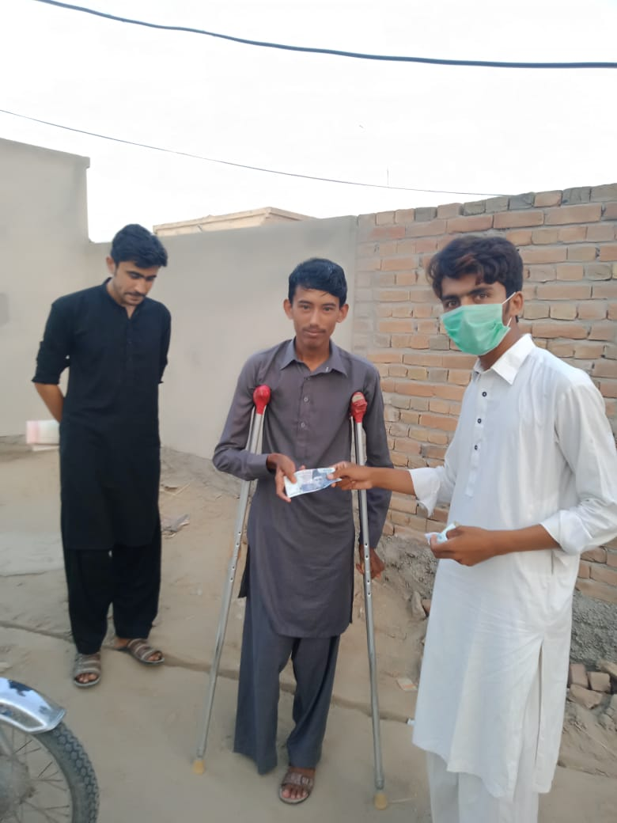
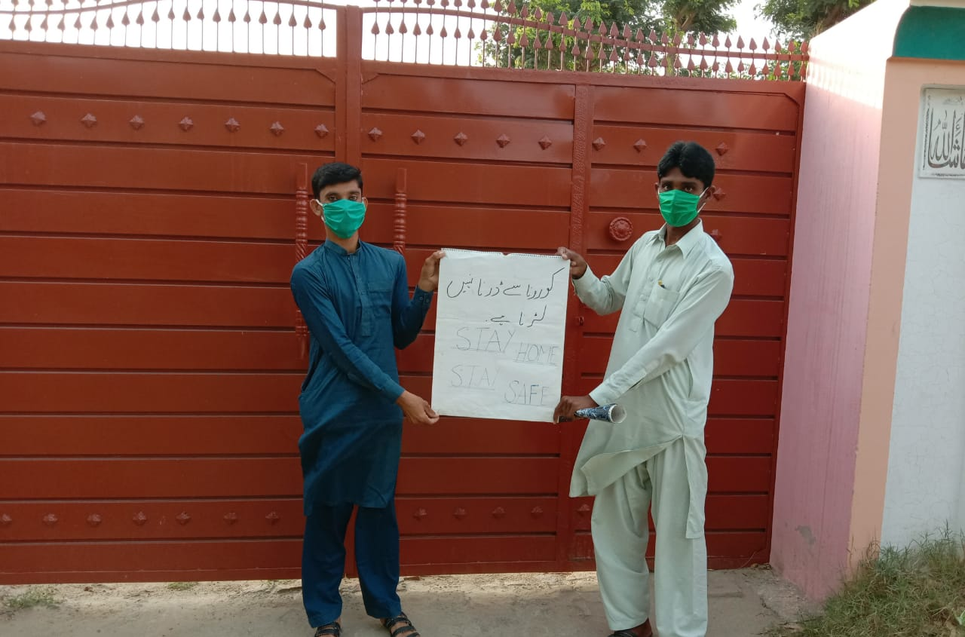

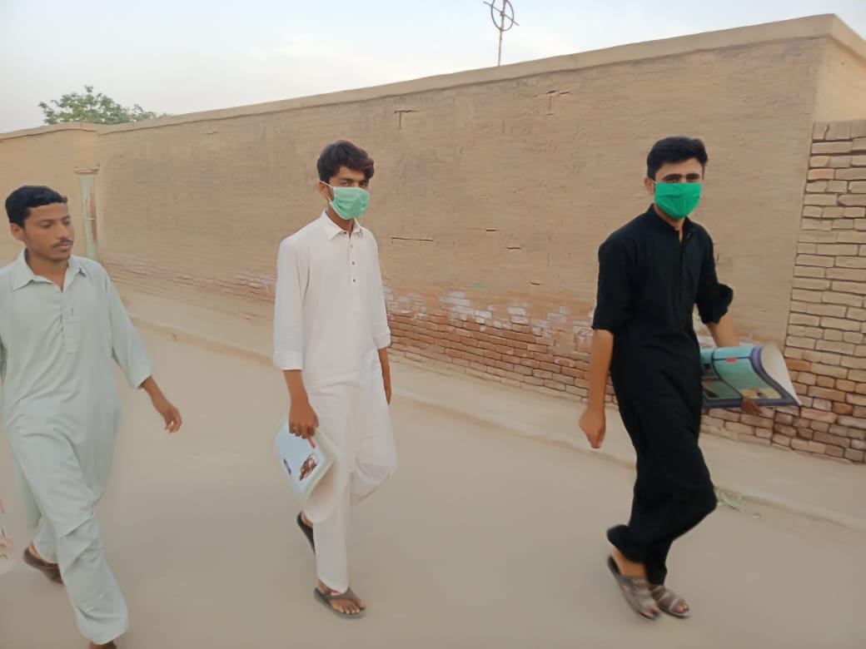
(GHULAM MUSTAFA)
As there are many poor people have been stuck in their houses due to this virus and lock down has been applied for this so they are consuming there are running shot of food and other eatables. That’s why we got some grocery things and packed it to give poor people.

Awareness about the COVID-19
Due to the COVID-19 I aware the people of my village .How we can save from these fatal disease.
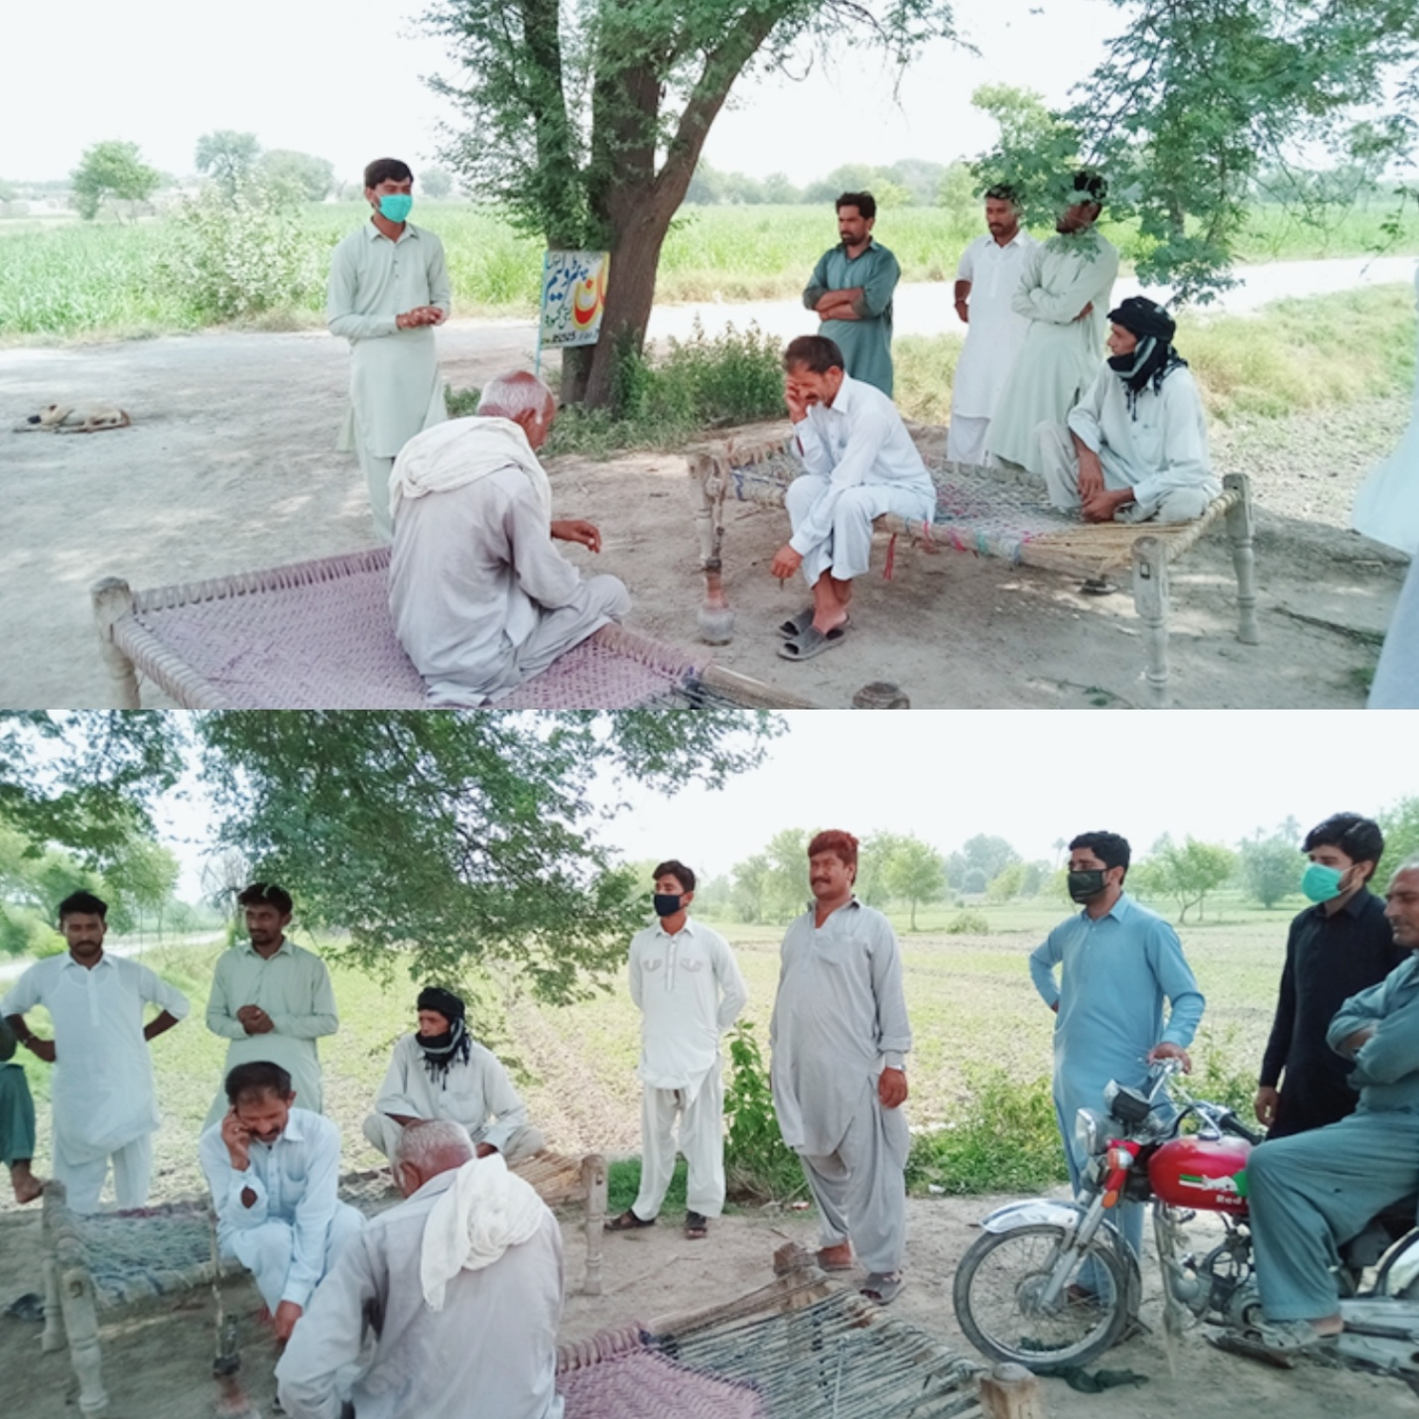
(SANA ULLAH)
Help the Needy People
I went to my village and met the widows and help them financially…………….

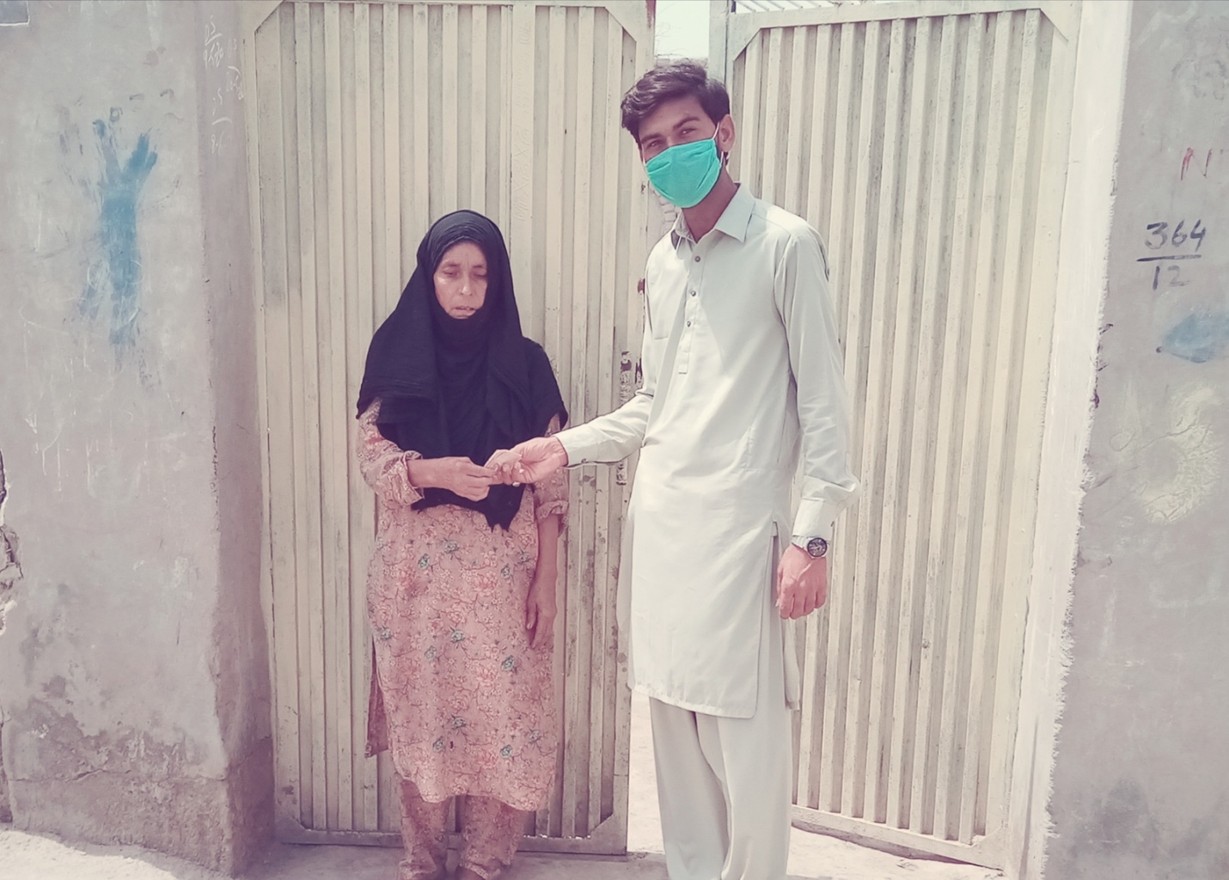
(SANA ULLAH)

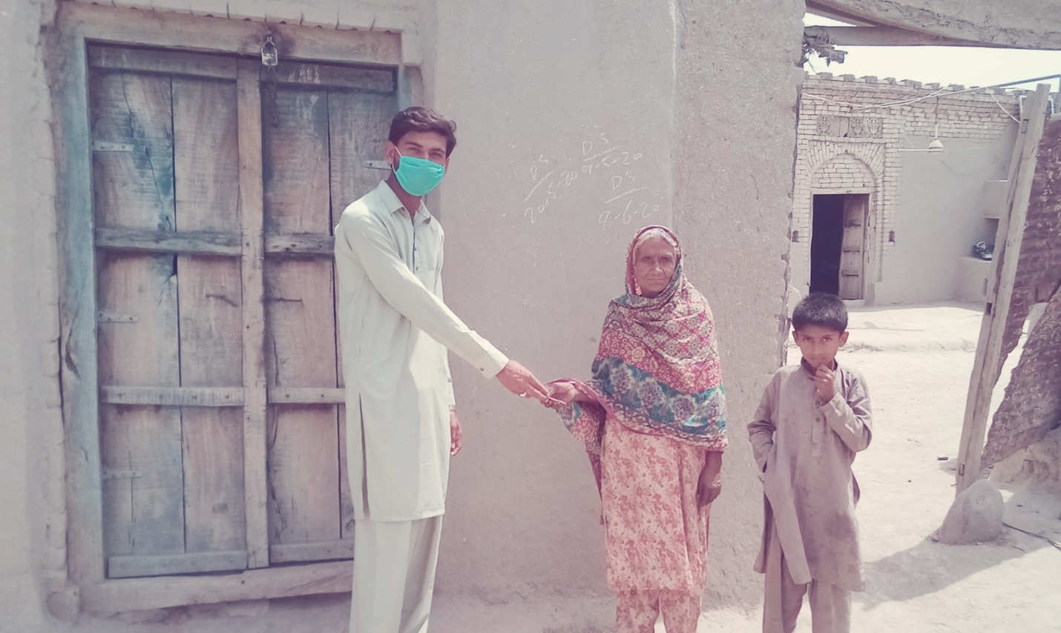
(SANA ULLAH)

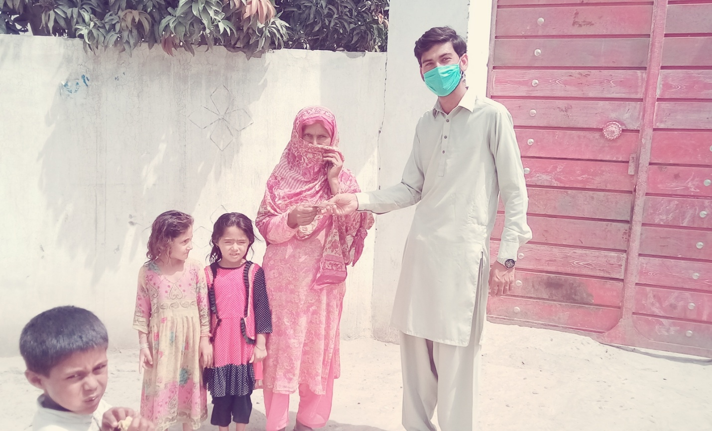

(SANA ULLAH)

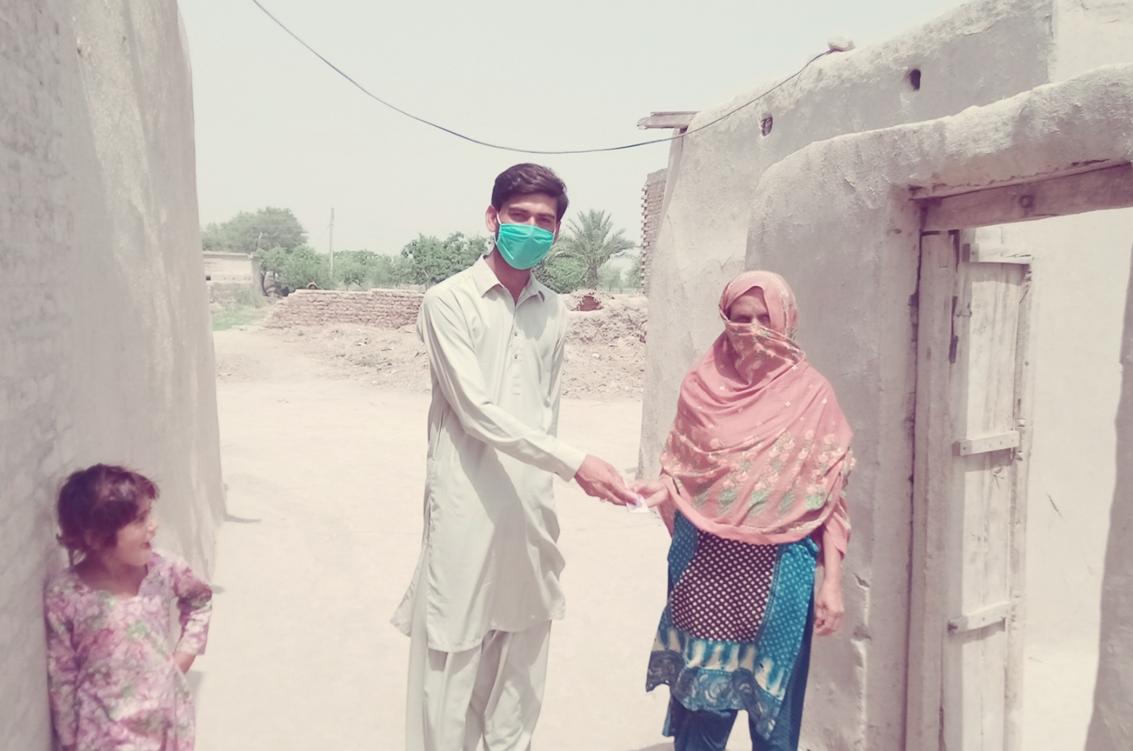

(SANA ULLAH)

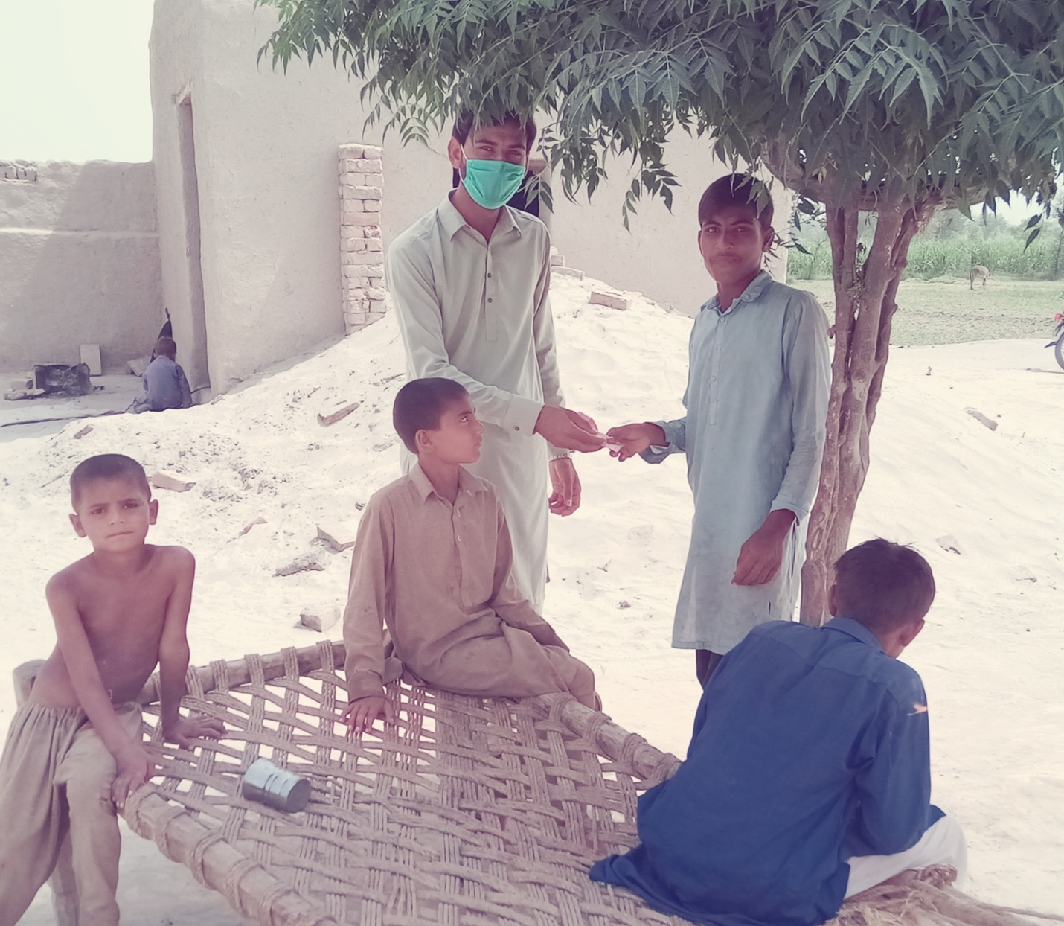

(SANA ULLAH)

SYED MUHAMMAD MHEDI SHAH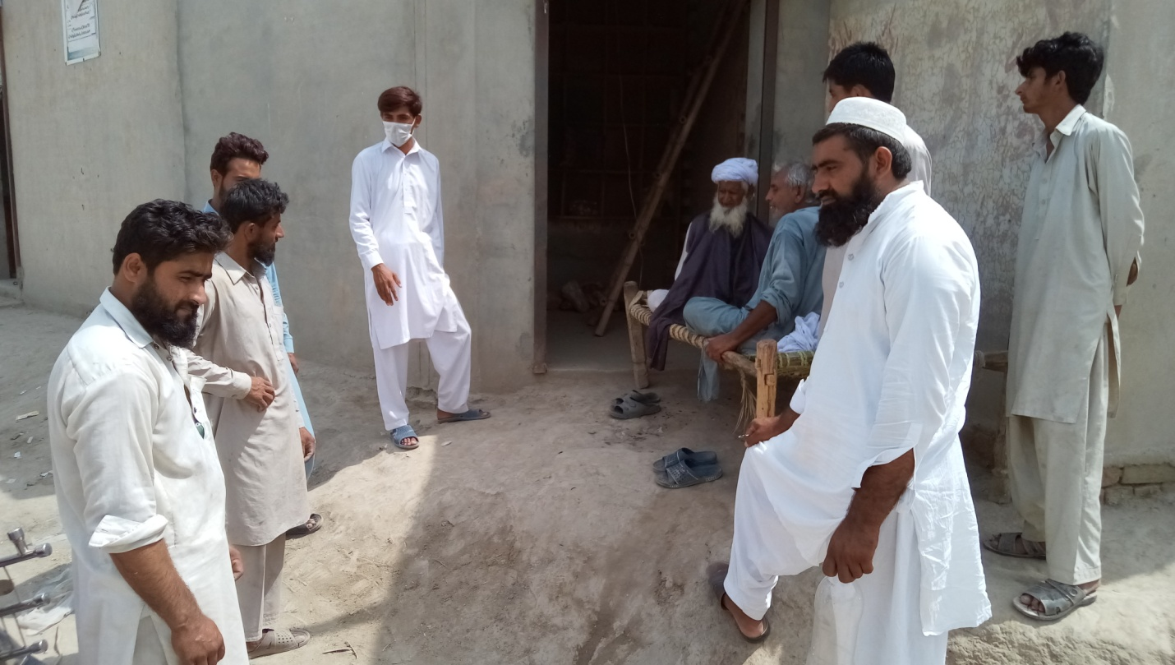
SYED MUHAMMAD MHEDI

