Communication models
Communication is a complex process, and it is difficult to determine where or with whom a communication encounter starts and ends. It can sometimes be helpful to consider different communication models.
Models of communication simplify the process by providing a visual representation of the various aspects of a communication encounter. Some models explain communication in more detail than others, but even the most complex model still doesn’t recreate what we experience in even a moment of a communication encounter. Models still serve a valuable purpose for students of communication because they allow us to see specific concepts and steps within the process of communication, define communication, and apply communication concepts. When you become aware of how communication functions, you can think more deliberately through your communication encounters, which can help you better prepare for future communication and learn from your previous communication. The three models of communication we will discuss are the transmission, interaction, and transaction models.
Although these models of communication differ, they contain some common elements. The first two models we will discuss, the transmission model and the interaction model, include the following parts: participants, messages, encoding, decoding, and channels. In communication models, the participants are the senders and/or receivers of messages in a communication encounter. The message is the verbal or nonverbal content being conveyed from sender to receiver. For example, when you say “Hello!” to your friend, you are sending a message of greeting that will be received by your friend.
The internal cognitive process that allows participants to send, receive, and understand messages is the encoding and decoding process. Encoding is the process of turning thoughts into communication. As we will learn later, the level of conscious thought that goes into encoding messages varies. Decoding is the process of turning communication into thoughts. For example, you may realize you’re hungry and encode the following message to send to your roommate: “I’m hungry. Do you want to get pizza tonight?” As your roommate receives the message, they decode your communication and turn it back into thoughts in order to make meaning out of it. Of course, we don’t just communicate verbally—we have various options, or channels for communication. Encoded messages are sent through a channel, or a sensory route on which a message travels, to the receiver for decoding. While communication can be sent and received using any sensory route (sight, smell, touch, taste, or sound), most communication occurs through visual (sight) and/or auditory (sound) channels. If your roommate has headphones on and is engrossed in a video game, you may need to get their attention by waving your hands before you can ask them about dinner.

Linear model of communication
The linear or transmission model of communication, one-way process in which a sender intentionally transmits a message to a receiver (Ellis & McClintock, 1990). This model focuses on the sender and message within a communication encounter. Although the receiver is included in the model, this role is viewed as more of a target or end point rather than part of an ongoing process. We are left to presume that the receiver either successfully receives and understands the message or does not. The scholars who designed this model extended on a linear model proposed by Aristotle centuries before that included a speaker, message, and hearer. They were also influenced by the advent and spread of new communication technologies of the time such as telegraphy and radio, and you can probably see these technical influences within the model (Shannon & Weaver, 1949). Think of how a radio message is sent from a person in the radio studio to you listening in your car. The sender is the radio announcer who encodes a verbal message that is transmitted by a radio tower through electromagnetic waves (the channel) and eventually reaches your (the receiver’s) ears via an antenna and speakers in order to be decoded. The radio announcer doesn’t really know if you receive their message or not, but if the equipment is working and the channel is free of static, then there is a good chance that the message was successfully received.
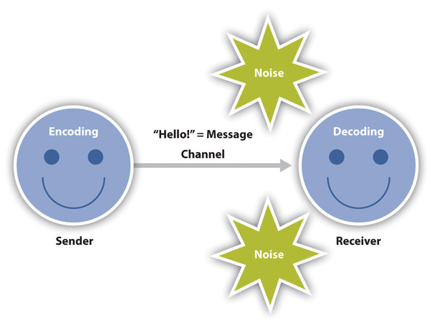
The linear model of communication
Although the transmission model may seem simple or even underdeveloped to us today, the creation of this model allowed scholars to examine the communication process in new ways, which eventually led to more complex models and theories of communication.

Interactive model of communication
The interactive or interaction model of communication, a process in which participants alternate positions as sender and receiver and generate meaning by sending messages and receiving feedback within physical and psychological contexts (Schramm, 1997). Rather than illustrating communication as a linear, one-way process, the interactive model incorporates feedback, which makes communication a more interactive, two-way process. Feedback includes messages sent in response to other messages. For example, your instructor may respond to a point you raise during class discussion or you may point to the sofa when your roommate asks you where the remote control is. The inclusion of a feedback loop also leads to a more complex understanding of the roles of participants in a communication encounter. Rather than having one sender, one message, and one receiver, this model has two sender-receivers who exchange messages. Each participant alternates roles as sender and receiver in order to keep a communication encounter going. Although this seems like a perceptible and deliberate process, we alternate between the roles of sender and receiver very quickly and often without conscious thought.
The interactive model is also less message focused and more interaction focused. While the linear model focused on how a message was transmitted and whether or not it was received, the interactive model is more concerned with the communication process itself. In fact, this model acknowledges that there are so many messages being sent at one time that many of them may not even be received. Some messages are also unintentionally sent. Therefore, communication isn’t judged effective or ineffective in this model based on whether or not a single message was successfully transmitted and received.
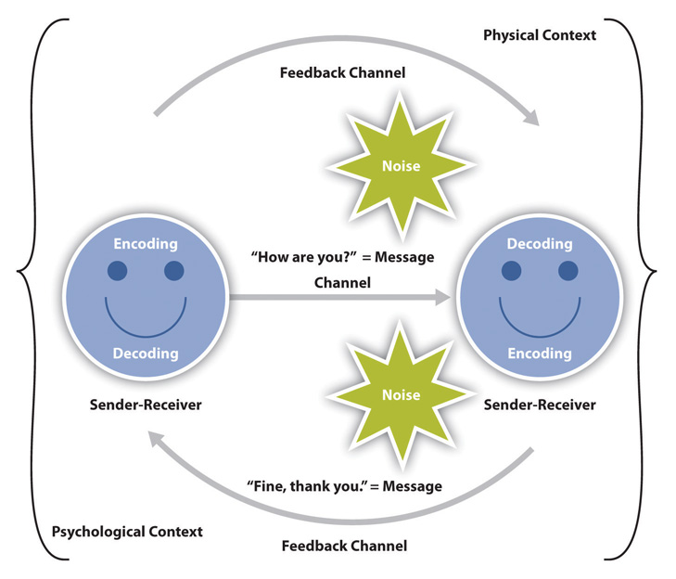
The interactive model of communication
The interactive model takes physical and psychological context into account. Physical context includes the environmental factors in a communication encounter. The size, layout, temperature, and lighting of a space influence our communication. Imagine the different physical contexts in which job interviews take place and how that may affect your communication. I have had job interviews over the phone, crowded around a table with eight interviewers, and sitting with few people around an extra large conference table. I’ve also been walked around an office to unexpectedly interview one-on-one, in succession, with multiple members of a search committee over a period of three hours. Whether it’s the size of the room or other environmental factors, it’s important to consider the role that physical context plays in our communication. Psychological context includes the mental and emotional factors in a communication encounter. Stress, anxiety, and emotions are just some examples of psychological influences that can affect our communication. Seemingly positive psychological states, like experiencing the emotion of love, can also affect communication. Feedback and context help make the interaction model a more useful illustration of the communication process, but the transaction model views communication as a powerful tool that shapes our realities beyond individual communication encounte

Transaction model of communication
As the study of communication progressed, models expanded to account for more of the communication process. Many scholars view communication as more than a process that is used to carry on conversations and convey meaning. We don’t send messages like computers, and we don’t neatly alternate between the roles of sender and receiver as an interaction unfolds. We also can’t consciously decide to stop communicating because communication is more than sending and receiving messages. The transaction model differs from the transmission and interaction models in significant ways, including the conceptualization of communication, the role of sender and receiver, and the role of context (Barnlund, 1970).
The transaction model of communication describes communication as a process in which communicators generate social realities within social, relational, and cultural contexts. In this model, we don’t just communicate to exchange messages; we communicate to create relationships, form intercultural alliances, shape our self-concepts, and engage with others in dialogue to create communities.
The roles of sender and receiver in the transaction model of communication differ significantly from the other models. Instead of labeling participants as senders and receivers, the people in a communication encounter are referred to as communicators. Unlike the interactive model, which suggests that participants alternate positions as sender and receiver, the transaction model suggests that we are simultaneously senders and receivers. This is an important addition to the model because it allows us to understand how we are able to adapt our communication for example, a verbal message in the middle of sending it based on the communication we are simultaneously receiving from our communication partner.
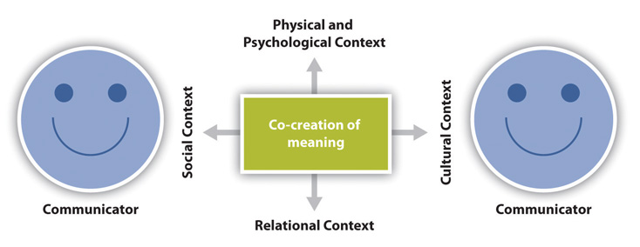
The transaction model of communication
The transaction model also includes a more complex understanding of context. The interaction model portrays context as physical and psychological influences that enhance or impede communication. While these contexts are important, they focus on message transmission and reception. Since the transaction model of communication views communication as a force that shapes our realities before and after specific interactions occur, it must account for contextual influences outside of a single interaction. To do this, the transaction model considers how social, relational, and cultural contexts frame and influence our communication encounters.
Social context refers to the stated rules or unstated norms that guide communication. Norms are social conventions that we pick up on through observation, practice, and trial and error. We may not even know we are breaking a social norm until we notice people looking at us strangely or someone corrects or teases us. Relational context includes the previous interpersonal history and type of relationship we have with a person. We communicate differently with someone we just met versus someone we’ve known for a long time. Initial interactions with people tend to be more highly scripted and governed by established norms and rules, but when we have an established relational context, we may be able to bend or break social norms and rules more easily. Cultural context includes various aspects of identities such as race, gender, nationality, ethnicity, sexual orientation, class, and ability. We all have multiple cultural identities that influence our communication. Some people, especially those with identities that have been historically marginalized, are regularly aware of how their cultural identities influence their communication and influence how others communicate with them. Conversely, people with identities that are dominant or in the majority may rarely, if ever, think about the role their cultural identities play in their communication. Cultural context is influenced by numerous aspects of our identities and is not limited to race or ethnicity.
Aristotle Model of Communication
It was Aristotle who first proposed and wrote about a unique model of communication. Today, his model is referred to as the Aristotle Model of Communication. The great philosopher Aristotle already created this linear model before 300 BC, placing more emphasis on public speaking than on interpersonal communication. The simple model is presented in a diagram and is still widely used in preparing seminars, lectures and speeches to this day.
Aristotle Model of Communication is formed with 3 basic elements
- Speaker, (ii) Speech, (iii) Audience
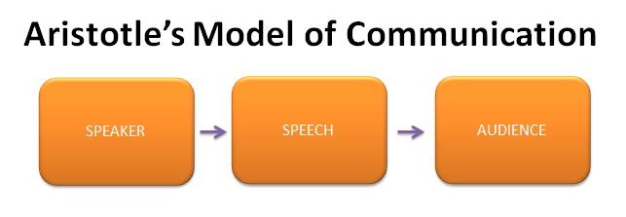

The Aristotle Model of Communication can roughly be divided into five elements. The speaker is the most important element, making this model a speaker-oriented model. It is the speaker’s task to give a speech to the public. The role of the audience is passive. This makes the Aristotle Model of Communication a one-way model, from speaker to receiver.

The Role of the Speaker
According to the Aristotle Model of Communication, the speaker is the main figure in communication. This person is fully responsible for all communication. In this model of communication, it is important that the speaker selects his words carefully. He must analyse his audience and prepare his speech accordingly. At the same time, he should assume the right body language, as well as ensuring proper eye contact and voice modulations. In order to entice the audience, blank expressions, confused looks, and monotonous speech must be avoided at all times. The audience must believe in the speaker’s ability to easily put his money where his mouth is.
An example. A politician (the speaker) gives a speech on a market square during an election campaign (the occasion). His goal is the win the votes of the citizens (the audience) present as well as those of the citizens potentially watching the speech on TV. The people will vote (the effect) for the politician if they believe in his views. At the same time, the way in which he presents his story is crucial in convincing his audience.
The politician talks about his party’s standpoints and will probably be familiar with his audience. In other situations, it would be more suitable to actively research the audience in advance and determine their potential viewpoints or opinions.
David Berlo Model of Communication (1960)
Another famous communication model is Berlo's model. In this model, he stresses on the relationship between the person sending the message and the receiver. According to this model, for the message to be properly encoded and decoded, the communication skills of both the source and the receiver should be good. The communication will be at its best only if the two are skilled. Berlo's SMCR model has four main components and each component has its own sub components
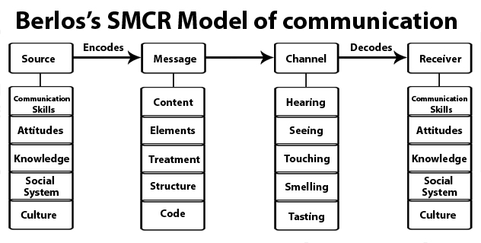
Berlo’s model follows the SMCR model. This model is not specific to any particular communication.
Berlo’s model includes a number of factors under each of the elements:
Source: The source is situated where the message originates.
Communication skills – It is the skill of the individual to communicate. For example, the ability to read, write, speak, listen etc.
Attitudes – This includes attitudes towards the audience, subject and towards oneself. For example, for the student, the attitude is to learn more and for teachers, it is to help teach.
Knowledge– Communicating also means that the person needs to be knowledgeable about the subject or topic. For e.g. a teacher needs to know about the subject in detail that he or she teaches so that they can communicate properly such that the students understand here.
Note: It refers, not to the general knowledge, but to the knowledge of the subject that the person is communicating and their familiarity with it.
Social system – The social system includes the various aspects of society like values, beliefs, culture, religion and a general understanding of society. It is where the communication takes place.
For example, classrooms differ from country to country just like people’s behaviours and how they communicate, etc.
Note: We can communicate only to the extent that the social system allows. When we communicate, we take the social system into account.
Culture: Culture of a particular society also comes under the social system.
According to this model, people can communicate only if the above requirements are met in the proper or adequate proportion.
Encoder: The sender of the message, from where the message originates, is referred to as the encoder. So the source encodes the message here.
Message
Content – The body of a message, from the beginning to the end, comprises its content. For example, whatever the class teacher teaches in the class, from beginning to end, is the content of the message.
Elements – It includes various things like language, gestures, body language, etc. They constitute all the elements of a particular message. Any content is accompanied by some elements.
Treatment – It refers to the packing of the message and the way in which the message is conveyed or the way in which it is passed on or delivered.
Note: When there is too much treatment, communication will not go smoothly.
Structure– The structure of the message refers to how it is arranged; the way people structure the message into various parts.
Note: Message is the same, but if the structure is not properly arranged then the receiver will not understand the message.
Code– The code of the message refers to the means through which it is sent and in what form. It could be, for example, language, body language, gestures, music, etc. Even culture is a code. Through this, people give and receive messages and communication takes place.
Note: Only when the code is clear, the message will be clear. The wrong usage may lead to misinterpretation.
Channel– It refers to the five sense organs. The following are the five senses:
- Hearing
- Seeing
- Touching
- Smelling
- Tasting
Communication occurs through one or more of these channels.
Hearing: The use of ears to receive the message. For example, orally transmitted messages, interpersonal communication etc.
Seeing: Visual channels, for example, Watching television so the message is conveyed through the scene/film.
Touching: The sense of touch can be used as a channel to communicate. For example, we touch, buy food, hugging our loved ones,etc.
Smelling: Smell also can be a channel to communicate. For example, perfumes, food, fragrances etc. Charred smell communicates something is burning. People can deduct which food is being cooked by its smell etc.
Tasting : The tongue is a muscular organ used in the act of eat and taste food. For example, while a food is being shared, the communication can happen regarding its taste.
Note: Despite not mentioning a medium, we need to assume that as communication is taking place, channels can be any of the 5 senses or combination.
Decoder : The person who receives the message and decodes it is referred to a decoder.
Receiver: The receiver needs to think all the contents and elements of the source, so as to communicate/responds to sender effectively.;
Berlo’s model believes that for effective communication to take place, the source and the receiver need to be on the same level. Only then communication will happen or take place properly. Hence, the source and the receiver should be similar.
For example, if the communication skill of the source is good, then the receiver should have equally good listening skills.
It cannot be said that the receiver does not receive the whole message because even though he may receive it, but may not be able to interpret its meaning. For effective communication, the source and the receiver need to be on the same level.
Note: Self-image differs from person to person. For communication, the person should consider the receiver, speak accordingly and give them what they need.
Criticism of Berlo’s SMCR model of communication:
- There is a lack of feedback. The effects are practically unknown.
- It does not mention the barriers to communication.
- There is no room for noise.
- It is a rather complex model.
- It is a linear model of communication.
- It requires people to be on the same level for effective communication to happen. However, that rarely happens in everyday life.
- The main drawback of the model is that it omits the usage of sixth sense as a channel of communication, which is an asset to human beings (thinking, understanding, analyzing etc.)

Lasswell Communication Model?
American sociologist and psychologist, Harold Lasswell is best known for his linear model of communication that he developed in 1948. The Lasswell model of communication (also known as Lasswell’s communication model) describes who is saying something, which channel is used to convey the messages, who the message is aimed at and what effect the message has. Communication sciences and public relations still often use this model, making this a classic sender receiver model.
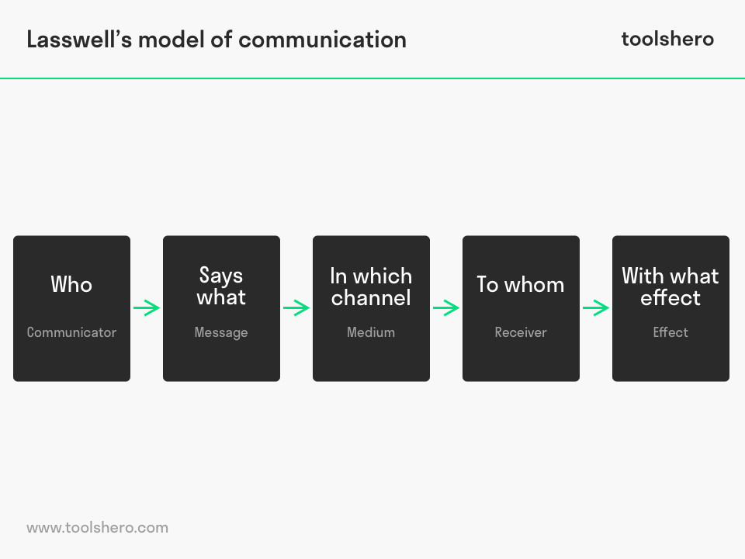

Lasswell Communication Model : five components
The Lasswell Communication Model describes verbal communication and consists of five elements. Who says What, in Which channel, to Whom, with What effect? This model is also called a ‘linear model of communication’, ‘uni-directional process’ or ‘action model, because it describes a one-way process within communication. It is seen as one of the most influential communication models. The model consists of five components, that are used as an analysis tool for evaluating the entire communication process. The previous ‘W’ questions are the basis for these components. The answers to these questions provide insight into the communication between people.
The Lasswell Communication Model consists of the basic questions below, aimed at a component and the gaining of an analysis:

Who?
Component: This is the communicator, also called the sender, who formulates and spreads a message. The sender can also be an intermediary.
Analysis: This is about a management and audit analysis, that helps the sender to have the power to communicate.

What?
Component: This is the content of the message or the message that the sender spreads.
Analysis: The content analysis is related to the aim of the message and/or the secondary intent.

Which channel?
Component: The channel describes the medium or media that is/are used to convey and spread the message. The medium can consist of several communication tools, mass media and social media.
Analysis: The media analysis shows which medium is best used to convey a message to the receivers as effectively as possible.

To whom?
Component: This describes the receiver(s), such as a target group or an individual. With mass communication, there’s an audience.
Analysis: The target analysis shows who the message is meant for and how they are best reached and/or influenced.

Which effect?
Component: The effect is the result the message leads to. The so-called triangle of success ‘knowledge, attitude, behaviour’ is often used to describe the desired effect.
Analysis: The effect analysis will need to be started beforehand, so the messages can be aimed at and fitted to the target audience.

A Lasswell Communication Model example
Communication can be understood as more than Lasswell’s linear communication model. The model can work really well when providing communication advice for organisations, by answering all five questions. This way, a communications advisor or marketer more easily gets an idea in advance about which concrete campaign should be carried out. Such a campaign plan states which message is sent via which channels and to which specific target audience in order to reach the desired effect and keep the lines of communication open between the organisation and its target groups. This is illustrated by the practical example below:
Imagine a large perfume chain that wants to reach a younger audience aged between 15 and 25 years old. Up until now, their customer base has been women between 25 and approximately 55 years old. Research has shown that especially young girls and women are also interested in make-up and perfume, but that they prefer not to visit shops, but rather prefer to look for products online.
For the perfume chain, this is a new challenge that Lasswell’s communication model can help them with. The five components of the Laswell Communication Model are used and each corresponding question is answered. In doing so, advice is formed and can be used to develop the campaign:

1. Who is communicating?
The perfume chain themselves. They want to present themselves as a modern company that also offers products online.

2. What needs to be communicated?
The perfume chain has opened an online shop and is now active on social media. The online shop offers a wide range of make-up and perfumes from well-known brands and orders are delivered within 24 hours. The language use will be hip and short and in the 2nd person singular (you), to make a connection and make the young target group feel involved.

3. Which channel is going to be used?
Other than large billboards advertising the opening of the online shop, there will also be investment in Facebook advertising as well as other social media, such as Twitter and Instagram.

4. Who is the message intended for?
These are girls and women between 15 and 25 years old who don’t go to perfume shops, but often order things online.

5. What effect does the campaign need to have?
The goal is for the target group to subscribe to the newsletter via Facebook or the website, so they will receive weekly offers and more quickly decide to order via the Internet.
- Lasswell Communication Model = Mass communication
The Lasswell Communication Model was primarily deigned to analyse mass communication. However, it is also applied to interpersonal and group communication; as is also clear from the previous example.
When Lasswell developed the model in 1948, it was meant to study media propaganda from countries and businesses. In that time, only the rich could use mass media like television and radio.
Newspapers were not read by everyone, simply because subscriptions were too expensive. It was from this perspective that Lasswell came up with the concept of effective mass communication; the relationship between the presentation of the message and how this generates different effects. The effect of a message can also be seen as feedback.
Despite the fact that the model was specifically designed for mass communication, it can nowadays also be applied to different media and new fields, such as the Internet.
De Fleur’s Model of Communication
De Fleur’s Model of Communication consists of a two way communication process where the receiver becomes the sender by providing feedback and by receiving the feedback, the sender becomes the receiver.
The model is named after American scholar Melvin Lawrence DeFleur. He was a professor of communications and social psychology with a PhD in Social Psychology.
This model is an expansion of Shannon and Weaver model of communication, which describes a one way communication with feedback mechanism.
It is also based on the Westley and Maclean model of communication which proposed a circular process of communication and feedback. Basically, De Fleur model is the combination of these two models.
So, we suggest you make yourself familiar with the two models first before diving into De Fleur model of communication.
Concept of De Fleur Model
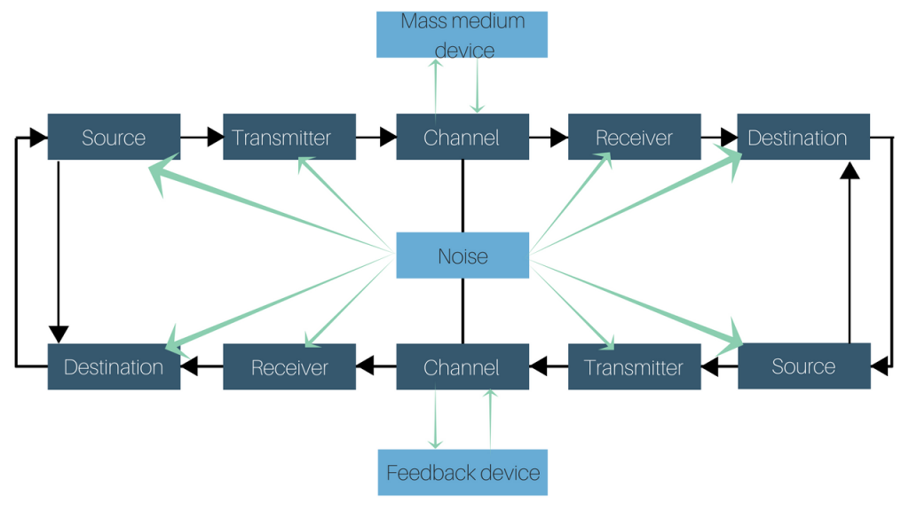
De Fleur model of communication describes of a mass media device in the communication process, which is circular in nature and is the first one to constitute a two way feedback process.
As any other model, the communication originates at a source. Then it is sent to a transmitter that operates signal, after which a channel transfers it to a receiver. Once the message reaches its destination, the receiver sends feedback. The feedback allows the sender to determine if proper communication has taken place.
Here, the receiver assumes the role of a sender by sending feedback while the sender becomes receiver by receiving feedback. Noise can occur at any stage in this model.
A feedback device is an important characteristic of this model. The feedback is given by a target audience, which is different from receivers, whether the message has been received or not.
De Fleur model Example
Let’s assume a brand wants to advertise its product to its audience. An advertisement is filmed and transmitted by a mass media device (television, internet etc.).
The message reaches the target audience through a receiver (television set, phone etc.). The target audience then provides the feedback through a different medium like social media or email.
The feedback from the target audience lets the brand know if their product is a success or not.
For instance, in January 2018, Swedish retail giant H&M circulated an online advertisement featuring a black boy wearing a sweatshirt that read, “Coolest monkey in the jungle.” The racial undertones of the ad ignited a widespread backlash on Twitter. After receiving an overwhelming negative feedback, H&M announced that the sweatshirt had been removed from their line of products.

Westley and MacLean’s Conceptual Model
Westley and MacLean’s model explains the difference between interpersonal and mass communication as feedback. Feedback can be direct in interpersonal communication whereas indirect in mass communication. According to this model, communication starts from the environment and not when the message is spoken or shown.
Westley and MacLean’s Model of Communication
Westley and MacLean’s Model of Communication was suggested by Bruce Westley (1915-1990) and Malcolm S. MacLean Jr. (1913-2001) in 1957. This model was an adaptation from Newcomb’s model of communication, which talked about co-orientation for simultaneous orientation in a two way communication. It also consisted of some concepts from Lewin’s model.
Unlike Dance’s Helical Model of Communication, the model says that communication does not begin when one person starts speaking, but it does when a person responds to something from his/her surroundings. The person must first receive message from the environment and then, he/she responds according to his/her object of orientation.
The Westley and MacLean’s model can be applied in two contexts: interpersonal and mass communication, the point of difference being the feedback. Feedback is direct and fast in interpersonal communication and indirect and slow in mass communication. The model also differentiates message as purposive and non-purposive.
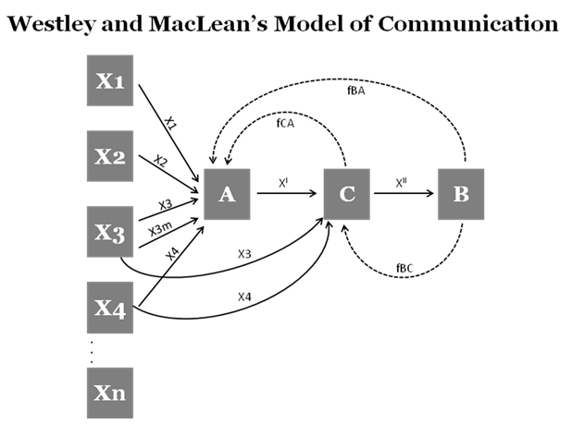

Components of Westley and MacLean’s Model of Communication
The major components in the communication process for the model are
• Source (A) – Source is the message creator and sender.
• Environment (X) – Environment is the physical and psychological situation where the message is being created and sent.
• Sensory experience (X1…) – Sensory experience is the first thing that the source sees by which the source gets the idea for the formation of the message.
• Objects of Orientation (X1, X2,…) – Objects of orientation is the person’s social and cultural reality that has formed from his/her past experiences and teachings.
• Message Interpretation or Coding (X’) – Message is interpreted with the objects of orientation of the receiver of the message.
• Receiver (B) – The person who gets the message sent by the source and the person who interprets according to his/her objects of orientation.
• Object of Orientation of Receiver (X, b) – The views and ideas of the receiver or his/her social reality is his/her object of orientation. That is how the receiver interprets the message.
• Feedback (f) – The receiver forms another message after interpreting the message and sends it back to the sender. It is known as feedback.
• Gatekeeper (C) – Gatekeepers are found in mass communication. The gatekeeper is the editor who filters the message as per the needs of the audience and media institution.
• Opinion Leader – Opinion leaders are well known and recognized people who can influence public opinions.
Concepts of Westley and MacLean’s Model of Communication
The process of communication in Westley and MacLean’s model of communication starts when the source creates a message from his/her environment. The communicator acts and creates the message as a response to the sensory experience with his/her own objects of orientation. Then, the response is coded after interpreting the environmental response. The coded message is transmitted to a second respondent who interprets the message differently according to his/her objects of orientation and provide feedback to the sender.
Gatekeeper and opinion leader are the parts of communication process in mass communication. They are the editors, proofreaders, etc. who choose which message should be published and what effect will it have on the audience. Filter of the message is dependent on many factors.
Gatekeeping is done in these levels:
1. Individual level: A person’s gender, sexual orientation, culture, likes, dislikes, etc.
2. Routine practice level: Pre-established set of rules and practices for a particular type of work to be done
3. Communication organizations: The policies of the organization that is publishing the work
4. Social institutions: The social systems by which the message is formed
5. Societies: Societal values and belief systems, rules and norms, etc.
Example of Westley and MacLean’s Model of Communication
A person ‘A’ is going to a meeting. Thunderstorms ‘X1’ and heavy rains ‘X2’ start. The roads ‘X3’ are all blocked. ‘A’ will have to convey the message to the people who are conducting the meeting that he/she will not be reaching on time. ‘A’ can inform all others through phone.
Here, the message is conceived from the environmental message through the person’s sensory experience. The object of orientation of the person makes him call others because he thinks that reaching late is impolite. Sender ‘A’ creates the message as a courteous request.
The message is coded in a language form and is sent to the receiver ‘B’. ‘B’ interprets according to his/her own object of orientation like the receiver can still find reaching late to a meeting rude. The feedback is given accordingly.
Similarly, in mass communication, ‘A’ sends a message to ‘C’ who is the editor. ‘C’ acts as a gatekeeper and publishes the news after proper editing. There might be readers’ ‘B’ replies to which are in the form of letters or directly face to face. The process of letter reaching the writer takes a long time whereas direct review reaches fast.
In a website, there are many writers. They write and send the articles to get them published. But the editor chooses the articles that are relevant. The comment box is the place where the audience can give feedback.
Here,
1. X1 is any article
2. X2 is the audience comments
3. X3 is the website
4. f is feedback
5. A is writers
6. B is the audience
7. C is the gatekeeper or the editor
So,
• There is a feedback loop between Audience (B) and the Editor (C) after sending the article for publishing, which is known as “fBC”.
• There is a feedback loop between Editor (C) and Writer (A) giving response to the writers, which is known as “fCA”.
• There is another feedback loop between Audience (B) and the Writers (A) in the comments, which is known as “fBA”.
The message received from the environment can be accidental or abrupt, so might not be intentional. So, the signals can be received anytime and message is formed anytime.
Advantages of Westley and MacLean’s Model of Communication
• There is the concept of feedback.
• As the message comes from the environment, sensory field improves the message formation.
• Social and other factors are included in objects of orientation.
• The model can be applied to interpersonal, group communication as well as mass communication.
• The model is very descriptive.
Disadvantages of Westley and MacLean’s Model of Communication
• There are many variables even for simple communication which makes the model very complicated.
• The model is only two-dimensional and does not explain communication which involves multiple messages and complicated messages.
• The information can get modified while sending it from the sender to the receiver as there can be noise. The model does not account for noise in communication.

Barnlund’s Transactional Model of Communication
Dean Barnlund proposed a transactional model of communication in 1970 for basic interpersonal communication which articulates that sending and receiving of messages happens simultaneously between people which are popularly known as Barlund’s Transactional Model of Communication.
The model has been further adapted and reformed by other theorists as General Transactional Model. The model shifted from the trend of linear model to dynamic and two way communication model.
Concepts of Barnlund’s Transactional Model of Communication

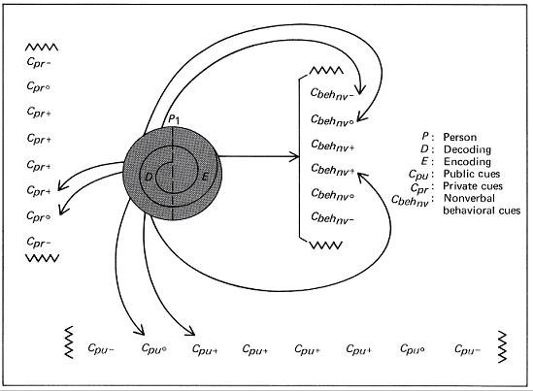

Barnlund’s Transactional Model is a multi-layered feedback system. This is a continuous process where sender and receiver interchange their places and both are equally important. The message passing takes place with a constant feedback being provided from both parties. A feedback for one is the message for the other.
Components of Barlund’s model
Cues refers to the signs for doing something. As per Barnlund there are: public cues, private cues and behavioral cues. In the model diagram shown above, spiral lines gives graphic representation to the assumptions like public cues and private cues.
• Public cues (Cpu) are physical, environmental or artificial and natural or man-made.
• Private cues (Cpr) are also known as private objects of orientation which include senses of a person. Both these cues can be verbal as well as non-verbal. Another set of cues are behavioral cues.
• Behavioral cues can be verbal (Cbehv) as well as non-verbal (Cbehnv).
The arrows and their directions show that the message is intentionally sent and actively taken where the receiver plays a key role of giving feedback. Arrows also show the process of production of technical encoding, interpretation and decoding.
The jagged lines show that the availability of cues can be unlimited and are denoted as VVVV.
The valence signs, +,0 and – are also attached to these types of cues which illustrates the amount/degree/strength of attractiveness of the cues in the message.
Speech act refers to particular instance of communication in the model.
Filters are the realities of people engaged in communication. Here the senders’ and receivers’ personal filters might differ according to cultures, traditions, content of the message, etc.
Noise is the problem that arises in communication flow and disturbs the message flow.
Advantages of Barnlund’s Transactional Model of Communication
• The model shows shared field experience of the sender and receiver.
• Transactional model talks about simultaneous message sending, noise and feedback.
• Barnlund’s model is taken by critics as the most systematic model of communication.
Disadvantages of Barnlund’s Transactional Model of Communication
• Barnlund’s model is very complex.
• Both the sender and receiver must understand the codes sent by the other. So they must each possess a similar “code book”. (The concept of code book is not mentioned in the model but understood.)
Newcomb’s Model of Communication
The New Comb’s model of communication was introduced by Theodore M Newcomb of the University of Michigan in 1953. He gives different approach to the communication process. The main purpose of this theory is to introduce the role of communication in a social relationship (society) and to maintain social equilibrium within the social system. He does not include the message as a separate entity in his diagram, implying it only by use of directional arrows. He concentrates on the social purpose of communication, showing all communication as a means of sustaining relationships between people. Sometimes it’s called as an “ABX” model of communication.
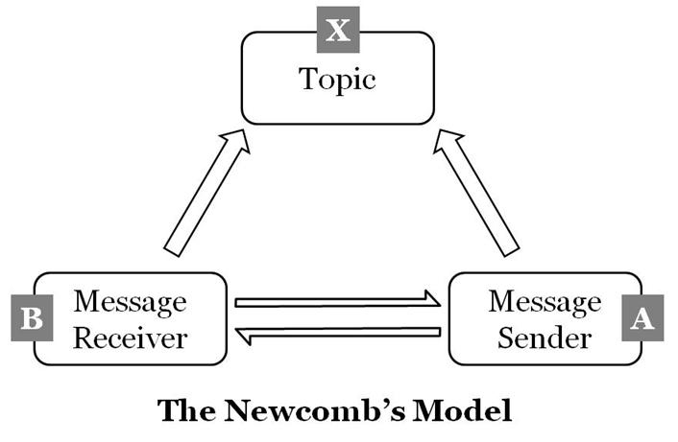

The Newcomb’s model works in a triangular format or A-B-X system
A – Sender
B – Receiver
X – Matter of Concern
The relationship between A and B is like student and teacher, government and public or newspaper and readers. Sender and Receiver may work in a same flow but the same time some factor like “X” may affect their flow of relationship. “X” it may be third persons, issue, topic or policy.
For Example:
Teachers introduce a new policy to increase the college timing from 6 hours to 8 hours.
A – Teachers B – Students X – Policy or issue
If both students and teachers are satisfied with this policy then the communication maintains its equilibrium status between them. Otherwise the flow of communication between “A” and “B” becomes trouble in the social system. If “A” or “B” is not ready to accept the policy then it will directly affect the social system and can’t maintain the equilibrium status. So Teachers “A” can convince students “B” as much as possible. Otherwise they have to make some adjustments in the Policy “X” and convince them towards the policy.

