LABORATORY EXPERIMENT ON THE FUNCTIONS OF THE COMPONENT OF A SIMPLE MICROSCOPE.

QUESTION: WHAT ARE THE FUNCTIONS OF THE COMPONENT OF A MICROSCOPE?

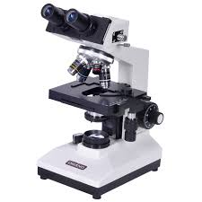

A SIMPLE MICROSCOPE.
The following are the parts of microscope:-
Eyepiece or ocular lens: Eyepiece is the lens, present at the top and is used to see the objects under study. Eyepiece lens contains a magnification of 10X or 15X.
Tube: Tube or the body tube, connects the eyepiece to the objective lenses.
Resolving nosepiece: It is also known as the Turret. Resolving nosepiece has holders for the different objective lenses. It allows the rotation of the lenses while viewing.
Objective lenses: Generally, three or four objective lenses are found on a microscope, with ranges of 10X, 40X, 100X powers. Lenses are colour coded, the shortest lens is of the lowest power, and the longest lens is high power lenses.
Diaphragm: Diaphragm helps in controlling the amount of light that is passing through the opening of the stage. It is helpful in the adjustment of the control of light that enters.
Coarse adjustment knob: Used for focus on scanning. Usually the low power lens is used enabling the movement of the tube.
Fine adjustment knob: Used for focus on oil. Moves the body tube for focusing the high power lens.
Arm: It supports the tube of the microscope and connects to the base of the microscope.
Stage: The platform that is flat used for placing the slides under observation.
Stage clip: Stage clips hold the slides in proper place.
Condensor: The main function of condenser lens is focusing the light on the specimen under observation. When very high powers of 400X are used, condenser lenses are very important. Presence of condenser lens gives a sharper image as compared to the microscope with no condenser lens.
Base: Provides basal support for the microscope.
Power switch: The main power switch that turns the illumination on or off.

