Table of contents

Sr.  No | Contents | Page No
1 | Introduction | 3
2 | Significance of plant community | 4
3 | Analytic characters | 4-16
4 | Synthetic characters | 17-18
5 | Conclusion | 19
6 | References | 20

Ecological characters of plant community 1: Introduction:

➢ Community:

Community is a grouping of animals and plant species living together in a specific area For example: grassland and forest.

➢ Plant community:

The group or association of plant growing together in a specific habitat is called plant community. A plant community consists of such species of plants which are ecologically related and can live and grow together in a particular area. A plant community is well organized .it has well developed composition and structure due to the continuous interaction between different plant species and their physical environment.

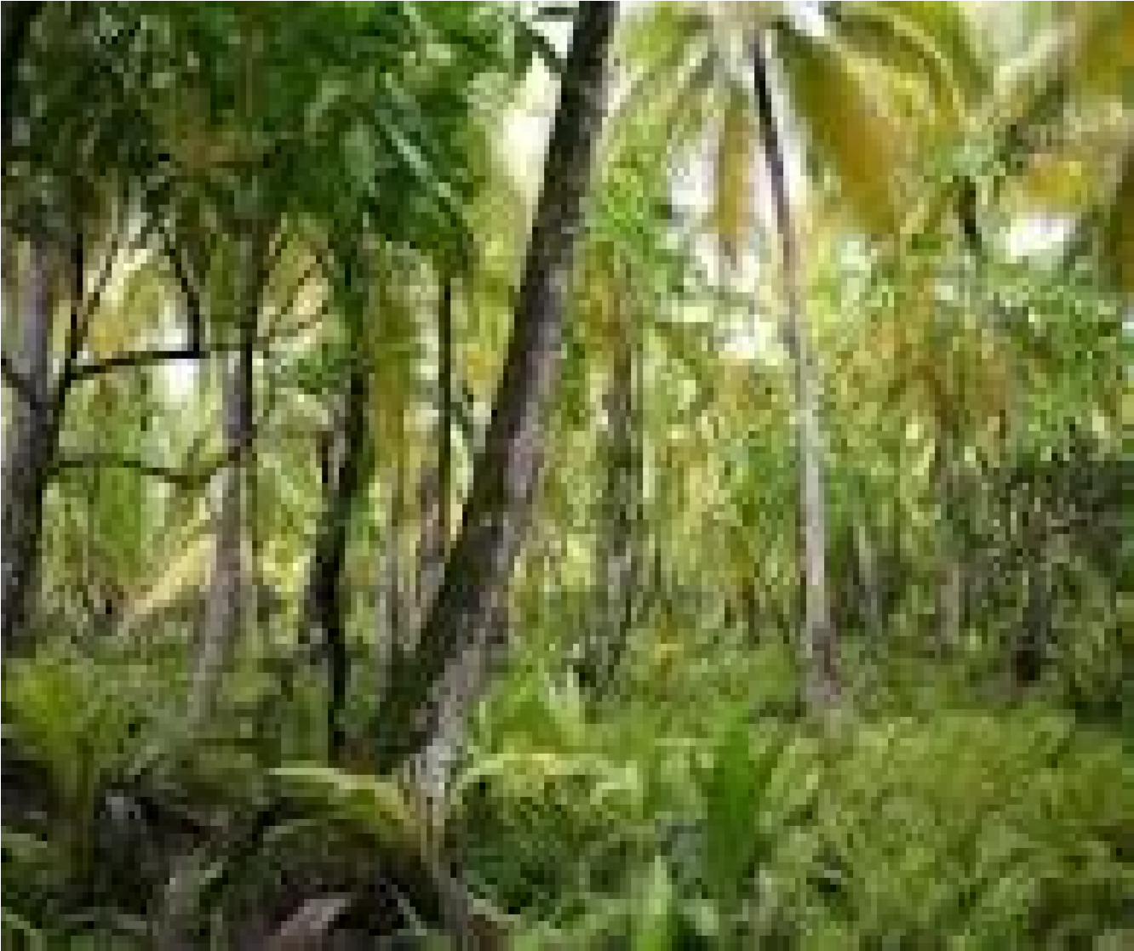

2: Significance of plant community:

The production of organic compound for herbivores in the bottom of the food web is an important ecological function of plants. Plants have played an important role in creating the oxygenated atmosphere of earth. Plants play very important role in the biosphere because these are primary producers in the biosphere and supply directly or indirectly food to all terrestrial and aquatic animals including man. Plants directly receive solar energy and use this energy to prepare their own food through the process of photosynthesis. This food or chemical energy is provided to different microorganisms and animals through different trophic levels of food chain.

The ecological characteristics of plant community are classified into two main groups:
- Analytic characteristics
- Synthetic characteristics

3: Analytic Characteristics:
These characteristics are directly observed or measured in sample schemes. Kinds and number of species, distribution of individuals, number of individuals, heights of plants are included in analytic characters.
Analytic characters are of 2 types: -
- Qualitative
- Quantitative

3.1 Qualitative: -

These are the characters which cannot be measured. They are shown only by qualitative method.

Qualitative characteristics: -
1) Physiognomy 2) Periodicity.
- Stratification.
- Sociability
- Vitality
- Life form (growth form)
- Phanerophytes
- Chamerophytes
- Hemicryptophytes
- Geophytes
- Therophytes

1)Physiognomy: -
Physiognomy is the apparent form of the plant community. Physiognomy may be described on the basis of dominance,density,colour and height of the plants. Grasslands and forests describe the physiognomy of various plant communities.

2) Periodicity: -
Periodicity is defined as the regular seasonal happening of many processes e.g. Seed shedding and the formation of leaves and flowers.

3) Stratification: -

The process of arrangement of plants of different species in different layers is known as stratification.

Kind of stratification: -

Following are the kinds of stratification:

- Vertical stratification
- Horizontal stratification

Vertical stratification: -
In vertical stratification, the plants of different species are arranged in vertical layering of a habitat according to the heights of plants. Vertical stratification happens due to the competition among various species of plant community to get sunlight because sunlight is necessary for the plants to prepare their own food through photosynthesis

Stratification in a terrestrial ecosystem:
Terrestrial ecosystem is classified into following different layers:
- Canopy
- Understory
- Shrub layer
- Herb or ground layer
.

Canopy:
Canopy refers to the upper layer formed by mature trees crowns. Canopy refers to the spread of the outer layer of leaves of an individual tree or group of trees.

Understory:
It is the underlying layer of vegetation. Only those plants survive that are shade tolerant.
Understory has more humidity than canopy. It consists of immature trees and small trees.

Shrub layer:
This layer consists of plants from 3 to about 15 feet in height. Shrubby vegetation and seedling trees are included in shrub layer.

Herb layer:
Herb layer contains herbaceous plants such as grasses, ferns etc. .

Forest floor layer:
This layer consists of decaying leaves, twigs and fallen trees.

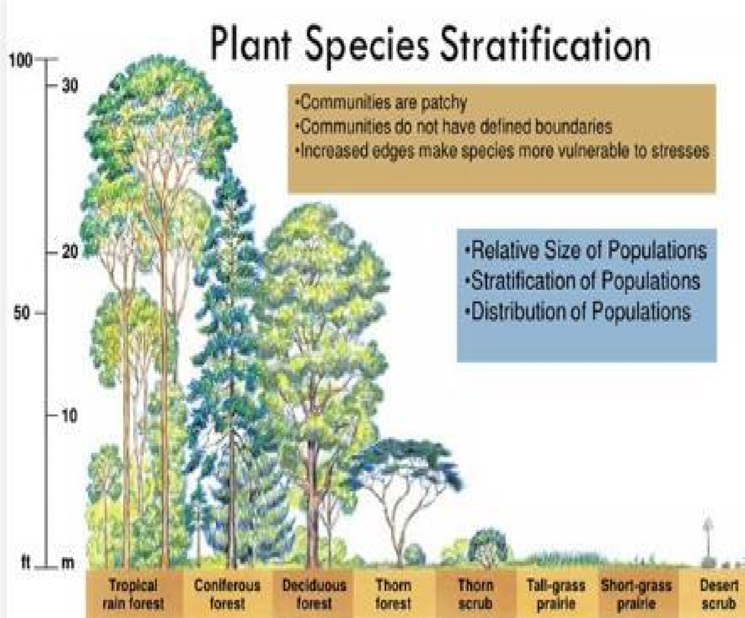

Horizontal stratification: -
In horizontal stratification individuals are distributed on a horizontal plane in a community
.

4) Sociability: -

Sociability expresses the relationship of plants to one another. It shows the degree of association between species.

Plants are classified into following five sociability groups:

- S1-plants grow singly, found separately from each other.
- S2-plants are present in small groups each group contains 4 to 6 plants.
- S3-plants growing in scattered patches and these patches are small.
- S4-plants growing in bigger groups at one place.
- S5-a large group covers larger area.

5)Vitality: -
It is the ability of species to grow and reproduce normally for successful survival. Vitality is determined by root length, stem height, leaf area, leaf number, number and weight of flowers, fruits and seeds.

6)Life form (growth form): -

A life form is the collection of the adaptation of the plant to climate.

Plants are classified into following 5 life form groups:

- Phanerophytes.
- Chamerophytes
- Hemicryptophytes
- Geophytes
- Therophytes

Phanerophytes:

There buds are covered with scales and are situated high upon the plants. Trees, shrubs and climbers are included in phanerophytes.

Chamerophytes:

In chamerophytes the buds are present close to the ground surface. Fallen leaves and snow covers give protection to the buds.
For example: trifolium reopens.

Hemicryptophytes:

Hemicryptophytes are mostly present in cold temperate zone. Their buds are found under soil surface. Their shoots die each year.

Example:

Biennial and perennial herbs

Geo phytes:

In these plants the buds are completely hidden in the soil. Hydrophytes and halophytes are included in this group.
Therophytes:
Dry hot or cold environment is suitable for therophytes.They have a specific single favorable season to complete their life cycle. In unfavorable period of year, they remain dormant in the form of seed.

3.2 Quantitative characters:

These characters can be measured. These are expressed in quantitative terms. Following are included in quantitative characters

- Frequency
- Density
- Cover and basal area
- Biomass
- Abundance
- Diversity
- Leaf area

Frequency:

It is the number of times a plant species presents in a given number of quadrats. Plot size has a great influence on frequency. Frequency is expressed in percentage.

Uses of frequency data:

- Frequency is used to compare plant communities.
- Changes in vegetation composition over time is deleted by frequency.
- Trend is measured by frequency
- Distribution of species in a community is described by frequency data.

Calculation of frequency:

Frequency %= number of sampling in which the species occurred ×100
Total number of sampling units' studies

Density:
The number of individuals of the species present in any unit area is known as its density. It shown the numerical strength of a species in the community. The idea of degree of competition is given by density.

Calculation of density:
Density =total number of individuals of the species in all the sampling unit /Total number of sampling units identified Basal area:
The proportion of the plant that extends into the soil is known as basal cover.
It is the average amount of an area covered by tree stems. Basal area is for a given tree the crosssectional area at 4.5 feet off the ground.
If we take an acre of trees and cut them all down at 4.5 feet and observe down from the top. The surface of all these tree stamps will represent the basal area. This 4.5foot level is known as breast height. The diameter of a tree at 4.5-foot level is known as diameter at breast height or DBH.
The basal area of one tree can also be calculated by using the formula:
BA=0.005454* DBH^ 2
e.g. if a tree has DBH of 6 inches then its basal area is calculated as follows:
BA=0.005454*6^2
Basal area of a forest can be calculated by adding the basal areas of all the trees in an area and then divide by the area of land in which the trees were present.
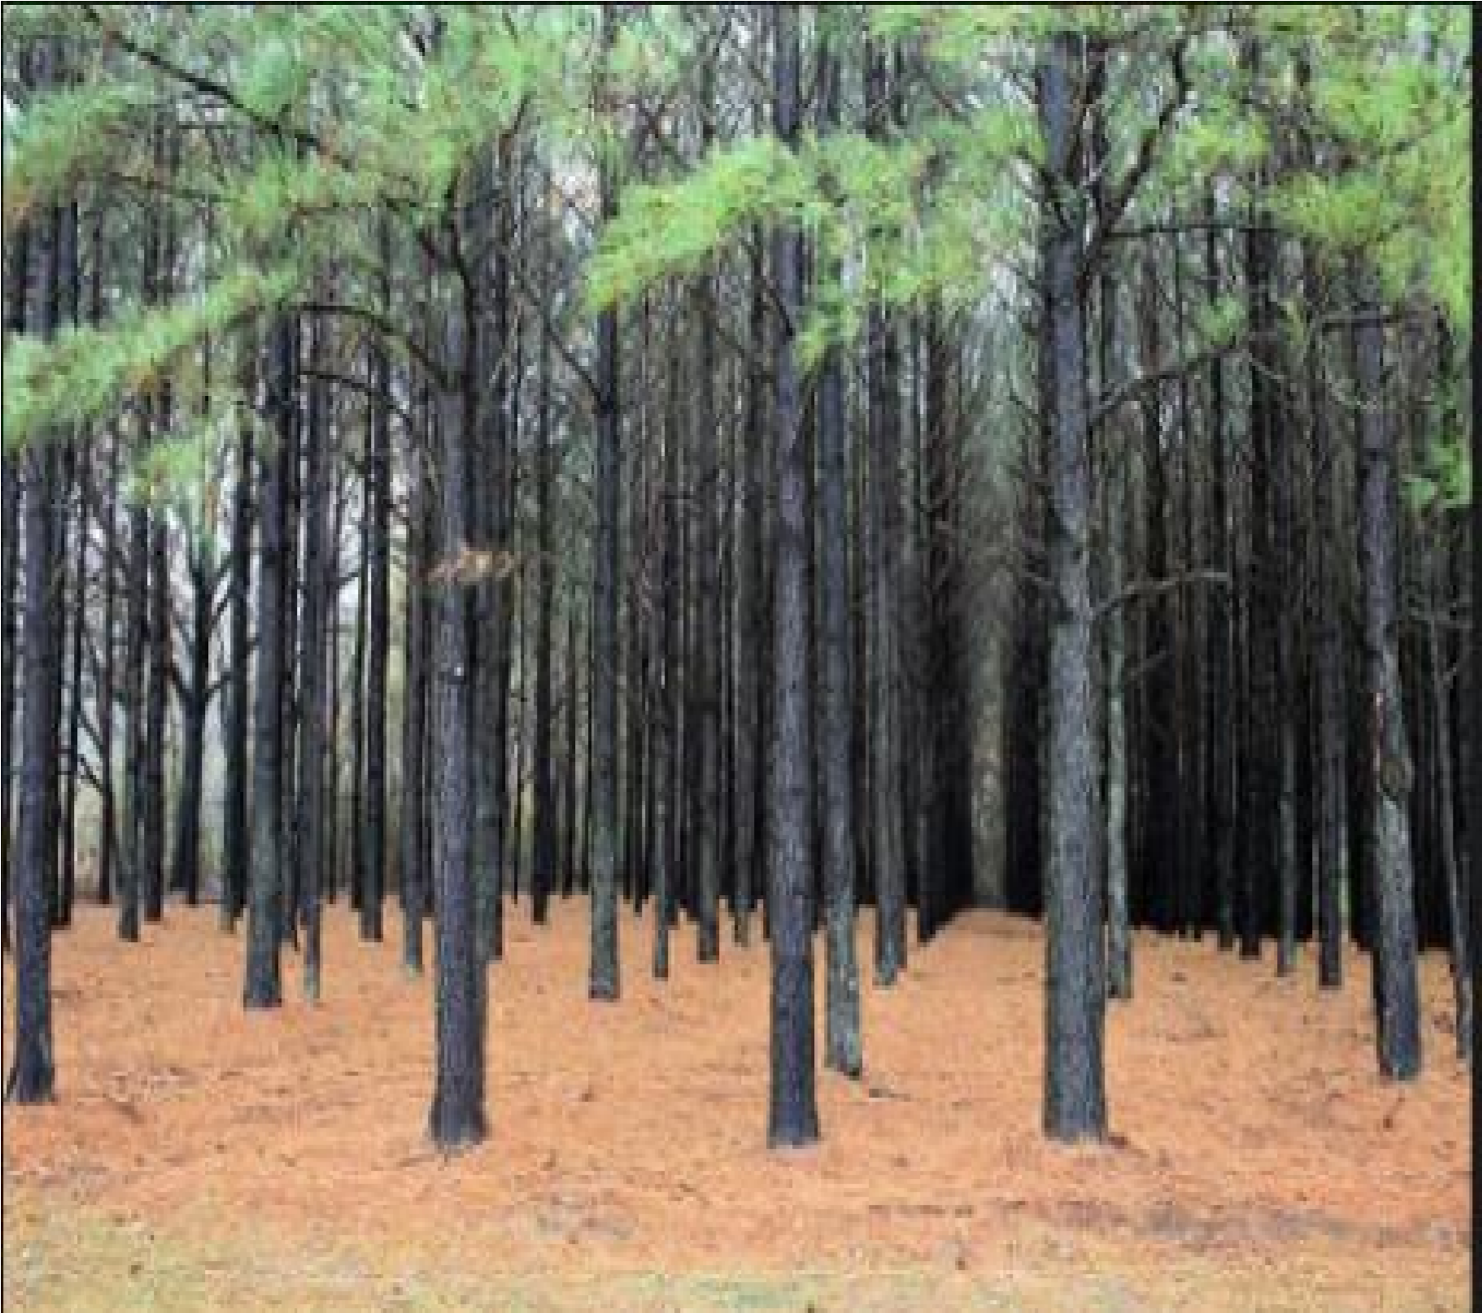

Biomass:
It shows the quantity of living material per unit area to determine the growth of a species.
Biomass is shown in terms of weight of the living matter present.

Abundance:
Number of individuals of any species present in an area.
Abundance =total number of individuals of the species in all the sampling unit / number of sampling unit studied. Diversity:
Number of individuals per unit area denotes diversity. Diversity shows the relative abundance of a species.

Leaf area:
Leaves are the most important organ of a plant. Plants prepare their food by photosynthesis. Leaves have important role in this process because light is necessary for photosynthesis and this light is trapped by chloroplast in leaves.Therefore,leaf shapes and sizes have important role in determination of quantitative characters. The percentage of species having different leaf sizes shows the variation of the vegetation to the predominating environment.
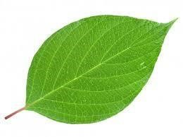

4: Synthetic characters:
They are derived from the measurements of analytic characters. Community comparison needs the calculation of their synthetic characters to compare the vegetation of different areas.
Synthetic characters are determined by following terms:
- Presence and constancy
- Fidelity
- Dominance

Presence and constancy:

It shows the extend of presence of the individuals of a particular species in the community.
Distribution of species in a given area is described by presence at constancy.

Fidelity:
The degree to which the growth of a particular species is restricted in a given community. The species which express higher fidelity are bounded to lesser number of communities. In case of less fidelity the plants are found in many communities.
The species have been classified into following five fidelity groups: A. Fidelity 1 (strangers):
In this group plant appears accidentally. B. Fidelity 2 (indifferent):
Indifferent plants may present in any community.

C. Fidelity 3 (preferential)
This group contains species which are present in many types of communities but are dominant in one.

D. Fidelity 4 (selective)
Specifically, present in one community but may present in other communities as well.

E. Fidelity 5 (exclusives)
Present only in one specific community and not in others. Dominance: -
Dominance expresses the relative importance of a species in the community. Mostly ecological communities are determined by their dominant species.
e.g. species of sphagnum are dominant vegetation in temperate bogs.

5: Conclusion:

Plants play important role in the biosphere. Plants prepare their own food and provide food to other organisms. Plants produce organic compounds for herbivores. Plants have 2 main ecological characters. These characters are analytic and synthetic characters.analytic characters are determined either qualitatively or quantitatively. Periodicity,stratification,sociability and vitality are included in analytic characters. Presence and constancy, fidelity and dominance are determined the synthetic characters of plant community.

