Experiment no#11
Objective:
To find the effect on flow rate and & velocity when jet impacts on various deflection angles.
Apparatus:
Impact of jet apparatus, Hydraulic Bench
Theory:
When a jet of water flowing with a steady velocity strikes a solid surface the water is deflected to flow along the surface. If friction is neglected by assuming an inviscid fluid and it is also assumed that there are no losses due to shocks, then the magnitude of the water velocity is unchanged. The pressure exerted by the water on the solid surface will everywhere be at right angles to the surface.
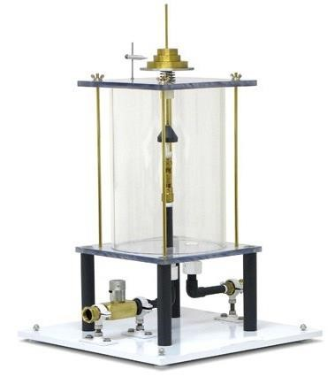

The four-basic type of deflections:
• Plate •Hemisphere | - Slope  - Cone

Formulas:
For Plate | For Hemisphere | For Cone
F=VρW₁ | F=2VρW₁ | F=W₁(1+cos²α)

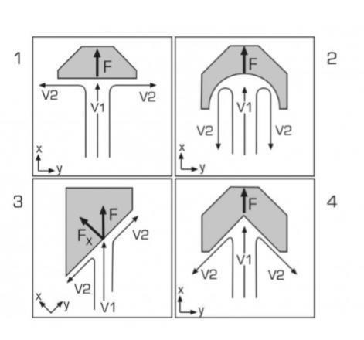
Procedure:

Observations:
Sr. No. | Flow Rate  Lit/sec | Velocity(w₁) m/s | Calculated Force  (N) | Measured Force  (N)
Calculations:
Diameter of nozzle= 8 mm
𝜋 𝑑²
Area of nozzle (A)=
4
Measured force= 2.7 N
𝑉
𝑄 =
𝑡
W₁=Discharge/Area

Conclusions:

