Why measure stomatal conductance and chlorophyll a fluorescence?
Stomatal openings regulate the exchange of water vapor and CO₂ between a leaf and the air. Stomatal conductance to water (g_{sw}), which responds to light, CO₂, temperature, and humidity, among others, is a measure of the degree of stomatal openness and the number of stomata. It is an indicator of a plant’s genetic makeup and physiological response to environmental conditions.
Measurements of chlorophyll a fluorescence can provide information about the leaf’s quantum efficiency, electron transport rate (ETR), non-photochemical quenching (NPQ), as well as an assortment of reactions that collectively protect a leaf when it absorbs excessive light energy.
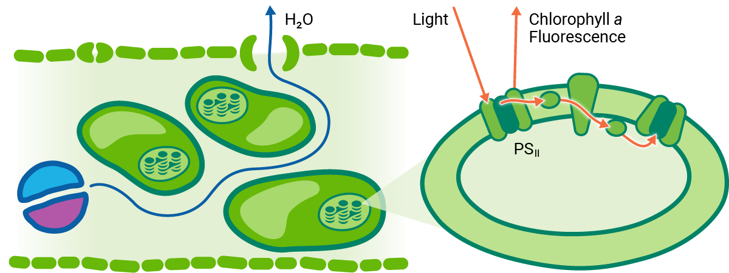
Combined measurements of stomatal conductance and chlorophyll a fluorescence present a more complete picture of a plant’s physiological state than either technique alone.
Understanding these processes is important to many research applications, including genetic screening, agronomy, plant physiology, ecology, climate change research, and stress tolerance.

Stomatal conductance
The LI-600 uses an open flow-through differential measurement for quantifying transpiration (E) and stomatal conductance that enhances its measurement process. First, E is quantified by measuring the flow rate and water vapor mole fraction of air that enters and leaves the chamber. Meanwhile, total conductance to water vapor (g_{tw}) is computed as a function of E and vapor pressures in the leaf and cuvette. Finally, stomatal conductance to water (g_{sw}) is computed as a function of g_{tw} and the boundary layer conductance to water vapor (g_{bw}).
The advantages of the LI-600 measurement flow path include the following:
- Flow rates that quickly flush through the small chamber volume and result in rapid stabilization for quick measurements
- A differential measurement that is close to ambient conditions
- Minimally disturbed light, CO₂, and H₂O during the measurement that eliminate the need for desiccant chambers or corrections for large diffusion gradients
- Automatic matching that accounts for drift between the reference and sample sensors

Chlorophyll a fluorescence
Measurements of chlorophyll a fluorescence provide insights into photosynthesis, and, when combined with stomatal conductance, results in a more complete picture of the overall plant physiology and health. In addition to rectangular flashes, the LI-600 supports multiphase flashes (MPF), which can prevent underestimation of F_{m}’ (Loriaux et al., 2013) and thereby reduce bias in numerous fluorescence parameters.
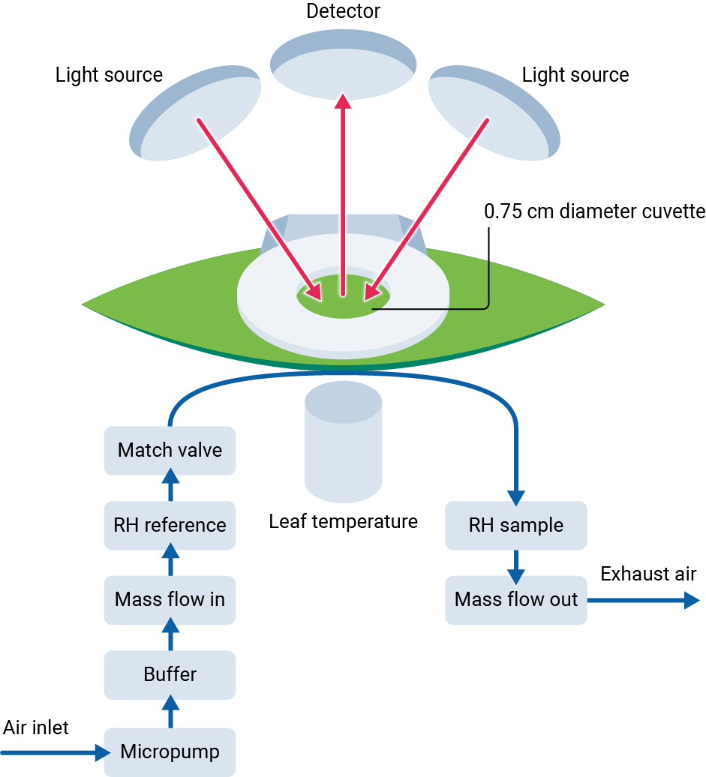
Loriaux SD, et al. (2013). Closing in on maximum yield of chlorophyll fluorescence using a single multiphase flash of sub-saturating intensity. Plant Cell Environ 36:1755-1770.

Light-adapted leaves
For light-adapted leaves, the LI-600 measures the quantum yield of fluorescence (Φ_{PSII}), or the proportion of light absorbed by PS_{II} used in biochemistry.
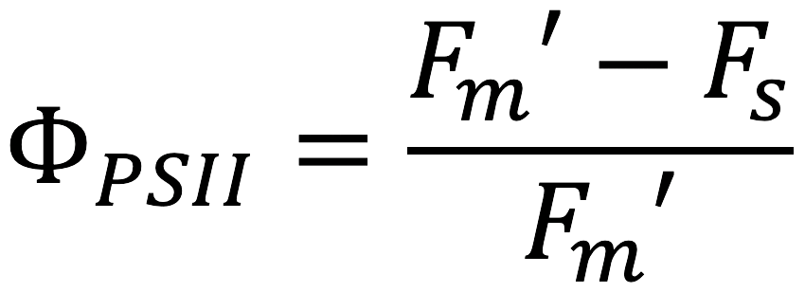
F_{m}’ is maximum fluorescence yield in a light-adapted leaf; F_{s} is steady-state fluorescence yield in a light-adapted leaf.

Dark-adapted leaves
For dark-adapted leaves, the LI-600 measures maximum quantum yield (F_{v}/F_{m}), or the maximum proportion of absorbed light that can be used to drive photochemistry.
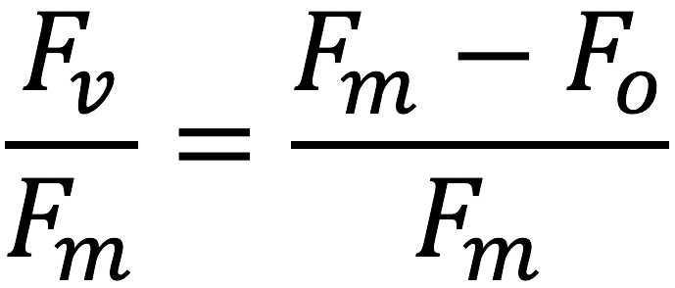
F_{v} is variable fluorescence yield in a dark-adapted leaf; F_{m} is maximum fluorescence yield in dark-adapted leaf; F_{o} is minimum fluorescence yield in a dark-adapted leaf.

CI-340

Handheld Photosynthesis System

The CI-340 Handheld Photosynthesis System is a portable, single-handed tool that measures photosynthesis, respiration, transpiration, stomatal conductance, PAR and internal CO₂. Light-weight and durable, the CI-340 was designed for field use. The optional accessory modules allow researchers to control CO_{2,} H₂O, temperature, light intensity, and measure chlorophyll fluorescence, while the ten different customized chambers accommodate any leaf size, including conifer needles and cacti. Direct chamber connection to the CO₂/H₂O gas analyzer reduces measurement delay and enables rapid measurement of gas exchange with minimal delays.
