Contents Page No
What is Reading 4
What is meant by reading skills? 5
Why is Reading important 5
Three components of Reading 7
1. Decoding 7
2. Comprehension 7
3. Retention 7
Steps evolved in Reading 7
1. Decoding 7
2. Fluency 7
3. Vocabulary 8
4. Sentence construction and cohesion 8
5. Reasoning and background knowledge 9
6. Working memory attention 9
Types of Reading 9
1. Oral 10
2. Silent 10
3. Intensive 10
4. Linguistic 10
5. Content 10
6. Extensive 10
7. Skimming 10
8. Scanning 10
What is Oral Reading? 10
What is Silent Reading? 10
Intensive Reading 10
Intensive reading characteristics 11
Intensive reading activities 12
Extensive Reading 12
Extensive reading characteristics 13
Extensive reading activities 14
Skimming characteristics 16
Skimming activities 17
Scanning characteristics 18
Scanning activities 19
Conclusion 21
References 22

What is Reading?

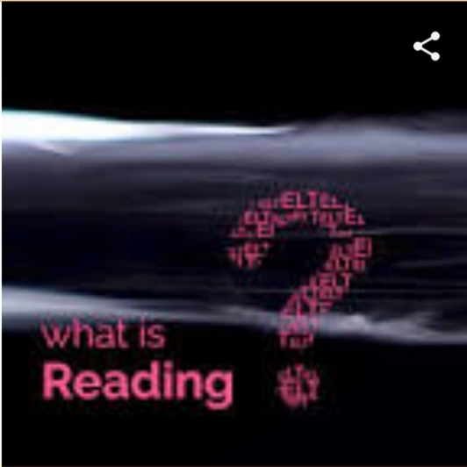

Reading is a cognitive process of decoding symbols to derive meaning from text (as in reading a book or reading music).
“Reading” is the process of looking at a series of written symbols and getting meaning from them. When we read, we use our eyes to receive written symbols (letters, punctuation marks and spaces) and we use our brain to convert them into words, sentences and paragraphs that communicate something to us.
Reading can be silent (in our head) or aloud (so that people can hear).
Reading is a receptive skill- through it we receive information. But the complex process of reading also requires the skill of speaking, so that we can pronounce the words that we read.

What is meant by Reading Skills?
Reading skills is the ability of an individual to read, comprehend and interpret written words on a page of an article or any other reading material. The possession of a good reading skill will enable the individual to be able to assimilate a written work within a short period while reading.
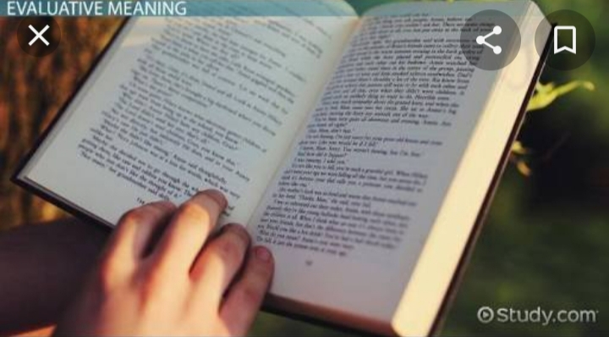

Why is Reading important?
Reading is fundamental to functioning in today’s society. There are many adults who cannot read well enough to understand the instructions on a medicine bottle. That is a scary thought-especially for their children. Filling out applications becomes impossible without help. Reading road or warning signs are difficult even following a map becomes a chore. Day-to-day activities that many people take for granted become a source of frustration, anger and fear.
Reading is a vital skill in finding a good job. Many well-played jobs require reading as a part of job performance. There are reports and memos which must be read and responded to poor reading skills increases the amount of time it takes to absorb and react in the workplace.

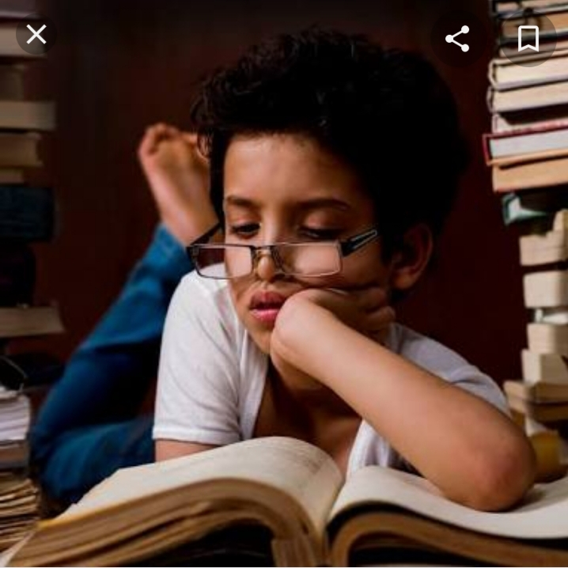

Three Components of Reading:
- Decoding
- Comprehension
- Retention

Steps Evolved in Reading:
1.Decoding:
Decoding is a vital step in the reading process. Kids use this skill to sound out words they’ve heard before but haven’t seen written out. The ability to do that is the foundation for other reading skills.
Decoding relies on an early language skill called Phonemic awareness. (This skill is part of an even broader skill called phonological awareness). Phonemic awareness lets kids hear individual sounds in words (known as phonemes). it also allows them to a” Play” with sounds at the world and syllable level.

2.Fluency:
To read fluently, kids need to instantly recognize words, including ones they can’t sound out. Fluency speeds up the rate at which they can read and understand text. It’s also important when kids encounter irregular words, like of and the, which can’t be sounded out.
When kids can read quickly and without making too many errors, they are “fluent” readers.

3.Vocabulary:
To understand what you’re reading, you need to understand most of the words in the text. Having a strong vocabulary is a key component of reading comprehension. Students can learn vocabulary through instruction. But they typically learn the meaning of words through everyday experience and also by reading.
What can help: The more words kids are exposed to, the richer their vocabulary becomes. You can help build’s your child’s vocabulary by having frequent conversations on a variety of topics. Try to include new words and ideas. Telling jokes and playing word games is a fun way to build this skill.

4.Sentence Construction and Cohesion:
Understanding how sentences are built might seem like a Writing skill. So might connecting ideas within and between sentences, which is called cohesion. But these skills are important for reading comprehension as well.
Knowing how ideas link up at the sentences level helps kids get meaning from passage and entire texts. It also leads to something called coherence, or the ability to connect ideas to other ideas in an overall piece of writing.

5.Reasoning and Background Knowledge:
Most readers relate what they’ve read to what they know. So it’s important for kids to have background or prior knowledge about the world when they read. They also need to be able to “read between the lines” and pull out meaning even when it’s not literally spelled out.
Take this example: A child is reading a story about a poor family in the 1930s. Having knowledge about the Great Depression can provide insight into what’s happening in the story. The child can use that background knowledge to make inference and draw conclusions.

6. Working Memory and Attention.
Two skills are both part of a group of abilities known as executive function. They’re different but closely related.
When kids read, attention allows them to take in information from the text. Working memory allows them to hold on to that information and use it to gain meaning and build knowledge from what they’re reading.

Types Of Reading:
Several types of reading may occur in a language classroom:
- Oral
- Silent

Intensive
- A. linguistic
- B. Content

Extensive
- A. Skimming
- B. Scanning

What is Oral Reading?:
Oral reading is a complex process, involving mental interpretations based on eye sweeps of the text accompanied by vocalization.

What is Silent Reading?
Silent readers simply interpret the material through a series of eye sweeps (without delays resulting from vocalization.

Intensive Reading:

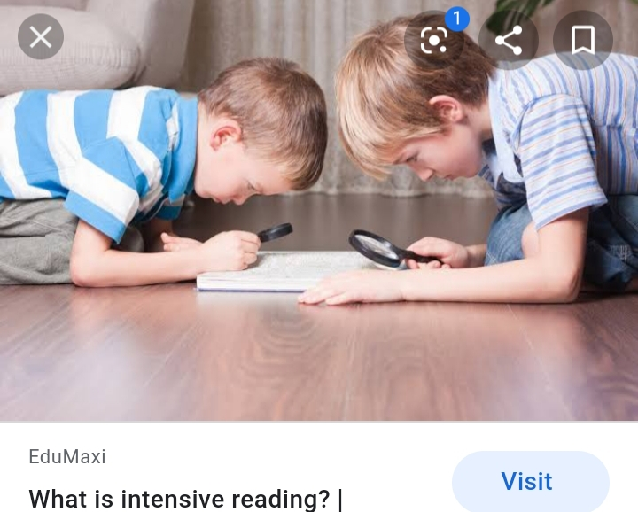

Intensive reading “ calls attention to grammatical forms, discourse markers, and other surface structure details for the purpose of understanding literal meaning , implications, rhetorical, relationships , and be like.” He draws an analogy to intensive reading as a “zoom lens” strategy.

Intensive Reading Characteristics:
- Reader is intensely involved in looking inside the text.
- Focus on linguistic or semantic details of a reading.
- Focus on surface structure details such as identifies key vocabulary.
- Draw pictures to aid them (such as in problem solving).
- Read carefully.
- Aim is to build more language knowledge rather than simply or practice the skill of reading.

Intensive Reading Activities:
- Identify main ideas and details.
- Making inferences.
- Looking at the order of information and how it affects the message.
- Identify words that connect one idea to another.
- Identifying words that indicate change from one section to another.

Extensive Reading:

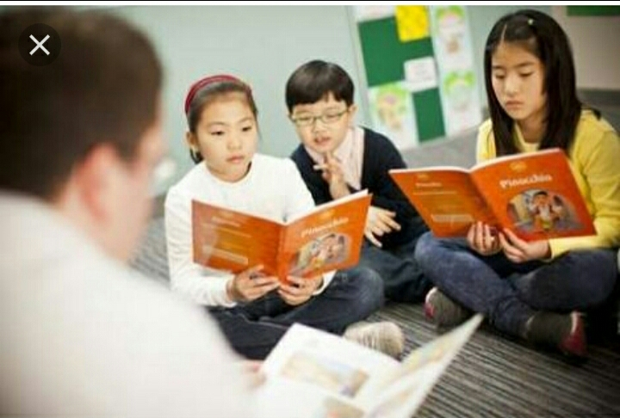

Extensive reading is carried out “to achieve a general understanding or a text.”
Extensive reading as “ occurring when students read large amounts of high interest material, usually out of class , concentrating on meaning, “reading for gist” and skipping unknown words.”
The aim of extensive reading is to build reader confidence and enjoyment.

Extensive Reading Characteristics:
- The purpose of reading are usually related to pleasure , information and general understanding .
- Reading is its own reward.
- Reading materials are well within the linguistic competence of the students in terms of vocabulary and grammar.
- Reading is individual and silent.
- Reading speed is usually faster than slower.
- Teachers orient students to the goals of the program.
- The teacher is a role model of a reader for the students

Extensive Reading Activities:
- Interview each other about their reading.
- Reading may be combined with a writing component. For example, after reading the newspaper, student may be asked to write a newspaper report.
- Class time reading.
- Students may set their own goals for their next session.
- A reading log (recording number of pages read and at what level).
- A reflection on what they noticed about their own reading .
- A book report or summary.
- A retelling of part of the text.
- Book.

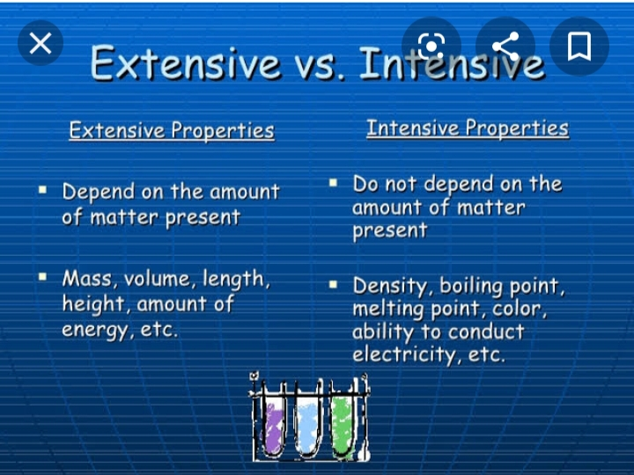

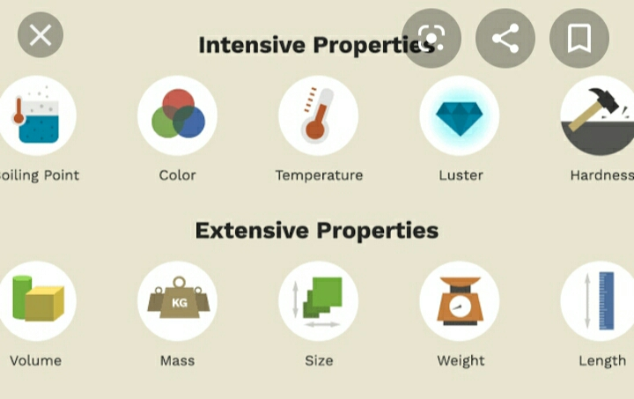

Skimming:
Skimming is a quick reading to get:
- To know the general meaning of a passage.
- To know how the passage is organized, that is, the structure of the text.
- To get the author’s purpose.

Skimming Characteristics:
- Skimming is used to build student confidence and an understanding that it is possible to gain meaning without reading every word in a text.
- Skimming is used as part of the SQ3R method of reading, often for speed reading. This method involves the student in surveying, questioning, reading, reviewing, and reciting.
- Skimming is used to review a topic.

Skimming Activities:
- Locate facts and opinions.
- Sets a time limit to the reading activity.

Scanning:

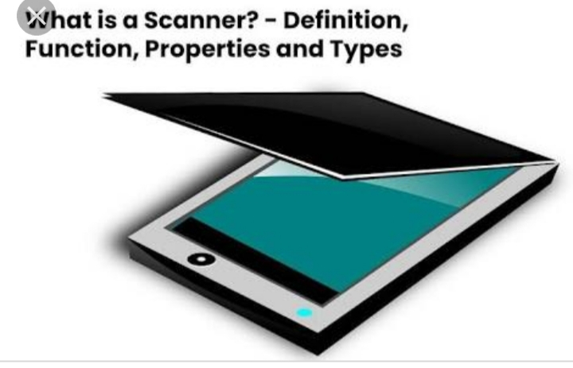

- A quick reading, focusing on locating specific information.
- Scanning involves quick eye movements, not necessarily linear in fashion, in which the eyes wander until the reader finds the piece of information needed.
- Scanning is used when a specific piece of information is required, such as a name, date, symbol, formula, or phrase, is required.

Scanning Characteristics:
- Scanning is used often with technical, scientific or professional materials to locate specific information.
- Scanning is valuable skill for second language learners to develop because often they do not require a detailed read of a text.

Scanning Activities:
- Make predictions and guesses.
- Use titles and tables of contents to get an idea of what a passage is about.
- Activities prior knowledge.
- Use titles, pictures, and prior knowledge to anticipate the contents of the text.
- Use key words that may have been given to them by the teacher, that do not appear in the text, that allude to the main idea.

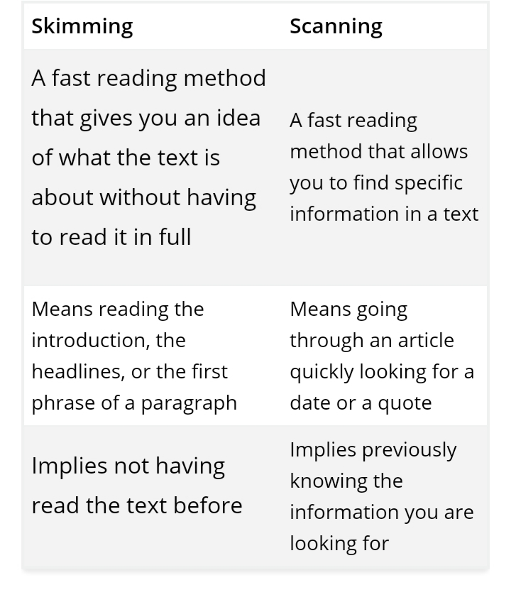

Conclusion:
Reading comprehension is more than decoding shapes and figures as many teachers and learners think. Comprehension occurs when the reader knows what skills and strategies are necessary and appropriate for the type of text and understands how to apply them to accomplish the reading process and reach high degree of comprehension and retention.
In addition, the results obtained in the analysis of the two questionnaires confirmed firmly that both teachers and students lack the essential requirements for reading and processing literary texts. Teachers actually assign literary texts for reading without considering the fundamental criteria and requirements for successful reading.

References:
https:II www.englishclub.com
https:II www.researchgate.net
Https: II www.understood.org
Https: II owII.massey.ac.nz
Https: II www.learn-to-read prince-george

