Process of molding casting
Molding and casting base on the sculpture wether its round or just relief sculpture if its relief than we make a one side mold in plaster or cylicone mold if its round or 3d than we divide in different parts

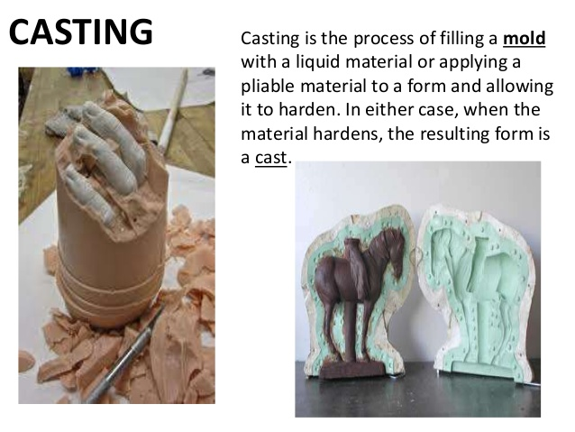
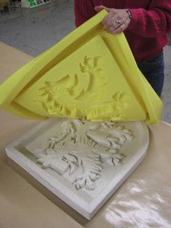
This Base relief sculpture with one side mold in cylicone and we made a cylicone if we want a good and fine detail and want multiple casts but if we want one or 2 casts than we make a plaster mold

