Bryan Krantz: University of California, Berkeley
MCB 102, Spring 2008, Metabolism Lecture 8
Reading: Ch. 16 of Principles of Biochemistry, “The Citric Acid Cycle.”

CITRIC ACID CYCLE

Three Phases
- Acetyl-CoA production—Organic fuels (glucose, amino acids, fats) → Acetyl-CoA
- Acetyl-CoA oxidation—Acetyl-CoA enters TCA and is enzymatically oxidized; energy is conserved in electron carriers, NADH FADH₂
- Electron transfer—energy rich e⁻ from NADH FADH₂ reduce O₂ to H₂O
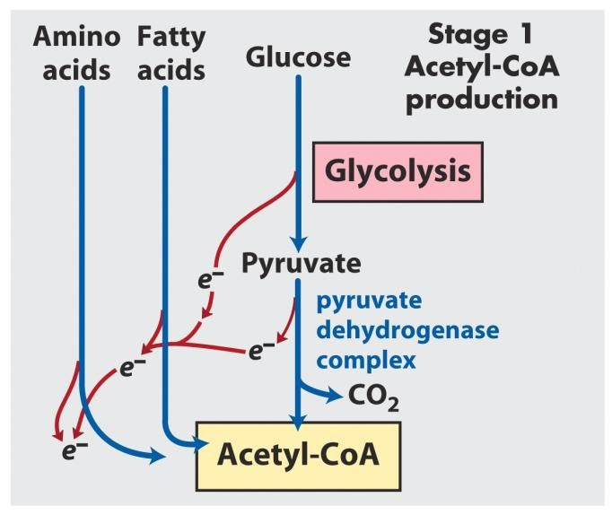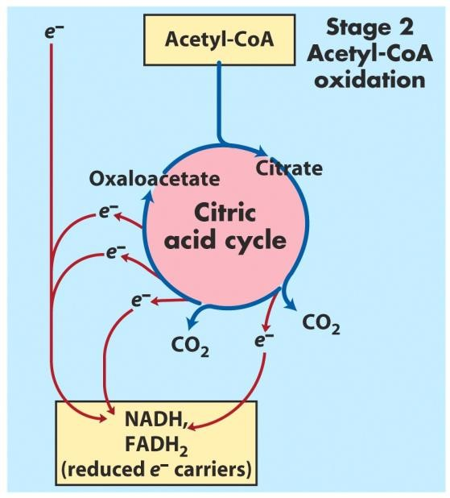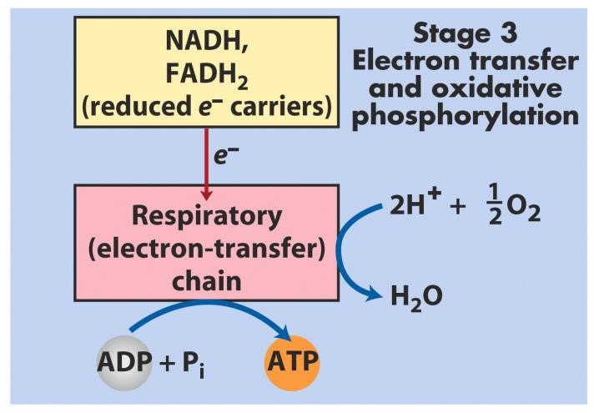

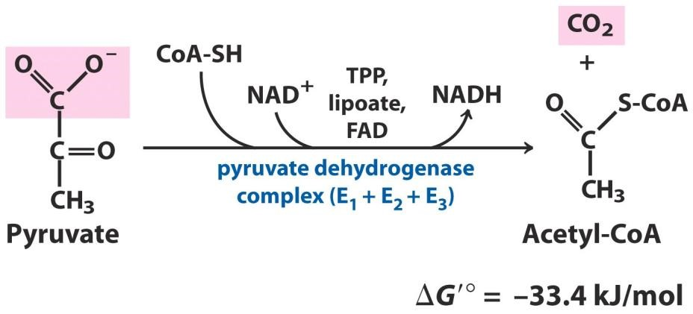
Pyruvate Dehydrogenase Complex
The first reaction before you enter the TCA cycle is the conversion of pyruvate into the two carbon intermediate that is necessary for entry into the cycle, acetyl-CoA–an acetate attached to Coenzyme A (CoA).

Pyruvate + NAD⁺ + CoA → Acetyl-CoA + NADH + CO₂
The enzyme is called Pyruvate Dehydrogenase Complex, which contains many coenzymes and co-factors. The simplest pyruvate dehydrogenase enzyme in E. coli contains 60 subunits! Subunits possess 1 of 3 activities: E1, E2 and E3. Other enzyme complexes are related & similar.
Overall Energetics. ΔGº’ is –33 kJ/mol—a strongly downhill reaction.
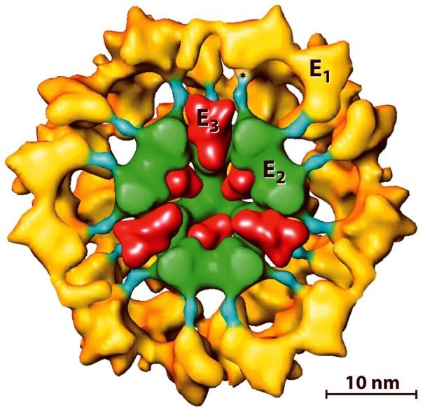

Mechanism Overview
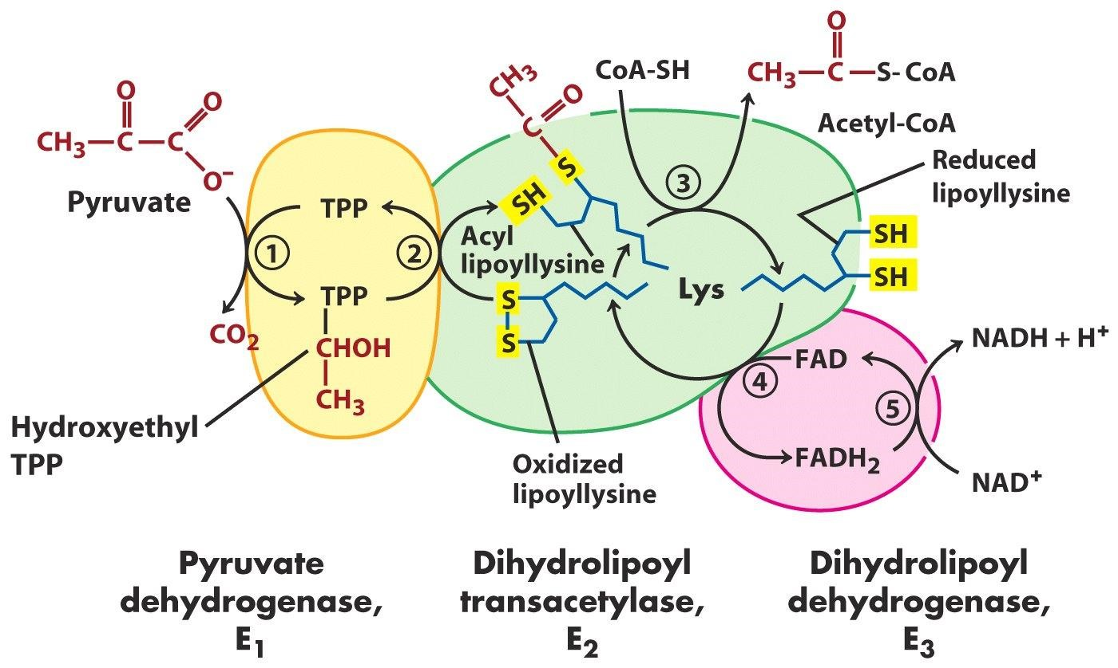

E1
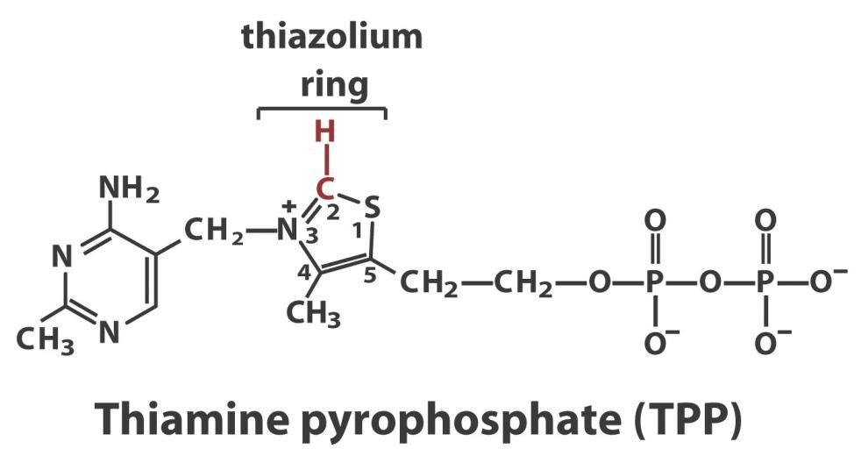
Pyruvate dehydrogenase is the actual dehydrogenase activity and first enzyme in the complex.

Pyruvate + TPP → Hydroxyethyl TPP + CO₂

Mechanism. E1 uses coenzyme, thiamine pyrophosphate, or TPP, (from vitamin B1)—which is powerful electron sink. Mechanism is similar to aldolase, where electron withdrawing power aids in breaking the C-C bond.
Carbanion carbon of TPP attaches to the carbonyl carbon of the pyruvate. The purpose of doing that is to use the strong electron sink, which is the quaternary nitrogen, of thiazol to allow the decarboxylation of CO₂, because CO₂ gets released. After decarboxylation and the addition of the proton, you get hydroxy-ethyl TPP. This reaction is like that for the decarboxylation of pyruvate to acetaldehyde.

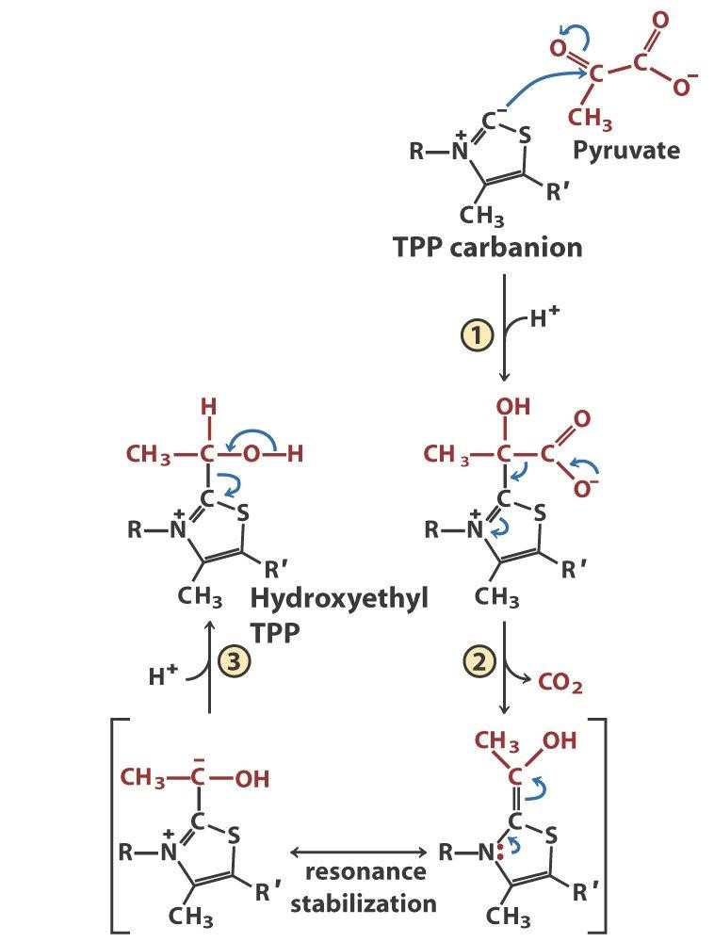

E2
Dihydrolipoyl transacetylase activity uses the lipoic acid modified lysine lipoyllysine. When acid joins to an amine this makes an amide so sometimes this is called lipoamide. Cofactor is a long, flexible extrusion, making an arm that can tilt to various sites in the complex.

Hydroxyethyl TPP + Lipoyllysine + CoA →Dihydrolipoyllysine + Acetyl-CoA

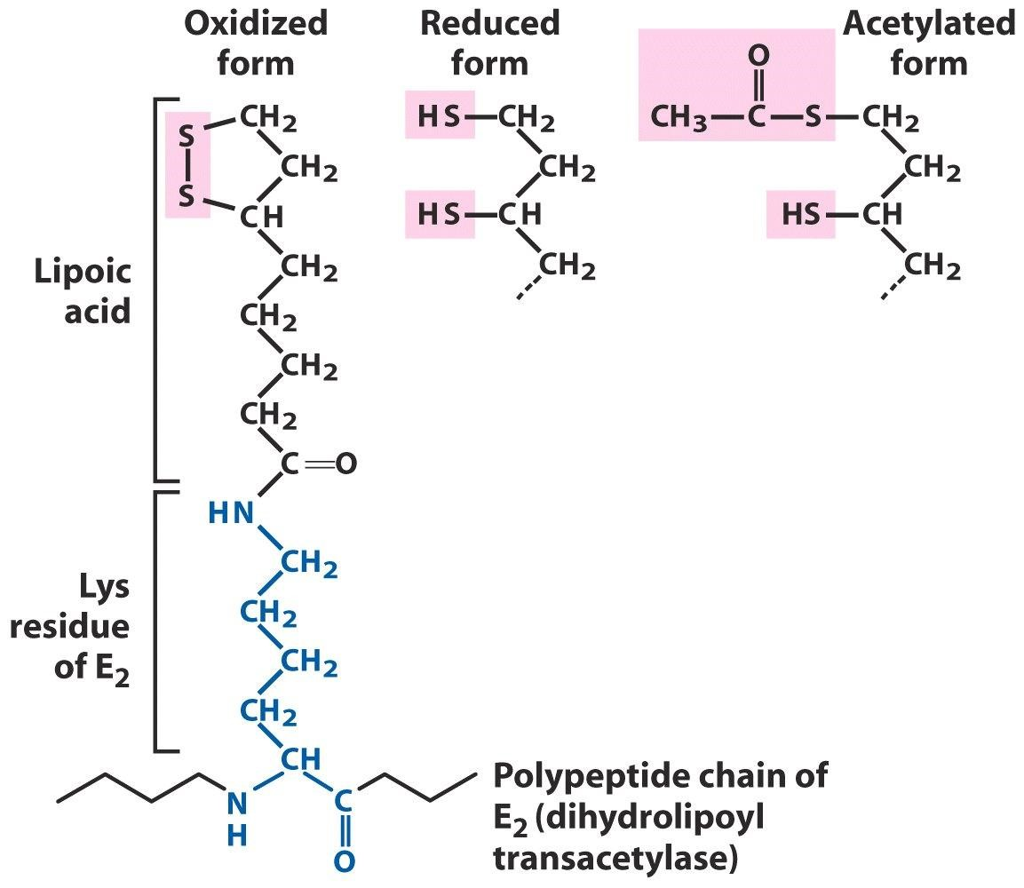
Mechanism. (1) Lipoyllysine oxidize the hydroxyethyl group; (2) the two-carbon unit will become attached to the dihydrolipoyllysine. The dihydrolipoyllysine will swing away from E1 and transfer the acetyl group to the coenzyme, CoA.

Coenzyme A (CoA)
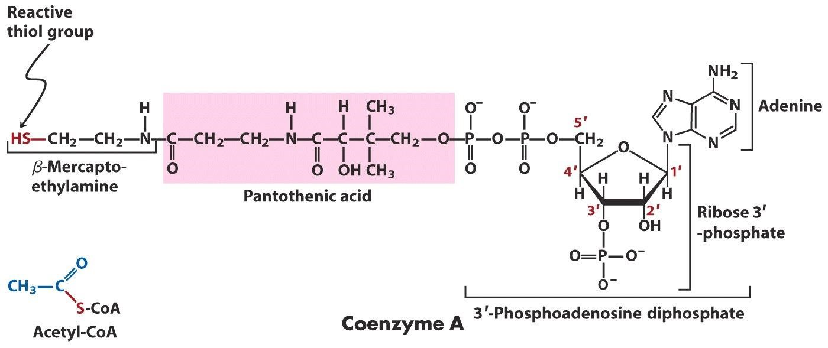

E3
Dihydrolipoyl dehydrogenase enzyme oxidizes dihydrolipoyllysine by transferring the energy rich electrons to an electron carrier, NAD⁺, via a tightly bound intermediary electron carrier, FAD. Dihydroxylipoyllysine + NAD⁺ → Lipoyllysine + NADH
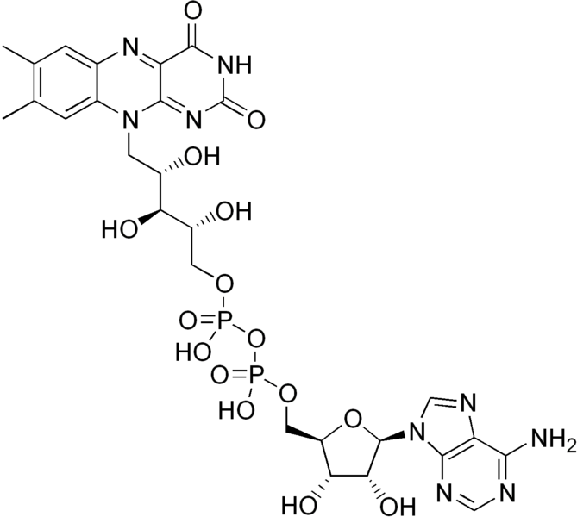
FAD. The flavin group is the business end of FAD; it is not linked to ribose, but to ribitol—a reduced product of ribose. Then, it is linked to a pyrophosphate moeity, ribose and adenine. FAD comes from vitamin B₂. A closely related coenzyme called FMN constitutes one half of this molecule, where you cut after the first phosphate group.
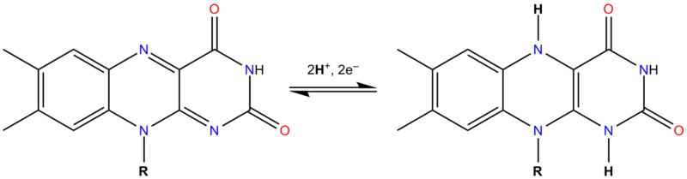
First the electrons in the lipoyllysine are transferred to FAD. In the second reaction, the oxidized form of FADH₂ is regenerated. The reason for all this is that unlike NAD⁺/NADH that exist freely in solution, FAD and FMN usually exist in close association with enzymes, so they cannot float away. FAD is still connected tightly with the E3 enzyme.

Citric Acid Cycle
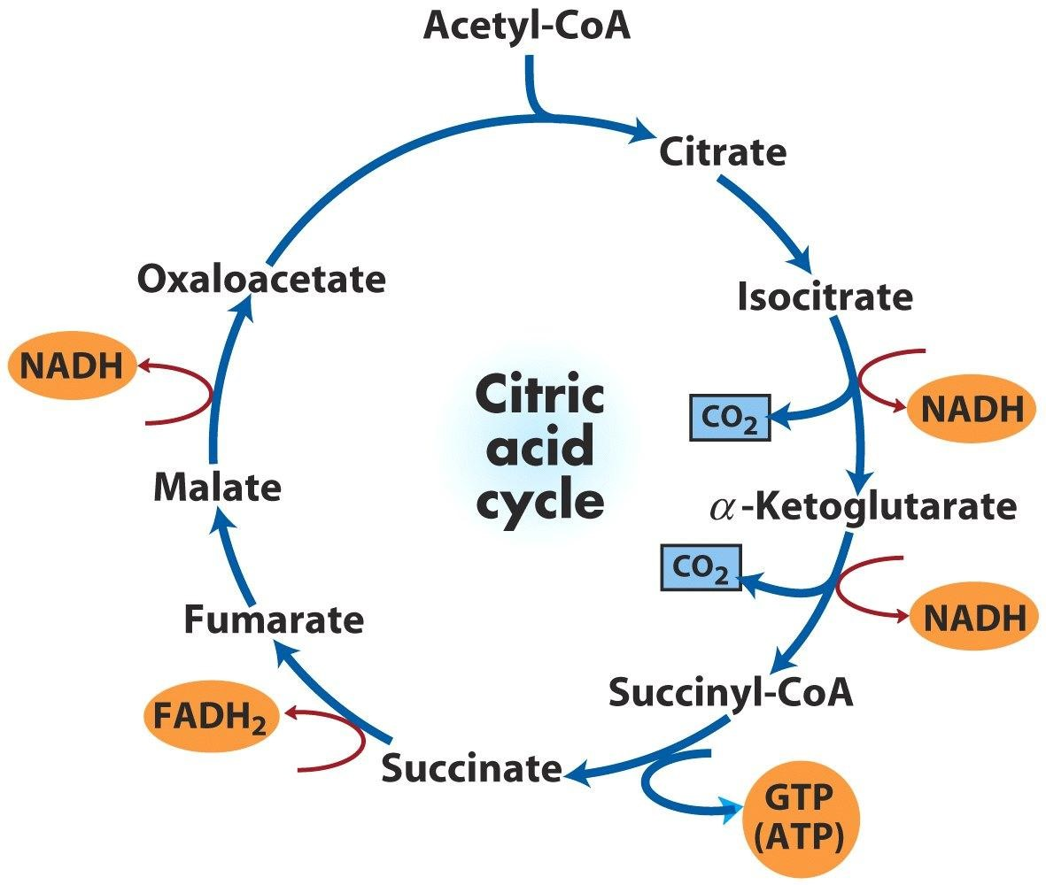

] Citrate Synthase. The first reaction is a synthase reaction, called such since a new
molecule is made but ATP is not used. (The latter is called a synthetase). Oxaloacetate + Acetyl-CoA + H₂O → Citrate + CoA
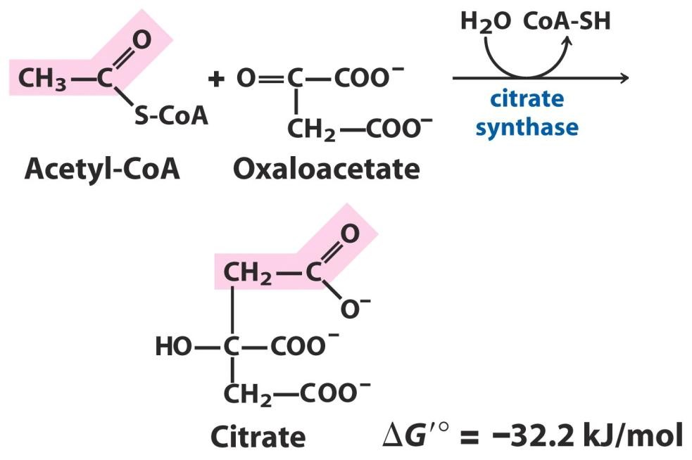
Mechanism. Claisen condensation reaction from organic chemistry, where thioester is combined with ketone. Methyl carbon of acetylCoA attack the electron poor ketone carbon of oxaloacetate. You have to abstract a proton, so you produce a carbanion here. The carbanion will attack this oxaloacetate carbonyl carbon. To produce carbanion, the enzyme uses the general acid/base mechanism with two His residues.

Energetics. The synthesis of the C-C bond here is probably should not be a strongly downhill reaction. To make this reaction strongly downhill, you use the high free energy difference gained by the hydrolysis of this thioester to drive the reaction. The thioester hydrolysis has a ΔGº’ = –30 kJ/mol so exothermic energy difference is almost entirely coming from the hydrolysis of the thioester.

Historic fight. It was thought that the synthase step was not the entry step into the TCA Cycle. Citrate is a symmetric molecule (lacks a stereocenter.) However, radiolabeling studies showed that the two symmetric carboxyl groups were not treated the same. Later, this was resolved: citrate is close to being chiral (prochiral) and a prochiral substrate is treated as chiral if the enzyme is chiral. ] Aconitase.

Citrate ←→[H₂O + cis-Aconitate ]←→ Isocitrate

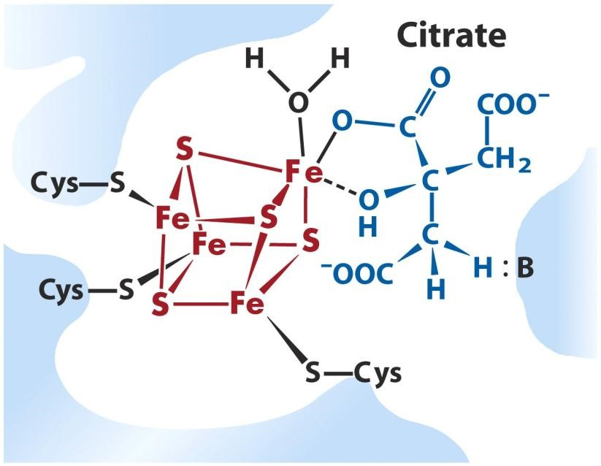
Mechanism. This is a dehydration reaction followed by a hydration. The dehydration step is like enolase in glycolysis. To facilitate the abstraction of the proton, you pull the electrons strongly from the carboxylate. Enolase did this by putting magnesium near the carboxylate oxygen. Aconitase uses an iron-sulfur cluster cofactor instead of magnesium to do this. Three Cys residues and multiple Fe atoms make the cluster.

Energetics. The equilibrium favors citrate (ΔGº’ = 13 kJ/mol) but under normal physiological conditions, isocitrate is favored. How?

Other Regulation. Aconitases also regulate iron uptake and metabolism in the cell.
Isocitrate Dehydrogenase. This is an oxidation coupled to a hydride transfer to NAD⁺.

Isocitrate →α-keto glutarate + CO₂

Mechanism. After hydride transfer, the enzyme uses a Mn²⁺-ion cofactor. The metal further enhances the electron withdrawing power of the carbonyl, facilitating decarboxylation. α-keto glutarate is a βketo carboxylic acid. β-keto carboxylic acids are known to be unstable and have a natural tendency to release this carboxylic acid group as CO₂.

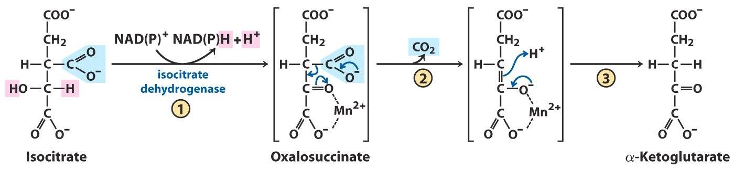

α-Keto Glutarate Dehydrogenase. This enzyme splits the carbon-carbon bond and is
related to pyruvate dehydrogenase.E1 and E2 are similar, and E3 is identical in sequence!

α-keto glutarate + CoA → Succinyl-CoA

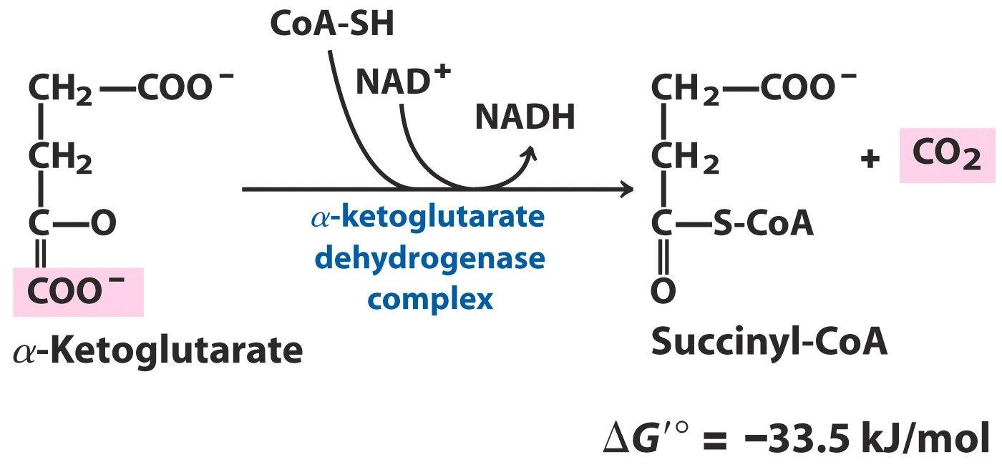
Mechanism. α-keto glutarate dehydrogenase works exactly like pyruvate dehydrogenase. You have the five coenzymes: TPP, lipoyllysine, CoA, FAD and NAD⁺. These are all used, and you get oxidation. The decarboxylated product occurs as a thioester. The product is succinyl-CoA. The thioester in the succinyl-CoA will be utilized later of course in an analogous manner.

Succinyl-CoA Synthetase.

Succinyl-CoA + GDP + Pi →Succinate + GTP
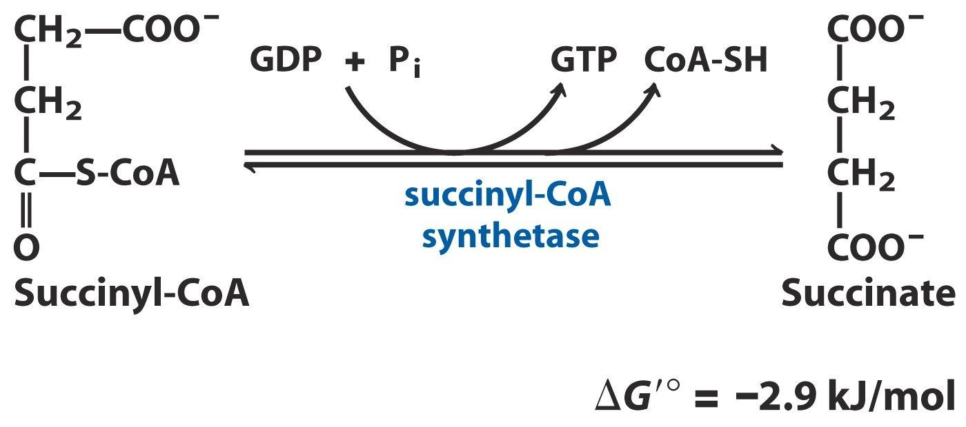
Mechanism. Phosphorylysis reaction is followed by phosphoryl transfer to GDP, producing succinate plus GTP. Note the phosphoryl group is transferred to the GDP via an intermediate that forms with a His residue on the enzyme’s active site.
Energetics. Capitalized on the CoA thioester by capturing free energy as a GTP. GTP is as good as ATP, because there is a free conversion of nucleoside triphosphates in the cell (by the enzyme, nucleoside diphosphate kinase).

GTP + ADP ←→ GDP + ATP where ΔGº’ = 0 kJ/mol

Succinate Dehydrogenase. The next step is succinate dehydrogenase. Starting from succinate and take away two hydrogen atoms to make fumerate. FAD is reduced to form FADH₂.
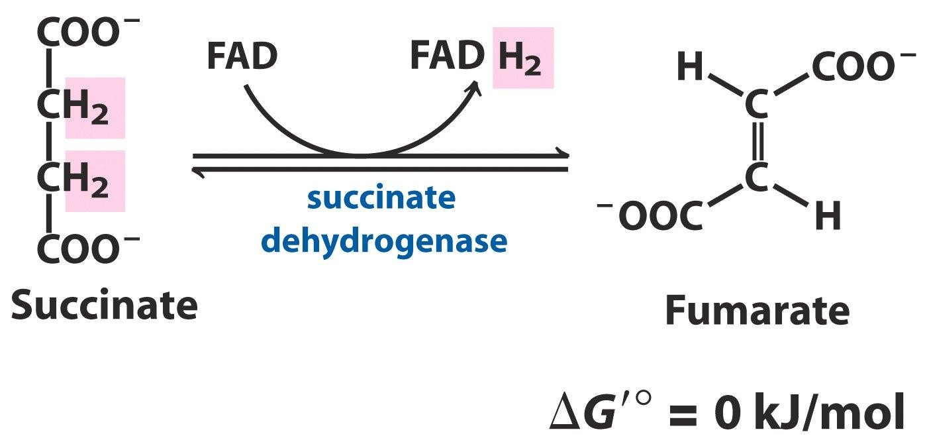
Energetics. The reason we use FAD in this reaction rather than NAD⁺ is that the succinate is a rather poor electron donor. The reduction potential of the succinate/fumarate pair is +0.03 Volts. There is no way that you can use such a poor electron donor to reduce NAD⁺. The reduction potential of
NAD⁺/NADH is –0.32 Volts. That is why you use the FAD/FADH₂ pair, which is much more oxidized.

Fumarase. The next reaction is called fumarase, which converts fumarate into a hydroxy-
dicarboxylic acid called malate. This is an addition of water across the double bond—a recurring theme in the course.

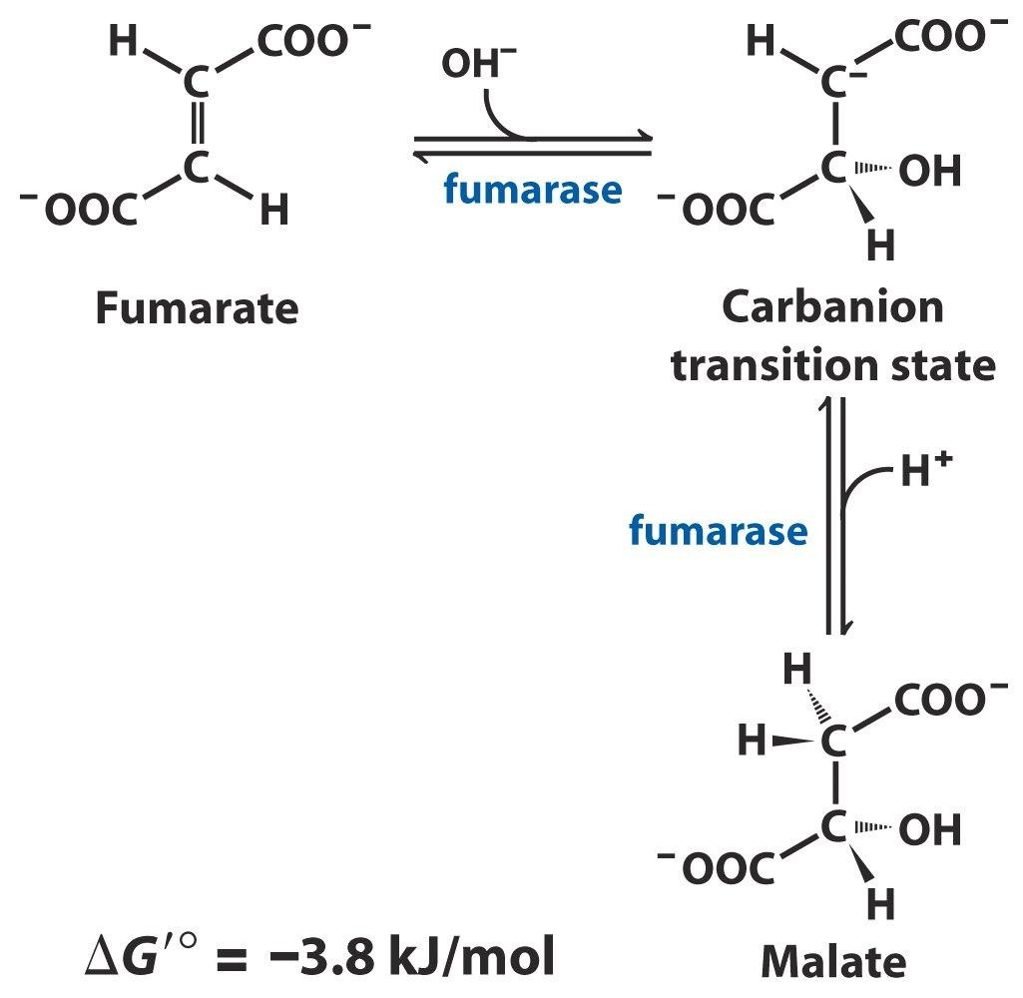

Malate Dehydrogenase. Finally, there is malate dehydrogenase, which uses NAD⁺ to
oxidize this product malate to oxaloacetate. This process yields NADH.

- We talked about this reaction in gluconeogenesis as a way to get reducing equivalents into the cytosol.
- Here the reaction completes the TCA Cycle, remaking oxaloacetate.
 

