Applications of social psychology & cognitive psychology in advertising

Applications of Cognitive Psychology & Social Psychology in Advertising

Psychology in advertising has long been used as an effective means to sell a product or service. Understanding the underlying concepts that affect human psychology can help a company better sell their product or alternatively can help a consumer understand marketing strategies that get them to buy products.
Persuasion is the changing of attitudes by presenting information about another attitude. This information is then processed one of two ways: centrally or peripherally. If it is processed centrally the attitude change is more likely to have permanence. If the information is processed peripherally it will be more susceptible to later change.
The Elaboration Likelihood Model is a theory that states that there are two routes to persuasion. These two routes may alter a person’s belief structure based on the cognitive processes that occur at the time of persuasion. The two routes are defined as the central and peripheral routes. The central route is an active and conscious process in the determination of the merit of a persuasive argument.
During the cognitive processing in the central route, favorable and unfavorable thought processing will determine whether the position that has been advocated holds any merit. The other route, the peripheral route, has to do with the fact people cannot exercise careful and effortful analization of every message that they come upon. There simply are too many messages in the environment for there to be a central processing route. There are many variables which affect the likelihood of thinking about the merits of a message and thus the route to persuasion. These variables affect a person’s motivation to think about issue-relevant information and the ability to do the cognitive processing. While, other variables affecting motivation are part of the person and the situation. Some variables affect the direction of thinking (favorable vs. unfavorable) and others affect the overall amount of thinking a person does.
One commonly used technique of persuasion is that of authority. Everyone has seen ads where "2 out 3 doctors recommend..." This is based on the idea that people will respect the opinions of someone who is assumed to have a lot of knowledge about the product. People feel better knowing that someone with authority has recommended what they are about to buy. Of course, the authority person has to have expert knowledge in that particular field. Would you buy a certain toothpaste because a car salesman recommended it?
First and foremost an advertisement has to catch your attention. One way in which it does this is by appealing to your emotions. It can arouse feelings of fear, love, pleasure, or vanity. Scarcity is the fear that you may miss an opportunity to purchase a product. "One day sales" and phrases such as, "For a limited time only" or "Limited supply" are common uses of this technique. Health advertisements often utilize fear to get the audiences’ attention. Once this is accomplished they hope to "scare" the audience enough to produce an attitude change, be it buying their product, changing your lifestyle, etc. Beer and cigarette advertisements appeal to peoples’ desires for fun and pleasure. The people in these ads are portrayed as having a good time, leading to the belief that if you purchase these products you too will have a good time. Many advertisements employ more than one technique in attempting to persuade the audience. Plastic surgery ads are a perfect example. They attempt to persuade by appealing to peoples’ vanity/egotism by exposing their fear of aging.
How to Use Psychology in Advertising to Make People Buy
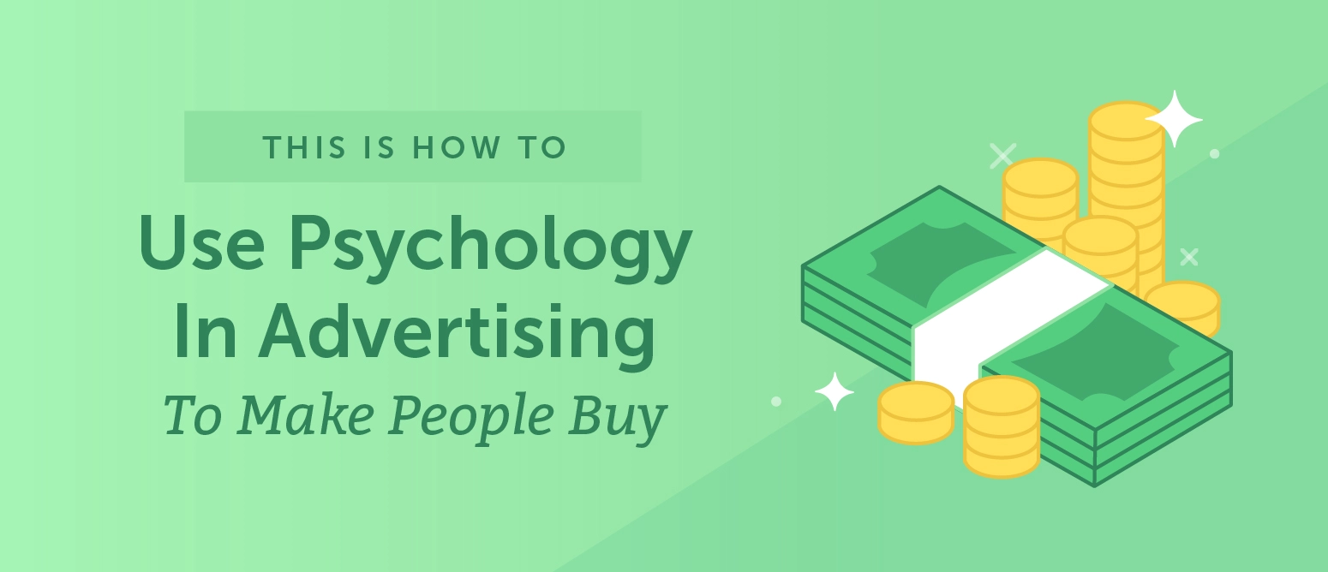
Advertisers have long discovered that they can leverage psychology to find what attracts attention, leaves an impression, persuades, and leads to the act of purchase. That being said, you can use psychology to make sure that your advertising is actually working.

Ok, that’s awesome. But how?

The Psychology of Advertising
Psychology explores human nature, the psyche, and why people behave the way they do.
Advertising explores the art of influencing human behavior to make certain purchase decisions. It’s no surprise that these two areas converge.
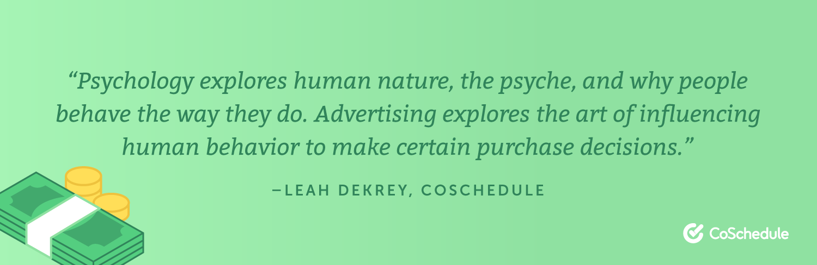
Basic Types of Advertisements
Nowadays, there are so many different types of advertisements.
Whether you’re using traditional tactics or digital tactics, understanding the psychology behind your advertisements is important. Here are a few of the basic forms of advertisements:
Traditional
- Commercials
- Newspaper
- Magazine
- Radio
- Direct mail
- Billboard

Digital
- Social
- Google Ads
- Search
- Display
- Inbox
- Sponsored listings

Whether you’re running a Google ad, or just put up a billboard, you’ll want to choose either the thinking or feeling approach for your advertisement.
CPM vs. HEM
There are two basic models that explain how people process information, the Consumer Processing Model and the Hedonic, Experiential Model.
In other words, thinking and feeling models. Chances are you’ll lean towards one model, depending on your product and audience. Ads don’t have to be one or the other, think of it more as a scale.
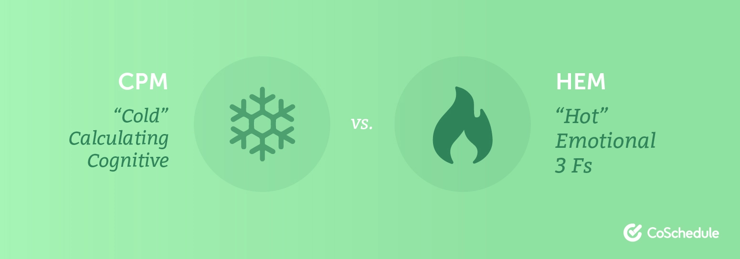
Thinking
Thinking approaches of advertisements allow consumers to use logic and reason to buy the product based on features or solving a problem. You can think of this advertisement as facts based if that helps.
You should use a thinking approach if:
- You want to highlight direct information, features, benefits, or advantages.
- Your product is interpreted as a product used to solve a serious need, for example, migraine medication.
- It aligns with your brand voice and target audience.
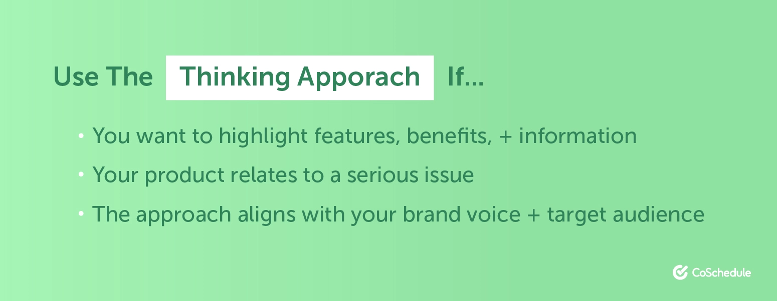
Feeling
According to a 2016 Nielson Report, ads that generated emotional response got a 23% lift in sales volume.
Feeling approaches use emotion to capture consumer behavior. Whether it’s fun, fantasy, or fear, the HEM approach persuades consumers using emotion.
You should use a feeling approach if:
- You can leverage some type of emotion (humor, fear, love, etc.) that will lead a consumer to buy your product.
- You want to make light of a situation.
- It aligns with your brand voice and target audience.
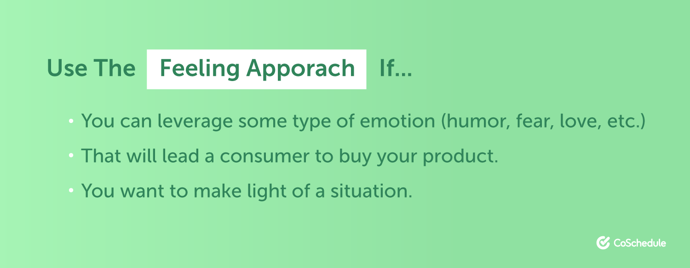
Persuasion Techniques Using Emotion
If you’ve decided to use the feeling approach for your advertisement, it’s important to choose the emotion that best appeals to your product, target audience, and brand. I’ve listed 4 of the basic emotions that people use in advertising.
Humor
Humor drives memorability. If you’re looking to make people remember your product and your brand, this may be the best option for you. Making people laugh helps people remember your brand in a positive light.
Fear
Using fear in an ad can be tricky, but if done right it can be very effective. This tactic uses fear as a persuasion technique by using your product to solve a problem or to change a behavior.
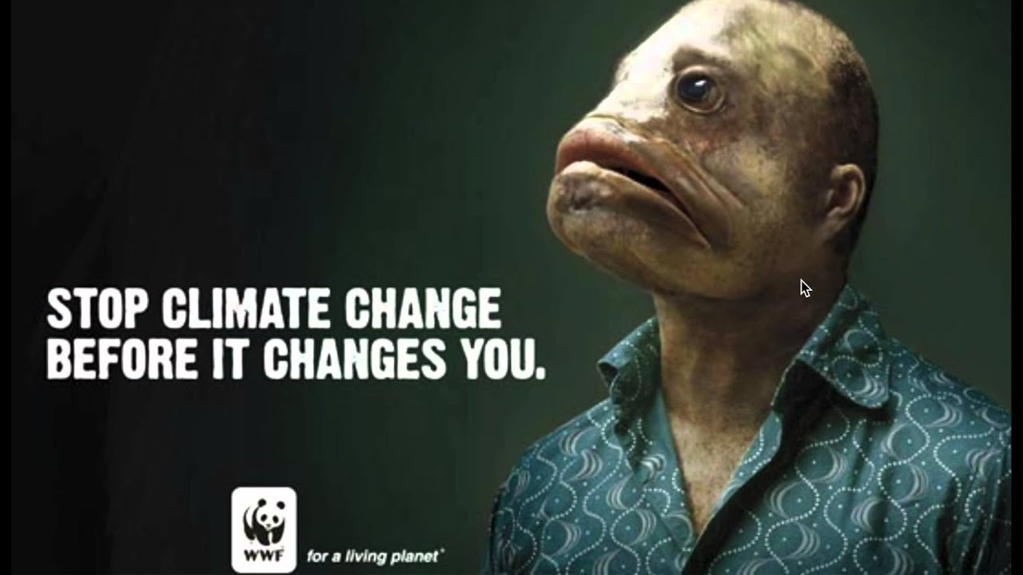
Excitement
Using excitement in your advertising can be perfect if you have a feature launch or something exciting to share with your audience. Excitement causes your mind and body to react, which can make people more likely to act and make a purchasing decision.
Sadness
Making people sad is a great way to get their attention. I know how awful that sounds, but it’s true. Remember that sad puppy commercial that Budweiser created back in 2014 with the puppies? It was sad in the beginning but made you feel good at the end, and was very memorable.
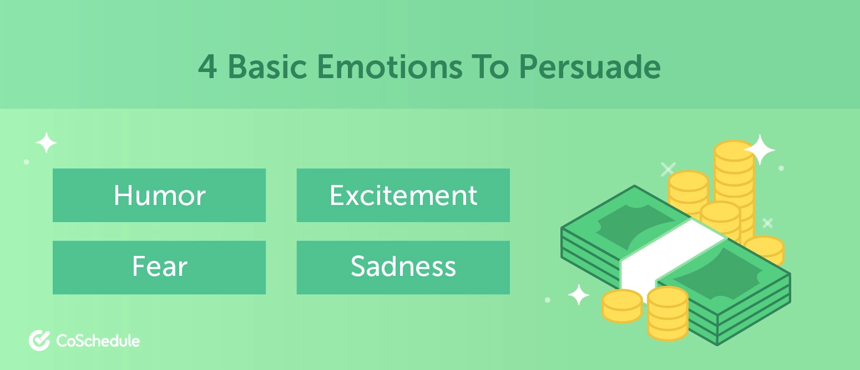
4 basic emotions to persuade
- Humor
- Fear
- Excitement
- Sadness
Every emotion persuades consumers in a different way, so make sure that the emotion you choose is the best match for your product and brand, and ultimately helps you towards the goal of your advertisement (a.k.a. make people buy).
Consumer Information Process
Now that we covered the basics, it’s important to know how your audience is going to process the information that you’re throwing in their face, literally.
There are 7 important steps that happen before your customer purchases. Ultimately, you have control over almost all of these steps.
Exposure to Information
This is the very first thing that happens when a viewer sees your ad.
This step stems from brand awareness. If it’s someone’s very first time seeing the ad, let alone your brand, they may not even notice it. That’s why it’s important to factor in repetition to make your audience more exposed to your advertisement.
Selective attention
Now that your consumer has been exposed to the information, it’s time to grab their attention (and never let go).
This step is tricky because you have no control over your consumer and there is no guarantee that they will see your ad.
What I mean is that just because you run a commercial, it doesn’t mean people are watching the TV, or just because you run a display ad, it doesn’t mean the consumer even looks at it. You have to make your target audience notice you with all the distractions going on in their everyday life.
Using the Color Psychology principles to attract viewers is one of the smartest ways to achieve their undivided attention.
Comprehension
This step is pretty important because if your consumer can’t comprehend what you’re selling, chances are they aren’t going to purchase. If you’re using the HEM approach, it’s important that you make sure that your underlying message is clear. Don’t let the message in your advertisement over shine your product.
Agreement
You’ve captured their attention, they understand what you’re selling, what’s next? Agreement. If you have a credible message that aligns with your target audience and their needs, this step should naturally happen.
Retention and Retrieval
Think back to the last ad you saw that you actually stood out.
Why did it stand out to you? This is your chance to make your ad stand out from the rest so when the consumer is ready to purchase, they think of you and not your competition.
Decision Making
At this step you’re so close, yet so far away. Your consumer realizes that your product may be right for them, but there are so many considerations in the decision making process.
Adding a call to action could be the extra push that your consumer needs to buy your product.
If the consumer decides to buy your product after seeing your advertisement, it doesn’t mean that they will follow through. Keep in mind that the product isn’t sold until that purchase is made.
Action
This final step was the goal all along, to make the consumer purchase your product.
Give yourself a pat on the back because this means your advertisement worked. Through all the ads that consumers are exposed to and the different steps their brain takes before purchasing a product, they chose yours.
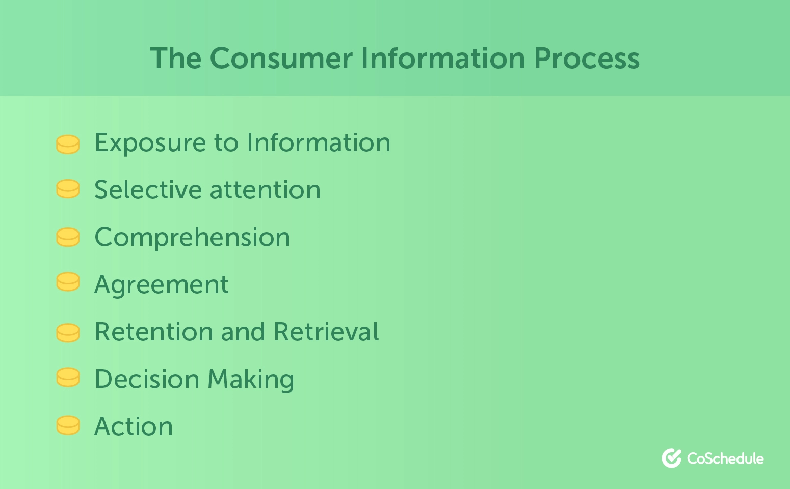

Persuasion and Authority
One of the best ways to persuade someone to action is to gain their trust or provide irrefutable logic. Advertising also uses these two basic principles to drive consumer purchase behavior. One of the most common ways advertising uses persuasion is through celebrity endorsement. Many consumers have a big (albeit often irrational) affinity for celebrities and give them implicit trust. Consumers feel they know these celebrities and believe if a product or service is good enough for the celebrity, then it is good enough for them. Celebrities can provide instant credibility for a product or service, often beyond what a “traditional” advertising program can provide.
Memories
Psychologists tell us memories change each time they are recalled, and the original story is altered just a little, thus becoming a new reality. Memories are thought to be a strong source of information, which they are, but just not always reflecting the true reality for which the memory is attached. Either way, memories are all we have of the past if we don’t have a recording of actual events. Advertising can leverage this biological gap to create affinity and intent. Every time a consumer recalls an ad it is an opportunity for a brand or product to create a new, happy or positive memory. By engaging in ongoing communications and advertising, companies can capitalize on recency to create and reinforce positive brand and product memories, potentially even crowding out past transgressions.
To illustrate the malleability of memories, Disney conducted an ad test with people who had visited one of their theme parks but did not actively recall meeting a character during the visit. After showing a test-group various commercials of the sights and sounds or the Disney Parks, including meeting Mickey, a staggering 90% of respondents recalled that they either remembered meeting Mickey or were confident that it might have happened.
Color
Colors illicit strong, and sometimes conflicting, emotions. Some evoke passion, mystery, and coldness while others convey happiness, trust or peace. Every color has a different purpose within an advertisement to control the emotion and perception of the ad, and thus the effectiveness in driving a specific reaction or action. Here are some examples of how each color can change the mood of an ad:
- Red: passion, energy, strength, love, power, determination, intensity, anger, excitement.
- Blue: depth, stability, wisdom, trust, confidence, calming.
- Yellow: energy, happy, warming, attention, aggravation, joy.
- Purple: wisdom, wealth, royalty, power, luxury, magic, powerful, calming, strength.
- Green: growth, health, harmony, safety, nature, calm, refreshed.
- Orange: enthusiasm, heat, success, creativity, warmth, excitement.
- White: purity, light, clean, sterile, innocent, spacious, cold, and unfriendly.
- Black: power, mystery, elegance, evil, mourning, death, confident, calm, stable, mysterious.
Psychology plays a large role in the overall design and success of an advertising campaign. By incorporating basic psychological principles, ads can be created to generate desired emotions and reactions, ultimately driving desired consumer behaviors. Ads can be targeted to specific demographic or psychographic groups enhancing brand recall and awareness and overall brand affinity.
Understanding the human mind and knowing how to use basic psychological principles is key to successful advertising and branding.

8 Social Psychology Lessons Applied to Marketing & Advertising
- Reciprocity
When a person receives a gift, she often experiences warm feelings toward the gift-giver and wants to give something back. This, in a nutshell, is the principle of reciprocity.
Here's what that looks like in action: The UK Behavioral Insights Team found that 11% of people were willing to donate an amount worth one day’s salary when they were given a small gift of candy while being asked for a donation, compared to 5% of those that were just asked for the donation.
What This Means for Marketers
Before asking something of your prospects, leads, or customers, provide them with a "gift" first -- as in, something for free. It doesn’t have to be big: Maybe a helpful ebook, a free consultation call, branded company swag, or even a handwritten note. Not only will people be more willing to follow through with your request, but you'll be portraying your company in a positive light, establishing brand loyalty, and leaving a community of brand evangelists in your wake.
- Foot-in-the-door Technique
In their famous 1966 experiment, Freedman and Fraser send someone around to ask people to place a small card in a window of their home supporting safe driving. Two weeks later, the same people were asked by a different person to put a large sign in their front yard advocating safe driving. The result: 76% of people who agreed to the first request now complied with the more intrusive request, compared to only 20% of people who were never asked to put a sign in their windows and were just asked to put up a large sign in their yards.
The lesson here is that you are more likely to get a big "yes" from someone if you get a small “yes” from them first. A bond forms between the requester and the requester during the small request, which makes them more likely to comply with a bigger request. Also, people tend to want to act consistently from how they acted in response to the first request.
What This Means for Marketers
Don’t ask someone to buy your product or set up an hour-long demo call when they visit your site for the first time. Make a smaller request instead; for example, asking to set up a quick 15-minute call to discuss something indirectly related to your product or service, like a consulting session. Think: Small requests before larger requests.
- Peer Comparison
When utility software company Opower wanted to encourage people to reduce energy consumption at home, it told people, “Your neighbors are reducing their energy use” and compared energy usage numbers within neighborhoods. This tactic led to a 4% reduction in household usage, as opposed to simply using the slogan “save energy to save money," which did not produce a reduction in household usage.
Peer comparison is connected to the theory of social proof, which is the positive influence created by finding out that other people are doing a certain action. This influence can lead someone to believe that they should be doing that same action.
What This Means for Marketers
In emails and landing pages, show prospects how many people with the same profession have downloaded this certain ebook or template. For example, you could place a ticker beside your social sharing icons showing how many of their colleagues have shared this post to their networks. This peer comparison should encourage both the downloading of the offer but also social sharing.
- Environment Effect
Meredith and Wheeler (2008) found that different polling environments impacted how people voted. For example, 56% of voters voted for a pro-school budget increase when voting in a school, compared to 53% of voters who voted in a location that wasn't a school. When reproduced in a lab, these results were found to be statistically significant when reproduced in a lab (64% versus 56%).
Our decisions are influenced by subconscious environmental cues. And at times, these activated cues are strong enough to influence the decisions we make by recalling past memories, attitudes, and predispositions to a certain topic.
What This Means for Marketers
When setting up sales calls for a product demo or price negotiation, schedule the call when the potential buyer is in an environment that he or she would be using the product -- usually the office, and not at home.
- Mere Exposure Effect
The theory behind the mere exposure effect is that you are more likely to have good feelings toward something that you are exposed to often. In 2000, Zajonc conducted a study in which it showed participants a series of foreign words, which they were asked to rate based on each word's connotation. The words that were shown repeatedly were rated, on average, one point higher in positivity than words that were only shown once.
What This Means for Marketers
Expose your marketing content to your buyer personas regularly by making sure they rank well in search. To succeed, you'll need to get to know your buyer personas like your best friends so your content ranks for a variety of topics they're searching for. The more exposure to your brand's content, the more likely they will feel positively toward your brand.
- Warm Environments and Product Valuation
The theory called the temperature premium effect is that physical warmth elicits positive emotions (or "emotional warmth"). A study published by The Journal of Consumer Psychology found that warm temperatures, which activate positive emotions, can actually increase a consumer’s product valuation. Participants in warm condition were willing to pay more for a pen ($8.72) than those in the cool condition ($7.20).
What This Means for Marketers
This is relevant to companies that have storefronts. When choosing your store atmosphere, it may be better to set the ambient temperature on the warmer side (although an optimal temperature has not been recorded in a study to date.)
- Expected vs. Surprise Rewards
In one experiment, children who had an interest in drawing were placed into three different experimental conditions: regular rewards, surprise rewards, and no rewards. After the experimenter left the room, the children were observed to measure the percentage of time they spent drawing after receiving their rewards (or lack thereof). Children in the surprise rewards condition drew 18% of their time alone, compared to 13% for those that received no rewards, and 5% for those that had regular rewards.
The study concluded that expected rewards reduce motivation on a task, but surprise rewards increase motivation on the same task. Expected rewards decrease intrinsic motivation, and up rise rewards maintain intrinsic motivation while also boosting mood.
What This Means for Marketers
Try providing your potential customers with surprise coupons or deals, rather than a promotion that exists weekly and at the same time each week.
- Scarcity
The scarcity principle goes back to the simple formula of supply and demand: The rarer the opportunity, content, or product, the more valuable it is to a consumer. Worchel, Lee, and Adewole (1975) asked people to rate chocolate chip cookies for their study. They put ten cookies in one jar, and two of the same cookies in another jar. The cookies from the two-cookie jar received ratings twice as high as the 10 cookie jar even though the cookies were exactly the same.
What This Means for Marketers
Scarcity is especially powerful for event marketing. If you’re looking to increase ticket sales, it might be worth sending a personalized email to people who haven’t registered yet to remind them that there are only X number of tickets left since so many people have registered. The same could be done for a webinar, or anything that has a limit on the number of registrants allowed.

