Cytoskeleton

History of Cytoskeleton
In 1903, Nikolai K. Koltsov proposed that the shape of cells was determined by a network of tubules that he termed the cytoskeleton. The concept of a protein mosaic that dynamically coordinated cytoplasmic biochemistry was proposed by Rudolph Peters in 1929 while the term (cytosquelette, in French) was first introduced by French embryologist Paul Wintrebert in 1931.
When the cytoskeleton was first introduced, it was thought to be an uninteresting gel-like substance that helped organelles stay in place. Much research took place to try to understand the purpose of the cytoskeleton and its components. With the help of Stuart Hameroff and Roger Penrose, it was discovered that microtubules vibrate within neurons in the brain, suggesting that brain waves come from deeper microtubule vibrations. This discovery demonstrated that the cytoskeleton is not just a gel-like substance and that it actually has a purpose.
Initially, it was thought that the cytoskeleton was exclusive to eukaryotes but in 1992 it was discovered to be present in prokaryotes as well. This discovery came after the realization that bacteria possess proteins that are homologous to tubulin and actin; the main components of the eukaryotic cytoskeleton.
Definition of Cytoskeleton
The cytoskeleton is a complex, dynamic network of interlinking protein filaments present in the cytoplasm of all cells, including bacteria and archaea. It extends from the cell nucleus to the cell membrane and is composed of similar proteins in the various organisms. In eukaryotes, it is composed of three main components, microfilaments, intermediate filaments and microtubules, and these are all capable of rapid growth or disassembly dependent on the cell's requirements.

Cytoskeleton Elements
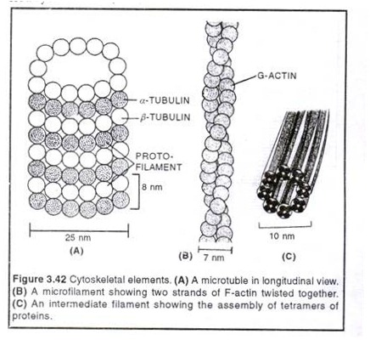

Functions of Cytoskeleton
A multitude of functions can be performed by the cytoskeleton. Its primary function is to give the cell its shape and mechanical resistance to deformation, and through association with extracellular connective tissue and other cells it stabilizes entire tissues. The cytoskeleton can also contract, thereby deforming the cell and the cell's environment and allowing cells to migrate. Moreover, it is involved in many cell signaling pathways and in the uptake of extracellular material (endocytosis), the segregation of chromosomes during cellular division, the cytokinesis stage of cell division, as scaffolding to organize the contents of the cell in space and in intracellular transport (for example, the movement of vesicles and organelles within the cell) and can be a template for the construction of a cell wall. Furthermore, it can form specialized structures, such as flagella, cilia, lamellipodia and podosomes. The structure, function and dynamic behavior of the cytoskeleton can be very different, depending on organism and cell type. Even within one cell, the cytoskeleton can change through association with other proteins and the previous history of the network.
A large-scale example of an action performed by the cytoskeleton is muscle contraction. This is carried out by groups of highly specialized cells working together. A main component in the cytoskeleton that helps show the true function of this muscle contraction is the microfilament. Microfilaments are composed of the most abundant cellular protein known as actin. During on parallel actin filaments. Muscle contraction starts from nerve impulses which then causes increased amounts of calcium to be released from the sarcoplasmic reticulum. Increases in calcium in the cytosol allows muscle contraction to begin with the help of two proteins, tropomyosin and troponin. Tropomyosin inhibits the interaction between actin and myosin, while troponin senses the increase in calcium and releases the inhibition. This action contracts the muscle cell, and through the synchronous process in many muscle cells, the entire muscle.
Types of Cytoskeleton
There are three basics types of Cytoskeleton.
- Microtubules
- Microfilaments
- Intermediate filament
Microtubules
Microtubules are hollow cylinders about 23 nm in diameter (lumen = approximately 15 nm in diameter), most commonly comprising 13 protofilaments that, in turn, are polymers of alpha and beta tubulin. They have a very dynamic behavior, binding GTP for polymerization. They are commonly organized by the centrosome.
In nine triplet sets (star-shaped), they form the centrioles, and in nine doublets oriented about two additional microtubules (wheel-shaped), they form cilia and flagella. The latter formation is commonly referred to as a "9+2" arrangement, wherein each doublet is connected to another by the protein dynein. As both flagella and cilia are structural components of the cell, and are maintained by microtubules, they can be considered part of the cytoskeleton.

There are two types of cilia: motile and non-motile cilia. Cilia are short and more numerous than flagella. The motile cilia have a rhythmic waving or beating motion compared to the non-motile cilia which receive sensory information for the cell; processing signals from the other cells or the fluids surrounding it. Additionally, the microtubules control the beating (movement) of the cilia and flagella. The dynein arms attached to the microtubules function as the molecular motors. The motion of the cilia and flagella is created by the microtubules sliding past one another, which requires ATP.

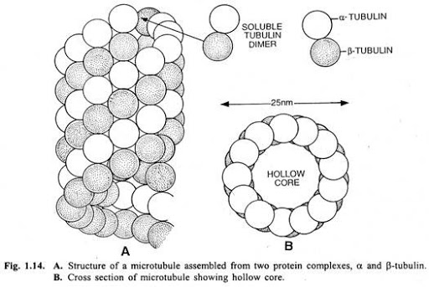

Functions of Microtubules
They play key roles in:
- Intracellular transport (associated with dyneins and kinesins, they transport organelles like mitochondria or vesicles)
- The axoneme of cilia and flagella.
- The mitotic spindle.
- Synthesis of the cell wall in plants.
Intermediate Filaments
Intermediate filaments are a part of the cytoskeleton of many eukaryotic cells. These filaments, averaging 10 nanometers in diameter, are more stable (strongly bound) than microfilaments, and heterogeneous constituents of the cytoskeleton. Like actin filaments, they function in the maintenance of cell-shape by bearing tension (microtubules, by contrast, resist compression but can also bear tension during mitosis and during the positioning of the centrosome). Intermediate filaments organize the internal tridimensional structure of the cell, anchoring organelles and serving as structural components of the nuclear lamina. They also participate in some cell-cell and cell-matrix junctions. Nuclear lamina exist in all animals and all tissues. Some animals like the fruit fly do not have any cytoplasmic intermediate filaments. In those animals that express cytoplasmic intermediate filaments, these are tissue specific. Keratin intermediate filaments in epithelial cells provide protection for different mechanical stresses the skin may endure. They also provide protection for organs against metabolic, oxidative, and chemical stresses. Strengthening of epithelial cells with these intermediate filaments may prevent onset of apoptosis, or cell death, by reducing the probability of stress.
Intermediate filaments are most commonly known as the support system or “scaffolding” for the cell and nucleus while also playing a role in some cell functions. In combination with proteins and desmosomes, the intermediate filaments form cell-cell connections and anchor the cell-matrix junctions that are used in messaging between cells as well as vital functions of the cell. These connections allow the cell to communicate through the desmosome of multiple cells to adjust structures of the tissue based on signals from the cells environment.

Intermediate Filaments
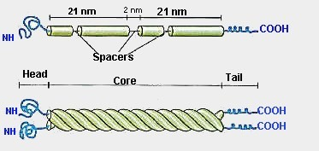
Different intermediate filaments are:
- made of vimentins. Vimentin intermediate filaments are in general present in mesenchymal cells.
- made of keratin. Keratin is present in general in epithelial cells.
- neurofilaments of neural cells.
- made of lamin, giving structural support to the nuclear envelope.
- made of desmin, play an important role in structural and mechanical support of muscle cells.
Microfilament
Microfilaments, also known as actin filaments, are composed of linear polymers of G-actin proteins, and generate force when the growing (plus) end of the filament pushes against a barrier, such as the cell membrane. They also act as tracks for the movement of myosin molecules that affix to the microfilament and "walk" along them. In general, the major component or protein of microfilaments are actin. The G-actin monomer combines to form a polymer which continues to form the microfilament (actin filament). These subunits then assemble into two chains that intertwine into what are called F-actin chains. Myosin motoring along F-actin filaments generates contractile forces in so-called actomyosin fibers, both in muscle as well as most non-muscle cell types. Actin structures are controlled by the Rho family of small GTP-binding proteins such as Rho itself for contractile acto-myosin filaments ("stress fibers"), Rac for lamellipodia and Cdc42 for filopodia.

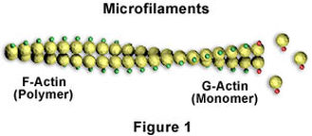

Functions of Microfilament
- Muscle contraction
- Cell movement
- Intracellular transport/trafficking
- Maintenance of eukaryotic cell shape
- Cytokinesis
- Cytoplasmic streaming
Conclusion
- Cell division is very important process to continue organism’s LIFE CYCLE. Mitosis is a somatic cell division which causes the growth of a living body. Pattern of mitosis is fundamentally same in all cells. Mitosis is observed in all types of cell i.e. haploid, diploid or polyploid. Hereditary material is equally distributed between two daughter cell.

- Microtubules and actin filaments are thought to formed a basic foundation of cytoskeleton. The microtubules are believed to be overall organizer of the cytoskeleton, affecting the position and functions of both actin and intermediate filament. In addition the function of various organelles depend on microtubules.

