Timurid art
History Art and Culture

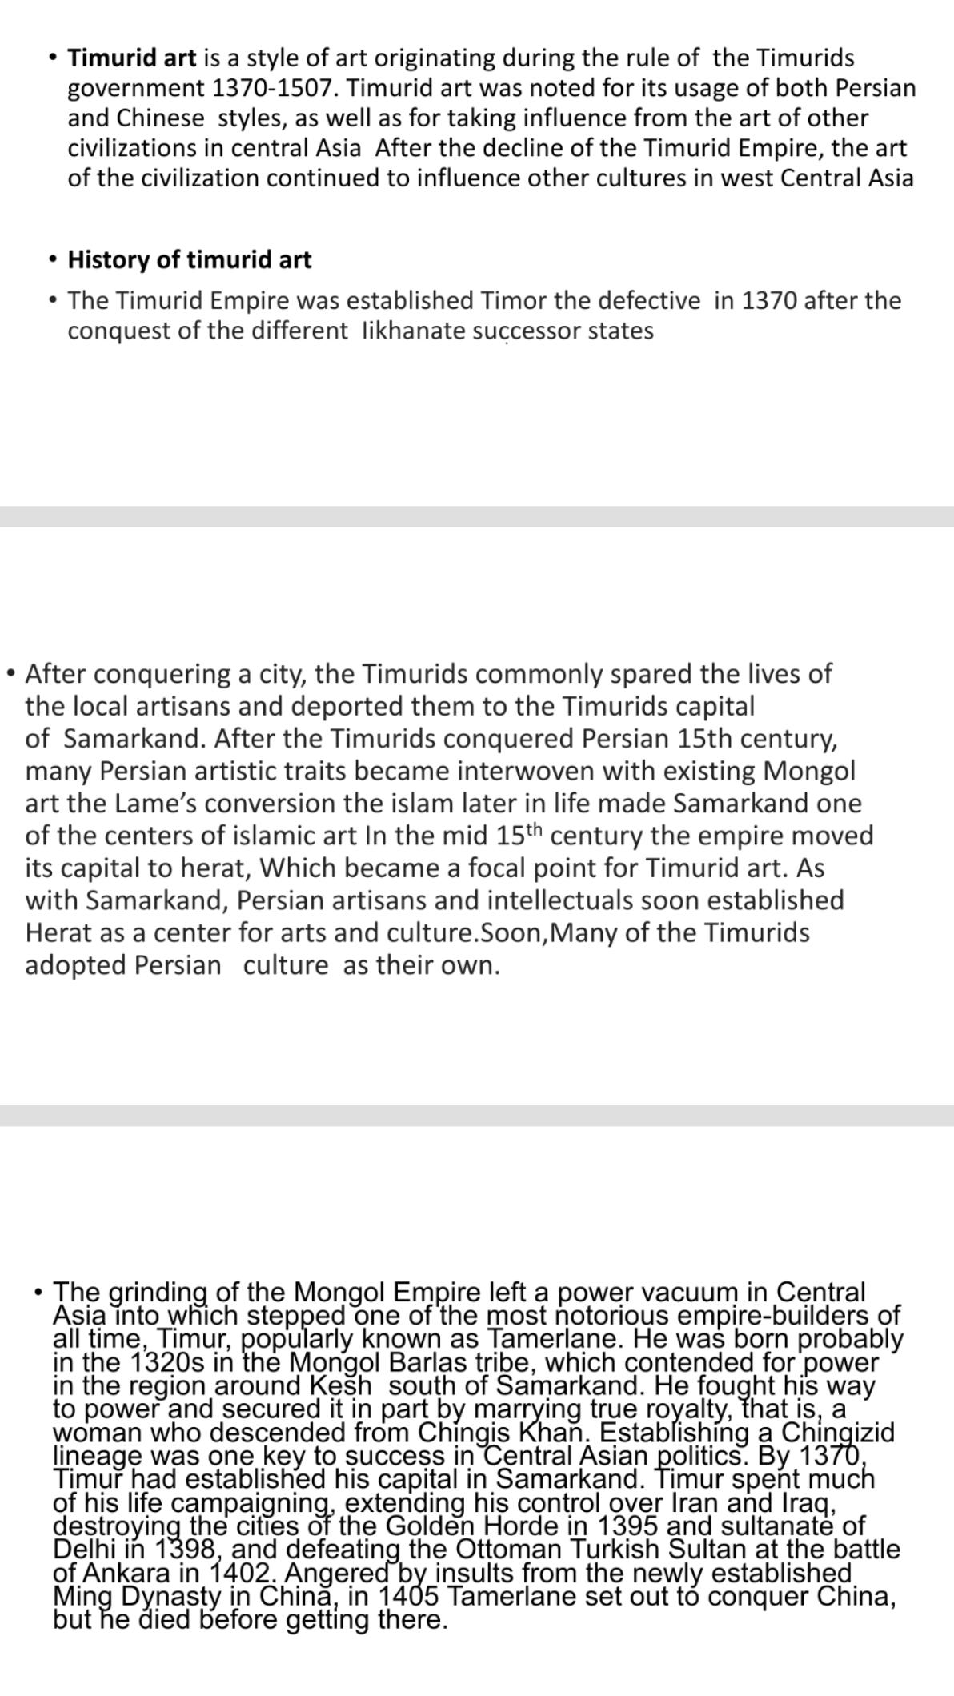
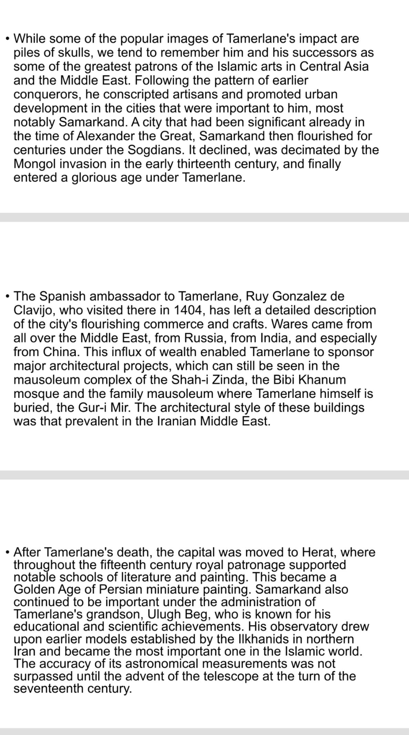
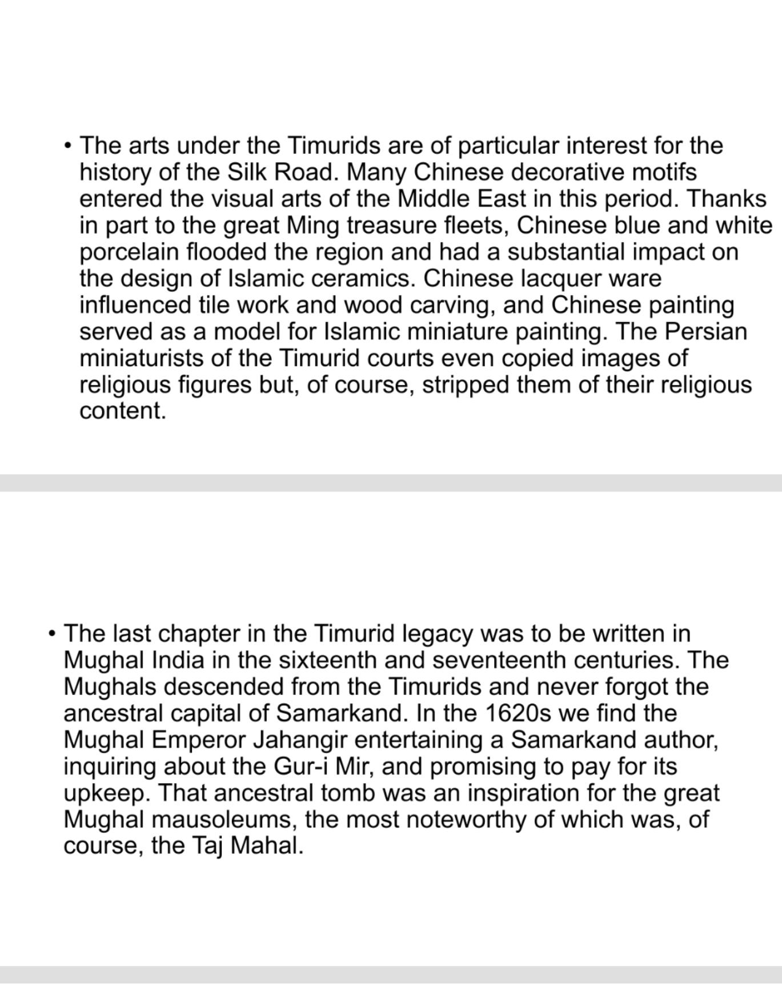

Timurid art is a style of art originating during the rule of the Timurid Empire (1370-1507). Timurid art was noted for its usage of both Persian and Chinese styles, as well as for taking influence from the art of other civilizations in Central Asia. After the decline of the Timurid Empire, the art of the civilization continued to influence other cultures in West and Central Asia.
History.
The Timurid Empire was established by Timor the Lame in 1370 after the conquest of the various Ilkhanate successor states. After conquering a city, the Timurids commonly spared the lives of the local artisans and deported them to the Timurid capital of Samarkand. After the Timurids conquered Persia in the early 15th century, many Persian artistic traits became interwoven with existing Mongol art. Timor the Lame's conversion to Islam later in life made Samarkand one of the centers of Islamic art. In the mid 15th century the empire moved its capital to Herat, which became a focal point for Timurid art. As with Samarkand, Persian artisans and intellectuals soon established Herat as a center for arts and culture. Soon, many of the Timurids adopted Persian culture as their own.
Illustration.
Timurid art absorbed and improved upon the traditional Persian concept of the "Arts of the Book". The new, Timurid-inflected works of art saw illustrated paper (as opposed to parchment) manuscripts produced by the empire's artists. These illustrations were notable for their rich colors and elaborate designs. Due to the quality of the miniature paintings found in these manuscripts, Suzan Yalman of the Metropolitan Museum of Art noted that "the Herat school [of manuscript painting] is often regarded as the apogee of Persian painting. Painting was not limited to manuscripts, as many Timurid artists also created intricate wall paintings. Many of these wall paintings depicted landscapes derived from both Persian and Chinese artistic tradition.While the subject matter of these paintings was borrowed from other cultures, Timurid wall paintings were eventually refined into their own, unique style. Mongol artistic traditions were not entirely phased out, as the highly stylized depictions of human figures seen in 15th century Timurid art are derived from this culture.
Metalwork, ceramics, and carving
The Timurid Empire also produced quality pieces of metalwork. Steel, iron, brass, and bronze were commonly used as mediums.Timurid silver-inlaid steel is often being cited as being of particularly high quality. Following the collapse of the Timurid Empire, several Iranian and Mesopotamian cultures co-opted Timurid metalwork.
Chinese-style ceramics were produced by Timurid artisans. Jade carving also had some presence in Timurid art.
Legacy.
Following the decline of the Timurid Empire in the late 15th century, the Ottomans, Safavid dynasty, and Mughal Empire co-opted Timurid artistic traditions into their own.

Timurid carved jade sword hilt.
/

Timurid-inspired image of Babur.
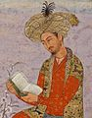
15th century Timurid tankard made in Herat.
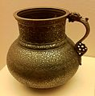
Works of Art
The Timurids were the final great dynasty to emerge from the Central Asian steppe. In 1370, the eponymous founder, Timur (Tamerlane), who belonged to a Turko-Mongol tribe settled in Transoxiana, became master of this province and established Samarqand as his capital. Within thirty-five years, he subjugated all of Central Asia, greater Iran, and Iraq, as well as parts of southern Russia and the Indian subcontinent. To the west, Timurid forces defeated the Mamluk army in Syria and that of the Ottomans at Ankara (1400–1402). In 1405, while preparing to invade China, Timur died. The vast empire he carved proved to be difficult to keep; his son and successor, Shah Rukh (r. 1405–47), barely managed to maintain the empire’s boundaries, and subsequent Timurid princes sought to establish their own kingdoms, weakening the empire with internal strife. Eventually only Khurasan and Transoxiana remained Timurid, and during the remaining years of the dynasty, these were ruled by separate branches of the Timurid family.
By bringing craftsmen from different conquered lands to his capital in Samarqand, Timur initiated one of the most brilliant periods in Islamic art. Timurid art and architecture provided inspiration to lands stretching from Anatolia to India. Though Timur’s extensive empire itself was relatively short-lived, his descendants continued to rule over Transoxiana as leading patrons of Islamic art. Through their patronage, the eastern Islamic world became a prominent cultural center, with Herat, the new Timurid capital, as its focal point. Timurid rulers were sympathetic to Persian culture and lured artists, architects, and men of letters who would contribute to their high court culture. Some of these rulers were also great patrons of the arts of the book, commissioning manuscripts that were copied, compiled, and illustrated in their libraries. Due to the flourishing of manuscript illumination and illustration, the Herat school is often regarded as the apogee of Persian painting. The Timurid period saw great achievements in other luxury arts, such as metalwork and jade carving. This cultural efflorescence found its ultimate expression at the court of Sultan Husain Baiqara (r. 1470–1506), the last effective Timurid ruler.
Many Timurid princes were also prodigious builders—religious institutions and foundations such as mosques, madrasas, khanqahs (convents), and Sufi shrines were the main beneficiaries of their building programs. Major architectural commissions from Timur’s lifetime include the Aq Saray Palace (Shahr-i Sabz, ca. 1379–96); the shrine of Ahmad Yasavi (Turkestan City, ca. 1397); Timur’s congregational mosque (Samarqand, ca. 1398–1405), popularly known as the mosque of Bibi Khanum after his wife, who built a madrasa next to it; and the Gur-i Amir (Samarqand, ca. 1400–1404), Timur’s burial place. Trademarks of the Timurid style were monumental scale, multiple minarets, polychromy tilework, and large bulbous double domes. The Timurid period also witnessed women as active patrons of architecture. Along with their immediate successors, the Shaibanids, the Timurid cultural tradition was also partly carried on by the Ottoman, Safavid, and Mughal empire
Timurid art history
- Timurid is a style of art originating during the rule of the Timurid Empire 1370-1507. Timurid art was noted for its usage of both Persian and Chinese styles, as well as for taking influence from the art of other civilizations in Central Asia. After the decline of the Timurid Empire, the art of the civilization continued to influence other cultures in West and Central Asia.

- The first khan of Tamurid period was Temur or Timur ,one of the last nomadic Mongol
conqurerors to rule.Timur was of mongol Turkis descent The term Tinured is derive from his
name ,he took over part of empire established by Genghis khan Timur also known as Timur lang
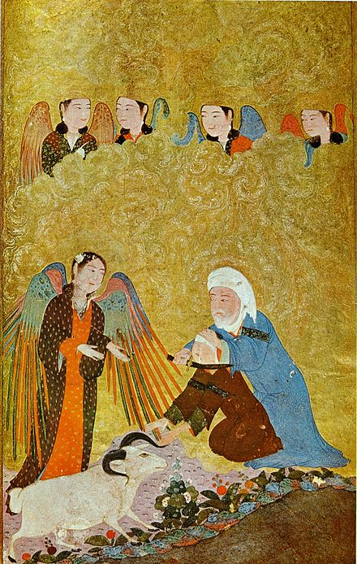
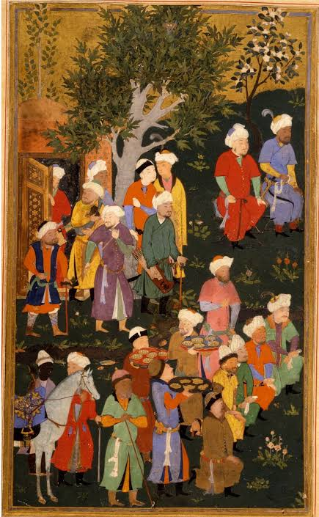
- The Timurid Empire was established by Timor the Lame in 1370 after the conquest of the various Ilkhanate successor states. After conquering a city, the Timurids commonly spared the lives of the local artisans and deported them to the Timurid capital of Samarkand. After the Timurids conquered Persia in the early 15th century, many Persian artistic traits became interwoven with existing Mongol art. Timor the Lame's conversion to Islam later in life made Samarkand one of the centers of Islamic art. In the mid 15th century the empire moved its capital to Herat, which became a focal point for Timurid art.

