ABSTRACT

Film is a visual receptor. Film is as type of Broadcast Media belongs to your interest’s topic, using equipment (belongs of technology) and to arrange them through the process of editing. As film is a major area of Broadcast Media, and it is used as a medium/media to convey a detailed message to the mass amount of people through one domain. So that Film is a form of Media.

MASS MEDIA

Mass media is a form of media which is addressed for large audiences (masses). It can be any form of media, broadcast such as television or radio, films, print media such as newspapers, magazines, pamphlets etc. In today’s generation internet media can also be considered as mass media because most these existing Medias use internet media to have an advantage of the available medium in many regions of the world. This medium can be termed as the interactive media. “To understand mass media first and important step is to understand communication”.

WHAT IS FILM
Film Communication a process of transferring meanings or information through visual receptor. It is a man who creates this form of communication. There exists a cognitive relationship between a filmmaker and a viewer. Cinema is perhaps the mainstreams of all art forms and most accessed and most preferred especially in India. Therefore, it is very important to understand how the country, its people and its aspirations are represented in the cinema. Cinemas can be a form of art, entertainment, social document or critique.
“Filming is all about to do a lot of artificiality to just show a real feel.” Film is a reflection of society for both the present and the past. Film and its innovation sometimes have to catch up to society but sometimes it leads the society and culture too.

CINEMA
Motion Pictures, a motion Picture theater, motion movies, the Art or technique of making moving visuals is defined as cinema. A movie theater, cinema, or cinema hall, also known as a picture house, the pictures, or the movies, is a building that contains auditoria for viewing films for entertainment. Most, but not all, theaters are commercial operations catering to the general public, who attend by purchasing a ticket.

DIFFERENCE BETWEEN FILM AND CINEMA

Movies is slang for a motion picture. Film is the medium on which motion pictures are fixed. Cinema is from the French cinématographe which comes in part from the greek kinema, meaning movement. So, cinema is really just another word meaning moving picture.

OBJECTIVE OF FILMS
- To covey your message to the masses
- To share your idea with others
- To compare your ideologies with other people
- To show your ideology that How you look to the society
- To engage your audience with your production/film
- To introduce a new way as a medium/tool for masses

STAGES/ELEMENTS OF FILM

Here are three main stages of filmmaking
- Pre-production
- Production
- Post-production

Pre-production:

Pre-Production is essential in the filmmaking process, because without proper planning, your production count run over time, the film could go over budget, or you could find yourself in the editing room with missing content. Some even say, “Production is Pre-Production.” Whether its storyboarding, location scouting or budgeting, each of the steps of pre-production plays a role in the success of your project.

Production:

Production is a second main essential in filmmaking, through production process you picturize your idea as per your script planning. Production process starts when you go out for shooting with the production equipment and you capture the scenes according to your storyboarding till editing. The process of Production includes Camera Framing, Pixels quality, Sound purity, Takes and retakes of the scenes, Cinematography, Set designing, Lights balancing, etc.

Post Production:

The Process of doing final editing with video shot, designing sound and to play with follies and after effects in editing software according to the designed script. This essential is very important because this production process shows what to show on a screen to your editing. Some even say, “Editing decides as your film is best or worst”

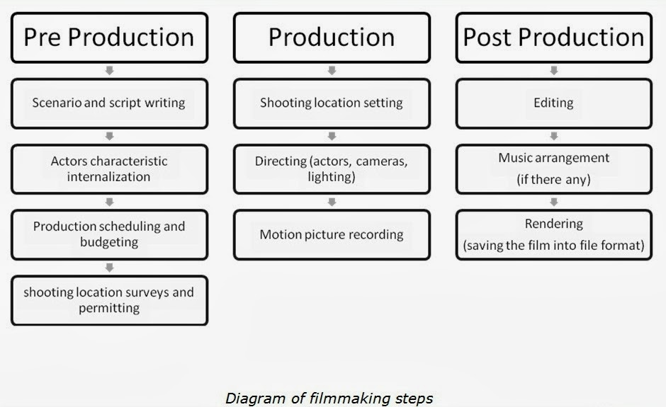

TYPES OF FILMS

If you go for the types of Films then here are a lot of types for Films. But the major genera of the Films are,
- Action Films
- Animated Films
- Disaster’s Films
- Comedy Films
- Historical Films
- Documentary Films
- Science Fiction Films
- Thriller Films
- War Films
- Romantic Films
- Musical Films, etc.

WHAT IS MEDIA/MEDIUM

Media is a term derived from the word medium that means tool, source or way. So media is the way through which you convey your message from one place to another. It could be you, it could be your voice, it could be a book, it could be the television or it could be anything like this that you use as a source or a tool.

FILM AS A FORM OF MEDIA
The motion picture today is the greatest medium of expression the world has ever known. Film as one such form of mass media has a great impact on the societies in many ways. Film industry is one of the most expensive and discovering industry in mass media. In true sense it is a dream industry.
Another footprint in the sand of communication is after the invention of films. Cinema or film a form of Mass Media has become a powerful tool since the day it was introduced to the world.
Today’s generation films have handled a lot of controversial topic has a main plot in this movies. Topics such as religion, terror attacks, transgender, homosexuality, child labor, poverty etc. Movies have actually brought to the world an idea about all the above and many more through their stories and concepts. But at the same time they idealize or generalize few things for the profit sake and public believes it and it finally becomes a stereotype process.

CONCLUSION

As Film is a major essential of Media and also used as a medium to convey a productive approach to the masses, so to show any Film belongs to any category (War, emotional, romantic, fiction, etc.) always provide the entertainment, information and somehow fulfill the desires of the viewers at ones. Because people go to the theatre or cinema as a practice, habit, sometimes even for information or entertainment. So, Film is a very effective form of Media in this running era.

