TOPIC:
TRANSCRIPTION
BACKGROUND
Roger David kornberg (born April 24 ,1947 is an amercian biochemist and professor of sturctural biology at stanford university school of medicine.kornberg was awarded the noble prize in chemistry in 2006 for his studies of the process by which genetic information from DNA is copied to RNA ,'the molecular basis of eukaroyotic transcription .Kornberge became a postdoctoral rescarch fellow at the labortary of molecular biology in Cambridge ,England and then an Assistant professor of biological chemistry at farward medicial in 1976 ,before to his first position as professor of structural biology at stanford medicial in 1978 Kornberg leads to the discovery of transcription
TRANSCRITION (BIOLOGY)
Transcription is the first step of DNA based gene expression in which a particular segment of DNA is copied into RNA (especially mRNA) by the enzytme RNA polymerase
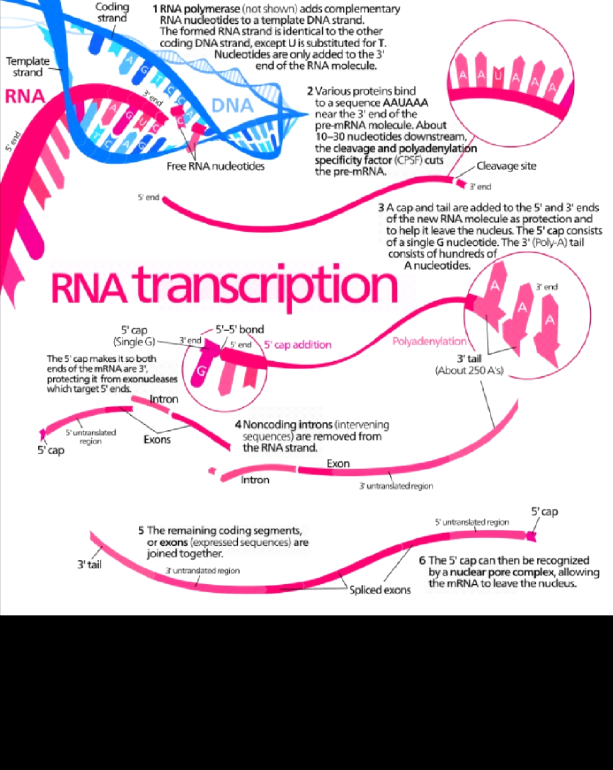
Both DNA and RNA are nucleic acids ,which use base pairs of nucleotides as a complementary language .During transcription a DNA sequence is read by an RNA polymerase ,which produces a complementary ,antiparallel RNA strand called a primary trancript
Transcription proceeds in the following steps
* RNA polymerase together with one or more general transcription factors , binds to promoter DNA.
* RNA polymerase generates a transcription bubbles , which separates the two stands of the DNA helix .This is done by breaking the hydrogen bonds between complementary DNA nucleotides .
* RNA sugar-phosphate backbone forms RNA polymerase to form an RNA stands .
* Hydrogen bonds of the RNA -DNA helix break,feelings the newly synthesized RNA stands .
* If the cell has a nucleus ,the RNA may be further processed .This may include polyadenylation ,capping ,and splicing .
*The RNA may remain in the nucleus or exit to the cytoplasm through the nuclear pore complex.
The stretch of DNA transcripted into an RNA molecule is called a transcripted unit and encodes at least one gene .If the gene encodes a protein ,the transcription produces messenger RNA (mRNA) ;the mRNA ,in turn ,serves as a template for the proteins synthesis through translation .Alternatively ,the transcribed gene may encode for non coding RNA such as microRNA ,ribosomal RNA (rRNA ) ,Transfer RNA (tRNA) ,OR ENZYMATIC RNA molecule called ribozymes .Overall ,RNA helps synthesis ,regulate,and process proteins ;it thereforeplays a fundamental role in performing functions within a cell .
In virology,the term may also be used when referring to mRNA synthesis from an RNAA MOLECULE (I.E ,RNA replication ) .FOR INSTANCE ,THE GENOME OF A NEGATIVE -SENSE SINGLE -STRANDED RNA (ssRNA ) VIRUS MAY BE TEMPLATE FOR A POSITIVE -SENSE SINGLE STRANDED RNA (ssRNA) VIRUS MAY BE template for a positive sense single stranded RNA .THIS is because the positive sense strand contains the informatiom nedeed to translate the viral proteins for viral replication afterwards .This process is catalyzed bu viral RNA REPLICASE.
BACKGROUND
A DNA transcription unit encoding for a protein may contain both a coding sequence which will be translated into the protein and the regulatory sequences which direct and regulate the synthesis of that protein .The regulatory sequence before UPSTREAM from the coding sequence is called five prime translated region 5UTR ,the sequence after DOWNWARDSTREAM from the coding sequence is called the 3 prime untranslatedregion 3UTR.
As oppose to DNA replication ,TRANSCRIPTION results in a RNA complement that includes the nucleotide uracil in all instances where thymine would have occured in a DNA complement.
only one of the two DNA strands serve as a template for transcription. the antisense strand of DNA is read by RNA polymearse from the 3 prime to 5 prime during transcription .The complementory RNA is created in the opposite direction ,in the 5 prime to 3 prime direction ,Matching the sequence of the sense strand with the exception of switching urcail for thymine.This directionality is because RNA polymerase can only add nucleotides to the 3' end of the growing mRNA chain .this use of only the 3' .....5' DNA strand eliminates the need for the Okazaki fragments that are seen in DNA replication .This also removes the need an RNA primer to initiate RNA synthesis ,as is the case in DNA replication .
The non-template (sense ) strands of DNA is called the coding strands ,because its sequence is the same as the newly created RNA transcript (except for the substitution of urail for thymine ) .This is the stand that is used by convention when presenting a DNA sequence .
Transcription has some proofreading machanisms ,but they are fewer and less effective than the control for coping DNA
INITIATION
Transcription begins with the bliding of RNA polymerase ,together with one or more general transcription factors to a specific DNA sequence reffered to as a 'promoter ' to form an RNA polymerase -promoter 'closed complex' .In the 'closed complex ' the promoter DNA is still fully double -stranded .
RNA -polymerase assisted by one or more general transcription factors ,then unwinds approximately 14 base pairs of DNA to form an RNA polymerase 'open complex' the promoter DNA is partly unwound and single -standed .The exposed ,single -standed .The exposed ,single -standed DNA is referred to as the 'transcription bubble'
RNA polymerase ,assisted by one or more general transcription factors ,then selects a transcrition bubble,binds to an initiating NTP and an extending NTP (OR a short RNA primer and an extending NTP ) Complementery to the transcription start site sequence ,and catalyze bond formation to yield an initial RNA product .
in bacteria ,RNA polymerase holoenzyme consist of five subunits 2 a subunits 1 B subunit,1 B' subunit and 1 W subunit .in bacteria ,there is one general RNA transcription factor known as a sigma factor .RNA polymerase core enzeme binds to the bacterial general transcription (sigma) factor to form RNA polymerase holoenzyme and then binds to a promoter .
IN archaea and eukaryoutes ,RNA polymerase contains sub units homologous to each of the five RNA polymerase subunits in bacteria and also contain bacteria and also contain additional sub units .In archaea and eukaryoutes ,the functions of the bacterial general transcription factor sigma are proformed by multiple general transcription factors that works together
Teanscription initiation is regulated by additional proteins ,known as activators and repressor ,and ,in some cases ,associated coactivators or corepressor ,which modulate formation and function of the transcription inititation complex.
PROMOTER ESCAPE
After the first bond is synthesized ,the RNA polymerase must escape the promoter .During the first time there is a tendency to release the RNA THE transcript and produce truncated transcripts.THIS is called absortive initation ,and is common for both eukaryotes and prokaryoutes .
Mechanistically ,promoter escape occursthrough DNA scrunching ,providing the energy needed to break interactions between RNA polymerase holomerase holoenzyme and the the promoter
In bacteria ,it was historically thought that the sigma factor is definitely released after promoter clearance occurs .This theory had been known as the onligate release model
In eukaryotes at an RNA polymerase II-dependent promoter ,upon promoter clearance ,tfIIH phosphoelylates serine 5 on carboxy terminal domain of RNA polymerase II ,leading to the recruitment of capping enzyme
ELONGATION
One strand of the DNA ,the template strand is used as a template for RNA synthesis .As transcription proceeds ,RNA polymerase traverses the templete stands and user base pairing complementary with the DNA TEMPLETE TO CREATE AN RNA copy .
mRNA transcription can involve multiple RNA polymerase on a single DNA template and multilple rounds of transcription ,so many mRNA MOLECULES CAN be rapidly produced from a single cpy of a gene
Elongation also involves a proofreading mechanism that can replace incorrectly incoropted bases .in eukaryoutes ,thismay correspond with short pauses during transcription that allow appropriate RNA editing factors to bind
TERMINATION
Bacteroia use only two different strategies for transcription terminition -Rho -independent termination-Rho -independent termination and RHO dependent termination in RHO-Dependent transcription termination ,RNA stops when the the newly synthesized RNA molecule forms a G-C-rich hairin loop following by a run of Us
Transcription terminationin eukaryoute is less well understood than in bacteria ,but involves cleavage of the new transcript followed by template -independent addition of adenines at its new 3' end ,in a process called polydenlation.
INHIBITORS
Transcription inhibitor can be used as antibiotics againist ,for example ,Pathogenic bacteria and fungi .An example of such an anti bacterial is rifampicin ,which inhibit bacterial transcription of DONA INTO mRNA by inhibiting DNA -dependent RNA polymerase by binding DNA dependent RNA polymerase by binding its beta-subunit,while8-hydroxyquinoline is an abtifungaltranscription inhibtor .
ENDOGENOUS INHIBITOR
IN VERTEBRATES ,THE majority of gene promoterscontain a cpg island with numerous cpG sites .when many of the gene's promoterCpG sites are methylated the gene becomes a inhibited .colorectal cancers typically have 3 to 6 drivers mutations and 33 to 66 hitchhikers or passengers mutations in causinfg progressing to cancer .eg in colorectal cancers about 600 to 800 genes are tanscriptionally inhibited by CpG island methylation .
TRANSCRIPTION FACTORIES
Active transcription units are clustered in the nucleus ,in discrete sites called transcription factories or euchomantin.Such sites can be visualized by allowing engaged polymerases to extend their transcripts in tagged precursors and immuno-LABELING the tagged nuscent RNA .Transcript factories can be localized using flourescence in situ hybridized or marked by antibodies directed against polymerases.
HISTORY
A molecule that allows the genetic material to be realized as a protein was first hypothesized by FRANSCOIS JACOB .savero ochao was a Noble prizr in physiology or Medicine in1959 for developing a process for synthesizing RNA INTO VITRO with polynucleotide ,which was useful for cracking the genetic code.RNA synthesis byRNA polymerases was established by vitro by several laborateries by 1965 however, ,the RNA synthesized by these enzymes had properties that suggested the existence of an additional factor needed to terminate transcription correctly.
MEASURING AND DETECTING
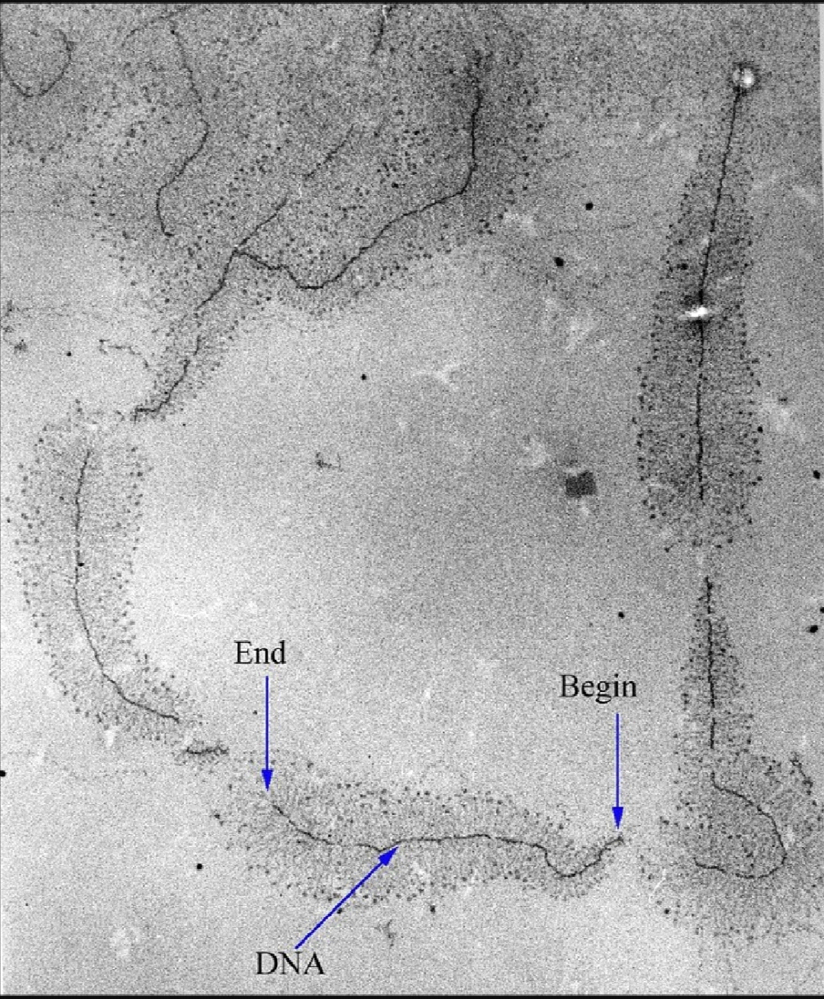
Transcription can be measured and detected in a variety of way
*G-Less cassette transcription assay,measure promoter strenght
*Run -off transcription assay .identifies transcription start sites
*Nuclear run-off assay.measures the relative abundance of newly formed transcript
*KAS -seq .measures single-stranded DNA geneated by RNA polymerase ,can work with 1000 cells
*RNA SEQUANCE , applies next -generation sequencing techniques to sequence whole transcriptomes , which allows the measurement of relative abundance of RNA ,as well as the detection of additional variations such as fusion genes,pemains ost transcriptional edits and novel splice sites
*Single cell RNA -Seq . amplifies and reads partial transcriptomes from isolated cells ,allowing for detailed analyses of RNA in tissues ,embroyos,and cancers
REVERSETRANSCRIPTION
SOME tissues have the ability to transcribe RNA into DNA .HIV has an RNA has an RNA genome that is reverse transcribed into DNA .THE resulting DNA can be merged with the DNA genome for the host cells
In the case of HIV,revserse transcriptase is responisible for synthesizing a complementary DNA strand to the viral RNA genome .HOWEVER,,in other retroviruses ,the host cell remains intact as the virus buds out of the cell
Telomerase is often activated in cancers cells to enable cancer cells duplicate their genomes indefinitely without losing important protein-coding DNA sequence
SELL ALSO
*LIFE
*CELL BIOLOGY
*CELL DIVISION
*GENE
*GENE REGULATION
*GENE EXPRESSION
*EPIGENETICS
*GENOME
*CRICK S CENTRAL DOGMA in which the product of transcription ,mRNA ,is translated to form polypeptites ,and where it is asserted that the reverse processes never occur
*TRANSCRIPTION BUBBLE IS a molecular structure formed during DNA transcription when a limited portion of the DNA double strand is unwound .The size of a transcription bubble range fron 12-14base of pair.

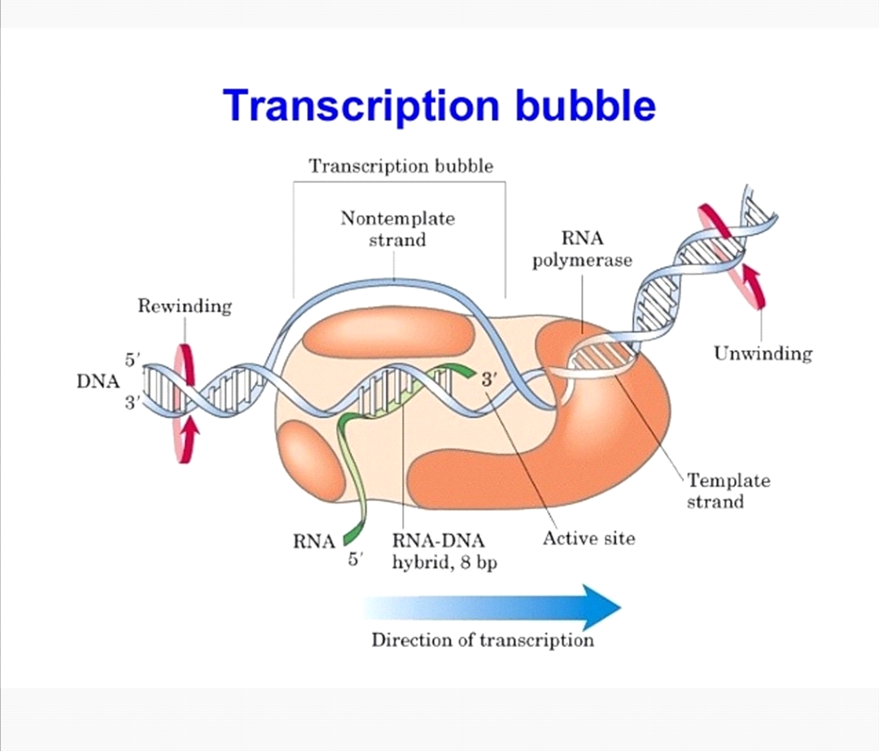
RNA POLYMERASE ENZYME IS A LEADING enzymeinvolved in formation of a transcription bubble ,users DNA template to guide RNA synthesis .it is present in two main forms core enzyme ,when it it is inactive ,and as a holoenzyme .when it is activated .A sigma factor is form as a sub unit that assists the process of transcription and it transcription buuble when it is binds to unpaired bases .These two factors when paired together ,build RNA polymerase holoenzyme which is then in its active form and ready to bind to a promoterto initate DNA transcription .once it binds to the DNA ,RNA polymerase turns from a closed to an open complex ,forming the transcripted bubble

PROKARYPTIC TRANSCRIPTION
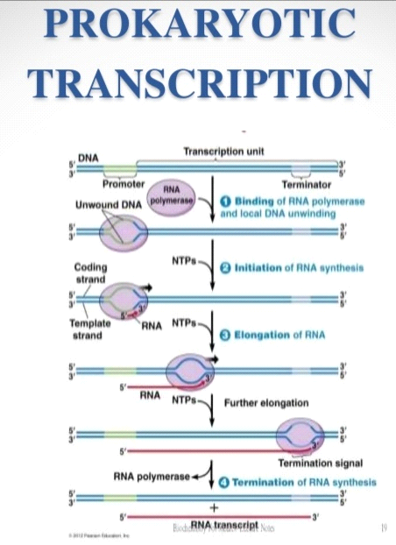

EUKARYOTIC TRANSCRIPTION

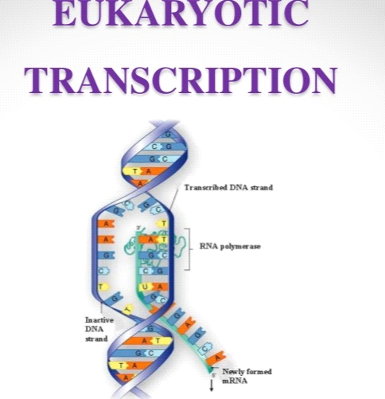

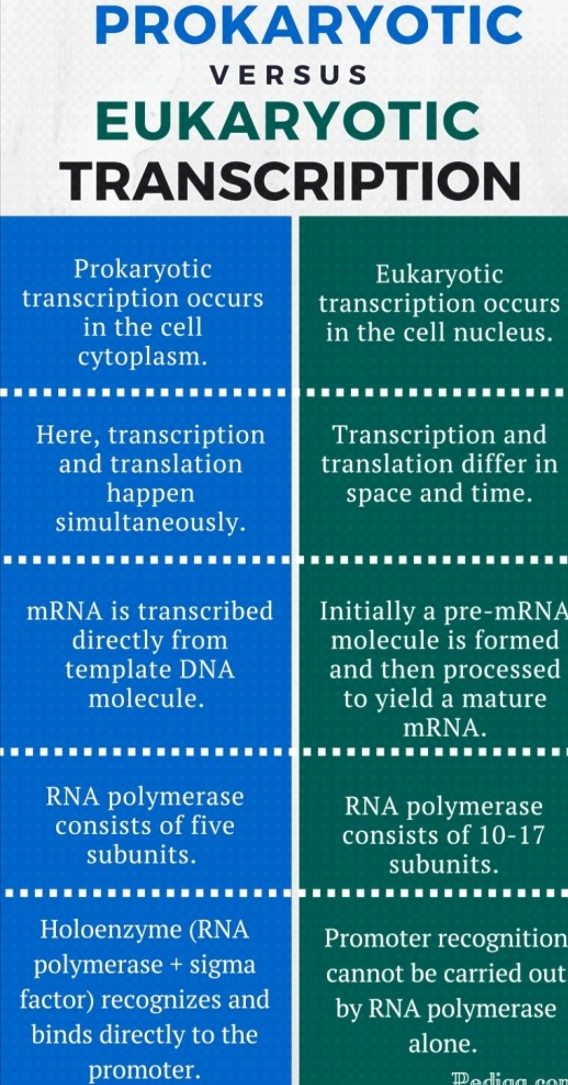
MCQS
*THE process of formation of RNA is known as....
*REPLICATION
*DNA REPAIR
*TRANSLATION
*TRANSCRIPTION
2 LIKE replication ,transcription also occurs bidirectionally
*TRUE
*FALSE
3 Mark the statement which is incorrect about the transcription unit
* It is a transcripted segment segment of DNA
*Eukaryotes have monocistronic transcriptin unit
*Prokaryoutes also have a monocistronic transcription unit
*Immediate product of transcription is primary transcript
4 Name the site where upstream sequences located
*Prior to start point
*After the start point
*Right border of DNA
*In the middle of DNA
5 Which of the following is TRUE for the RNA polymerase activity
*DNA dependent DNA synthesis
*Direct repair
*DNA dependent RNA synthesis
*RNA dependent RNA synthesis
6 Who discovered RNA polymerase ....
*Samuel. B Weiss
*Nirenberg
*Watson and Crick
*Darwin
7 Which of the following ensure stable binding of RNA polymerase at the promoter site......
*DNA photolyase
*Sigma factor
*DNA glycosylase
*RecA
8 Name of the sigma factor which is used for promoter recognition.....
*Sigma 32
*Sigma 70
*Sigma 60
*Sigma 40
9 How many base pairs of DNA IS TRANSCRIBED by RNApolymaerase in one go..........
*5...6
* 3
*4
*7....8
10 Name the one intrinsic terminator of transcription....
*Intercalating agents
*Rho independent
*Rho dependent
* Acridine orange

THE END

