Ana Molka Ahmed – the first woman painter of Pakistan

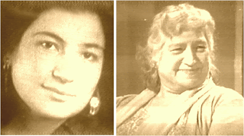
Ana Molka Ahmed – the first woman painter of Pakistan
Whenever and wherever art is talked about, specially in Pakistan, the name of Ana Molka Ahmed stands out prominently. It would not be wrong to say that she was a glowing beacon for the artistes in general and female artists in particular. “In fact she has been the facilitator of a movement that made the proactive role of women artists a possibility,” once remarked by Nilofur Farrukh, the president of International Art Critics Association, Pakistan sections.

Professor Ana Molka Ahmed (1917-1994) was among the first few female artists at the time of independence of Pakistan in 1947. Born as Molly Bridger in London to a Jewish couple, a Polish mother and a Russian father, she studied painting, sculpture and design from the famous St. Martin School of Arts, London, followed by a scholarship to the Royal Academy of Art. But she was to make her name far from her home in the scorching summer of the Indo-Pak subcontinent. She converted to Islam at the age of 18 in 1935, before marrying Sheikh Ahmed, a would be Pakistani in October 1939, then studying in London. The couple later came to Lahore in 1940. Although the marriage broke in 1951, she elected to stay in Pakistan and continued to stay in Lahore with her two daughters till her death.

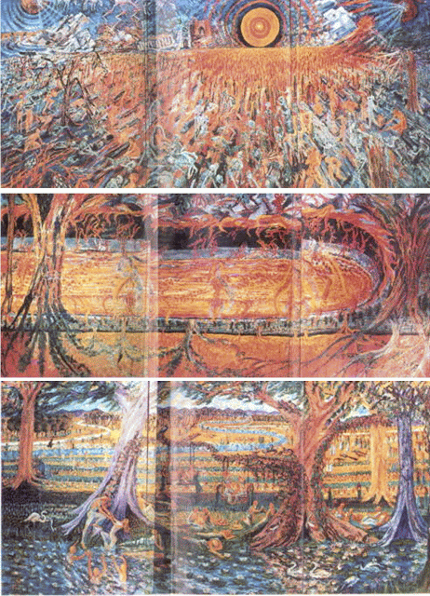
hree famous paintings of Ana Molka Ahmed: "The day of Resurrection - Qiyamat" (top) - "The Hell (Jhahanum - Hell)" (centre) - "Heaven (Jannat - Heaven)" (bottom)
She was the driving force behind setting up the Fine Arts Department of the Punjab University, Lahore in 1940. The same institution was to later become the training ground for the women artists of Pakistan after the independence. Initially, there were only five or six Muslim students in the art department, but Anna Molka Ahmed went from one college to other seeking and convincing students for her arts department. She headed the department for next three decades (1940-1978). Many of her students, like Colin David, Abrar Termizi, Ghulam Rasool, Shahnawaz Zaidi and Javed Iqbal became famous artists in the country and many of them are playing their role globally.
She even took evening art classes at Lahore Arts Council (Alhamra) and later in a village near Lahore. Her untiring efforts gradually upgraded art education beyond B.A to M.A. in fine art at the Punjab University.

It is because of trend setters like her that the feminist art in Pakistan is gaining strength away from traditional gender discriminatory dominance. In fact these days we are witnessing a gradual dismantling of social and gender classifications. This has not been easy, since a lot of women had to struggle hard to bring women atop many a prestigious position - above men, Ana Molka Ahmed has been one such woman.

Beside painting, she was an avid gardener. She would wear her trade mark while tending the garden, cutting hedges in new and artistic pattern, and went on painting and gardening till the very last time until she was ordered by the doctors to stop because it was straining her health badly. She breathed her last in Lahore on April 21, 1994.
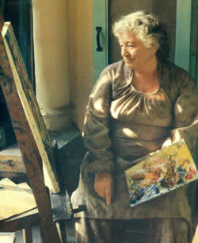
Ana Molka Ahmed – the first woman painter of Pakistan
Remembering Ana, Professor Dr. Saadat Saeed Urdu Department Ankara University Turkey writes, “She used to treat her subjects boldly. Her grand paintings contain sparks of her domineering and impressive personality. Her impressionistic technique blended with expressionistic tones and shades made her work unique. The suggestiveness of her knife was creative. She chose knife to paint in preference to smooth brushes and made her style so unique that the audience could do nothing but stand and wonder. The style originated by her was so unusual in its essence that art critics declared her work far better than the work done by most of her contemporary artists. Anna Molka's multi- cultural background made her viewpoint vast and liberal. Anna Molka used the media of drawing, painting, graphic arts, sculpture and design. She was known as an expert in the domain of still life, animal nature and figures. She used the media of water colour, gouache, fresco, tempera, oil, wax, mosaic to paint and produce unique portraits, still life, landscapes, figure compositions and animal paintings. She loved to paint solitude, loneliness, alienation, mannerism, sufferings and sadness in the perspective of urban landscape. Most of her paintings symbolize materialistic life around us. She painted poetry and wrote sceneries. Her colours were bright and strokes fascinating.”

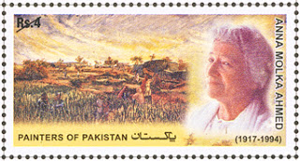
ana molka ahmed
Anna is part of the beginning of art developments in Pakistan. I am, she said once, "the Mother of all the artists." Recognition of her work is documented through a number of national awards, which include the Tamgha-i-Imtiaz, in 1963, the President's Award for the Pride of Performance in 1969 and also the Khudeja Tul Kubra Medal. A commemorative stamp was also issued a postage stamp in her honour.

