Practical 2

Adding duration and predecessor/successor relationships

Adding durations
- Open practical1.mpp file and save to a file called practical2.mpp. You now have a copy of your work to use in practical2.mpp. You will use practical2.mpp as the starting point for this week’s practical.
- If it is not already open, open practical2.mpp by double clicking on the file.
- Enter the task durations given in the table below. Note that the durations are only entered for specific tasks and not for deliverables/summary tasks. You will notice that as you enter durations for the specific tasks, Microsoft Project automatically calculates the totals for the summary tasks. The units we are using are weeks, but durations can be months, days or even minutes.
Task names | Durations
New Billing System
Requirements Analysis
Information gathering | 3 weeks
Define Requirements | 3 weeks
Disk Storage Upgrade
Purchase | 11 days
Install | 3 days
Software Modifications
Database
Design DB Changes | 2 weeks
Modify DB | 1 week
Programs
Design Programs | 3 weeks
Program A
Code program A | 2 weeks
Unit test A | 1 week
Program B
Code program B | 4 weeks
Unit test B | 2 weeks
Program C
Code program C | 3 weeks
Unit test C | 2 weeks
Program D
Code program D | 3 weeks
Unit test D | 2 weeks
Program R1
Code program R1 | 2 weeks
Unit test R1 | 1 week
Integration
Integrate | 2 weeks
test | 1 week
Advertising Brochures
Design | 2 weeks
print | 1 day
Mail out | 1 day

Adding predecessor/successor relationships
- Scroll out the left hand window (with the task name, duration etc columns) until you can see the predecessor column.
- There are various options for entering the predecessor relationships. We will enter them by adding the predecessor task number into the predecessor column. (The “link” icon in the schedule group on the Task ribbon is another option you might like to experiment with in the lab.) It is possible that a task has more than one predecessor. In that case enter the list of predecessor task numbers separated by commas (e.g. 3,7,9). Enter the predecessor relationships shown in the table below:
Task Number | WBS Number | Task names | Predecessor (task numbers)
0 | 0 | New Billing System
1 | 1 | Requirements Analysis
2 | 1.1 | Information gathering
3 | 1.2 | Define Requirements | 2
4 | 2 | Disk Storage Upgrade
5 | 2.1 | Purchase | 3
6 | 2.2 | Install | 5
7 | 3 | Software Modifications
8 | 3.1 | Database
9 | 3.1.1 | Design DB Changes | 3
10 | 3.1.2 | Modify DB | 9
11 | 3.2 | Programs
12 | 3.2.1 | Design Programs | 3
13 | 3.2.2 | Program A
14 | 3.2.1.1 | Code program A | 12
15 | 3.2.1.2 | Unit test A | 14
16 | 3.2.3 | Program B
17 | 3.2.3.1 | Code program B | 12
18 | 3.2.3.2 | Unit test B | 17
19 | 3.2.4 | Program C
20 | 3.2.4.1 | Code program C | 12
21 | 3.2.4.2 | Unit test C | 20
22 | 3.2.5 | Program D
23 | 3.2.5.1 | Code program D | 12
24 | 3.2.5.2 | Unit test D | 23
25 | 3.2.6 | Program R1
26 | 3.2.6.1 | Code program R1 | 12
27 | 3.2.6.2 | Unit test R1 | 26
28 | 4 | Integration
29 | 4.1 | Integrate | 6, 10, 15, 18, 21,24,27
30 | 4.2 | Test (Integration testing) | 29
31 | 5 | Advertising Brochures
32 | 5.1 | Design | 3
33 | 5.2 | print | 32
334 | 5.3 | Mail out | 33

Note that
- The predecessor(s) should be the lowest level in your WBS, i.e. a predecessor task should not be a “summary task”.
- You can include a “WBS predecessor” column. If you scroll through the list of available columns in the column with the heading “Add a New Column” which should appear after the “Resource Names” column, you will find the WBS Predecessors column. Columns can be rearranged, so this could be positioned after the “Task Name” column if required. This column may be useful to check your schedule if the predecessor information was provided in terms of WBS numbers.
- It is always a good idea to save your work regularly. You can use the (Ctrl+S ) shortcut or the ”save” icon at the top of Microsoft Project to save your work (see screenshot below). Save the current version of your work before you continue.
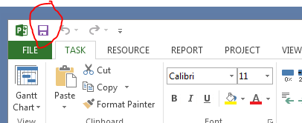
- Observe the changes in the Gantt chart. It may be difficult to view the entire project at this point. One option is to use the scroll bar at the side and bottom of the Gantt chart. Another option to allow you to see an overview is to select “Entire Project” in the zoom group on the View ribbon.
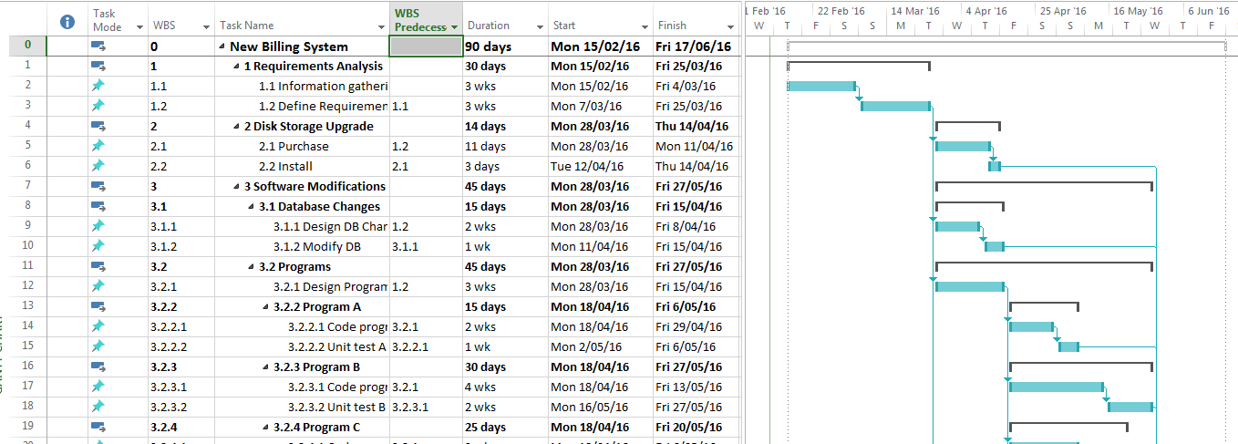

How scheduling works in Project 2010 and Project 2013
The following notes are extracted from Microsoft Project “Help”.
“Project 2010 introduces a new mode that gives users complete control over how tasks are scheduled — manual scheduling.
Project can schedule tasks using two methods: manual scheduling and automatic scheduling. With manual scheduling, changes to factors such as task dependencies, constraints, and project calendars do not automatically adjust task dates.
Tasks are manually scheduled by default. Project managers who are accustomed to automatic scheduling with past versions of Project can turn the manual scheduling feature off for specific tasks or for the entire project. Some projects, especially complicated ones, may require Project's powerful scheduling engine to take care of scheduling for you. “ (Microsoft Help, 2010)
Note: we will only use automatic scheduling for our project schedules in this course. The difference between the behaviour of automatically and manually scheduled tasks is demonstrated in the next section where we also learn about inserting lags.
- You will change to automatic scheduling in the next section.
- The details of how Microsoft Project schedules tasks can be quite complicated and depends on whether the task is automatically or manually scheduled, the link types, any task constraints etc. For a comprehensive description of this topic you should read Microsoft Project “Help” on “How scheduling works in Project”. To quote Microsoft Project help “This stuff isn’t necessarily easy to understand at first, but charging forward through it will make you a more knowledgeable project manager - and give you firmer control over the end date of your project.” .
- To access Microsoft Project help, click on the “?” help icon.
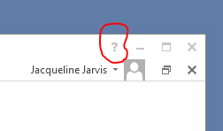
- Enter “How project schedules tasks” in the search text box and click on the link to “How Project schedules tasks” that appears as a result of the search.

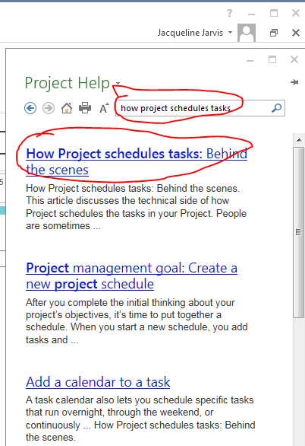

Inserting Lags
We have currently allowed 11 days for purchasing of the hardware. However, actually placing the purchase order is likely to take 1 day. The remainder of the time was to allow for shipment and delivery. We could add another task that is “delivery” to make this clearer or we could introduce a lag time between the purchase and the installation to allow for the delivery time. We will introduce a lag time now.
- Change the duration for the purchase of the disk storage upgrade to 1 day.
- Notice that when you reduce the time for the purchase, the installation is still scheduled to be in 10 days after the purchase. This is because we are still using the default scheduling which is to manually schedule tasks.
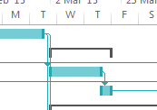
has become
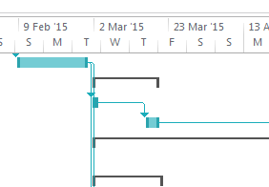
- Change all the tasks to use automatic scheduling by using your mouse to select (highlight) all the tasks, followed by clicking on “Auto Schedule” in the tasks group on the Task ribbon.
- Note that the disk storage upgrade now only takes 4 days and the installation is started immediately after purchase. This has been scheduled automatically according to its predecessor relationship.
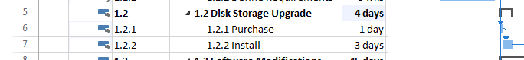

- However, remember that we do want to introduce a lag time for the delivery of the new hardware. We will do that now.
- Double click on the “install” disk storage task and select the predecessors tab in the pop-up “task information” window that appears.
- Click on the Finish-to-Start(FS) relationship in the Type column and notice that there is a dropdown list associated with the type cells.
- Open the drop down list and observe the different types of predecessor relationships. What are they? FS, SS, FF, SF
- What do the different types of relationships mean?
Useful URL: http://blogs.msdn.com/b/project/archive/2008/07/29/back-to-basics-understanding-task-dependencies.aspx
(Use the Microsoft Help function to read about the different types of predecessor relationships if you have not read about them already. Hint: Search for “predecessor” and click on the “About Linking Tasks” link.

- The link between the purchase and install tasks for the disk storage upgrade is a Finish-to-Start relationship (the default). However, we wish to introduce a “lag time”, i.e. there is to be a delay between the purchase order being completed and the installation to allow for the delivery of the new hardware. Introduce this lag now by changing the value in the lag column of the task information window for the “install” task. Change the lag value in this column to 10 days. (If you no longer have this window open, remember that it can be opened by double clicking on the task.)
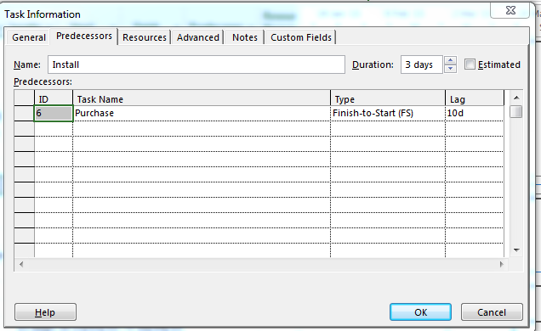

- Observe the change in the Gantt chart. The time for the disk storage upgrade should now be 14 days again. (Use the undo and re-do arrows to check that you are achieving the desired result.)
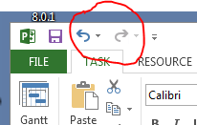
- Note that the predecessor column for the install task now has 6FS+10 days showing the predecessor relationship and lag. This could also have been entered manually in the predecessor column.
- To ensure that any new tasks added to your schedule are automatically scheduled, you should click on “New Tasks: Manually Scheduled” on the bottom left hand corner and select “New Tasks: Auto Scheduled”. Unless you have a situation where you specifically want manual scheduling, you would normally set the default value to “New Tasks: automatically scheduled at the beginning of your project schedule development. That is what you should do in the assignment work unless you are told otherwise. The change is illustrated in the images below:
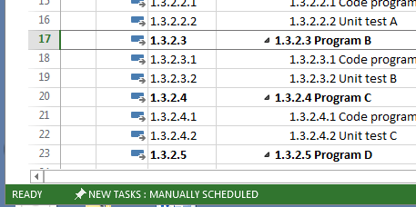
Changes to:
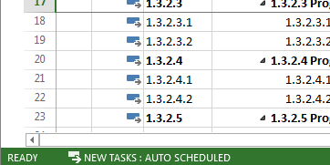

Adding a milestone
When the integration and testing is complete, the new “system is ready to go”. This is a milestone for the project. (We could have other milestones during the project, but this is the only one we will add for the purposes of these practical exercises.)
- Insert a new task underneath the final “Mail Out” task called “System ready”. If you have inserted the task correctly, it should be “6 System Ready “. Use the indent/outdent arrows on the Task ribbon to make any necessary adjustment to your WBS hierarchy.
- Make the predecessor of “system ready” the “integration testing” task (i.e. task 30 with WBS 4.2 and name of Test)
- Change the duration to 0 days. Notice the new milestone symbol that appears on the Gantt chart (a small diamond).

- Now suppose that we want to mail the brochures out 2 weeks before the system is ready. Add the appropriate relationship between the “mail out” task the “system ready” milestone to work back 2 weeks to determine when the mail out task should take place. Hint: use a negative lag relative to the “system ready” task. You will be able to view their relationship on the Gantt chart to check if it has been entered correctly.

Modifying the timescale
In some situations you may not want to use the default time scale used in the Gantt chart. For example, it can be useful to condense the Gantt chart to see the “big picture” better. In other situations it may be clearer if you expand the chart.
- One way to view the whole project is to select the “Entire Project” from the zoom group on View ribbon. Note that if you select “Zoom …” from the drop-down list of zoom options, there are options that allow you to zoom to 1 week, 1 month etc. Experiment with some of these options now.
- You can also modify the timescale by selecting the Timescale option from the Timescale drop-down list in the zoom group on the View ribbon.
- There are three tiers that can be displayed above your Gantt chart. Experiment with the different “Timescale options” that you can select from the “Show” drop down box. This will clarify what is meant by the different tiers. (Try one tier, then three tiers and observe what happens on your Gantt chart.)
- Return to the default which shows two tiers (middle, bottom).
- Again in the Timescale window, select the “middle tier” tab and change the units to quarters instead of weeks.
- Select the bottom tier and change the units to months instead of days.
Notice how this has condensed your Gantt chart.
- Set the middle tier back to weeks and the bottom tier back to days or select “Entire Project” from the zoom group.

Displaying the critical path
- Select the Format tab and click in the “critical tasks” check box in the bar styles group.
- Observe that the tasks on the critical path are now displayed as red bars on your Gantt chart.
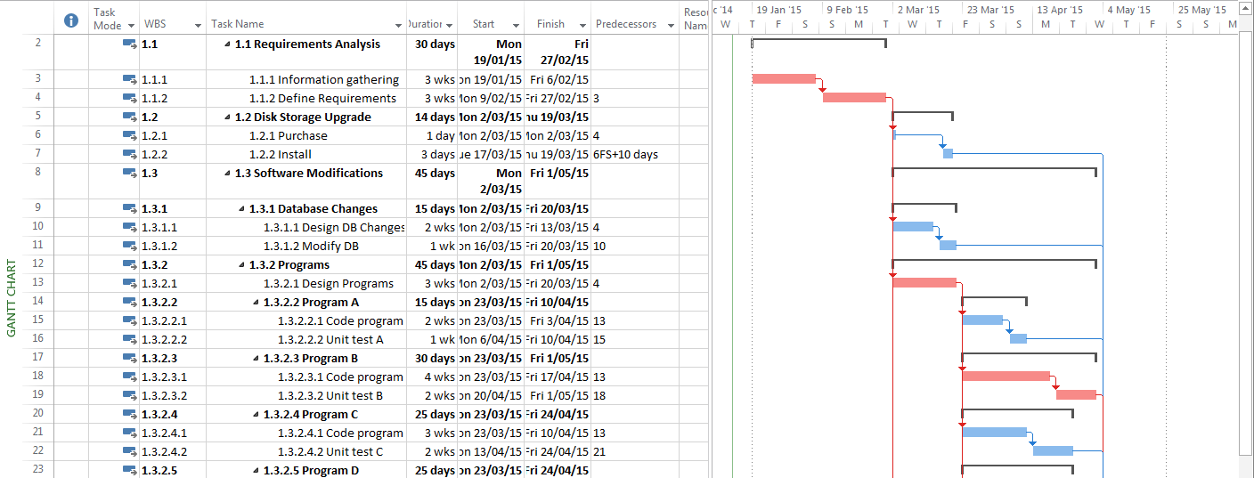

- You can also use the filter in the Data group on the View tab to filter out all tasks except those on the critical path.
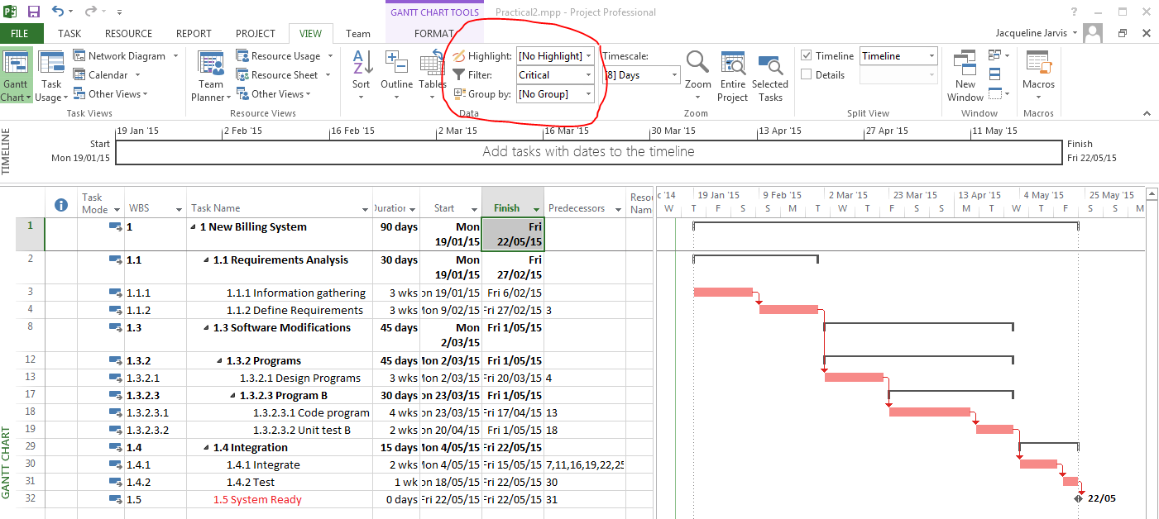
- What tasks are on the critical path(s) for your project?
___________________________________________________________________________
________________________________________________________________________
- If you used the filter, return it back to the default “no filter”, so that you can now view all your tasks again.

Assessing the sensitivity of your schedule
The sensitivity of a schedule is a measure of how likely it is that the original critical path (or paths) will change when the project is underway. If the likelihood is high, then the schedule is very sensitive. The sensitivity depends on:
  - The number of critical paths in the network. In general, the sensitivity increases as the number of critical paths increases. You have already identified the critical path or paths for your network. How many have you identified? Note that this question is not asking how many tasks are on the critical path (or paths), it is asking how many critical path(s) are in the network.
and
  - The amount of slack the non critical tasks have - if there is a reasonable amount of slack relative to the non critical task durations, then these tasks are less likely to become critical, i.e. the network is more likely to be stable (insensitive). The instructions to view slack are given below:
- Click the arrow on Tables in the Data group on the View ribbon and select the “schedule” table. This allows you to view the “schedule table”.
You should now see a table of the schedule with ES, EF, LS, LF, Free slack and total slack columns.
- What is the slack for the non critical tasks?

- What does this (and the number of critical paths) suggest about the sensitivity of the network?

Remember,
Free slack (FS) is the amount of time a task can be delayed without delaying its successor task(s).
Total slack (TS) is the amount of time a task can be delayed without delaying the project.
Tasks on a path can have the same TS, but different FS – i.e. the tasks on the path “share” the total slack, so if one is delayed it reduces the TS for the path and all the subsequent tasks on that path. However, if a task is not at the end of the chain its delay will delay the start of its successor, so by definition, the task (or tasks) not at the end of the chain will have no free slack. Free slack tends to show up in the last task at the end of a chain of non critical activities or in a single non critical activity.
You can observe examples where tasks on the same path have the same TS, but only the task on the end of the chain has FS by looking at this in the schedule table. Give one example for this project.

- Return to the default view of the task entries by selecting “Entry” from the list of available tables in Tables drop-down list. (The drop-down list is in the Data group on the View ribbon.)

Viewing the network diagram
- Select “Network diagram” from the “Task Views” group on the View ribbon. You should now see the network diagram view of the project.
- It may be difficult to see the whole project. Select Zoom from the Zoom drop-down list in the Zoom group on the View ribbon and select “Entire Project”.
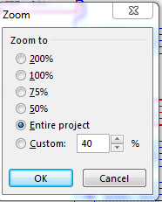

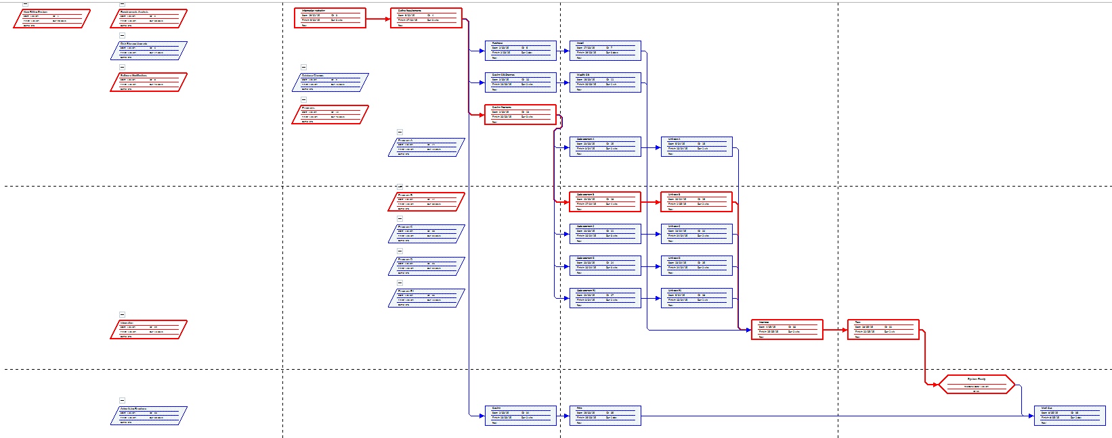

- There are various options you can explore to modify the network diagram. For example, you can remove the “summary task” boxes, so that your network diagram is less cluttered (uncheck the Summary Tasks check box on the Format ribbon). You can also manually position the boxes. Select the layout option from the Layout group on the Format ribbon and you will see the various options available in the Layout window. Experiment with some of the options available on the Format ribbon.
- Before finishing practical 2 return to the Gantt view and make sure that you have saved your work.

