CAMERA MOVEMENT
Camera movements generally fall into two types: the kind that feel like machine movement (Dolly, Pedestal, Boom, Tongue, Arc and Truck) and the kind that feel like human movement (Tilt, Pan and Steady Cam).
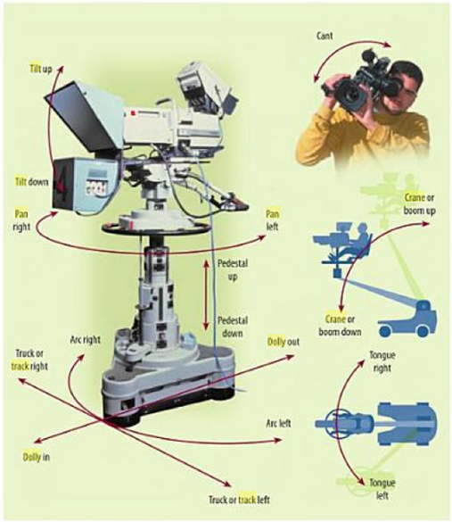
1. DOLLY : Motion towards or motion from. The name comes from the tracks - very much like railroad tracks - that used to be laid down for the heavy camera to move along in the days before steadicams got so popular. The phrase dolly-in means step towards the subject with the camera, while dolly-out means to step backwards with the camera, keeping the zoom the same.
2. PEDESTAL: Moving the camera up or down without changing its vertical or horizontal axis. A camera operator can do two types of pedestals: pedestal up means “move the camera up;” pedestal down means “move the camera down.” You are not tilting the lens up, rather you are moving the entire camera up, just like an elevator.
3. BOOM OR CRANE: rotates a camera up or down on the end of a fixed boom.
4. TONGUE: rotates a camera right or left on the end of a fixed boom.

5. ARC: moves a camera in a circular path while maintaining the object it is looking at in the center of its view. You can arc left and arc right. This is a rotation about a vector in the direction of a camera's vaxis with the center of rotation at a camera's center point.

6. TRUCK: Trucking is like dollying, but it involves motion left or right. Truck left means “move the camera physically to the left while maintaining its perpendicular relationship.” This is not to be confused with a pan, where the camera remains firmly on its axis while the lens turns to one direction or the other. You might truck left to stay with a pedestrian as she walks down a street.
7. PAN: Moving the camera lens to one side or another. Look to your left, then look to your right - that's panning.
8. TILT: Moving the cameras lens up or down while keeping its horizontal axis constant. Nod your head up and down - this is tilting.
9. STEADY CAM: Camera movement that imitates the human movement. A stabilization system for motion picture or video cameras allows a single operator to easily make smooth shots while moving.

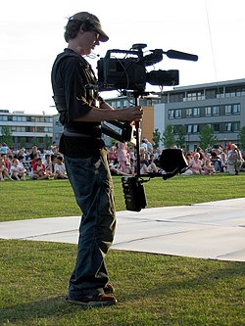

10. ZOOM : Zooming is one camera move that most people are probably familiar with. It involves changing the focal length of the lens to make the subject appear closer or further away in the frame. Most video cameras today have built-in zoom features. Some have manual zooms as well, and many have several zoom speeds. Zooming is one of the most frequently-used camera moves and one of the most overused.
Zooming the camera changes the focal length of the lens, which can introduce wide-angle distortion or changes in the apparent depth of field. It's a very unnatural movement. For this reason, it's sometimes preferable to dolly than zoom.

