EDITING

HEADLINES
• A headline is catch line or a marketing sentence of the news item of a newspapers/News channels.
• Headline is, in fact, the lead (intro) punchy or dramatic words which attracts the readers / viewers.
• Writing headings is an art.
• Headline job is to help the reader to decide whether or not to read the story or buy a newspaper.
• Good Vocabulary of a sub editor can be helpful in writing the attractive headlines.

Effective headlines are those which have the following characteristics.
• In present tense
• In active voice
• With a personal tone
• Simple
• Precise
• Positive

As an example of present tense we can see the following.
• The President signs the legislation at noon (active).
• At noon, the legislation will be signed by the president (passive)
• How an economy of words can be done in headline. Two trains get in to each others (accident)
• One way of making news is ……..
• 50 were injured ]
when trains ] 8 words
were in collision ]

The other way to make the news headline.
• Two trains get in to each others (accident)
• 50 are injured ]

as trains ] 6 words
collide ]
Another way to make the news with using minimum words.
• 50 hurt ]
As trains ] 5 words (BEST)
collide ]
• In headlines avoid Jargon.
• Jargon is terminology which is especially defined in relationship to a specific activity.
• Some time phrasing jargon would attract reader to read the news.

• For example

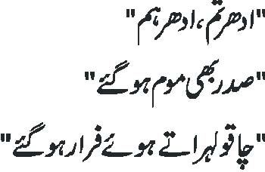

• Headlines should be designed to attract the reader’s attention. In headlines punctuation --- colons, semi-colons, dashes should be avoided.

ABBREVIATION

• Abbreviation should not be used unless they are standard, conventional and generally understood, such as FIA, FBI, UN, USA………
• How To Start Writing
• “Once you know what you want to say, start writing immediately. Forget the words count, forget the rhythm – just keep pounding away your idea”. If you will capture the first thought you can improve that but if you delay in capturing your thoughts you may feel difficulty in phrasing the headline.

SOME RULES

• Match the lead with the story. Make sure they say the same thing.
• Be consistent.
• Be accurate.
• Start the head with an action word.
• Avoid double meanings.
• Don’t split adjectives and nouns.
• Be specific.
• Solve layout problems.
• Avoid initials.
• Avoid meaningless words.
• Write conversationally (simple and direct )
• Write concisely
• Simplify the massage
• Don’t give orders (listen up)
• Don't characterize the news as good, bad, interesting or shocking.
• Don’t start a lead sentence with the name of an unknown or unfamiliar person.
• Don’t write a first sentence with yesterday.
• Don’t use technical words
• Don’t start a story with “Another”, “More” , “Once” and “Again”
• Don’t lose or fail to reach the viewer… talk to them, not “at” them.
• Here are some guidelines for Urdu medium students.

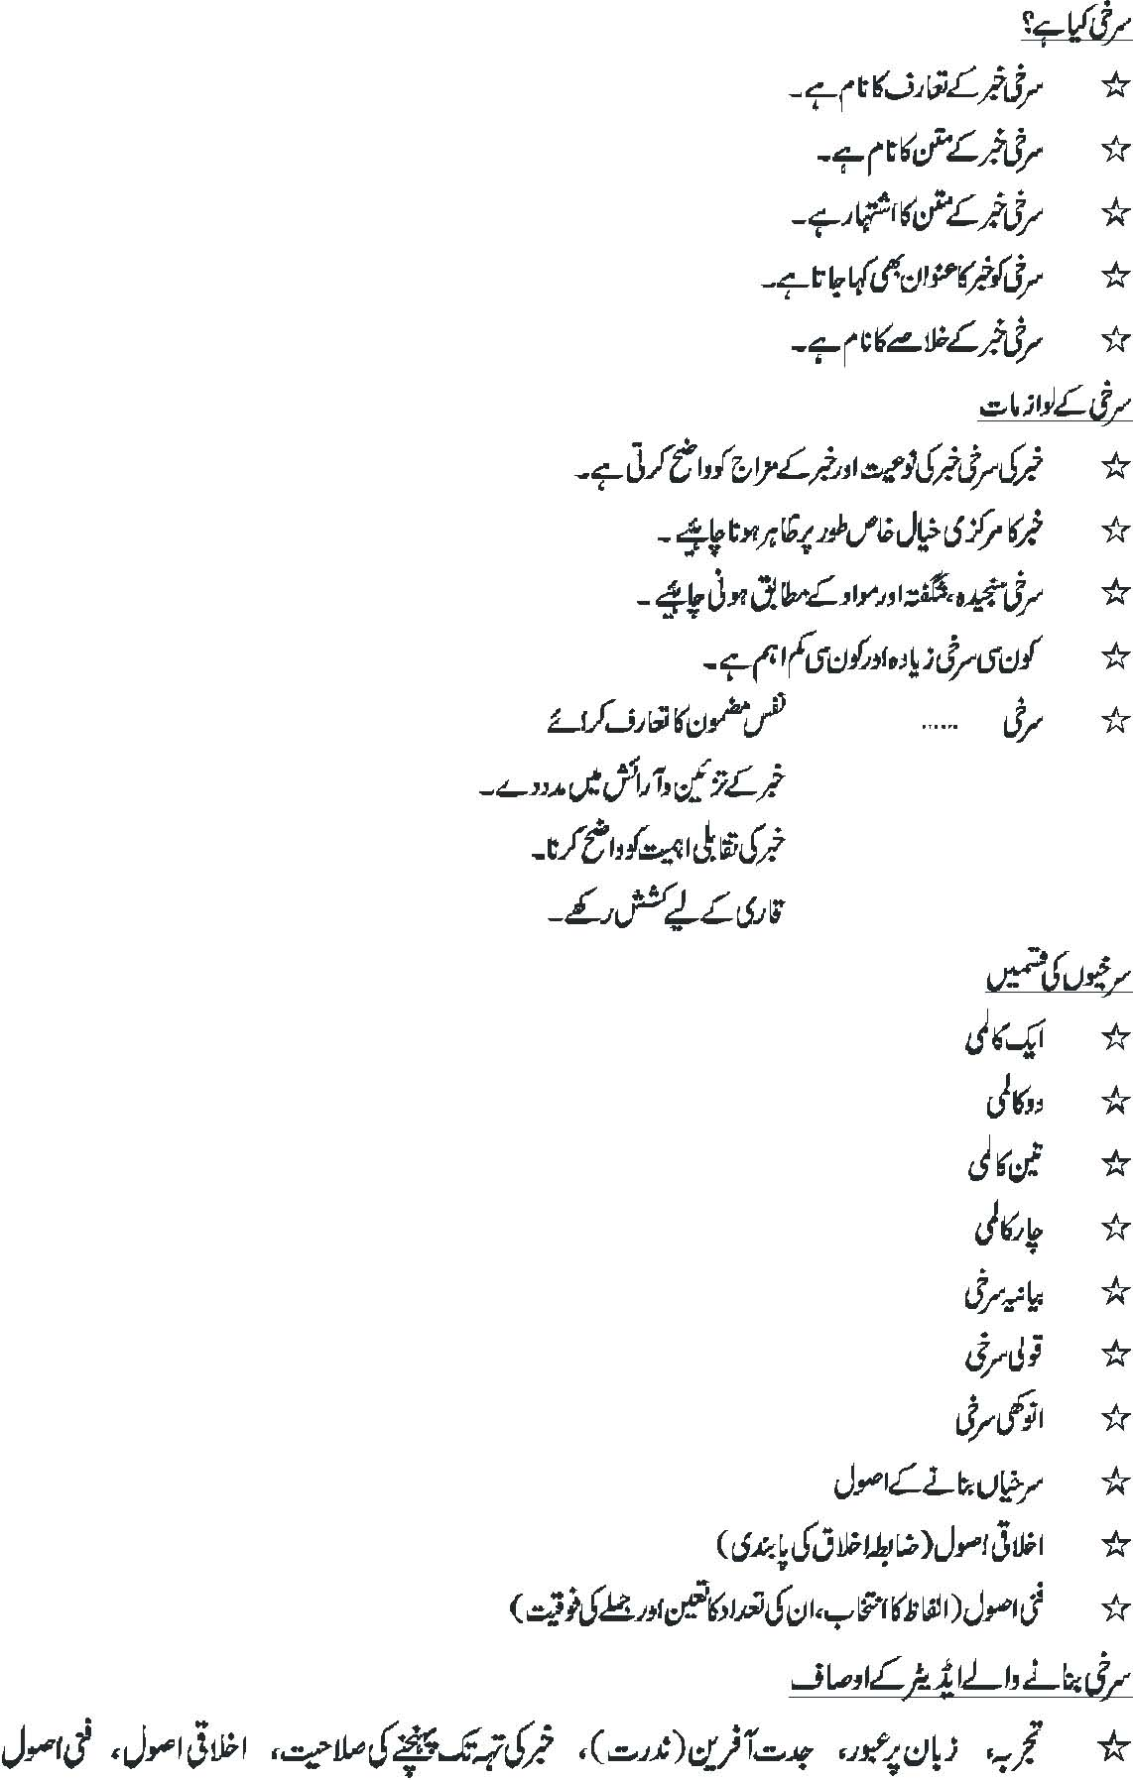

PRINT MEDIA NEWSROOM
Following are the main professionals who work in print media news room:
• Managing editor
• News Editor
• Copy editor
• Metropolitan editor
• City editor
• National and foreign news editor
• Photo editor
• Graphic editor
• Sports editor
• Financial editor
• District editor

