Agro-7117 3(3-0), (Climate Change and Agriculture), Dr. Amjed Ali
Mitigation and Adaptation Strategies for Climate Change
NASA stands for National Aeronautics and Space Administration. NASA is a U.S. government agency that is responsible for science and technology related to air and space. The Space Age started in 1957 with the launch of the Soviet satellite Sputnik. NASA opened for business on Oct. 1, 1958. The agency was created to oversee U.S. space exploration and aeronautics research.
NASA is a world leader in climate studies and Earth science. While its role is not to set climate policy or prescribe particular responses or solutions to climate change, its purview does include providing the robust scientific data needed to understand climate change. NASA then makes this information available to the global community – the public, policy- and decision-makers and scientific and planning agencies around the world.
Climate change is one of the most complex issues facing us today. It involves many dimensions – science, economics, society, politics and moral and ethical questions – and is a global problem, felt on local scales, that will be around for decades and centuries to come. Carbon dioxide, the heat-trapping greenhouse gas that has driven recent global warming, lingers in the atmosphere for hundreds of years, and the planet (especially the oceans) takes a while to respond to warming. So even if we stopped emitting all greenhouse gases today, global warming and climate change will continue to affect future generations. In this way, humanity is “committed” to some level of climate change.
When it comes to tackling climate change to prevent the impacts it causes in the different systems of the planet, the human being applies two types of measures: mitigation and adaptation.
Mitigation measures are those actions that are taken to reduce and curb greenhouse gas emissions, while adaptation measures are based on reducing vulnerability to the effects of climate change.
Mitigation – reducing climate change – involves reducing the flow of heat-trapping greenhouse gases into the atmosphere, either by reducing sources of these gases (for example, the burning of fossil fuels for electricity, heat or transport) or enhancing the “sinks” that accumulate and store these gases (such as the oceans, forests and soil). The goal of mitigation is to avoid significant human interference with the climate system, and “stabilize greenhouse gas levels in a timeframe sufficient to allow ecosystems to adapt naturally to climate change, ensure that food production is not threatened and to enable economic development to proceed in a sustainable manner”
Mitigation, therefore, attends to the causes of climate change, while adaptation addresses its impacts.
How to mitigate climate change?
These are some of the mitigation measures that can be taken to avoid the increase of pollutant emissions:
- Practice Energy efficiency
- Greater use of renewable energy
- Electrification of industrial processes
- Efficient means of transport implementation: electric public transport, bicycle, shared cars ...
- Carbon tax and emissions markets
Many adaptation and mitigation options can help address climate change, but no single option is sufficient by itself. Effective implementation depends on policies and cooperation at all scales and can be enhanced through integrated responses that link mitigation and adaptation with other societal objectives.
Adaptation to climate change:
Climate adaptation refers to the ability of a system to adjust to climate change (including climate variability and extremes) to moderate potential damage, to take advantage of opportunities, or to cope with the consequences.
In terms of adaptation measures, there are several actions that help reducing vulnerability to the consequences of climate change:
- More secure facility locations and infrastructures
- Landscape restoration (natural landscape) and reforestation
- Flexible and diverse cultivation to be prepared for natural catastrophes
- Research and development on possible catastrophes, temperature behavior, etc.
- Preventive and precautionary measures (evacuation plans, health issues, etc.)
In this info graphic you can learn what are the measures of adaptation and mitigation to climate change.
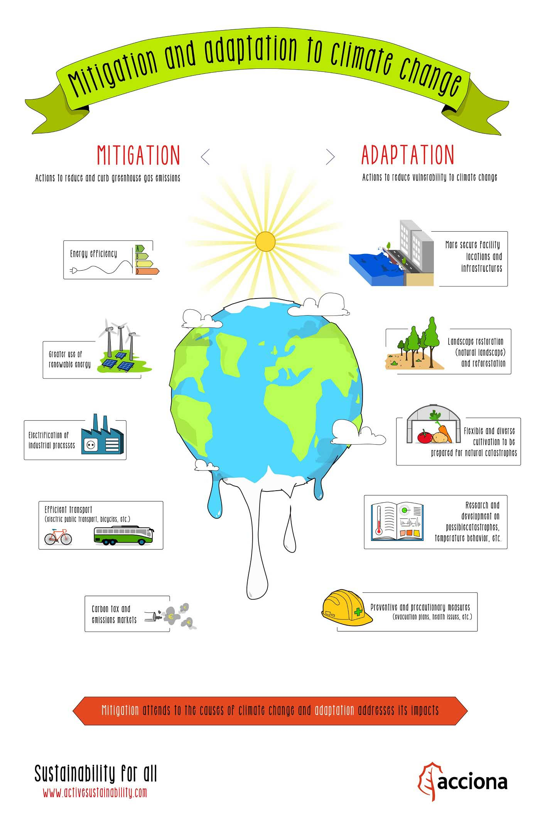
Nationally Appropriate Mitigation Action (NAMA)
Nationally Appropriate Mitigation Action (NAMA) refers to a set of policies and actions that countries undertake as part of a commitment to reduce greenhouse gas emissions. The term recognizes that different countries may take different nationally appropriate action on the basis of equity and in accordance with common but differentiated responsibilities and respective capabilities. It also emphasizes financial assistance from developed countries to developing countries to reduce emissions. NAMA was first used in the Bali Action Plan as part of the Bali Road Map agreed at the United Nations Climate Change Conference in Bali in December 2007, and also formed part of the Copenhagen Accord issued following the United Nations Climate Change Conference in Copenhagen in December 2009.
Intended nationally determined contributions (INDC) are (intended) reductions in greenhouse gas emissions under the United Nations Framework Convention on Climate Change (UNFCCC).
INDCs are the primary means for governments to communicate internationally the steps they will take to address climate change in their own countries. INDCs reflect each country's ambition for reducing emissions, taking into account its domestic circumstances and capabilities.
The Clean Development Mechanism (CDM) is an arrangement (flexible mechanism) under the Kyoto Protocol which allows industrialized countries with a greenhouse gas reduction commitment to invest in projects that reduce greenhouse gas emissions in developing countries.

