TOPIC CELL THEORY AND CELL TYPES

Cell
The cell is the structural and functional unit of life. It is smallest unit of body. Cells are building block of complete multicellular organisms.
Study of cell is called as cell biology
Cell vary from individual single cell organisms(bacteria) to multicellular structures (tissues, organs) and organisms (animals and plants)
- ROBERT HOOKE
He discovered cell in 1665. after that study of cell (cell biology) begun. His work published in micrographia.
He prepared a thin section of cork. Cork is made up of dead plant material. Hooke studied this section under his self-made compound microscope.
He observed that the cork was composed of minute honey comb like compartments. He called them cells. He described cell as an empty space. Cell are bound by thick wall.
- Diagram
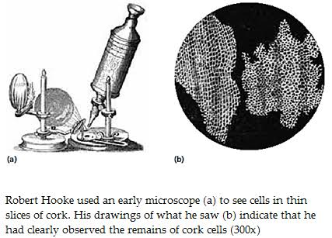
- ANTON VAN LEEUWENHOEK
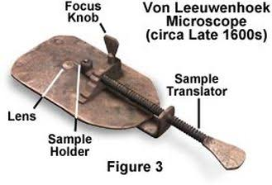
The discovery of the cell was made possible by the invention of microscope, which was made possible by improved lens-grinding techniques.
Anton van Leeuwenhoek a Dutch tradesman, learned to grind lenses and assemble them into simple microscope.
First person to observe single celled organisms.
It was a simple light microscope because it contained one lens and used natural light to view objects
Robert Hooke (1635-1703) used such an instrument to observe cork cells, sketches of which appeared in his publication Micrographia in 1665.
In 1678, he reported the royal society that he had discovered little animals---bacteria and protozoa---in various sample.
The society asked Hooke to confirm Leeuwenhoek findings, and he did.
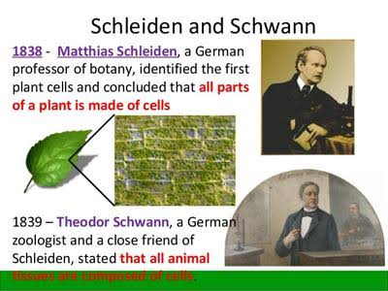
This paved the way for wide acceptance that a hidden world existed just beyond the limits of human vision and encouraged many scientists to take up the microscope in their investigations

- RUDOLF VIRCHOW
In 1858 Rudolf Virchow (1821-1902) extended the work of Schleiden and Schwann by proposing that all living cells must arise from preexisting cells. This was radical idea at the time because most people, scientists included, believed that nonliving matter could spontaneously generate living tissue. The inexplicable appearance of maggots on a piece of meat was often given as evidence to support the concept of spontaneous generation.
- CELL THEORY
All organisms are composed of one or more cells.
Cell is the basic unit of life in all living things.
All cells are produced by the division of pre-existing cells.
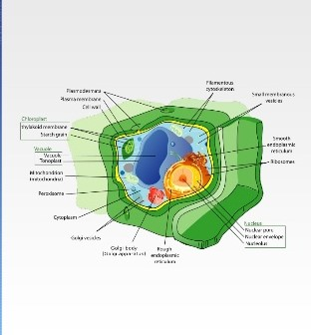

- MODERN CELL THEORY
Modern cell theory contains four statements, in addition to the original cell theory.
The cell contains hereditary information (DNA) which is passed on from one cell to cell during cell division
All cells are basically the same in chemical composition and metabolic activities.
All basic chemical and physiological functions are carried out inside the cells (movement, digestion)
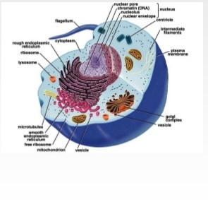

Cell activity depends on the activities of sub-cellular structures within the cell (organelles, nucleus, plasma membrane.)
- TYPES OF CELLS
Cells are of two types i.e. prokaryotic and eukaryotic cells. Eukaryotic cell contains a nucleus and prokaryotic do not.
- Eukaryotes contains a single nucleus and prokaryotic do not.
- Prokaryotes are single-celled organisms, while eukaryotes can be either single celled or multi celled.
- Prokaryotic cells
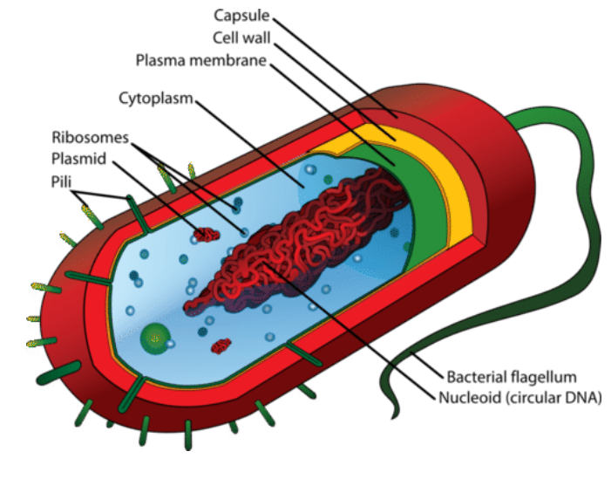

- EXAMPLES
Prokaryotes include bacteria and archaea. The photosynthetic prokaryotes include cyanobacteria hat perform photosynthesis.
- CELL MEMBRANE
A prokaryotes cell consists of single membrane and therefore all the reactions occur within the cytoplasm.
They may be free living and parasites.
- MICROSCOPIC ANIMALS
Prokaryotes are microscopic animals that have neither membrane bound nucleus nor membrane bound organelles. Some cell biologists consider the term organelle to describe membrane bound structures only. Whereas other cell biologist defines organelles as discrete structures that have a specialized function.
- RIBOSOMES
Prokaryotes have ribosomes, which are not surrounded by a membrane but do have a specialized function, and could therefore consider as organelles. A Prokaryotic cell does not have a nuclear membrane.
- NUCLEOID
However, the genetic material is present in a region in the cytoplasm known as nucleoid. They may be spherical, rod shaped.
All metabolic functions carried out by a prokaryote takes place in the plasma membrane and cytosol.
- SIZE
Prokaryotes are the smallest types of cells, with average 2-5µm in diameter. Despite their small size, inside each cell there is chemical and biochemical machinery necessary for growth, reproduction, and acquisition and utilization of energy.
- FEATURES OF PROKARYOTES
- The common features of prokaryotes are;
- Cell wall
- Plasma membrane
- Ribosomes
- Genetic material
- Capsule (most, but not at all)
- Flagella (most, but not at all)
- Pili (most, not at all)
- Lack of compartmentalization
- Plasmid (most, not at all)
- Binary fission
- FLAGELLA
All prokaryotes have a cell wall that adds structural support, acts as a barrier against outside forces and anchors the whip like flagella.
- CAPSULE
Some prokaryotes have an extra layer outside their cell wall called a capsule, which protects he cell which is engulfed by other organisms, assists in retaining moisture, and helps the cells to adhere to surfaces and nutrients.
It is the outermost layer of cell which gives shape to cell.
The cytoplasm is mainly composed of enzymes, salts, cell organelles and gel- like compartment.
- Cell membrane
This layer surrounds the cytoplasm and regulates the entry and exit of substances in the cells.
- Flagella
These are long structures in the form of whip that help in the locomotion of cell.
- Nucleoid region
It is the region I the cytoplasm where the genetic material is present.
- PILLI
Pilli are hair like structures on the surface of cells that attach to other bacterial cells or surfaces.
Within the plasma membrane, the cytoplasm is not subdivided by membranes into organelles, a lack of compartmentalization that is most evident in the organization of the genetic material.
- PLASMIDS
Prokaryotic cells contain only a single circular piece of circular piece of chromosomal DNA called plasmids. Plasmids are physically separate from, and can replicate independently of, the chromosomal DNA.
The genetic material on the plasmids is transferable between cells, allowing prokaryotes to share abilities, such as antibiotic resistance.
A prokaryotic cell lacks certain organelles like mitochondria, endoplasmic reticulum, and Golgi bodies.
Scientists have discovered that plastid serve as important tools in genetics and biotechnology labs for their ability to amplify (make coprisin) or to express particular genes
Reproduction in prokaryotic cells is by binary fission. A process of growth enlargement and division
Prokaryotes have a large array of characteristics, that enable them to Some live in the absence of oxygen, environment and resources. Some live in the absence of oxygen. Some in extreme cold or hot temperature. some live in the bottom of the ocean where their only resource is hot hydrogen sulfide, bubbling up from the core of the earth.
- Chacteristics of prokaryotic cells
Prokaryotic cells have different characteristics features. The characteristics of prokaryotic cells;
They lack a nuclear membrane.
Mitochondria, Golgi bodies, chloroplast, and lysosomes are absent.
- The genetic material is present
- The histone proteins, the important constituents of eukaryotic chromosomes, are lacking in them.
- The cell wall is made up of carbohydrates and amino acids.
- The plasma membrane acts as the mitochondrial membrane carrying respiratory enzymes.
- The divide asexually by binary fission. the sexual reproduction involves conjugation.
- Binary fission
The DNA of an organism replicates and the new copies attach to the cell membrane.
The cell wall starts increasing in size and starts moving inwards.
A cell wall is then formed between each DNA, dividing the ell into two daughter cells.
- Conjugation
It is the process in which genes are transferred between 2 bacteria through a protein tube structure called pilus.
- Example of prokaryotic cells.
The examples of prokaryotic cells are mentioned below;
Bacterial cells;
- These are unicellular organisms found everywhere on earth from soil to the human body.
- They have different shapes and structures.
- The cell wall is composed of peptidoglycan that provides cell wall to the cell structure.
- Bacteria have some unique structures such as pili, flagella and capsule.
- They also possess extrachromosomal DNA known as plasmids.
- They have the ability to form tough dormant structures known as endospores that help them to survive under unfavorable conditions.
- The endospores become active when condition is favorable.
- Archaeal cells
- Archaebacteria are unicellular organisms similar to bacteria in shape and size.
- They have a cell wall and flagella. The cell wall of archaea does not contain peptidoglycan.
- The membranes of archaea have different lipids.
- Just like bacteria, it also has one circular chromosomes. They also possess plasmid
- EUKARYOYIC CELL
- Definition
A eukaryote is an organism whose cells are organized into complex structures by internal membrane and cytoskeleton. The most characteristic membrane- bound structure of eukaryotes is the nucleus.
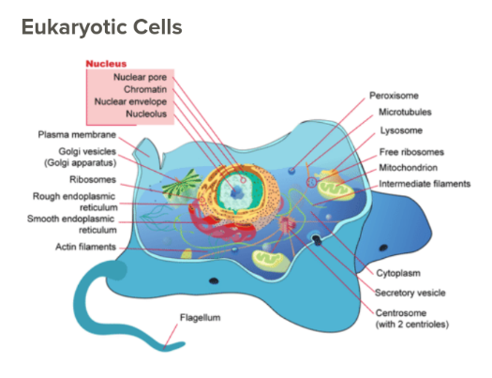

Eukaryotic cells are cells that contain a nucleus and organelles, and are enclosed by a plasma membrane. Organisms that have eukaryotic cells include protozoa, fungi, plants, and animals. These organisms are grouped into the biological domain eukaryote. Eukaryotic cells are larger and more complex than prokaryotic cells, which are found in Archaea and bacteria, the other two domains of life.
- Characteristics of eukaryotic cells.
Eukaryotic cells contain a variety of structures called organelles, which perform various functions within the cell.
This feature gives them their name, which comes from Greek and means true nucleus. The nucleus is membrane enclosed organelle that contains DNA
Eukaryotic DNA is organized in one or more linear molecules, called chromosomes. Some eukaryotes are single-celled, but many are multicellular.
Any cell or organism that possess a clearly defined nucleus. The eukaryotic cell has nuclear membrane that surround the nucleus, in which the well- defined chromosomes are located. Eukaryotic cells also contain organelles, include mitochondria, a Golgi apparatus, an endoplasmic reticulum and lysosomes
Examples of organelles are ribosomes, which make proteins, the endoplasmic reticulum, which sorts and packages the proteins, and mitochondria, which produce the energy molecule adenosine triphosphate (ATP). they also have a true nucleus, which contains the genetic material DNA and is surrounded by a nuclear envelope. All of the organelles are stabilized and given physical support through the cytoskeleton, which is also involved in sending signals from one part of the cell to the cell. In eukaryotic cells, the cytoskeleton is composed mainly of three types of filaments; microtubules, microfilaments and intermediate filaments.
- Cytosol
The gel-like substance that surrounds all the organelles in the cell is called cytosol.
- Examples of eukaryotic cells

Eukaryotes include all protists, fungi, plants and animals.
- Plant cells
Plant cells are unique among eukaryotic cells for several reasons. They have reinforced, relatively thick cell walls that are made mostly of cellulose and help maintain structural support in the plant. Each plant has a large vacuole in the center that allows it to maintain turgor pressure, which is pressure from having a lot of water in the cell and helps keep the plant upright. Plant cell also contain organelles called chloroplasts which contain the molecule chloroplast. This important molecule is used in the process of photosynthesis, which contain the molecule chlorophyll.
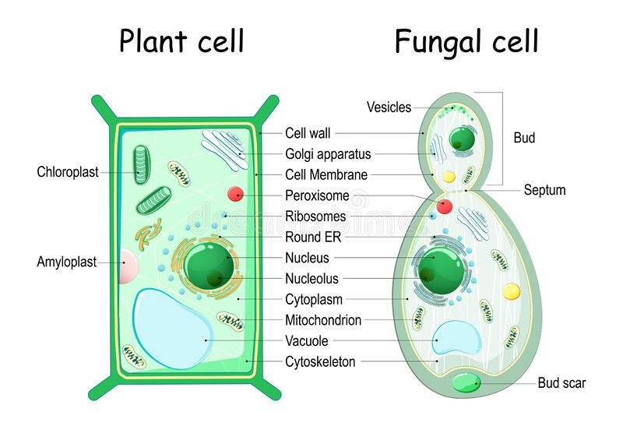

- Fungal cells
Like plant cells, fungal cells also have a cell wall, but their cell wall is made of chitin (the substance found in insect exoskeleton). Some fungi have septa, which are holes that allow organelles and cytoplasm to pass between them. This makes the boundaries between different cells less clear.
- Animal cells
Animal cells do not have cells walls. Instead, they have only a plasma membrane. The lack of cell wall allows animal cells to form many different shapes, and allows for the processes of phagocytosis cell eating and pinocytosis cell drinking to occur. animal cells differ from plant cells in that they do not have chloroplast and have smaller vacuoles instead of a large central vacuole.
- Protozoa
Protozoa are eukaryotic organisms that consist of a single cell. and they digest food in vacuoles. Some protozoa have many cilia, which are small arms that allow them to move around. Some also have a thin layer called a pellicle which provides support to the cell membrane.

In addition to having a plasma membrane, cytoplasm, a nucleus and ribosomes, eukaryotic cells can carry out many more functions than prokaryotic cells a Eukaryotic cell are 10 times the size of typical prokaryote; they range between 10 and 100µm in diameter. Scientists believe that eukaryotes developed about 1.6 – 2.1 billion years ago a cytoskeleton.

Mcqs
1)What is the name of the region where double-stranded single circular DNA is found in the prokaryotic cell?
(a) Pronucleus
(b) Nucleus
(c) Nucleoid
(d) Nucleoplasm
Answer: (c)

2. In prokaryotic cells, ribosomes are
(a) 70 S
(b) 80 S
(c) 60S + 40S
(d) 50S + 40S
Answer: (a)

3. The two domains to which prokaryotes are classified into are:
(a) Bacteria and Protista
(b) Bacteria and Archaea
(c) Archaea and Eukarya
(d) Eukarya and Monera
Answer: (b)

4. When a water sample from a hot thermal vent was tested, it was found to contain a single-celled organism having a cell wall lacking a nucleus. What is its classification most likely?
(a) Eukarya
(b) Fungi
(c) Protista
(d) Archaea
Answer: (d)

5. Which of these is a characteristic of prokaryotic cells?
(a) Absence of cell organelles
(b) Absence of nucleus
(c) Presence of 70S ribosomes
(d) All of these
Answer: (d)

6. A difference between eukaryotic and prokaryotic cells is in having
(a) Ribosomes
(b) Cell wall
(c) Nuclear membrane
(d) None of the above
Answer: (c)

7. In prokaryotes, the hair-like outgrowths which attach to the surface of other bacterial cells are
(a) Flagella
(b) Pili
(c) Capsule
(d) Plasmids
Answer: (b)

8. A component of prokaryotic cells:
(a) Plasma membrane
(b) DNA
(c) Cytoplasm
(d) All of these
Answer: (d)

9. The process of recombination in prokaryotes takes place in this way
(a) Transformation
(b) Conjugation
(c) Transduction
(d) All of the above
Answer: (d)

10. The flagella of a prokaryotic and eukaryotic cell vary in
(a) Mode of functioning and location in the cell
(b) Types of movement and placement in the cell
(c) Microtubular organization and function
(d) Microtubular organization and type of movement
Answer: (d)

11)The first man to observe live cell under microscope was
a) Robert Hooke
b) Leeuwenhoek
c) Schleiden
d) Virchow
answer b
12). He placed a slice of cork under his microscope and he called the structure observed as 'cell'. The person mentioned is
- Anton van Leeuwenhoek
- Zacharias Janssen
- Schwann
- Robert Hooke
Answer d
13). All the following statements are true regarding the "cell theory" except
- All living things or organisms are made of cells
- All cells arise spontaneously
- Cell is the basic structural and functional unit of life
- All cells arise from preexisting cells
Answer b
14). Robert Hooke published the discovery of the cell in his book
- Genera plantarum
- Species plantarum
- Micrographia
- The origin of species
Answer c
15). All cells arise from preexisting cells. This tenet of cell theory was put forward by
- Schwann
- Virchow
- Schleiden
- Robert Hooke
Answer b
16). The 'theory of cell lineage' was proposed by
- Schleiden
- Flemming
- Virchow
- Robert Hooke
Answer c
17). Robert Hooke's observation of honey comb like structural units under microscope was actually
- Plant protoplasm
- Plasma membrane
- cell wall
- entire cell
answer c
18). Which of the following is not an exception of cell theory
- bacteria
- viruses
- prions
- viroid
answer a
19). The 'protoplasm theory' stating protoplasm as the physical basis of life was proposed by
- Flemming
- Purkinje
- Robert Brown
- Weismann
Answer b

20). The nucleus was first described by
- Robert Brown
- Robert Hooke
- Weismann
- Nageli
Answer a

