EFFECT OF PRECIPITATION ON
DISTRIBUTION OF PLANTS

PRECIPITATION
Precipitation is a very important part of climate. Precipitation is the solid, liquid, or gaseous water that falls from the atmosphere to Earth's surface.
This includes snow, sleet, hail, rain, and even mist. Changes in the amount of precipitation falling to Earth affect our lives in many ways
Daily human activities, business and industry, agriculture, and the environment all require water. Much of Earth's water ultimately comes from precipitation.

EFFECT OF PRECIPITATION
- WHEN PRECIPITATION TOO LITTLE

Too little precipitation can result in dry soil, shallow streams, and shortages of municipal water supplies.
- WHEN PRECIPITATION TOO HIGH
However, too much precipitation can also have a negative impact on human activities, business and industry, agriculture, and the environment. For example, too much rain or snowmelt (water from melted snow) at one time can lead to flooding. Living organisms, including crops, can drown in floodwaters. Homes, businesses, even land can be washed away.

REASON FOR CHANGE IN PRECIPITATION
There are many reasons for changes in precipitation. The leading cause is a change in temperature. Many scientists believe an increase in temperature could lead to a more intense water cycle. The rates of evaporation from soils and water, as well as transpiration from plants, could increase. The amount of precipitation could also increase.

Predicted changes in the water cycle differ according to the region of the planet being examined. Many scientists believe rates of evaporation will be greater than precipitation in the middle latitudes such as the United States. This could result in drier summers in these regions.
Of course, predicted changes in the water cycle also differ according to the climate
EFFECT OF PRECIPITATION ON PLANTS ANTS DISTRIBUTION:
Terrestrial biomes on Earth are each distinguished by characteristic temperatures and amount of precipitation. Comparing the annual totals of precipitation and fluctuations in precipitation from one biome to another provides clues as to the importance of abiotic factors in the distribution of biomes. Temperature variation on a daily and seasonal basis is also important for predicting the geographic distribution of the biome and the vegetation type in the biome. The distribution of these biomes shows that the same biome can occur in geographically distinct areas with similar climates-

Biomes
Biomes are large-scale environments that are distinguished by characteristic temperature ranges and amounts of precipitation. These two variables affect the types of vegetation and animal life that can exist in those areas. Because each biome is defined by climate, the same biome can occur in geographically distinct areas with similar climates;
There are eight major terrestrial biomes
- TROPICAL WET FORESTS
- SAVANNAS
- SUBTROPICAL DESERTS
- CHAPARRAL
- TEMPERATE GRASSLANDS
- TEMPERATE FORESTS
- BOREAL FOREST
- ARCTIC TUNDRA

The same biome can occur in different geographic locations with similar climates. Temperature and precipitation, and variations in both, are key abiotic factors that shape the composition of animal and plant communities in terrestrial biomes. Some biomes, such as temperate grasslands and temperate forests, have distinct seasons, with cold weather and hot weather alternating throughout the year. In warm, moist biomes, such as the tropical wet forest, net primary productivity is high, as warm temperatures, abundant water, and a year-round growing season fuel plant growth. Other biomes, such as deserts and tundra, have low primary productivity due to extreme temperatures and a shortage of available water
.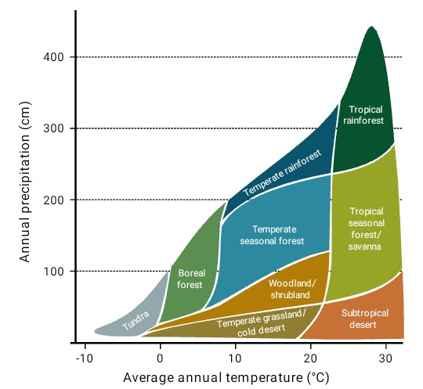Precipitation and temperature are the two most important climatic variables that determine the type of biome in a particular location.

TROPICAL WET FORESTS
Tropical wet forests are also referred to as tropical rainforests. This biome is found in equatorial regions. The vegetation is characterized by plants with broad leaves that fall off throughout the year. Unlike the trees of deciduous forests, the trees in this biome do not have a seasonal loss of leaves associated with variations in temperature and sunlight; these forests are “evergreen” year-round.
Temperature range:
The temperature and sunlight profiles of tropical wet forests are very stable in comparison to that of other terrestrial biomes, with the temperatures ranging from 20 °C to 34 °C (68 °F to 93).When one compares the annual temperature variation of tropical wet forests with that of other forest biomes, the lack of seasonal temperature variation in the tropical wet forest becomes apparent. This lack of seasonality leads to year-round plant growth, rather than the seasonal (spring, summer, and fall) growth seen in other biomes. In contrast to other ecosystems, tropical ecosystems do not have long days and short days during the yearly cycle. Instead, a constant daily amount of sunlight (11–12 hours per day) provides more solar radiation, thereby, a longer period of time for plant growth.
Rain fall:
The annual rainfall in tropical wet forests ranges from 125 to 660 cm (50–200 in) with some monthly variation. While sunlight and temperature remain fairly consistent, annual rainfall is highly variable. Tropical wet forests have wet months in which there can be more than 30 cm (11–12 in) of precipitation, as well as dry months in which there are fewer than 10 cm (3.5 in) of rainfall. However, the driest month of a tropical wet forest still exceeds the annual rainfall of some other biomes, such as deserts.
Characteristics of plants:
Tropical wet forests have high net primary productivity because the annual temperatures and precipitation values in these areas are ideal for plant growth. Therefore, the extensive biomass present in the tropical wet forest leads to plant communities with very high species diversities - Tropical wet forests have more species of trees than any other biome; on average between 100 and 300 species of trees are present in a single hectare (2.5 acres) of South America. One way to visualize this is to compare the distinctive horizontal layers within the tropical wet forest biome. On the forest floor is a sparse layer of plants and decaying plant matter. Above that is an understory of short shrubby foliage. A layer of trees rises above this understory and is topped by a closed upper canopy—the uppermost overhead layer of branches and leaves. Some additional trees emerge through this closed upper canopy. These layers provide diverse and complex habitats for the variety of plants, fungi, animals, and other organisms within the tropical wet forests. For instance, epiphytes are plants that grow on other plants, which typically are not harmed. Epiphytes are found throughout tropical wet forest biomes. Many species of animals use the variety of plants and the complex structure of the tropical wet forests for food and shelter. Some organisms live several meters above ground and have adapted to this arboreal lifestyle
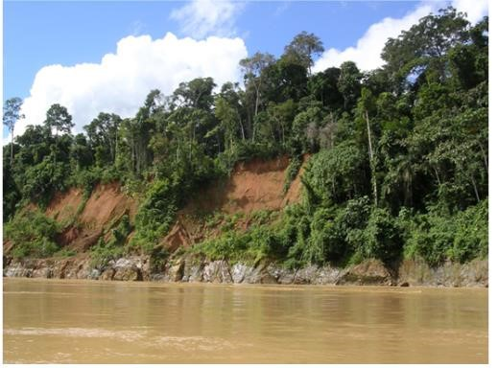
. Tropical wet forests, such as these forests of Madre de Dios, Peru, near the Amazon River, have high species diversity.
SAVANNAS:
Savannas are grasslands with scattered trees, and they are located in Africa -south America and
northern Australia
Temperature range:
Savannas are hot, tropical areas with temperatures averaging from 24 °C to 29 °C (75 °F to 84 °F) and an annual rainfall of 10–40 cm (3.9–15.7 in). Savannas have an extensive dry season; for this reason, forest trees do not grow as well as they do in the tropical wet forest (or other forest biomes).
Adaptations:
As a result, within the grasses and forbs (herbaceous flowering plants) that dominate the savanna, there are relatively few trees (Figure 2). Since fire is an important source of disturbance in this biome, plants have evolved well-developed root systems that allow them to quickly resprout.
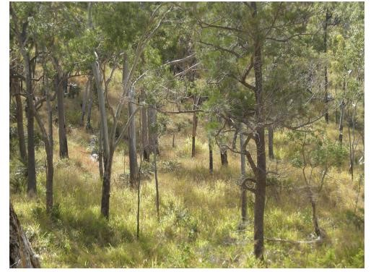 2.
Savannas, like this are dominated by grasses.
SUBTROPICAL DESERT :Subtropical deserts exist between 15 ° and 30 ° north and
south latitude and are centered on the Tropics of Cancer and Capricorn-This biome is very dry; in some years, evaporation exceeds precipitation.
Temperature range:
Subtropical hot deserts can have daytime soil surface temperatures above 60 °C (140 °F) and nighttime temperatures approaching 0 °C (32 °F). In cold deserts, temperatures can be as high as 25 °C and can drop below −30 °C (−22 °F).
Precipitation:
Subtropical deserts are characterized by low annual precipitation of fewer than 30 cm (12 in) with little monthly variation and lack of predictability in rainfall. In some cases, the annual rainfall can be as low as 2 cm (0.8 in) in subtropical deserts located in central Australia (“the Outback”) and northern Africa.
Adaptations:
The vegetation and low animal diversity of this biome is closely related to this low and unpredictable precipitation. Very dry deserts lack perennial vegetation that lives from one year to the next; instead, many plants are annuals that grow quickly and reproduce when rainfall does occur, then they die. Many other plants in these areas are characterized by having a number of adaptations that conserve water, such as deep roots, reduced foliage, and water-storing stems. Seed plants in the desert produce seeds that can be in dormancy for extended periods between rains. Adaptations in desert animals include nocturnal behavior and
burrowing.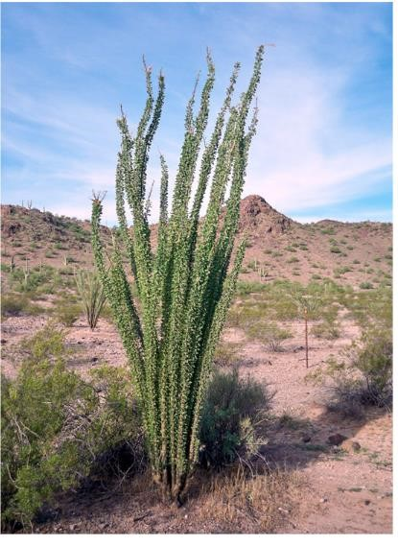
Figure 3. To reduce water loss, many desert plants have tiny leaves or no leaves at all. The leaves of ocotillo shown here in the Sonora Desert near Gila Bend, Arizona, appear only after rainfall, and then are shed.
CHAPARRAL:
The chaparral is also called the scrub forest and is found in California, along the Mediterranean Sea, and along the southern coast of Australia.
Rainfall:
The annual rainfall in this biome ranges from 65 cm to 75 cm (25.6–29.5 in), and the majority of the rain falls in the winter. Summers are very dry and many chaparral plants are dormant during the summertime.
Adaptations:
The chaparral vegetation, is dominated by shrubs and is adapted to periodic fires, with some plants producing seeds that only germinate after a hot fire. The ashes left behind after a fire are rich in nutrients like nitrogen that fertilize the soil and promote plant regrowth.
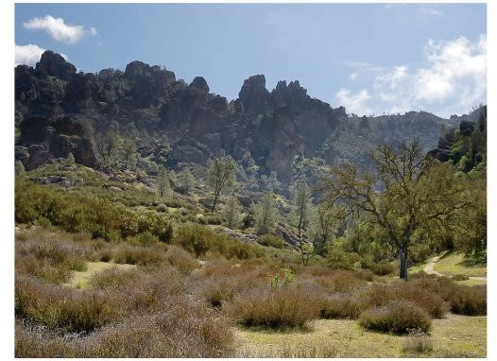
Figure 4. The chaparral is dominated by shrubs
TEMPERATE FORESTS:
Temperate forests are the most common biome in eastern North America, Western Europe, Eastern Asia, Chile, and New Zealand. This biome is found throughout mid-latitude regions
Temperature range:
Temperatures range between −30 °C and 30 °C (−22 °F to 86 °F) and drop to below freezing on an annual basis. These temperatures mean that temperate forests have defined growing seasons during the spring, summer, and early fall. Precipitation is relatively constant throughout the year and ranges between 75 cm and 150 cm.
Adaptations:
Because of the moderate annual rainfall and temperatures, deciduous trees are the dominant plant in this biome- Deciduous trees lose their leaves each fall and remain leafless in the winter. Thus, no photosynthesis occurs in the deciduous trees during the dormant winter period. Each spring, new leaves appear as the temperature increases. Because of the dormant period, the net primary productivity of temperate forests is less than that of tropical wet forests. In addition, temperate forests show less diversity of tree species than tropical wet forest biomes.
The trees of the temperate forests leaf out and shade much of the ground; however, this biome is more open than tropical wet forests because trees in the temperate forests do not grow as tall as the trees in tropical wet forests. The soils of the temperate forests are rich in inorganic and organic nutrients. This is due to the thick layer of leaf litter on forest floors. As this leaf litter decays, nutrients are returned to the soil. The leaf litter also protects soil from erosion, insulates the ground, and provides habitats for invertebrates (such as the pill bug or roly-poly, Armadillidium vulgare) and their predators, such as the red-backed salamander.
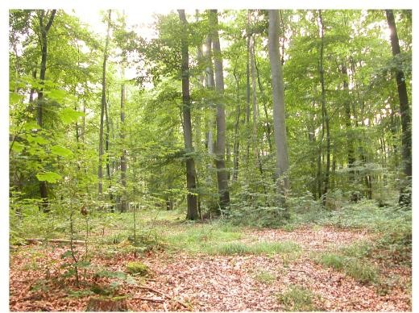
Deciduous trees are the dominant plant in the temperate forest
BOREAL FORESTS:
The boreal forest, also known as taiga or coniferous forest, is found roughly between 50ºand
60º north latitude across most of Canada, Alaska, Russia, and northern Europe. Boreal forests are also found above a certain elevation (and below high elevations where trees cannot grow) in mountain ranges throughout the Northern Hemisphere.
Temperature range:
This biome has cold, dry winters and short, cool, wet summers. The annual precipitation is from 40 cm to 100 cm (15.7–39 in) and usually takes the form of snow; relatively little evaporation occurs because of the cool temperatures.
Adaptations:
The long and cold winters in the boreal forest have led to the predominance of cold-tolerant cone-bearing plants. These are evergreen coniferous trees like pines, spruce, and fir, which retain their needle-shaped leaves year-round. Evergreen trees can photosynthesize earlier in the spring than deciduous trees because less energy from the Sun is required to warm a needle-like leaf than a broad leaf. Evergreen trees grow faster than deciduous trees in the boreal forest. In addition, soils in boreal forest regions tend to be acidic with little available nitrogen. Leaves are a nitrogen-rich structure and deciduous trees must produce a new set of these nitrogen-rich structures each year. Therefore, coniferous trees that retain nitrogen-rich needles in a nitrogen limiting environment may have had a competitive advantage over the broad-leafed deciduous trees.
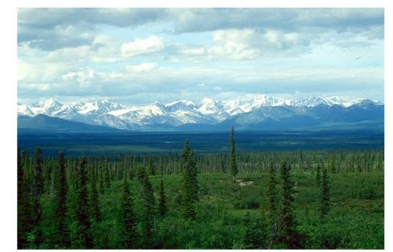

The boreal forest (taiga) has low lying plants and conifer trees.
The net primary productivity of boreal forests is lower than that of temperate forests and tropical wet forests. The aboveground biomass of boreal forests is high because these slow-growing tree species are long-lived and accumulate standing biomass over time. Species diversity is less than that seen in temperate forests and tropical rainforests. Boreal forests lack the layered forest structure seen in tropical rainforests or, to a lesser degree, temperate forests. The structure of a boreal forest is often only a tree layer and a ground layer. When conifer needles are dropped, they decompose more slowly than broad leaves; therefore, fewer nutrients are returned to the soil to fuel plant growth.
ARCTIC TANDRA:
The Arctic tundra lies north of the subarctic boreal forests and is located throughout the Arctic regions of the Northern Hemisphere. Tundra also exists at elevations above the tree line on mountains.
Temperature and precipitation range:
The average winter temperature is –34°C (–29.2°F) and the average summer temperature is 3°C–
12°C (37°F –52°F). Plants in the Arctic tundra have a short growing season of approximately
50–60 days. However, during this time, there are almost 24 hours of daylight and plant growth is rapid. The annual precipitation of the Arctic tundra is low (15–25 cm or 6–10 in) with little annual variation in precipitation. And, as in the boreal forests, there is little evaporation because of the cold temperatures.
Adaptations:
Plants in the Arctic tundra are generally low to the ground and include low shrubs, grasses, lichens, and small flowering plants. There is little species diversity, low net primary productivity, and low above-ground biomass. The soils of the Arctic tundra may remain in a perennially frozen state referred to as permafrost. The permafrost makes it impossible for roots to penetrate far into the soil and slows the decay of organic matter, which inhibits the release of nutrients from organic matter. The melting of the permafrost in the brief summer provides water for a burst of productivity while temperatures and long days permit it. During the growing season, the ground of the Arctic tundra can be completely covered with plants or
lichen.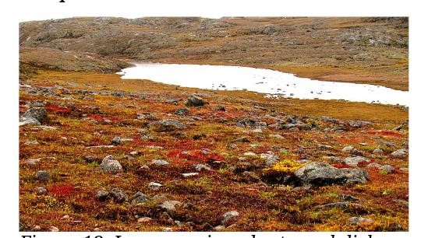
Low-growing plants such lichen and grasses are common in tundra.
CONCLUSION:
Precipitation is any form of liquid and solid and water particles that fall from atmosphere and reach the surface of earth.
From the gulf area coast area, precipitation includes drizzles, rain, hail and on rare occasion snow and sleet.
Different region and geographical locations see varying amount of precipitation in amount and intensity.
Precipitation is caused when a mass of warm, moist air hits a mass of cold air. condensation causes the moisture to form droplets that become rain and crystal.
When these droplets or crystals become too heavy to be suspended in atmosphere, they fall to earth as precipitation.

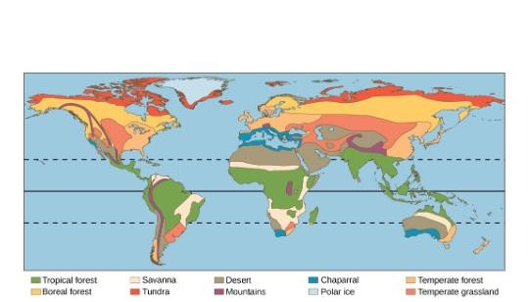
Each of the world’s eight major biomes is distinguished by characteristic temperatures and amount of precipitation. Polar ice caps and mountains are also shown.

