Housing management for sheep and goats
Introduction
Small ruminants have always been left with poor housing facilities in spite they perform well. Better housing management will boost their performance. There are some key points to be considered while housing for small ruminants like orientation, elevation, space requirement, length of wall, shed, feeders, water trough, etc.
Features for proper housing
• Simple shed with low cost housing materials is enough.
• Sheds with mud floor are suitable for most of parts of the country except where high rainfall is observed.
• Sheds should be constructed in an elevated area.
• Fodder trees can be grown around the shed, which acts as a source of feed for the growing goats.
• Clean drinking water should be available.
• Sheds should be constructed with proper ventilation.
• Walls of the shed should be free from cracks or holes, while constructing.
• Floors of the shed should be firm and should have the capacity to absorb water.
• The floors should be constructed in such a way, so that it should be easily cleaned.
• Open type housing with a covered area and run space is generally enough.
• The run space should be covered by chain links.
• East-west orientation more suitable.
• Thatched roof is best suited one due to cheaper cost.
• However corrugated asbestos sheets can also be used for organized farms
• Gable roofing is generally preferred.
• When the animals are taken for grazing during the daytime and sheltered only during night, the covered space will be enough.
• When the animals are housed intensively, the pen and run system of housing is suitable.
• There is no restriction for the length of the shelter, however, breadth of shed should not exceed 12 meter and optimum breadth of shelter is 8 meter.
• Height of eaves should be 2.5 meter and height at ridge should be 3.5 meter.
• The height of chain link used for open space should be 4 feet. The length of the overhang should be 75cm – 1 meter.
• Separate feeders and water troughs should be placed for concentrate feeds, green fodders and water.
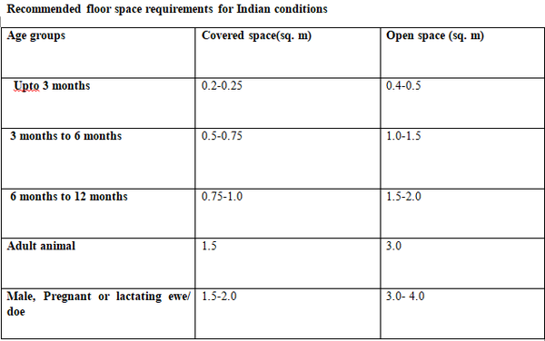
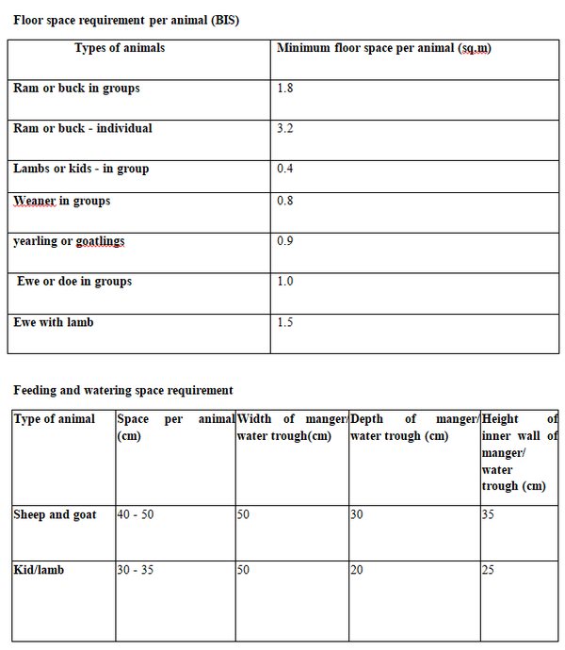
Manger
• The manger may be either of cement concrete or of wood with two compartments for providing feed and hay.
• A separate hay rack may also be provided by fixing at level or slightly below the heads of the animals.
• With the help of clamps, the manger may be raised within the height ranging between 450 and 600 mm from the ground.
• The water trough may be of cement concrete or galvanized steel pails or buckets and may be fixed or hung from a hook fixed to the walls.
• The manger may also be of portable type.
• The number of mangers and water troughs in each shed may vary according to the number of animals.
Dipping tank
• To protect the animals from infection a dipping tank may be made either of galvanized steel sheets or constructed of stone or brick in cement mortar, whichever is likely to prove economical, as per local conditions.
• If the base of the soil is unstable, the tank may be bedded in cement concrete. The dipping tank may be at one side of the yard.
Footbath
• A footbath made of galvanized steel sheets or brick in cement mortar shall be provided at the entrance to the yard to protect the animals from foot-rot disease.
Rearing in mud
• In this method, once in a year 1-2 inches of mud surface should be removed.
• Application of lime powder once in a month will reduce the disease occurrence in the shed.
• The shed should be constructed in elevated area to prevent water stagnation.
Deep litter shed
• In this method, the litter materials like ground nut husk, sugarcane tops etc. are spread on the floor for a depth of ½ feet and animals are reared in it.
• The urine and dung mixed with the litter materials are used as fertilizer.
• The litter materials should be removed once in six months.
• In heavy rain seasons, the litter materials should not be over wet to prevent which would cause ammonia gas production.
Elevated floor shed
• Its initial investment is high.
• In the wooden floor sheds, in a distance of 3m from the floor, the animals are reared.
• This requires less labour and more irrigation land for the fodder production.
• The elevated sheds will be clean and urine and dung will be collected in the floor and periodical removing is required once in six months.
Conclusions
Better housing management of small ruminants will definitely increase their efficacy and utility. While housing, key points should be taken into consideration as per the requirement of small ruminants so that maximum profitability could be obtained

