TOPIC
BASIC PROPERTIES OF CELL
- THE CELL
The cell can be defined as the structural and functional unit of life. It is the smallest unit that can carry out all activities of life. Cells are building blocks of complex multicellular organisms.

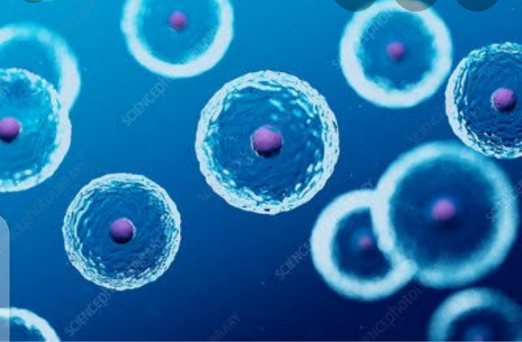

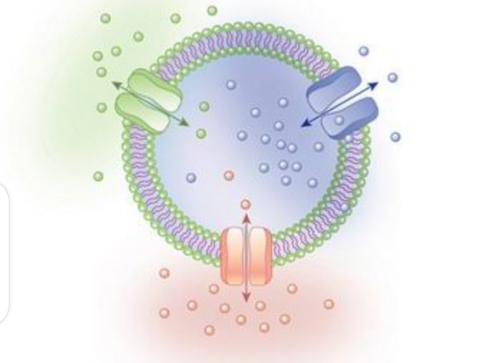

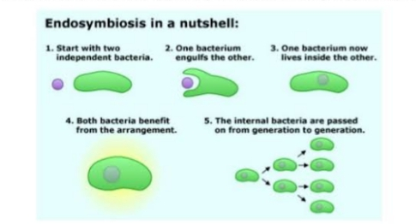
- Structure of cell
A cell consists of the following basic components.
- Plasma membrane, also a cell wall in plant cell.
- Cytoplasm, containing cell organelles.
- Nucleus, with nuclear or chromatin material.

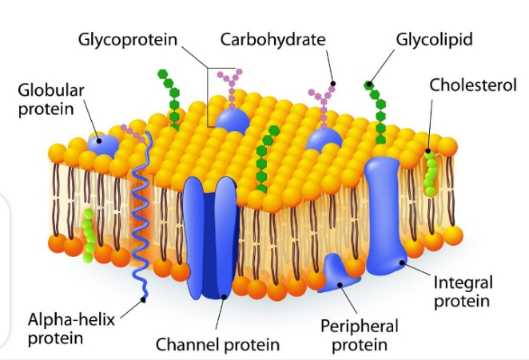

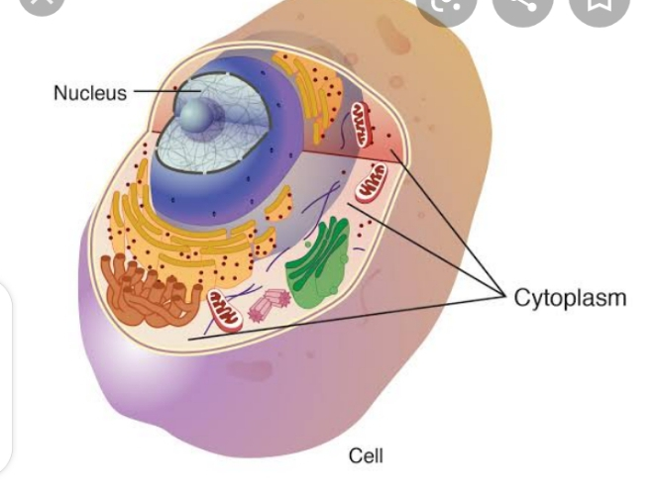

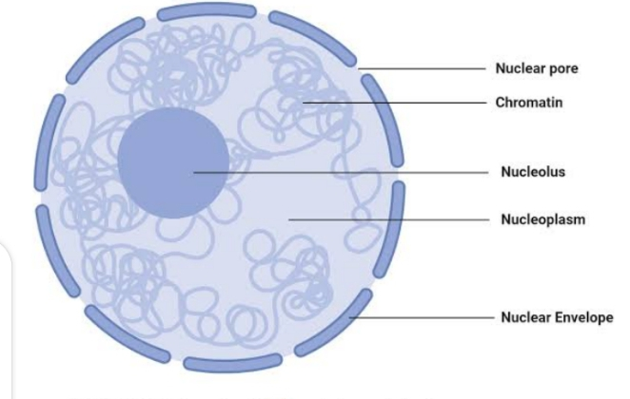

- Basic properties of cell
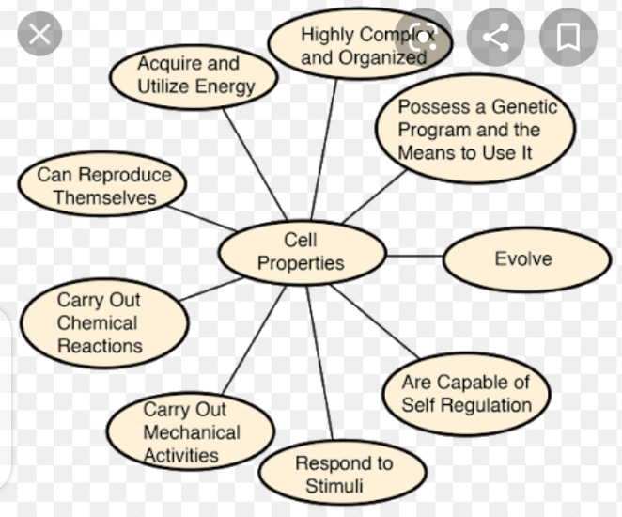

- Basic properties of cell
- Cells are highly complex and organized.
- Cells possess a genetic program and the means to use it.
- Cells acquire and utilize energy.
- Cells carry out a variety of chemical reactions.
- Cells engage in mechanical activities.
- Cells are able to respond to stimuli.
- Cells are capable of self-regulation.

Basic properties of cell

- Life is the most basic property of cells.
- Cells can grow and reproduce in culture for extended periods.
- Hela cells are cultured tumor cells located form a cancer patient.
- Cultured cells are an essential tool for cell biologists.

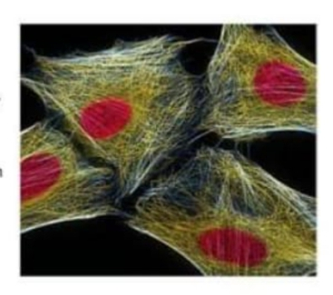

- Cells Are Highly Complex and Organized
Complexity is a property that is evident when encountered, but difficult to describe. For the present, we can think of complexity in terms of order and consistency. The more complex a structure, the greater the number of parts that must be in their proper place, the less tolerance of errors in the nature and inter-actions of the parts, and the more regulation or control that must be exerted to maintain the system.
Cellular activities can be remarkably precise. Cellular activities can be remarkably precise. DNA duplication, for example, occurs with an error rate of less than one mistake every ten million nucleotides incorporated and most of these are quickly corrected by an elaborate repair mechanism that recognizes the defect.
We discuss the organization of atoms into small sized molecules; the organization of these molecules into giant polymers; and the organization of different types of polymeric molecules into complexes, which in are organized into subcellular organelles and finally into cells. As will be apparent, there is a great deal of consistency at every level.
Each type of cell has a consistent appearance when viewed under a high – powered electron microscope; that is, its organelles have a particular shape and location, from one individual of a species to another. Similarly each type of organelle has a consistent composition of macromolecules, which are arranged in a particular pattern.

Consider the cells lining the intestine are tightly connected to each other like bricks in a wall. The epithelial cells that line the intestine are tightly connected to each other like bricks in a wall. The epical ends of these cells, which face the intestinal channel, have long processes (microvilli) that facilitate absorption of nutrients.

The microvilli are able to project outward from the apical cell surface because they contain an internal skeleton made of filaments, which in turn are composed of protein monomers polymerized in a characteristic array.

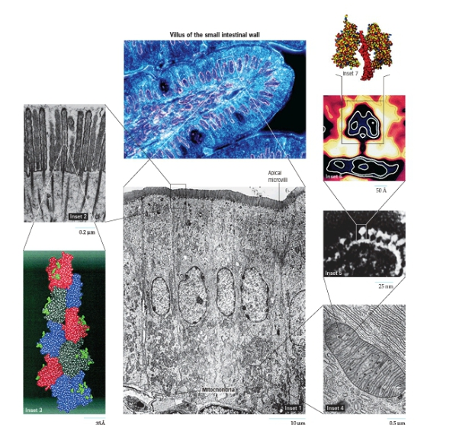

- Cells possess a genetic program and the means to use it

Organisms are built according to information encoded in a collection of genes, which are constructed of DNA. The human genetic program contains enough information, if converted to words, to fill millions of pages to text. Remarkably this vast amount of information is packaged into a set of chromosomes that occupies the space of a cell nucleus –hundreds of times smaller than the dot on this i.
Genes are more than storage lockers for information: they constitute the blueprints for constructing cellular structures, the directions for running cellular activities, and the program for making more of themselves. The molecular structure of genes allows for changes in genetic information. That leads to variation among individuals, which forms the basis of biological evolution. Discovering the mechanisms by which cells use and transmit their genetic information has been one of the greatest achievements of science in recent decades.
- Cells are capable of producing more of themselves

Just as individual organisms are generated by reproduction, so too are individual cells. Cells reproduce by division, a process in which the contents of a mother cell are distributed into two daughter cells. Prior to division, the genetic material is faithfully duplicated, and each daughter cell receives a complete and equal share of genetic information.
In most cases, the two daughter cells have approximately equal volume. In some cases, however, as occurs when a human oocyte undergoes division, one of the cells can retain nearly all of the cytoplasm, even though it receives only half of the genetic material.

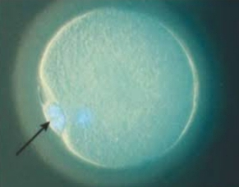

- Cells Acquire and Utilize Energy
Every biological process requires the input of energy. Virtually all of the energy utilized by life on the Earth’s surface arrives in the form of electromagnetic radiation from the sun. The energy of light is trapped by light-absorbing pigments present in the membranes of photosynthetic cells. Light energy is converted by photosynthesis into chemical energy that is stored in carbohydrates, such as sucrose or starch.
For most animal cells energy arrives prepackaged, often in the form of the sugar glucose. In humans, glucose is released by the liver in to the blood where it circulates through the body delivering chemical energy to all the cells. Once in a cell the glucose is disassembled in such a way that its energy content can be stored in a readily available form that is later put to use in running all of the cell’s myriad energy requiring activities.
Cells expend an enormous amount of energy simple breaking down and rebuilding the macromolecules and organelles of which they are made. This continual turnover as it is called maintains the integrity of cell components in the face of inevitable wear and tear and enables the cell to respond rapidly to changing conditions.

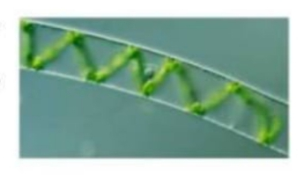

- Cells carry out a variety of chemical reactions
Cells function like miniaturized chemical plants. Even the simplest bacterial cell is capable of hundreds of different chemical transformations, none of which occurs at any significant rate in the inanimate world. Virtually all chemical changes that take place in cells require enzymes-molecules that greatly increase the rate at which a chemical reaction in a cell represents that cell’s metabolism.
- Cell’s engage in mechanical activities
Cells are sites of bustling activity. Materials are transported from place to place, structures are assembled and then rapidly disassembled, and, in many cases, the entire cell moves itself from one site to another. These types of activities are based on dynamic, mechanical changes in the shape of motor proteins. Motor proteins are just one of many types of molecular machines employed by cells to carry out mechanical activities.

- Cells are able to respond to stimuli
Some cells respond to stimuli in obvious ways; a single-celled protist, for example, moves away from an object in its path or moves toward a source of nutrients. Cells within a multicellular plant or animal respond to stimuli less obviously. Most cells are covered with receptors that interact with substances in the environment in highly specific ways.
Cells possess receptors to hormones, growth factors, and extracellular materials, as well as to substances on the surfaces of other cells. A Cell’s receptors provide pathways through which external stimuli can evoke specific responses in target cells. Cells may respond to specific stimuli by altering their metabolic activities, moving from one place to another, or even commiting suicide.

- Cells are capable of self-Regulation
In recent years, a new term has been used to describe cells: robustness. Cells are robust, that is, hearty or durable, because they are protected from dangerous fluctuations in composition and behavior. Should such fluctuations occur, specific feedback circuits are activated that serve to return the cell to the appropriate state.
In addition to requiring energy, maintaining a complex, ordered state requires constant regulation. The importance of a cell’s regulatory mechanisms becomes most evident when they break down. For example, failure of a cell to correct a mistake when it duplicates its DNA may result in a debilitating mutation, or a breakdown in a cell’s growth-control safe guards can transform the cell into a cancer cell with the capability of destroying the entire organism. We are gradually learning how a cell controls its activities, but much more is left to discover
Consider the following experiment conducted in 1891 by Hans Driesch, a German embryologist. A primary goal of biologists is to understand the molecular structure and role of each component involved in a particular activity, the means by which these components interact and the mechanisms by which these interactions are regulated.

Structure of cell

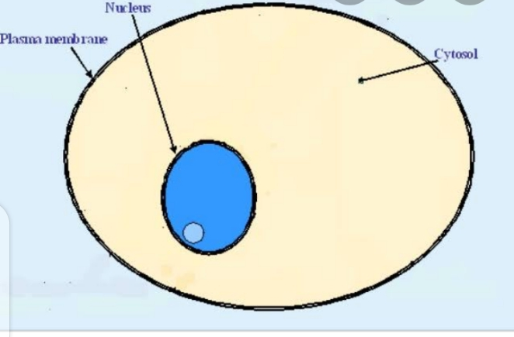

- Plasma membrane

A cellular membrane also called a plasma membrane surround all cells. This membrane function to give the cell shape and to keep the internal components confined and separate from the extracellular fluid that surrounds all .cells. Plasma membrane consists of lipids, fatty acids or wax like substances and proteins.

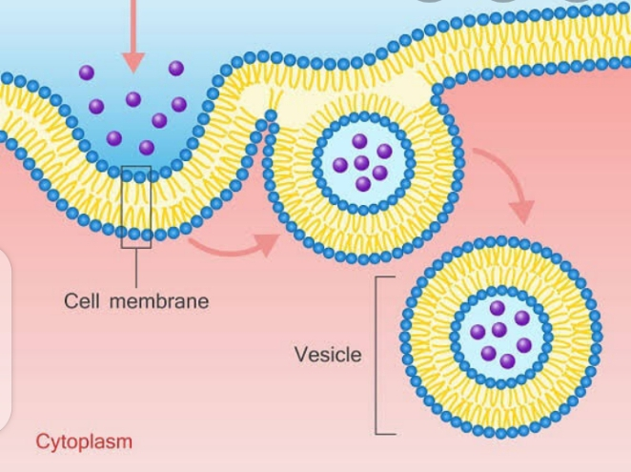

- Nucleus
The nucleus a spherical organelle surrounded by a membrane, is the information center of the cell. The nucleus which occupies approximately 10 % of the cell serves two main functions. It holds the genetic material known as deoxyribose nucleic acid or DNA. It also coordinates the activities of the cell including growth, energy conversion, protein production and reproduction.

- Cytoplasm
The remaining part of the cell bound by the plasma membrane and surrounding the nucleus is the cytoplasm. The cytoplasm consists of a jelly like matrix that holds the other organelles of the cells, including mitochondria and endoplasmic reticulum. Proteins, amino acids and sugars used for growth and cellular reproduction are contained within the cytoplasm. The cytoplasm serves several important cellular functions.

MCQS
- Which cells are found in the intestinal lining?
- Neurons
- Epithelial cells
- Hepatocytes
- Red blood cells
- Microvilli are composed of ________
- Red blood cells
- Myosin
- White blood cells
- Actin
- The sum total of all the chemical reactions taking place inside the cell, represent the cell’s ___________
- Metabolism
- Catabolism
- Anabolism
- Regulation
- It is responsible for the beginning of the life of organisms.
- Tissue
- Zygote
- Cell
- Embryonic layer
- It is the smallest cell.
- Bacteria
- Mycoplasma
- Yeast
- Blue green algae
- The cell is not applied for
- Algae
- Bacteria
- Virus
- Fungi
- Cells present in living organism differ in
- Numbers
- Shape
- Size
- All of these
- Cells which lack nuclear membrane are
- Eukaryotic cells
- Prokaryotic cells
- Single cells
- Multi cells
- The control centre of all the activities of a cell is
- Nucleus
- Nucleoplasm
- Cytoplasm
- Organelles
- The other name of plasma membrane is
- Cell membrane
- Cell wall
- Nuclear membrane
- None of these

THE END

