Markeet mix and markeet & economic system
Definition: The marketing mix refers to the set of actions, or tactics, that a company uses to promote its brand or product in the market. The 4Ps make up a typical marketing mix - Price, Product, Promotion and Place. However, nowadays, the marketing mix increasingly includes several other Ps like Packaging, Positioning, People and even Politics as vital mix elements.
Marketing mix refers to the combination of elements that shape how a business delivers value to its customers. These elements are called the 7Ps: Product, Price, Promotion, Place, People, Process, and Physical evidence.
The concept was originally introduced in 1960 as the 4Ps: Product, Price, Promotion, and Place. But as the marketing landscape evolved, the 4Ps expanded to 7Ps, adding People, Process, and Physical Evidence to the mix. It’s thought that the additional elements better address modern competitive environments affected by the rise of technology and the changes in how people communicate.

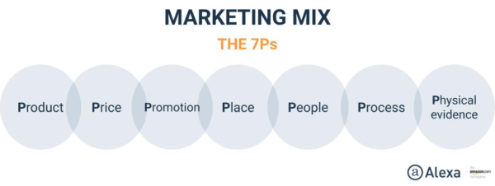

. The Importance of Each Element of the Marketing Mix in Fueling Growth
The importance of marketing mix in achieving business objectives cannot be overstated. As we mentioned, you must make sure each element of the marketing mix works with the others to support your objectives. For example, you need to support a premium product with premium pricing and location, and your promotion must communicate that value. When even one element is “off,” you may find yourself handicapped.
Some companies with standout growth are experiencing the effects of leveraging individual elements of the marketing mix. One element can even help elevate the others, as we’ll see in some of these examples
These original 4 Ps, which still form the core of the marketing mix to this day, can be defined as follows:

Product
The product should do what the customer wants or needs it to do. Whether it’s a CPG product (Consumer Packaged Goods), a luxury item, a digital service or anything else, it should live up to the expected level of quality.In order to design or identify a suitable product, the business should conduct thorough research into the tastes, requirements and buying habits of its target audience. This research-backed approach provides a surer path to commercial success than simply creating a product under the assumption it will find its place in the market.

Price
The product should be sold at a price which the target audience deems to be good value-for-money.
When calculating product price, we must take into account all the costs entailed in producing, promoting and delivering that product. If production and promotion are set to carry relatively high costs, this should be reflected in an appropriately high price.
Effective pricing is not a simple matter of offering a cheaper alternative to the competition. Imagine you’re in a supermarket, browsing the wine section. Whether consciously or not, you will likely select a bottle within a quite specific price range, which is habitual to you. You’re highly unlikely to consider the bottles well outside of your habitual price range – even if a cheaper alternative is in-fact better suited to your taste. Thus, the cut-price vintner’s under-pricing of the product causes them to miss out on a sale.The superior approach, then, is to identify the price your target customer is used to paying for products and services similar to your own, taking into account your costs and the profit margin required.
Place
The product should be available where the customer expects to find it, e.g. in supermarkets, at boutiques, or online. Let’s say you’ve got an amazing sandwich bar in the making, and you decide to place it in a top restaurant district. This would be a serious misplacement, as you’d be targeting the wrong market. Further, we must identify how the product should be presented in each context. For example, which aisle of a supermarket should a CPG product be stocked in? Should it be sold in a trade promotion? In which contexts should it appear as an online ad?
Place also takes into account the logistical factors affecting a product’s profitability, such as storage and distribution. This is as true of digital products and services as it is of traditional ones, with factors such as website design and hosting costs to consider.
In ecommerce, the device type preferences of the target audience should also be factored into your planning. Your customers’ desktop, tablet and mobile usage habits should determine the level of priority you give to each device in your digital marketing.

Promotion
The product should be promoted to the appropriate audience via appropriate channels, using advertising methods which resonate with that audience. These channels may include (and are not limited to):
- branding
- advertising
- PR
- corporate identity
- social media
- content marketing
- influencer marketing
- sales management
- promotions
- exhibitions
The product/service benefits and features highlighted through promotion should align with the audience’s most compelling requirements. Promotion may differ somewhat in tone and content from channel to channel – but never in such a way as to create contradictions.

The 3 further Ps of marketing
In 1981, twenty-one years after E. Jerome McCarthy’s original four Ps, a further 3 Ps of marketing were put forward by Booms & Bitner in their extended marketing mix. These principles, which reflected the changing reality of marketing theory and practice, are as follows:

People
The team involved in the delivery of the project should possess the skills and qualities needed to ensure its success (barring unforeseen mishaps).This is perhaps especially true of customer-facing staff, whose communication and behaviour will greatly impact the audience’s perception of the brand. You could well have developed the best product of its kind – but if your customer
facing people are off-putting to customers, the project will not reach its full commercial potential.
As such, marketing campaign teams must put in place processes and best practices for how customer-facing team members behave publicly and communicate with customers. Methods for doing this include distributing a social media policy, paying attention to communication skills when hiring customer-facing staff, providing training on good communication, and imposing disciplinary measures to deter misbehavior.

Processes

The processes involved in a product’s delivery will significantly affect the customer’s experience, level of satisfaction, and lifetime value to your business. These processes may include (and are not limited to):
- Website user experience
- Delivery time
- Delivery methods and service
- In-store wait time
- Communicating with customer support
- Aftercare
In addition to the processes used to deliver a product or service, we must also have processes in place for when something goes wrong – for example, the allocation of appropriate compensatory gifts for customers who’ve had a bad experience.

Physical evidence
The final P refers to the physical context and paraphernalia (such as receipts, “thanks for ordering” cards, confirmation emails and PDF invoices) that come along with the product. In order to reinforce the product’s and the seller’s credibility, these components should exhibit the qualities customers expect of them, based on up-to-date industry standards.
For example, precious jewellery might be displayed within a locked cabinet; ethical supermarkets might choose to use as little print as possible on their receipts (or offer digital receipts as an alternative), and doctors’ surgeries should look suitably clinical.
In a nutshell, “Physical evidence” is all about ensuring every component involved with the product adheres to the same brand values as the product itself. This creates a consistent, convincing experience for the customer.

Partners: the 8th P of marketing?
Not content with the conventional 7 Ps of marketing, some marketers like to add an eighth factor into the extended marketing mix: partners.
This refers to the third parties involved in the marketing of a product or service – especially referral partners in a digital marketing context. We would tend not to include partners in the marketing mix unless the project relies heavily on referral marketing campaigns.
Is there an 8th P?
In some spheres of thinking, there are 8 Ps in the Marketing Mix. The final P is Productivity and Quality. This came from the old Services Marketing Mix and is folded in to the Extended Marketing Mix by some marketers so what does it mean?

The 8th P of the Marketing Mix:
- Productivity & Quality - This P asks “is what you’re offering your customer a good deal?” This is less about you as a business improving your own productivity for cost management, and more about how your company passes this onto its customers.
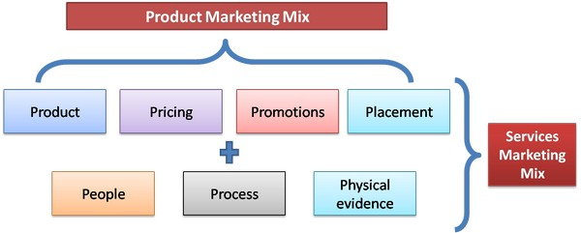

Importance of Marketing Mix: 7Ps in Your Growth Strategy
The benefits of a marketing mix analysis can make all the difference when it comes to growing your business. With the marketing mix model on hand, you can start to think of ways to apply the 7Ps. Consider each element — product, price, place, promotion, people, processes, and physical evidence — and how you’re firm approaches each.
© Al Internet, Inc. 1996 - 2019 | Privacy | Te

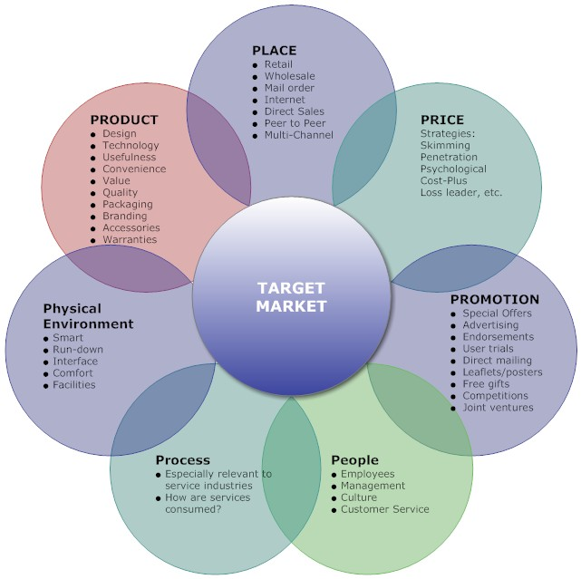

• The MM does not consider customer behavior but is internally oriented.
• The MM regards customers as passive; it does not allow interaction and cannot capt

The SIVA Model:
The S.I.V.A. Model provides a demand/customer-centric alternative to the well-known four Ps marketing mix model (product, price, placement, promotion ) of marketing management. The idea behind it is to restate the four P’s in a way that reflects today’s marketing environment where the power of building brands has shifted from corporations to communities.
Based on this model:
- Product→ Solution;
- Promotion →Information;
- Price→ Value;
- Place (Distribution)→Access

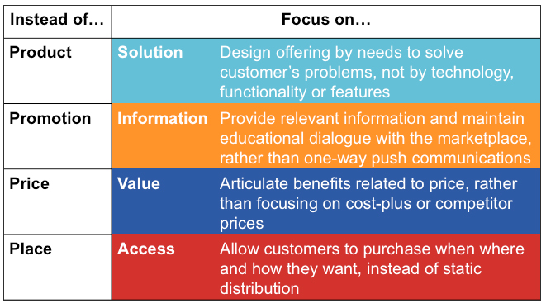

Market Economy:

A market economy is a system where the laws of supply and demand direct the production of goods and services. Supply includes natural resources, capital, and labor. Demand includes purchases by consumers, businesses, and the government.
Businesses sell their wares at the highest price consumers will pay. At the same time, shoppers look for the lowest prices for the goods and services they want. Workers bid their services at the highest possible wages that their skills allow. Employers seek to get the best employees at the lowest possible price.
Capitalism requires a market economy to set prices and distribute goods and services. Socialism and communism need a command economy to create a central plan that guides economic decisions. Market economies evolve from traditional economies. Most societies in the modern world have elements of all three types of economies. That makes them mixed economies.

Key Takeaways
- A market economy functions under the laws of supply and demand.
- It is characterized by private ownership, freedom of choice, self-interest, optimized buying and selling platforms, competition, and limited government intervention.
- Competition drives the market economy, optimizing efficiency and innovation.
- Market economies marginalize those that are unable to compete, contributing to income inequality.

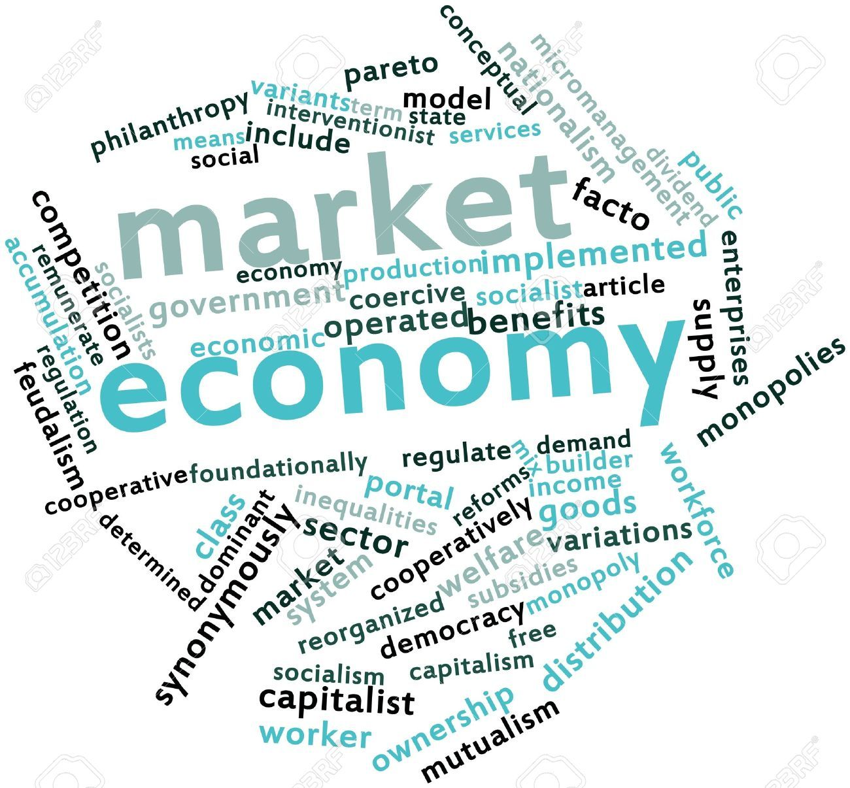

Uniqueness of a Market Economy
The following six characteristics define a market economy.
- Private Property. Most goods and services are privately-owned. The owners can make legally-binding contracts to buy, sell, or lease their property. Their assets give them the right to profit from ownership. There are some assets U.S. law excludes. Since 1865, you cannot legally buy and sell human beings. That includes you, your body, and your body parts.
- Freedom of Choice. Owners are free to produce, sell, and purchase goods and services in a competitive market. They only have two constraints. First is the price at which they are willing to buy or sell. Second is the amount of capital they have.
- Motive of Self-Interest. Everyone sells their wares to the highest bidder while negotiating the lowest price for their purchases. Although the reason is selfish, it benefits the economy over the long run. This auction system sets prices for goods and services that reflect their market value. It gives an accurate picture of supply and demand at any given moment.
- Competition. The force of competitive pressure keeps prices low. It also ensures that society provides goods and services most efficiently. As soon as demand increases for a particular item, prices rise thanks to the law of demand.. Competitors see they can enhance their profit by producing it, adding to supply. That lowers prices to a level where only the best competitors remain. This competitive pressure also applies to workers and consumers. Employees vie with each other for the highest-paying jobs. Buyers compete for the best product at the lowest price. There are three strategies that work to maintain a competitive advantage.
- System of Markets and Prices. A market economy relies on an efficient market in which to sell goods and services. That's where all buyers and sellers have equal access to the same information. Price changes are pure reflections of the laws of supply and demand. There are five determinants of demand.
- Limited Government. The role of government is to ensure that the markets are open and working. For example, it is in charge of national defense to protect the markets. It also makes sure that everyone has equal access to the markets. The government penalizes monopolies that restrict competition. It makes sure no one is manipulating the markets and that everyone has equal access to information.

Advantages of a Market Economy
Since a market economy allows the free interplay of supply and demand, it ensures that the most desired goods and services are produced. Consumers are willing to pay the highest price for the things they want the most. Businesses will only create those things that return a profit.
Second, goods and services are produced in the most efficient way possible. The most productive companies will earn more than less productive ones.
Third, it rewards innovation. Creative new products will meet the needs of consumers in better ways that existing goods and services. These cutting-edge technologies will spread to other competitors so they, too, can be more profitable. This illustrates why Silicon Valley is America's innovative advantage.
Fourth, the most successful businesses invest in other top-notch companies. That gives them a leg up and leads to increased quality of production.

The Disadvantages of a Market Economy:
The key mechanism of a market economy is competition. As a result, it has no system to care for those who are at an inherent competitive disadvantage. That includes the elderly, children, and people with mental or physical disabilities.
Second, the caretakers of those people are at a disadvantage. Their energies and skills go toward caretaking, not competing. Many of these people might become contributors to the economy's overall comparative advantage if they weren't caretakers.
That leads to the third disadvantage. The human resources of society may not be optimized. For example, a child who might otherwise discover the cure for cancer might instead work at McDonald's to support her low-income family.
Fourth, society reflects the values of the winners in the market economy. A market economy may produce private jets for some while others starve and are homeless. A society based on a pure market economy must decide whether it's in its larger self-interest to care for the vulnerable.
If it decides it is, society will grant the government a significant role in redistributing resources that is why many market economies are also mixes economies. Most so called market economies are mixed economies.
Types of economic system:
There are four primary types of economic systems in the world: traditional, command, market and mixed. Each economy has its strengths and weaknesses, its sub-economies and tendencies, and, of course, a troubled history.
Below we examine each system in turn and give ample attention to the attributes listed above. It’s important to understand how different parts of the world function economically, as the economy is one of the strongest forces when it comes to balancing political power, instigating war and delivering a high (or low) quality of life to the people it serves. Anyone interested in economics on a global level should check out this fantastic course on the crisis of capitalism and why the global economy is teetering on the verge of collapse.

1. Traditional Economic System
A traditional economic system is the best place to start because it is, quite literally, the most traditional and ancient type of economy in the world. There are certain elements of a traditional economy that those in more advanced economies, such as Mixed, would like to see return to prominence.
Where Tradition Is Cherished: Traditional economies still produce products and services that are a direct result of their beliefs, customs, traditions, religions, etc. Vast portions of the world still function under a traditional economic system. These areas tend to be rural, second- or third-world, and closely tied to the land, usually through farming. However, there is an increasingly small population of nomadic peoples, and while their economies are certainly traditional, they often interact with other economies in order to sell, trade, barter, etc. Learn about the complexities of globalization and how it shapes economic relationships and affects cultures with this great class on the geography of globalization.
Minimal Waste: Traditional economies would never, ever, in a million years see the type of profit or surplus that results from a market or mixed economy. In general, surplus is a rare thing. A third-world and/or indigenous country does not have the resources necessary (or if they do, they are controlled by wealthier economies, often by force), and in many cases any surplus is either distributed, wasted, or paid to some authority that has been given power.
Advantages And Disadvantages: Certainly one of the most obvious advantages is that tradition and custom is preserved while it is virtually non-existant in market/mixed economies. There is also the fact that each member of a traditional economy has a more specific and pronounced role, and these societies are often very close-knit and socially satisfied. The main disadvantage is that traditional economies do not enjoy the things other economies take for granted: Western medicine, centralized utilities, technology, etc. But as anyone in America can attest, these things do not guarantee happiness, peace, social or, most ironically of all, economic stability.

2. Command Economic System
In terms of economic advancement, the command economic system is the next step up from a traditional economy. This by no means indicates that it is fairer or an exact improvement; there are many things fundamentally wrong with a command economy.
Centralized Control: The most notable feature of a command economy is that a large part of the economic system is controlled by a centralized power; often, a federal government. This kind of economy tends to develop when a country finds itself in possession of a very large amount of valuable resource(s). The government then steps in and regulates the resource(s). Often the government will own everything involved in the industrial process, from the equipment to the facilities.
Interested in earning CFA certification? Get all the training you need from this CFA Level 1 Economics curriculum.

Supposed Advantages: You can see how this kind of economy would, over time, create unrest among the general population. But there are actually several potential advantages, as long as the government uses intelligent regulations. First of all, a command economy is capable of creating a healthy supply of its own resources and it generally rewards its own people with affordable prices (but because it is ultimately regulated by the government, it is ultimately priced by the government). Still, there is often no shortage of jobs as the government functions similarly to a market economy in that it wants to grow and grow upon its populace.
Hand In The Cookie Jar: Interestingly – or maybe, predictably – the government in a command economy only desires to control its most valuable resources. Other things, like agriculture, are left to be regulated and run by the people. This is the nature of a command economy and many communist governments fall into this category.
You should also consider this micro and macro economics program. It’s been approved by the CFA institute and focuses on the impact of economic variables on the financial market and industry.

3. Market Economic System
A market economy is very similar to a free market. The government does not control vital resources, valuable goods or any other major segment of the economy. In this way, organizations run by the people determine how the economy runs, how supply is generated, what demands are necessary, etc.
Capitalism And Socialism: No truly free market economy exists in the world. For example, while America is a capitalist nation, our government still regulates (or attempts to regulate) fair trade, government programs, moral business, monopolies, etc. etc. The advantage to capitalism is you can have an explosive economy that is very well controlled and relatively safe. This would be contrasted to socialism, in which the government (like a command economy) controls and owns the most profitable and vital industries but allows the rest of the market to operate freely; that is, price is allowed to fluctuate freely based on supply and demand. If you want to know how the global economy works and the role you play in it, check out this sweet class on Economics Without Boundaries.

Market Economy And Politics: Arguably the biggest advantage to a market economy (at least, outside of economic benefits) is the separation of the market and the government. This prevents the government from becoming too powerful, too controlling and too similar to the governments of the world that oppress their people while living lavishly on controlled resources. In the same way that separation of church and state has been to vital to America’s social success, so has a separation of market and state been vital to our economic success. Yes, there is something wary about a system which to be successful must foster constant growth, but as a result progress and innovation have occurred at such incredible rates as to affect the way the world economy functions.

4. Mixed Economic System
A mixed economic system (also known as a Dual Economy) is just like it sounds (a combination of economic systems), but it primarily refers to a mixture of a market and command economy (for obvious reasons, a traditional economy does not typically mix well). As you can imagine, many variations exist, with some mixed economies being primarily free markets and others being strongly controlled by the government. Learn more about an essential part of our economy with this free post on understanding the stock market.
Benefits Of A Mixed Economy: In the most common types of mixed economies, the market is more or less free of government ownership except for a few key areas. These areas are usually not the resources that a command economy controls. Instead, as in America, they are the government programs such as education, transportation, USPS, etc. While all of these industries also exist in the private sector in America, this is not always the case for a mixed economy.
Disadvantages Of A Mixed Economy: While a mixed economy can lead to incredible results (America being the obvious example), it can also suffer from similar downfalls found in other economies. For example, the last hundred years in America has seen a rise in government power. Not just in imposing laws and regulations, but in actually gaining control, becoming more difficult to access while simultaneously becoming less flexible. This is a common tendency of mixed economies.
Please Respect The Thin Line: A current, pivotal debate between Democrats and Republicans is the amount of governmental control. Can a true balance exist? Where should there be more government regulation? Where should there be less? These questions have no real answer; it is subjective, and therefore only a relatively small portion of the population will, at any given time, agree with the state of a mixed economy. It must be a strong form of government indeed to avoid collapsing under this constant pressure.

The American Economy
Now that you have a general idea of how the world’s economies function, you can see how some countries are light-years behind others. But the progress of first-world nations allows slower economies to make faster, longer strides. In fact, there is even reason to hope: several initiatives have been implemented in the past ten years that are helping developing countries avoid making the same mistakes we made: pollution, depletion of resources, civil rights, etc. Learn more about your own government and economy with this top-rated course on how the economy really works in the 21st century.

• The concept of the MM has implied marketers as the major element.

marketing manager’s job is a matter of trading off the benefits of one’s competitive strengths in the MM

