Almanacs
Almanacs are not usually used for extensive research, but are good for looking up specific facts, statistics, tables and lists about people, places, events, countries, organizations, zip codes, and popular culture such as sports and entertainment. Generally, almanacs cover a broad period of time, while Yearbooks, which contain similar information, only cover a given year.
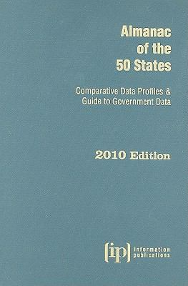

Bibliographies
Bibliographies compile comprehensive lists of resources that share one or more common attributes about a particular subject, person, geographical area, etc. Some bibliographies also briefly describe the resources that are listed. One should consult a bibliography when they want citations that will guide them to specific resources.
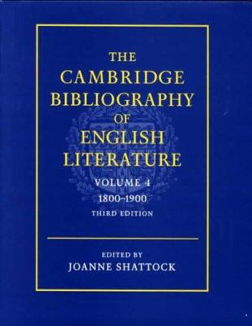

Dictionaries
Standard dictionaries give an alphabetical list of words and their definitions, but there are several useful variations also classified as dictionaries. Thesauri contain synonyms and antonyms (opposites) but usually don't define the words. There are also dialect and slang dictionaries, dictionaries of abbreviations and acronyms, dictionaries of quotations, and picture dictionaries. Dictionaries can be unabridged (general) or can be thematically organized in some way. The Oxford Dictionary of Islam
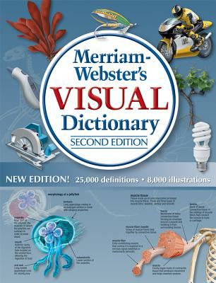

Encyclopedias
Encyclopedias contain full coverage of information about an area of knowledge. They can be general or can cover a specific subject, and contain alphabetically organized entries with varying detail. These are great starting points for fact-finding, getting background topic information, learning of key events and individuals, or starting a research project. Below is a major general encyclopedia. See Best Practices on this guides Home page to pinpoint valuable subject-specific encyclopedias.
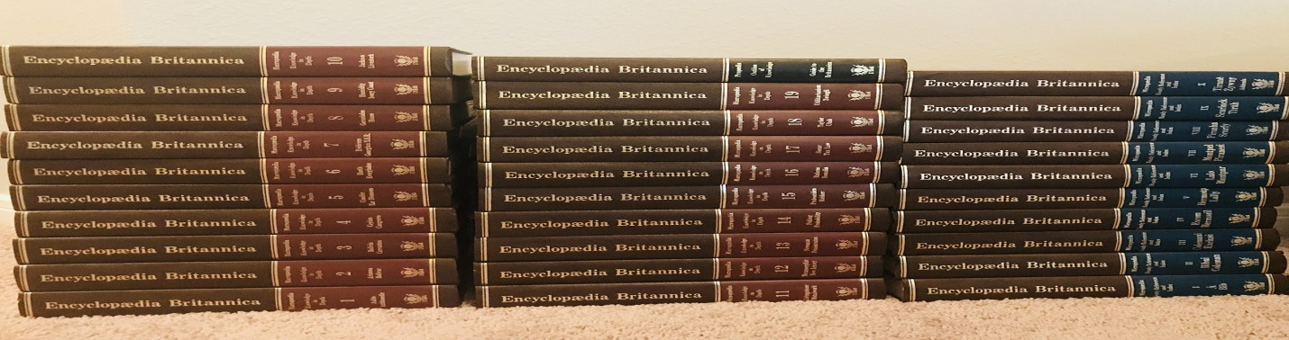

Atlases
Atlases contain an organized group of pictorial or illustrated political, cultural, physical, road, and/or thematic maps. Atlases may be organized around a specific subject, theme, or geographic area.
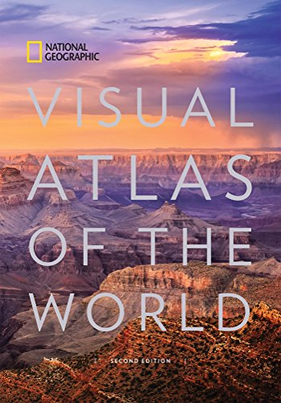

Biographies
Biographies contain information about people, both living and deceased - they can contain brief summaries of data about individuals, contain lists of citations of resources about a person, or be full length books detailing the life of one particular person. Biographies may cover general important figures, or may be organized thematically/geographically, etc. One would use a biography to look up facts or detailed information about a person or group of people.
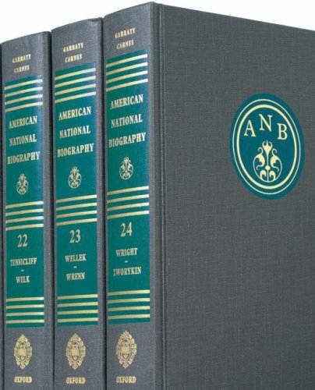

Directories
Directories contain an organized list of people and/or organizations, and help one to find information such as addresses, phone numbers, and email addresses, etc. for the organizations or people included within the scope of that directory.

Handbooks / Manuals
A handbook contains facts about a specific subject or instructions that can be used to accomplish something. A handbook can come in several forms, such as a manual for completing tasks, or a guidebook providing information about a subject, region, etc. (such as a travel guidebook).
