Action Research
1. What is Action Research?
Origins:
Kurt Lewin is generally considered the ‘father’ of action research. A German social and experimental psychologist, and one of the founders of the Gestalt school, he was concerned with social problems, and focused on participative group processes for addressing conflict, crises, and change, generally within organizations. Initially, he was associated with the Center for Group Dynamics at MIT in Boston, but soon went on to establish his own National Training Laboratories.
Lewin first coined the term ‘action research’ in his 1946 paper “Action Research and Minority Problems”
Action research is used in real situations, rather than in contrived, experimental studies, since its primary focus is on solving real problems. It can, however, be used by social scientists for preliminary or pilot research, especially when the situation is too ambiguous to frame a precise research question. Mostly, though, in accordance with its principles, it is chosen when circumstances require flexibility, the involvement of the people in the research, or change must take place quickly or holistically.
It is often the case that those who apply this approach are practitioners who wish to improve understanding of their practice, social change activists trying to mount an action campaign, or, more likely, academics who have been invited into an organization (or other domain) by decision-makers aware of a problem requiring action research, but lacking the requisite methodological knowledge to deal with it.
Definition
Action research is known by many other names, including participatory research, collaborative inquiry, emancipatory research, action learning, and contextural action research, but all are variations on a theme. Put simply, action research is “learning by doing” - a group of people identify a problem, do something to resolve it, see how successful their efforts were, and if not satisfied, try again. While this is the essence of the approach, there are other key attributes of action research that differentiate it from common problem-solving activities that we all engage in every day. According to Thomas Gilmore, Jim Krantz and Rafael Ramirez,
"Action research...aims to contribute both to the practical concerns of people in an immediate problematic situation and to further the goals of social science simultaneously. Thus, there is a dual commitment in action research to study a system and concurrently to collaborate with members of the system in changing it in what is together regarded as a desirable direction. Accomplishing this twin goal requires the active collaboration of researcher and client, and thus it stresses the importance of co-learning as a primary aspect of the research process."
What separates this type of research from general professional practices, consulting, or daily problem-solving is the emphasis on scientific study, which is to say the researcher studies the problem systematically and ensures the intervention is informed by theoretical considerations. Much of the researcher’s time is spent on refining the methodological tools to suit the exigencies of the situation, and on collecting, analyzing, and presenting data on an ongoing, cyclical basis.
Several attributes separate action research from other types of research. Primary is its focus on turning the people involved into researchers, too - people learn best, and more willingly apply what they have learned, when they do it themselves. It also has a social dimension - the research takes place in real-world situations, and aims to solve real problems. Finally, the initiating researcher, unlike in other disciplines, makes no attempt to remain objective, but openly acknowledges their bias to the other participants.
2. Action Research Process:
Gerald Susman (1983) gives a somewhat more elaborate listing. He distinguishes five phases to be conducted within each research cycle (Figure 1). Initially, a problem is identified and data is collected for a more detailed diagnosis. This is followed by a collective postulation of several possible solutions, from which a single plan of action emerges and is implemented. Data on the results of the intervention are collected and analyzed, and the findings are interpreted in light of how successful the action has been. At this point, the problem is re-assessed and the process begins another cycle. This process continues until the problem is resolved.
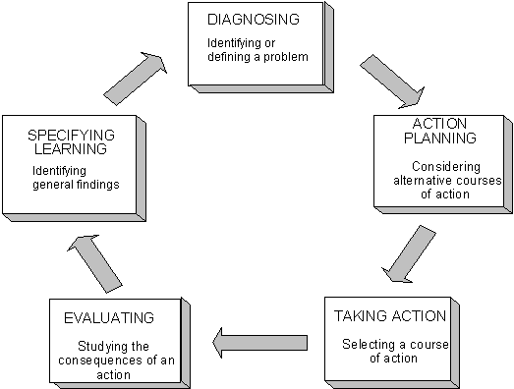

Fig.1: The process of Action Research
3. Principles of Action Research
What gives action research its unique flavor is the set of principles that guide the research. Winter (1989) provides a comprehensive overview of six key principles.
1) Reflexive critique
An account of a situation, such as notes, transcripts or official documents, will make implicit claims to be authoritative, i.e., it implies that it is factual and true. Truth in a social setting, however, is relative to the teller. The principle of reflective critique ensures people reflect on issues and processes and make explicit the interpretations, biases, assumptions and concerns upon which judgments are made. In this way, practical accounts can give rise to theoretical considerations.
2) Dialectical critique
Reality, particularly social reality, is consensually validated, which is to say it is shared through language. Phenomena are conceptualized in dialogue; therefore a dialectical critique is required to understand the set of relationships both between the phenomenon and its context, and between the elements constituting the phenomenon. The key elements to focus attention on are those constituent elements that are unstable, or in opposition to one another. These are the ones that are most likely to create changes.
3) Collaborative Resource
Participants in an action research project are co-researchers. The principle of collaborative resource presupposes that each person’s ideas are equally significant as potential resources for creating interpretive categories of analysis, negotiated among the participants. It strives to avoid the skewing of credibility stemming from the prior status of an idea-holder. It especially makes possible the insights gleaned from noting the contradictions both between many viewpoints and within a single viewpoint
4) Risk
The change process potentially threatens all previously established ways of doing things, thus creating psychic fears among the practitioners. One of the more prominent fears comes from the risk to ego stemming from open discussion of one’s interpretations, ideas, and judgments. Initiators of action research will use this principle to allay others’ fears and invite participation by pointing out that they, too, will be subject to the same process, and that whatever the outcome, learning will take place.
5) Plural Structure
The nature of the research embodies a multiplicity of views, commentaries and critiques, leading to multiple possible actions and interpretations. This plural structure of inquiry requires a plural text for reporting. This means that there will be many accounts made explicit, with commentaries on their contradictions, and a range of options for action presented. A report, therefore, acts as a support for ongoing discussion among collaborators, rather than a final conclusion of fact.
6) Theory, Practice, Transformation
For action researchers, theory informs practice, practice refines theory, in a continuous transformation. In any setting, people’s actions are based on implicitly held assumptions, theories and hypotheses, and with every observed result, theoretical knowledge is enhanced. The two are intertwined aspects of a single change process. It is up to the researchers to make explicit the theoretical justifications for the actions, and to question the bases of those justifications. The ensuing practical applications that follow are subjected to further analysis, in a transformative cycle that continuously alternates emphasis between theory and practice.

