Report (Group no:09)Bs Botany llSmester::
Course name::
Citizenship education and community engagement
Report title::
- Awareness about Coronavirus
- Distribution of garbage dustbin at the roadside
- Awareness how to make sanitizer at home
- Anti germ soap distribution
- Mask distribution
Group members::
Ayesha iqbal (05) Anousha Akbar (16)Areeba rauf (19) Umme ruman(34) Misbah- Hussain(43)

Submittion date::
07-06-2020

Submitted to:
Mam Mehlah jabeen
Session::
2019-2023
Biological department UOS Sub campus Bhakkar::

1)Title of the project:
- Awareness about Coronavirus
- Distribution of garbage dustbin at the roadside
- Awareness how to make sanitizer at home
- Anti germ soap distribution
- Mask distribution
2)Introduction
1.2) Background problems
- Today’s the condition of Pakistan was not good ,Infect the Condition of whole world was critical. Every country is worried about the situation. A virus who’s name is covid- 19 was spreading all around .A virus is a infectious agent that infect all type of animals .some virus only infect animals specially humans .
- A covid-19 is also a disease causing virus in humans .It spread though contact , by shaking hands ,touching the infected person ,through materials who’s infected person was touched.
- It was seen first in China in Wuhan in December 2019 . Then it spread very rapidly all over the world included Pakistan .All people worried about these .All the educational schools, colleges, universities was closed .The education was sneezed .All the shops was closed .No work was done .All the businesses was stop .No one take actions .Even the government was announced lockdown. So that people not gathered place . Park was also closed .No people allowed to roam outside the house .Army was called to insure that no people go outside for none .
- It was says that stay home stay live .The covid- 19 cases was greatly increase day by days. Many deaths was confirmed by corona virus .It was affected the people who has weak immune system .Many people do not aware about covid-14 .They do not know how it was spread , what was there symptoms and what precautions should we take to protect herself and others.
- If we talk about the origin of disease then the dirty environment was on of the cause of spreading disease causing germs .in roads many people throw garbage openly. In the street we see garbage everywhere. People does not take interest in cleanses of environment . To live healthy the environment should be clean .The should not thrown in the street and roads as they are the cause of spreading disease and down the health of people .
2.2) present situations:
- The covid-19 spreads rapidly in 209 counties including Pakistan .There are more then fifty thousand mortalities and one million plus people have been affected. While rate increased rapidly . The government take different steps for the control of covid-19 .As Pakistan has less resources but he taken rigorous measures like special hospitals treatment, laboratories for testing , awareness campaign and Lockdown to control the spread of virus .The government take different steps to combat these deadly pneumonia.
- The border countries of Pakistan greatly affected including China where it start firstly ,then Italy was the highest mortalities ,Iran was high number of mortalities then Italy . In Pakistan the first case of covid-19 appear on February 26 2020 in Karachi Sindh province. In fifteen day’s the total confirm cases was 20 out of 471. The government of the Pakistan was taken different measures against covid-19. The government of Pakistan was established a covid-19 relief fund for the welfare of people. Social network helplines were launched by government in seven different languages. Many hospitals been working in this scenario to fight against covid-19. The government was also announced the Ehsas imdad program to help the needy people. In these the people get 12000 rupees .
- There is much critical situation now a days. Many people are not known how covid-19 was spread and what are their symptoms. They are unknown about present situation. Many people starved to death. All shops was closed. So there is unemployment prevail. People was Hungry. The education is stop. All the educational means are closed. They do not avail to education. To see these many steps was taken .
- To aware people about covid-19 many people help individually or as a group. They give awareness to people and discuss their symptoms and how to prevent people from it.
- To educate students online classes was arranged at universities level. A channel was arranged for children in which students get their education. Many students of higher level teach the children’s at home without tuition fee .
- To protect the environment and stay healthy we should use garbage dustbin. We put our garbage in the dustbin and not spread the garbage everywhere. For these we are work .we should put garbage dustbin for these in road sides ,in Streets and different places .
Reference(www.worldometers.info)
3)Justification of the project:
- Importance of this project activity:
Importance of garbage dustbin at the road side:
- A dustbin play and great role in environment if any countries want that a country must be clean then dustbin is needed in each corner of a country. Infect mostly in Pakistan the people are not throwing the garbage on the dustbin and it also lack of dustbin in its citizens. However, we have put the garbage on the dustbin but unfortunately we are throwing them in anywhere else.
- If we want to a good environment to breath pure air everyday then need to live a clean environment which helps us to be a part from different diseases.
- Dustbin is an effective way of reducing trash and keeping your environment clean .Dustbin make our surroundings clean. It also make dust to not to collect on ground and make the people disease free and also make ecosystem clean and main thing it make us proud .Reference(https://brainly.in)

Importance of about awareness to make sanitizer at home:
- With the global spread of CORONA VIRUS, some grocery shops and pharmacies may have limited supplies of alcohol based sanitizer. This means people may try to make hand sanitizer at home. With the announcement of the COV -19 by the health organizations, experts around the world recommend frequent hand washing, to reduce the virus spread.
- Hand washing is one of the most effective ways a person can protect themselves. If soaps and alcohol based sanitizer are not immediately available, people can also use hand made sanitizer. Due to shortage of sanitizer at stores some people try to make it at homes.
- Thus, hand made sanitizer can reduce allergic reactions and skin irritation. And giving awareness how to make sanitizer at home is important for poor and needy people because they do not afford these expensive alcohol based sanitizer . And making this sanitizer at home they protect yours and their loving neighbors’.

Importance of hand made masks:

In recent weeks there has been considerable debates around the use and effectiveness of masks, particularly in the context of developing the rights exit strategy form lockdown.
There are many misconceptions around what masks are for and what they can help other. During the early days of virus health organizations made it clear that unless you are sick or are a medical professionals, you need to wear a masks.
With the COVID 19 cases soaring doctors, nurses confront a serve shortage of masks and continuing people against buying them can help offset the problem. Simple hand made masks can lower the risk of infection.
It is important to note that wearing a hand made masks alone. Its effect is better when combined basis safety precautions. Reference: https://institute.global

Importance of anti germ soaps:
- Soaps also imparts a fresh and uplifting after a shower and helps protect your delicate skin with its entire range of natural and fresh ingredients, it cares for your skin and gives you superior protection along with freshness.
- Lifebuoy is one soap that will keep evolving but with the same basic goals- protection to the family. Lifebuoy soap has championed the cause for better health through hygiene for more than a century. Lifebuoy product gives protection from ten infection causing germs.
- It is important for civilians because this is the only one soap in which carbonic acid is present which is not present in any other soaps and this is highly suitable for poor people while other soaps are expensive and civilians not afford this high prices soaps.
- Practical implications of the project :
Outcomes:
- Today the world is facing the most dangerous diseases in the form of CORONA VIRUS. It affects the whole world rapidly. About thirty million people have been effected and more than one million people have been died all over the world. So we students of B.S Botany give awareness to people about this unseen virus and we get many benefits through this project.
- When we put dustbin in the difference streets of our area. People use them for throwing garbage and the people understand the importance of cleanliness. Throwing garbage in the dustbin is a good practice and we see that people learn more visualization.

“Great speeches won't help people understand our action will"
By doing this, people were notice uncommon practice happening around them by keeping dustbin at road side. We notice that people attain many benefits and our hones, streets, and cities were clean and they were save from many diseases and allergic reactions.
- The third benefit is that we use hand made sanitizer in our project, we distribute many hand made masks . Due to shortage of masks, the hand made masks show very good benefits and saves many lives. We see that those people who do not afford masks and also use these hand made masks easily and giving advice to their loving neighbours to use these hand made masks and make as this type of masks at home for their family easily. Thus, this activity show many helpful result.
- The fourth benefit is that we distribute anti germ soap among the people and ask them with the use of anti septic soaps. We distribute Lifebuoy soap and keep these soaps near null. People notice that children another people passing this area washed this hand with his anti germ soaps and protect their lives with harmful diseases and allergic reactions. In this way, we save many lives and protect their lives from harmful diseases.
- In this way, we save their selves from CORONA VIRUS. So, the level of cleanliness is uprising and they shear their ideas to the other people.
- The last benefit of this project when we distribute face masks among people so we save ourselves from this virus. We see when we distribute these masks people know the importance of these masks and they also made a lot of hand made masks and distribute them areas of the city.
- At the conclusion , we get many benefits through this project and save a lot of people from the unseen CORONA
4)Objectives of the project:-
Objectives of mask distribution:
- Wearing a face mask may create a false feeling of security, leading to relaxing of physical distancing and increased frequently of face touching.
- The use of face masks in the community could be considered ,when visiting busy and closed spaces like shopping center ,grocery shops and when using public transport and could be considered as a complementary measures such as physical distancing and avoiding touching the face, nose, eyes and mouth. The aim of this project was to show them our actions.
- When we distribute face masks among the people and tell them that CORONA VIRUS enters through our breath in human body. So the use of these masks can saves lives other from CORONA VIRUS.
- The use of face masks was a key for the effectiveness of the measures and the aims of this project were be Improved through education campaign.
- The use of face masks in public may serve as a means of source control to minimum spread of the unseen virus(CORONA VIRUS) in the community by minimizing the excretion of respiratory droplets from infected individual.
- The aims of this project was to create awareness among the people for the betterment of society and stops such activities which had been created a negative impact on our society, culture and country. (www.cdc.gov/niosh/topics/healthcarehsps/respiratory.html)
Objectives of hand made sanitizer:
- Here we explain to you the type of activities and challenges our group was going to take in order to create awareness among the people to handmade sanitizer in an easy way at homes and also giving the awareness about cleanliness among the people and made them realize its importance. The aims of this project was to show them our actions.
- When we distributed hand made sanitizer in our area, people liked the use of sanitizer. They impressed with our efforts and they also made sanitizer to distribute them in other areas.
- The aims of this project was to create awareness among the people for the betterment of society.(AREEBA RAUF BBTF19BM019)
Objectives of anti germ soap:
- The objectives of distribution of anti germ soap was to create awareness among the people for the betterment of society. We distributed anti germ soap among the people and also told them the use of anti germ soaps.
- In thus project, we saved other lives from many infected diseases.
Objectives of awareness about corona virus:
- CORONA VIRUS is most dangerous that effect the whole world rapidly. About thirty million people have been effected and more than one million people have been died all over the world. So, our group of five member made a project to aware the people about corona virus.
- The main objective of this project saved other lives from many infected diseases.
Objectives of garbage box:
- Dustbin are container that are designed for holding waste till it is disposed off or otherwise removed. These dustbins are place in most houses, roadside since the importance of controlling refuse is crucial to communities all over the world.
- Throwing garbage in the dustbin is a good practice people learn more visualization ,therefore the aim of this project was to show them our actions and the level of cleanliness was uprising and they shear ideas with other people.
- Project Amal is a project, where our group of five member were taking part in a cause activity mean an activity which were for the betterment of society
- The aims of this project was to create awareness among the people to do and stop such activities which had been created a negative impact on our society, culture and country.
- In this project , we saved other lives from many diseases which pollute the environment.
- Refrence:AREEBA RAUF BBTF19BM019)
5)Plan of action:
a) How will you do this project activity?
- First of all, we collected money from our group members.
- After then we bought a mask, sanitizer, and antigerm soap. Then we divided all these among people because these things provide protection against Corona-VID19.
- We also bought a garbage box and make the sanitary charts. The main purpose of making these charts to aware the people about the importance of sanitization.
- We bought clothes for making hand made masks and sanitizers.
b)Needed resources and the source of generation (financial, human resources)
- We needed some resources in this project such as,
- We needed a transport system such as motor bike to convey our message to people .
- We needed some money for doing this project. And we collected this money from our group members. We needed clothes for making hand mask
- We needed all things for making sanitizer such as spray bottles, Dettol and Anti germ soap etc. We needed a chart paper and colours, because it is better way to aware people about sanitization.
c)Each person role in a society:
- Our family members such as our sisters and brothers, they went with us and gave awareness to people about sanitization and COVID-19.Our family members helped us and provide us everything that we needed.
1)Misbah Hussain (BBTF19BM043)
- I gave awareness to people of my neighbors at least ten houses about COVD-19 and how to make sanitizer at homes
- I stitched mask and distribute among people
- l put at least two garbage box in the streets for cleanliness
Mahreen Hussain( sister)
- My sister will help me in giving awareness to people and also making in hand made masks
Ghullam Hussain (father)
- My father will help to buy garbage box and give money
- We will also buy cloth for making hand made masks
- We will put dustbin in the
4)Umme ruman(BBTF19BM034)
- I gave awareness to people through making charts on which protective measures written against COVID-19.
- And I distribute hand made mask and hand made sanitizer to people for the protection
- I put a garbage box in the streets for sanitization.
Muhammad Usama saim (brother)
- He bought garbage boxes ,Clothes for making mask, Chart paper and antigerm soap from the bazzar
- He helped me in distribution of mask to people
Zunaira Marjan (sister)
- My sister helped me in distribution of mask
- She helped me in giving awareness to people about sanitization and protective measures against COVID-19.
Areeba Rauf :
- I gave awareness to people about corona virus and also tell how to make and use of sanitizer.
- And I also distributed hand made masks and hand made sanitizer to cover about two villages.
- I put dustbin in the streets.
Maryam Rauf (sister):
- My sister helped me in making hand made sanitizer and masks.
- She also helped me in the distribution of masks.
Abdul- Rauf (Father):
- My father helped me to buy dustbins anti germ soap from the bazar .
- He also gave money for the use of this project.
- My father and me put dustbin in the streets.
Aysha Iqbal:BBTF19BM05
- I distributed the hand made mask and hand made sanitizer
- I put the garbage box in the streets
Muhammad iqbal(father):
- My father helped in distribution of mask
- My father helped in putting garbage box in the streets
d)Proposed duration of the project:
- We completed this project in one month, after then, we submitted a final report of our project. We took one month because we l performed our project in a better way.
- During this period ,we gave awareness to people about sanitization and protective method against COVID-19.we provided handmade mask and sanitizer to people.
- 6)How will you evaluate your project for possible outcomes:
- Anti soap ;
- First of all I kept the anti soap (which kills the germs ) on the road side near the watercourse . This watercourse was present near the superstore . This superstore is very popular and always a huge crowd of people is present there . The shop owner name is bilal khan . He is very nice and polite fellow . I met with him and explain our project . Then I kept anti soap near the watercourse and came back to home . After few days I went there because I wanted to saw the results of my project . I met with shop owner and asked about the soap and he said that he saw many people to using that anti soap . He said that before that people came and washed their hands only with water . But now people use that anti soap and kills the germs and protect themselves and also the other people .
- Another anti soap I kept near the watercourse of durbar sardar bakhsh . It is crowded place many people come here for pilgrimage . After few days I went there and asked about the use of soap from durbar care taker . He said that he saw many people to washing their hands with this soap before going on durbar .He said that he himself used that soap many times in a day .
- Masks :
- I bought many masks and divide these to the needy people of my area . I with my older sister and cousin went to the various houses of my area I met with them , aware them about COVID – 1229 and gave them masks . I realized that they wanted to protect themselves but they lacked the basic facilities . Because they could not afford the costly masks and hand sanitizer . I also delivered these masks to the street boys and the laborer people of my area .
- After few days , I went there to saw the results , I saw hat all the members of various houses were wearied masks with proper way .
- Hand Sanitizer ;
- I delivered hand sanitizer to the people of my area . I also educated them that how to use it properly . Hand sanitizer is a germ killer liquid . It kills the germs and protect the humans . It was very costly and was out of the reach from the common man , so I dispense it at home . And delivered to the needy people of my area . After few days , I went there and saw the condition , I saw that an old women wearing her mask properly and washing her hands with sanitizer with the same method which ,I denote her and her baby also followed the same method of his mother .
- Now people wash their hands with sanitizer with the proper way . In this way they kills the germs and save not only themselves but also the other peoples . Because nowadays due to COVID-19 I think my this step save people lives.
- Garbage Box ;

- After achieving the amazing and shocking results my zeal and emotion went to the top . Then I move forward and went to the next step of my project . I bought some garbage box one is placed at the corner of long street of my area which is very crowded every time .
- And the other garbage box I kept at the front of my uncle shop . Then after few days I saw that children and other people were using that garbage box . The children were bought things and spreads the stump there . I asked to my uncle about this box then he said that now children and other people of our area use that box . In this way all the place around his shop remain neat and clean .
- Then I saw that the street garbage box was also full with dunghill and at that time the committeeman were making it empty .
- In this way people understood the worth of cleanliness and healthy environment . The clean surrounding generated the healthy environment .By my these steps the uneducated and poor people become more efficient. Now they become more sensible and carefully treated every method .
- Reference :-Anousha Akbar(BBTF19BM016)
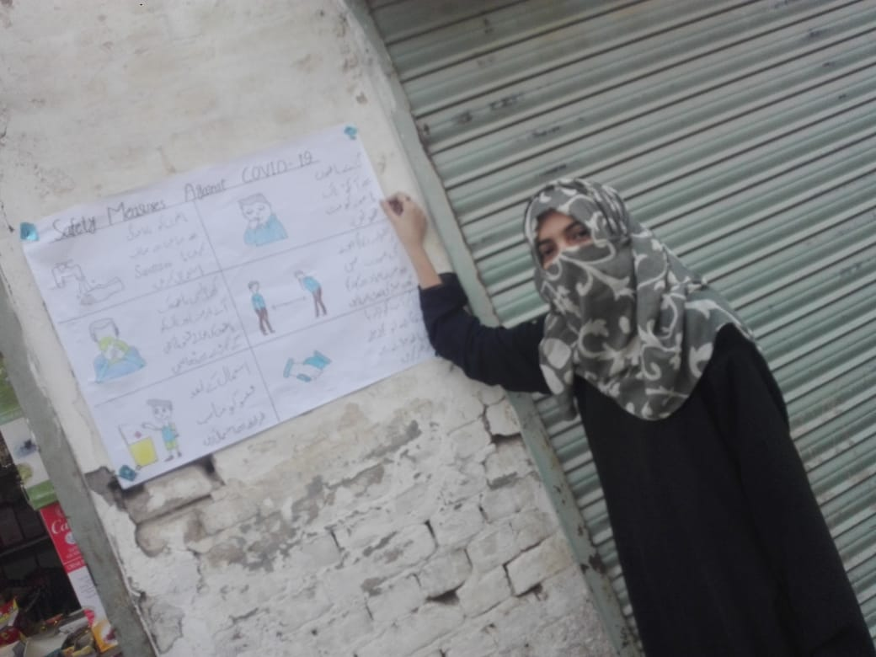
- Proof:-
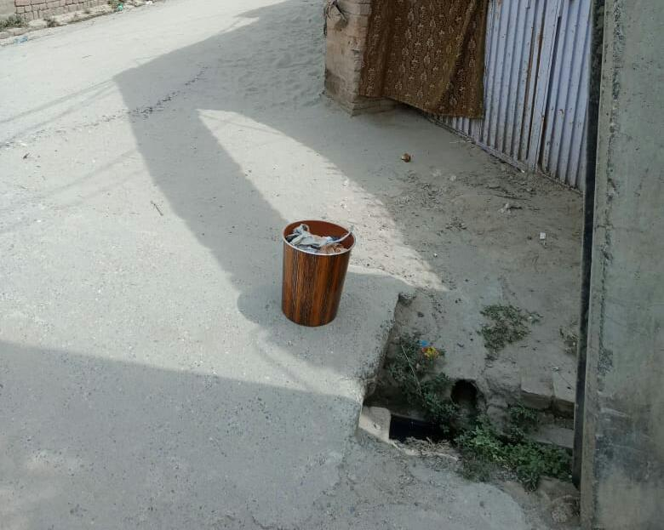
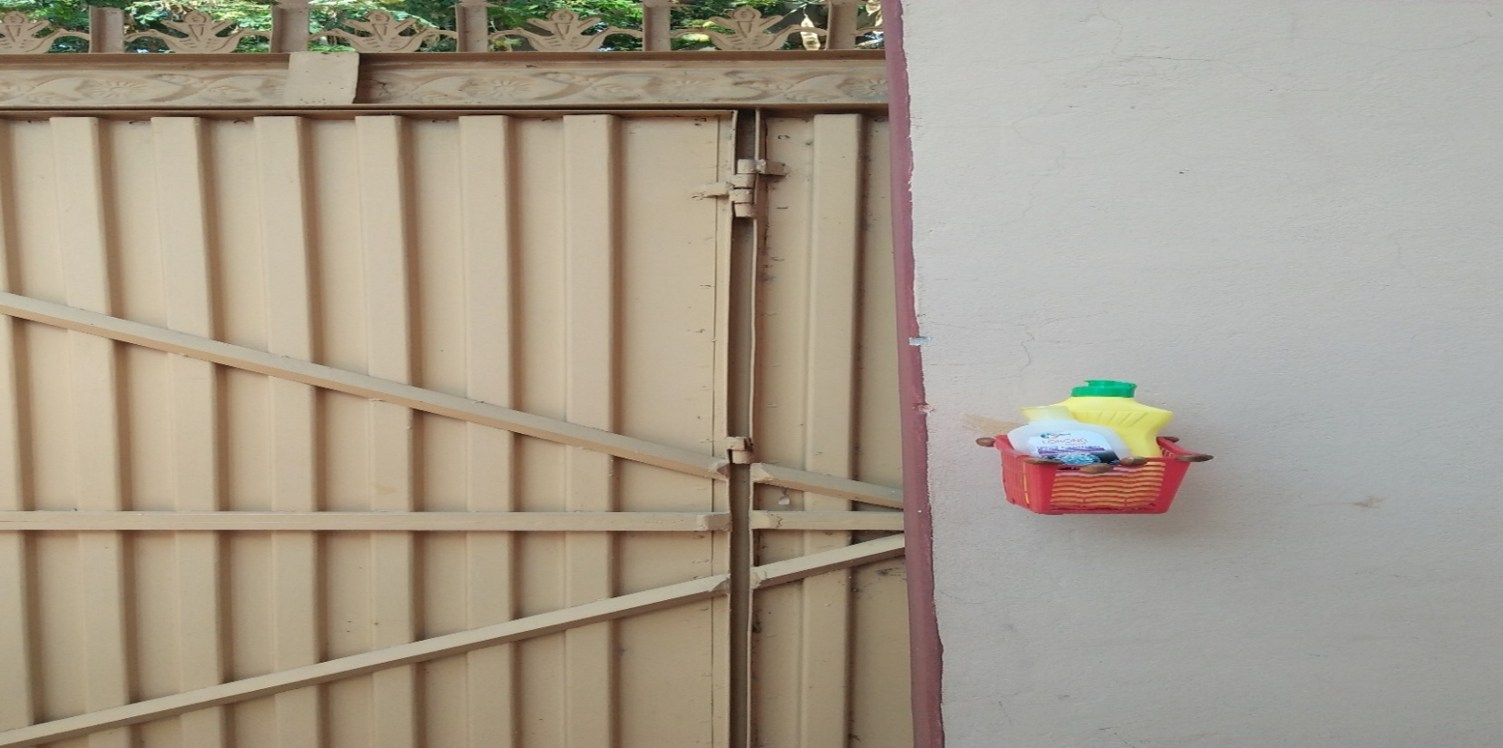
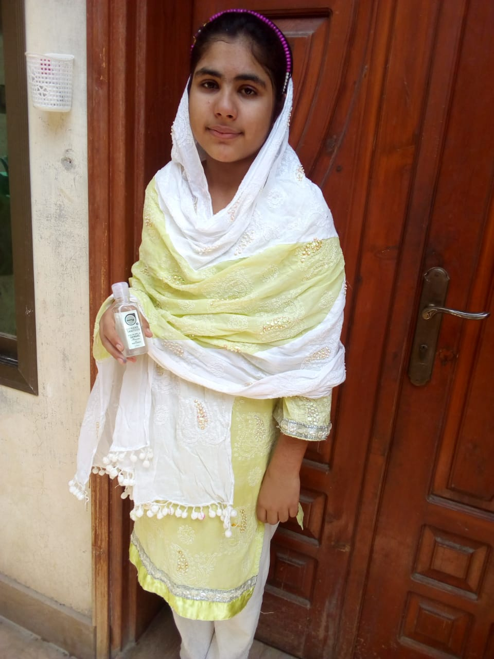
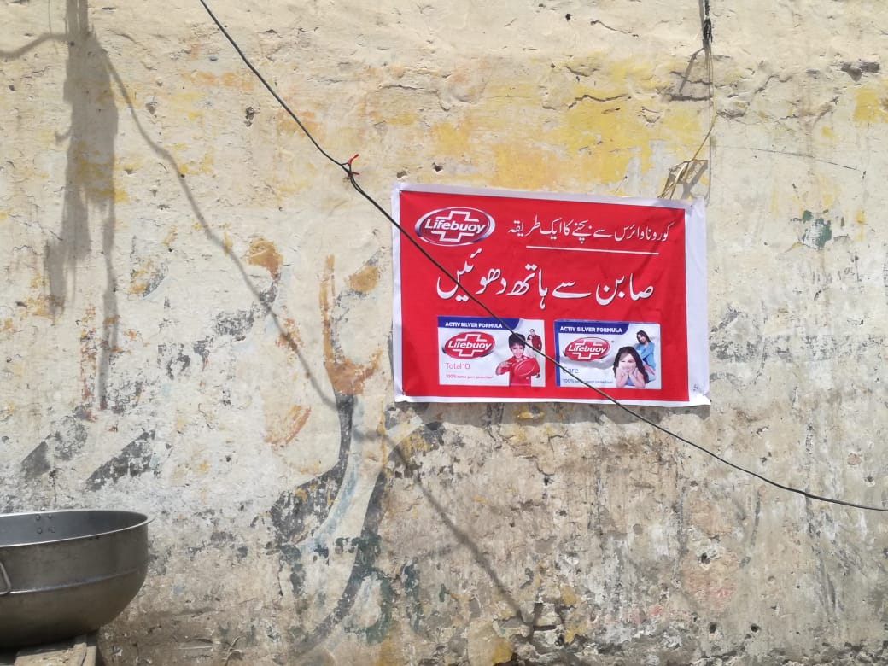
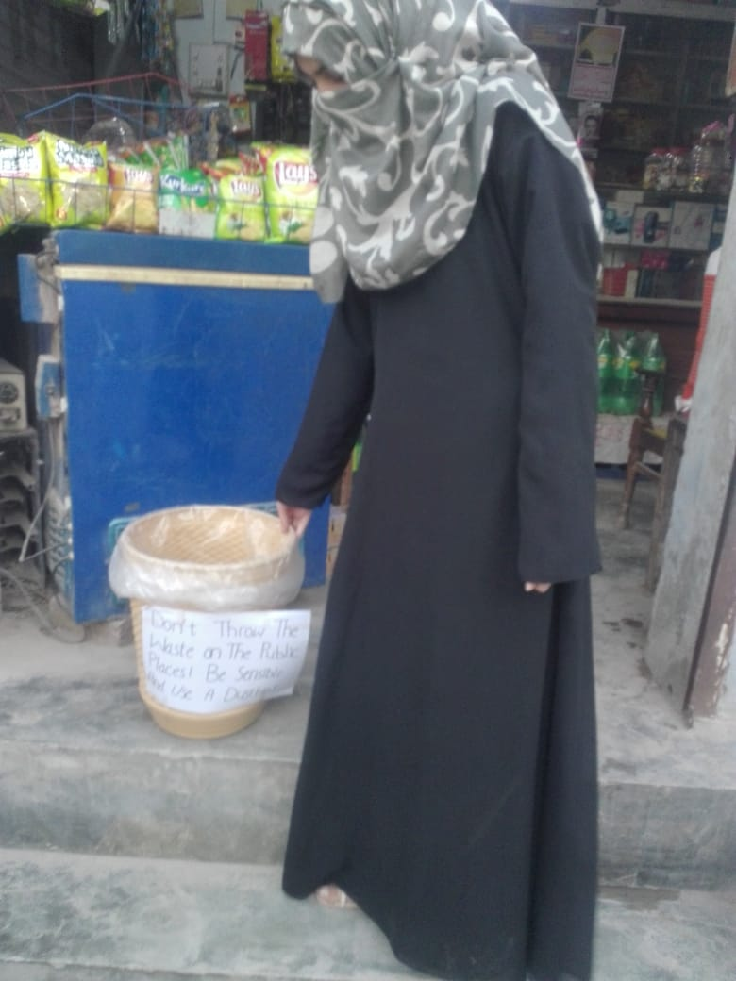
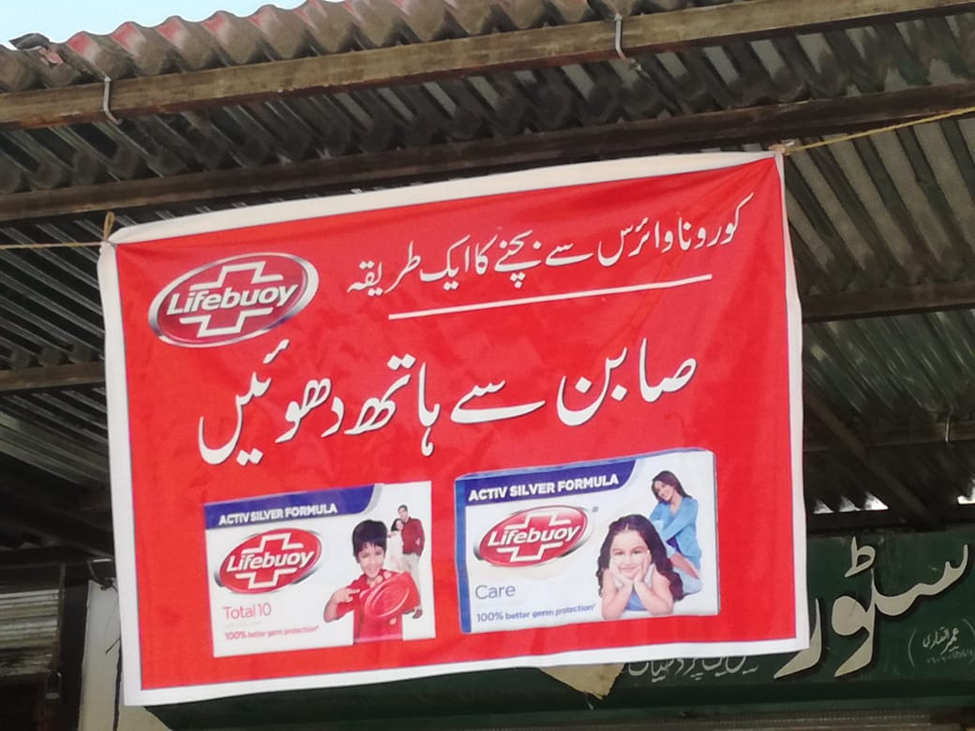
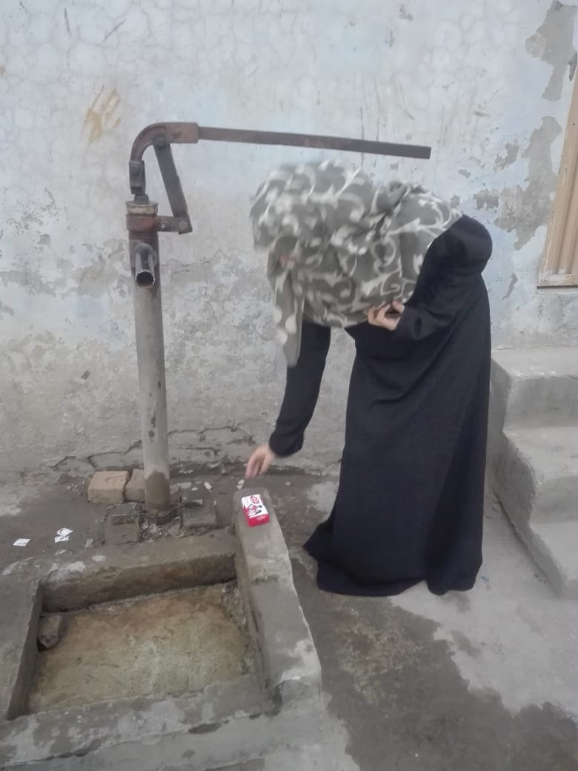
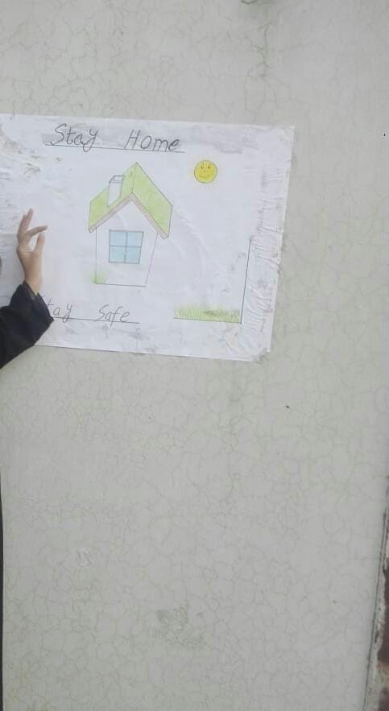
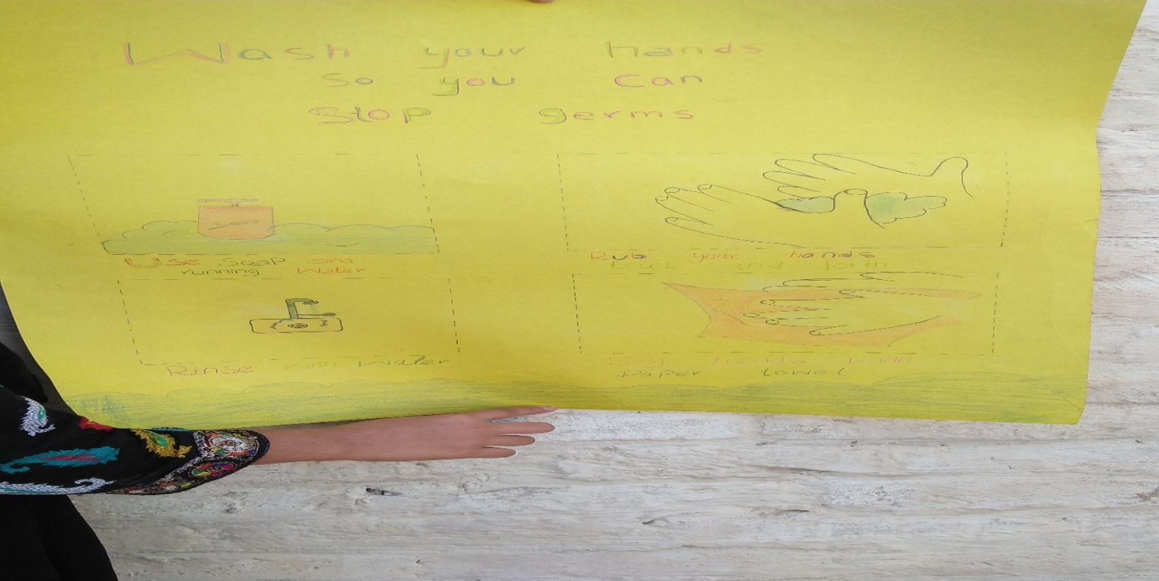
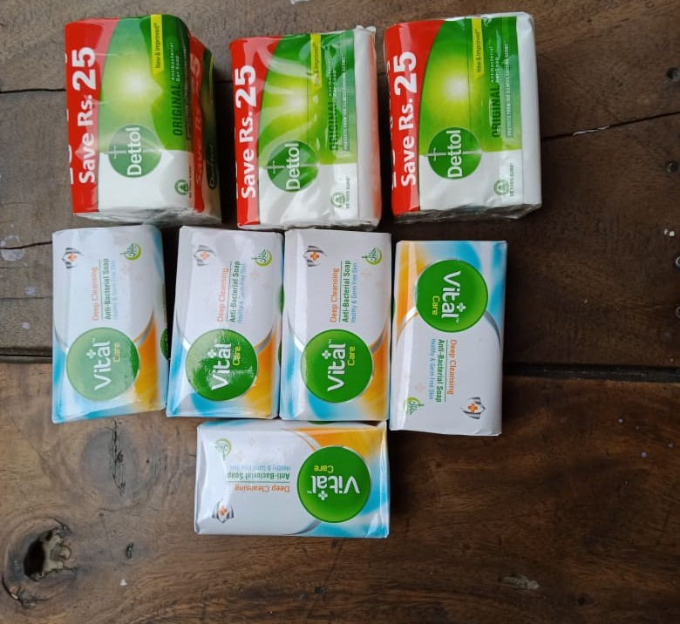
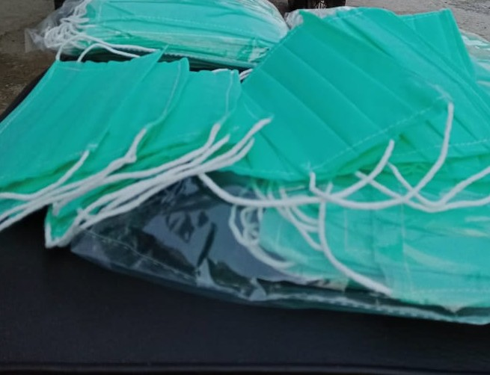
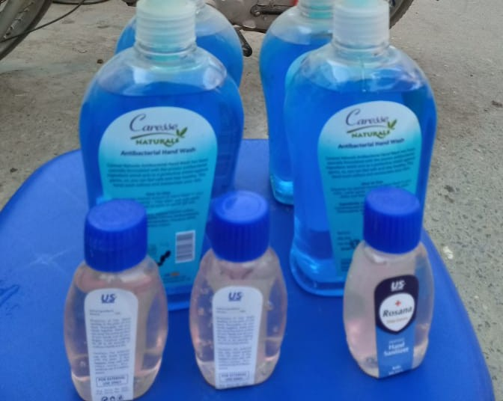
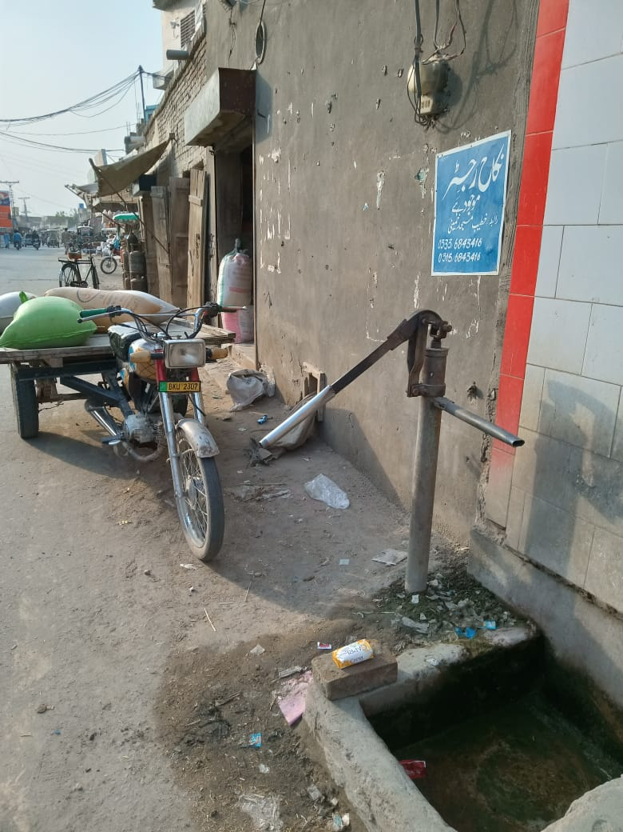

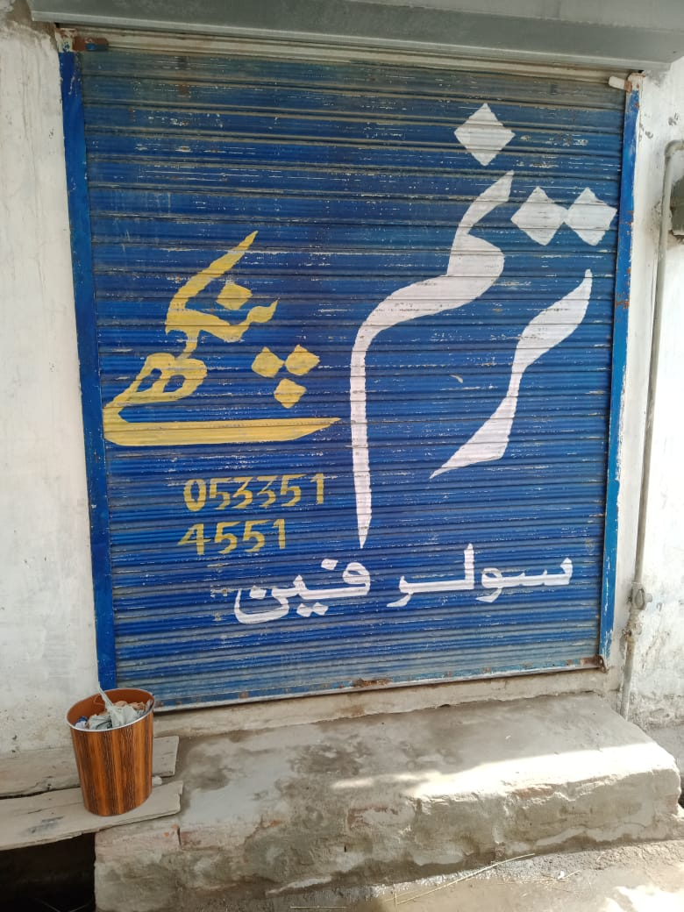
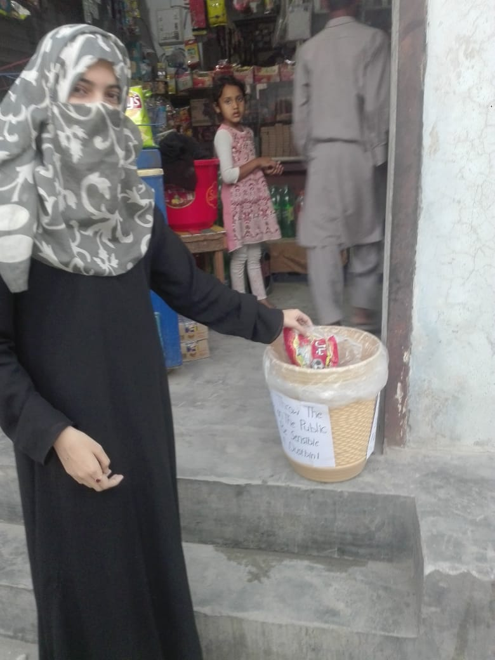

References::
Question(1,2)
- Misbah Hussain BBTF19BM043 (2020).Bs Botany ll Semester. Department of Biological Sciences UOS, Sub Campus Bhakkar.
Question no:(3,4)
- Aysha iqbal BBTF19BM05
Bs Botany ll Semester. Department of Biological Sciences UOS, Sub Campus Bhakkar.
Objectives of the project:
Anousha akber:BBTF19BM16
Question no:(05)
- Umme ruman BBTF19BM034
Bs Botany ll Semester. Department of Biological Sciences UOS, Sub Campus Bhakkar.
Question no:(06)
- Areeba rauf BBTF19BM19
Bs Botany ll Semester. Department of Biological Sciences UOS, Sub Campus Bhakkar.

