Market Segmentation and Its Implications
Market: A market is a group of potential customers with similar needs who are willing to exchange something with sellers offering goods or services⸺that is, ways of satisfying those needs.
Marketing: It is the process of satisfying customers’ needs (in terms of products or services or both) with profitability.
Positioning: It refers to how customers think about proposed or present brands in a market. It is a realistic view of products or services.
Market Segment: A market segment is relatively homogenous groups of customers who will respond to a marketing mix in a similar ways.
Market Segmentation: It is a process of diving a big market of heterogeneous customers into submarkets of homogenous customers to easily conduct business and best satisfy customers’ needs.
Criteria for Market Segmentation: Ideally, “good” market segments meet following criteria:
- Homogenous (similar) within: The customers in a segment should be as similar as possible with respect to their likely responses on a marketing mix and the segmenting dimensions.
- Heterogeneous (different) between: The customers in different segments should be as different as possible with respect to their likely responses on a marketing mix and the segmenting dimensions.
- Substantial: A marketing segment should be big enough to be profitable for conducing the business.
- Operation: The segmenting dimensions should be useful for identifying customers and deciding on market mix variables.
Approaches to Market Segmentation: Three approaches are usually used for segmentations.
- Single Target Market Approach: Segmenting the target market and conducting business on a one homogenous segment (one group of similar customers).
- Multiple Target Market Approach: Segmenting the target market and conducting business on two or more homogenous segments (two or more groups of similar customers), then treating each segment independently by applying different marketing mix on each segment.
- Combined Target Market Approach: Combing two or more submarkets (segments) into a larger target market and applying one marketing strategy.
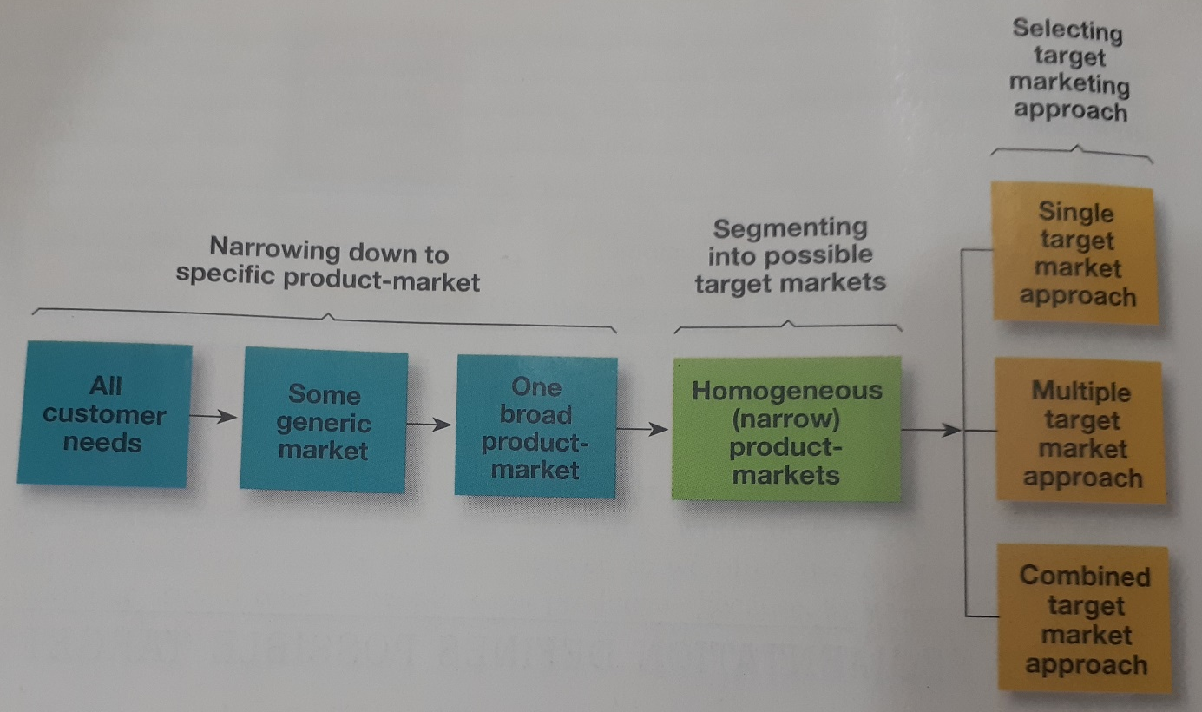

Segmenters vs. Combiners
- Segmenters: They make one or more heterogeneous segments and apply different marketing mix on each segment.
- Combiners: They try to increase the side of their business market by combining two or more market segments and conduct business with a same marketing mix.
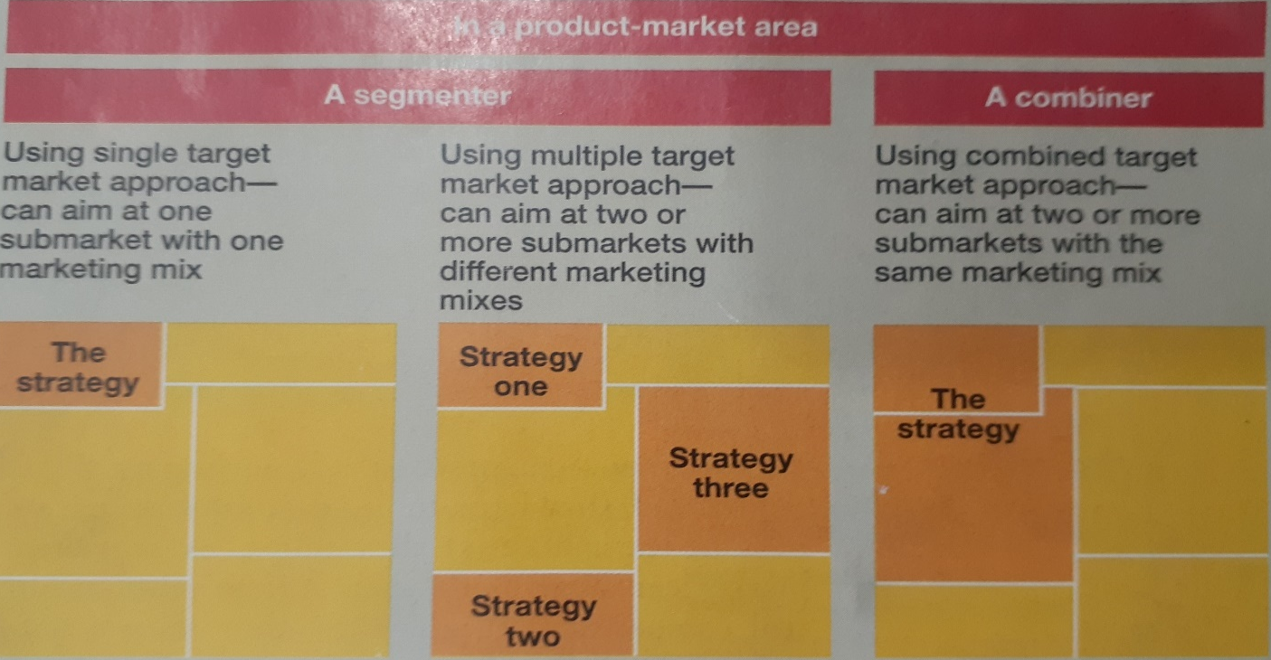
Generic vs. Product Market Definition
- Generic Market Definition: It focuses on customers’ needs (users), customer types and geographic area.
- Product Market Definition: It focuses on customers’ needs (users), customer types, geographic area and product type.
Types of Market Segmentation
- Geographic Segmentation: Geographic segmentation divides the market on the basis of geography. This type of market segmentation is important for marketers as people belonging to different regions may have different requirements. For example, water might be scarce in some regions which inflates the demand for bottled water but, at the same time, it might be in abundance in other regions where the demand for the same is very less. People belonging to different regions may have different reasons to use the same product as well. Geographic segmentation helps marketer draft personalized marketing campaigns for everyone.
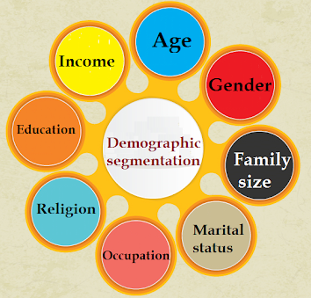
- Demographic Segmentation: Demographic segmentation divides the market on the basis of demographic variables like age, gender, marital status, family size, income, religion, race, occupation, nationality, etc. This is one of the most common segmentation practice among marketers. Demographic segmentation is seen almost in every industry like automobiles, beauty products, mobile phones, apparels, etc and is set on a premise that the customers’ buying behavior is hugely influenced by their demographics.

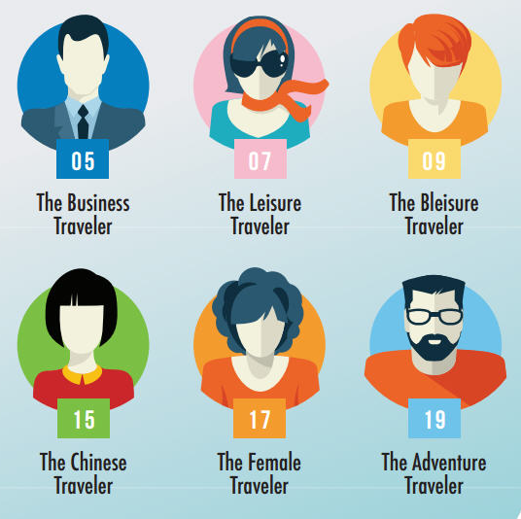
- Behavioral Segmentation: The market is also segmented based on audience’s behavior, usage, preference, choices and decision making. The segments are usually divided based on their knowledge of the product and usage of the product. It is believed that the knowledge of the product and its use affect the buying decision of an individual. The audience can be segmented into those who know about the product, those who don’t know about the product, ex-users, potential users, current users, first time users, etc. People can be labelled as brand loyal, brand-neutral, or competitor loyal. They can also be labelled according to their usage. For example, a sports person may prefer an energy drink as elementary (heavy user) and a not so sporty person may buy it just because he likes the taste (light/medium user).
- Psychographic Segmentation: Psychographic Segmentation divides the audience on the basis of their personality, lifestyle and attitude. This segmentation process works on a premise that consumer buying behavior can be influenced by his personality and lifestyle. Personality is the combination of characteristics that form an individual’s distinctive character and includes habits, traits, attitude, temperament, etc. Lifestyle is how a person lives his life.
