Name
Muhammad Shuja-at
Roll No
38(m)
Assignment
Bio mecnics
Topic
Forms of motion
Submitted to
Sir Qasid Naveed
Semester
4th
Department of sport Sciences
University of Sargodha

Contents
- Definition of motion
- Curvilinear motion
- Non-linear motion
- Angular motion/ Rotation
- Angular motion about and internal axis
- Angular motion about and external axis

MOTION
“A body is said to be at rest , if it does not change its position with respect to its surroundings”
“In physics, motion is the change in the position of an object over time. Motion is mathematically described in terms of displacement, distance, velocity, acceleration, speed, and time.”
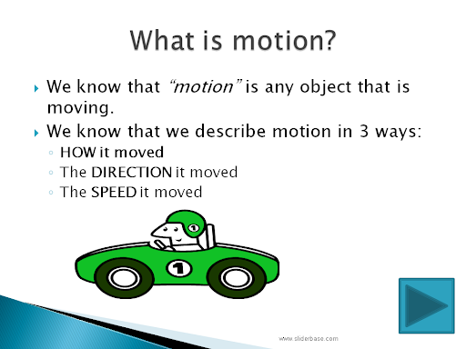

Examples of motion in life
- Stretching.
- Bending.
- Walking.
- Dancing (almost daily in some fashion or another ;)
- Lifting.
- Reaching (not vis-a-vis “stretching” but reaching for objects)
- Digging (garden)
- Wrist turning (bottle caps, jar lids

FORMS
- Linear motion/ translation
        - Rectilinear translation
        - Curvilinear translation
        - Non –linear motion
- Angular motion /rotation
        - Angular motion about and internal axis
        - Angular motion about and external axis
Linear Motion
Straight line motion of a body is called linear motion

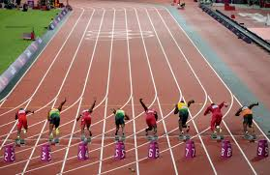

Example
1 ) the motion of the objects such as car moving on a straight and level road is leaner motion
2) Airplane flying straight in air
3) Objects falling vertically down are also a example of linear motion

Rectilinear translation
Rectilinear motion is another name for straight-line motion. This type of motion describes the movement of a particle or a body. A body is said to experience rectilinear motion if any two particles of the body travel the same distance along two parallel straight lines
Example
- Planes in the sky that move in a straight path are considered to be in rectilinear motion.
- A ball rolling down an inclined path is considered to be in rectilinear motion.
- People marching at the San Francisco Pride Parade are in rectilinear motion.
Curvilinear translation
Curvilinear motion is defined as motion that occurs when a particle travels along a curved path. The curved path can be in two dimensions (in a plane), or in three dimensions. This type of motion is more complex than rectilinear (straight-line)motion.

Examples
- Cyclist racing on curved tracks of velodrome.
- Earth moving around the sun.
- A car taking a turn on a road.
- Throwing of a javelin.
Motion of a snake
The motion of an object moving in a curved path is called curvilinear motion.Example: A stone thrown into the air at an angle. Curvilinear motion describes the motion of a moving particle that conforms to a known or fixed curve
Non –linear motion
Nonlinear motion is motion along a curved path; i.e., the combination of two 'components of motion' horizontal motion (without acceleration) vertical motion (under the acceleration of gravity)
Example
- Earth revolving around the sun.
- A car moving in a highway with uniform speed.
- The hour and minute hand moving in a clock.
- A bob of pendulum in a clock.

. Angular motion /rotation
he motion of a body about a fixed point or fixed axis, as of a planet or pendulum. It is equal to the angle passed over at the point or axis by a line drawn to the body.

Example
- Virtually any club, stick, bat, racket that is swung.
- A gymnast going around the high bar.
- A runner on a circular track.
- Essentially anything that is turning, twisting, or rotating is an example of angular

General Motion.
General motion is a combination of linear and rotary motions. General motion is the most common type of motion in sport and physical exercise. Running and walking are among typical examples. ... Riding a bicycle is another example of general motion
General motion is the most common type of motion in sport and physical exercise. Running and walking are among typical examples. In this case the trunk moves in linear motion as a result of rotary motions of individual segments of extremities. Riding a bicycle is another example of general motion.
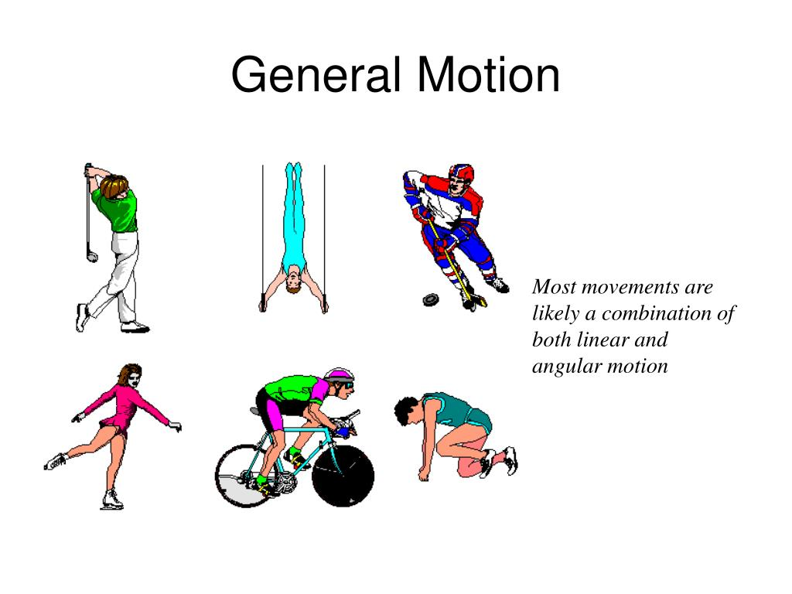

Angular motion about and internal axis
Rotational dynamics. These definitions apply to objects spinning about an internal axis, such as a wheel spinning on its axle, or to objects revolving around a point external to the objects, such as the earth revolving around the Sun. A spinning or revolving object has angular velocity ω.
Motion at Internal Axis
Rotational dynamics. These definitions apply to objects spinning about an internal axis, such as a wheel spinning on its axle, or to objects revolving around a point external to the objects, such as the earth revolving around the sun. A spinning or revolving object has angular velocity Rotational dynamics. These definitions apply to objects spinning about an internal axis, such as a wheel spinning on its axle, or to objects revolving around a point external to the objects, such as the earth revolving around the sun. A spinning or revolving object has angular velocity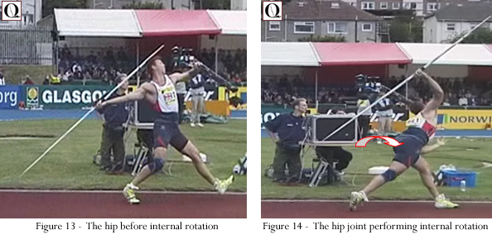

Example: hammer throw

Angular motion about and internal axis
When a body moves on it .it is motion on external axis
Motion at External Axis
If the axis passes through the body's center of mass, the body is said to rotate upon itself, or spin. A rotation around an external point, e.g. the planet Earth around the Sun, is called a revolution or orbital revolution, typically when it is produced by gravity. The axis is called a pole.
An axis that is outside the body. For example, the high bar in gymnastics is the external axis around which the gymnast rotates.
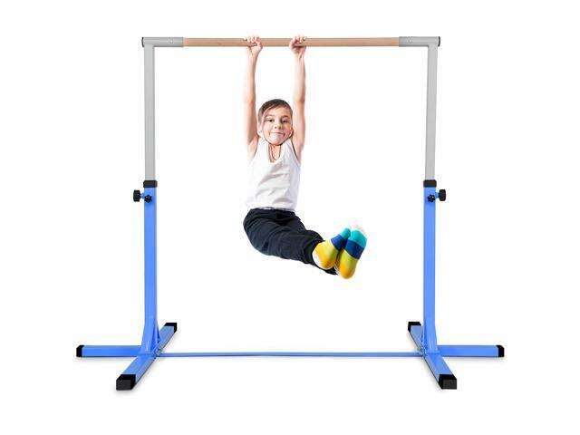

Example: gymnastic bar

