[Date]

Translation

Define translation?
The synthesis of protein at a ribosome from mRNA is called translation.
Translation requires some specialized equipment. Just as you wouldn't go to play tennis without your racket and ball, so a cell couldn't translate an mRNA into a protein without two pieces of molecular gear: ribosomes and tRNAs.
- Ribosomes provide a structure in which translation can take place. They also catalyze the reaction that links amino acids to make a new protein.
- tRNAs (transfer RNAs) carry amino acids to the ribosome. They act as "bridges," matching a codon in an mRNA with the amino acid it codes for.

Where the translation happens
Translation takes place inside structures called ribosomes, which are made of RNA and protein. Ribosomes organize translation and catalyze the reaction that joins amino acids to make a protein chain.
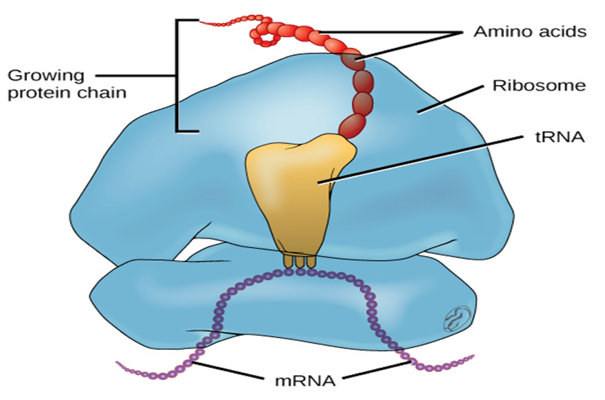

Structure of the ribosome
A ribosome is made up of two basic pieces: a large and a small subunit. During translation, the two subunits come together around a mRNA molecule, forming a complete ribosome. The ribosome moves forward on the mRNA, codon by codon, as it is read and translated into a polypeptide (protein chain). Then, once translation is finished, the two pieces come apart again and can be reused. Overall, the ribosome is about one-third protein and two-thirds ribosomal RNA (rRNA). The rRNAs seem to be responsible for most of the structure and function of the ribosome, while the proteins help the rRNAs change shape as they catalyze chemical reactions.
The ribosome has slots for tRNAs
transfer RNAs (tRNAs) bring amino acids to the ribosome.
Ribosome has three slots for tRNAs: The A site, P site, and E site. tRNAs move through these sites (from A to P to E) as they deliver amino acids during translation.
A site (Aminoacyl site)
This site contains successive (next) amino acid with its rRNA.
P site (peptidyl site)
It is the site of a ribosome where peptide bonds are formed.
E site (exit site)
It is a site of ribosomes where empty tRNA is present.

What exactly is a tRNA?
A transfer RNA (tRNA) is a special kind of RNA molecule. Its job is to match an mRNA codon with the amino acid it codes for. You can think of it as a kind of molecular "bridge" between the two.
Each tRNA contains a set of three nucleotides called an anticodon. The anticodon of a given tRNA can bind to one or a few specific mRNA codons. The tRNA molecule also carries an amino acid: specifically, the one encoded by the codons that the tRNA binds.
There are many different types of tRNAs floating around in a cell, each with its own anticodon and matching amino acid. In fact, there are usually 40 to 60 different types, depending on the species. tRNAs bind to codons inside of the ribosome, where they deliver amino acids for addition to the protein chain.
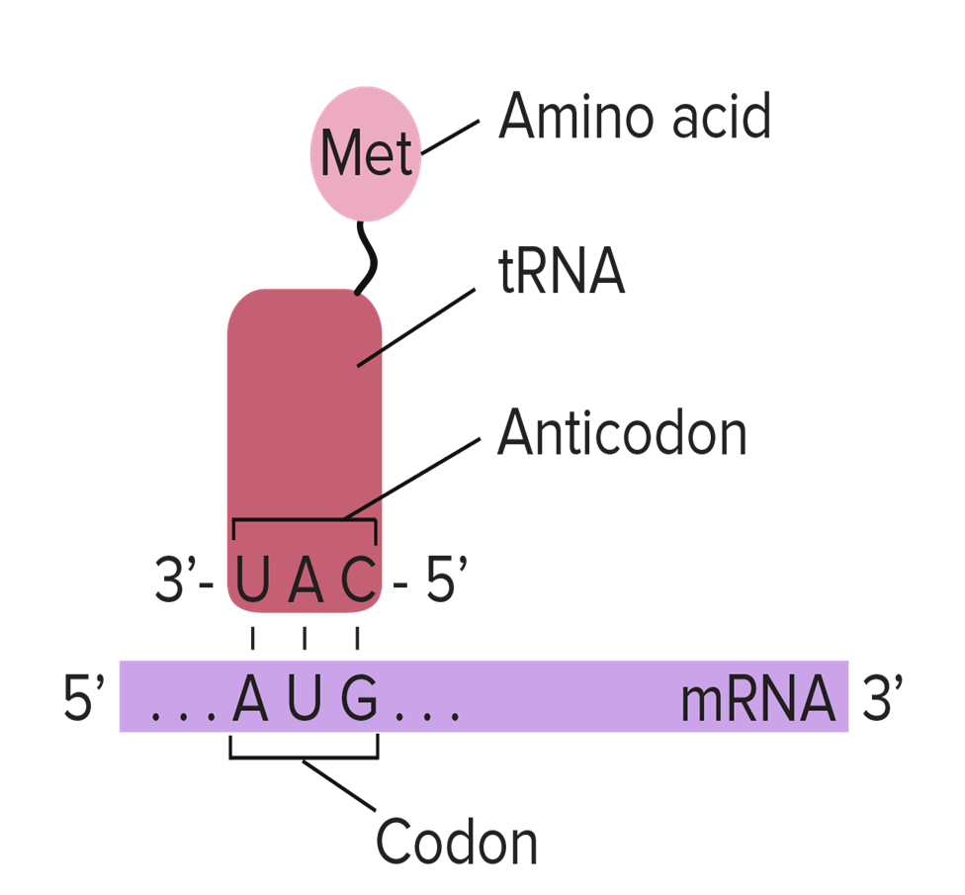

Stages of translation
- Initiation ("beginning"): in this stage, the ribosome gets together with the mRNA and the first tRNA so translation can begin.
- Elongation ("middle"): in this stage, amino acids are brought to the ribosome by tRNAs and linked together to form a chain.
- Termination ("end"): in the last stage, the finished polypeptide is released to go and do its job in the cell.
Initiation: -
In order for translation to start, we need a few key ingredients. These include:
- A ribosome (which comes in two pieces, large and small)
- An mRNA with instructions for the protein we'll build
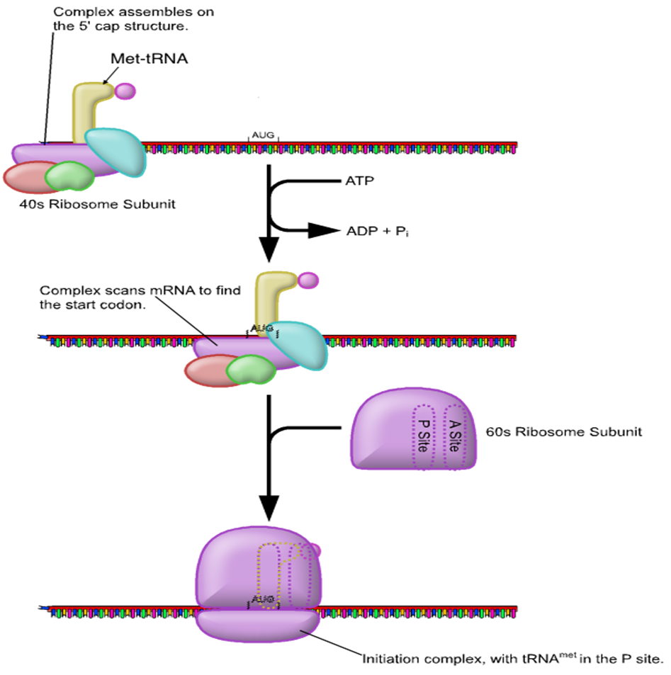

• An "initiator" tRNA carrying the first amino acid in the protein, which is almost always methionine (Met)
During initiation, these pieces must come together in just the right way. Together, they form the initiationcomplex, the molecular setup needed to start making a new protein.
Elongation
Following process takes place durng elongation of protien.
Peptide bond formation
The initiating complex has already formed. Second tRNA molecule carries second amino acid .it binds with large ribosomal subunit with its anticodon.
A protein called elongation factors help the tRNA to bind on exposed mRNA codon at the A site. The two amino acids now lie adjacent to each other. These amino acids undergo a chemical reaction and peptide bond is formed between them. This reaction is catalyzed by the large ribosomal subunit. This subunit separates the initial methionine from its tRNA
Translocation
The ribosome now moves to next code on the mend molecule in 5 to 3 direction. It is guided by another elongation factor. This movement translocate the initial tRNA to the E site and ejects it from the ribosome. It exposes the next codon on the mRNA at the A site. Third molecule again bind to the A site. It places its amino acid adjacent to the growing chain. The chain then transfers to the new amino acid. This process is repeated again and again and all the entire mRNA is translated.
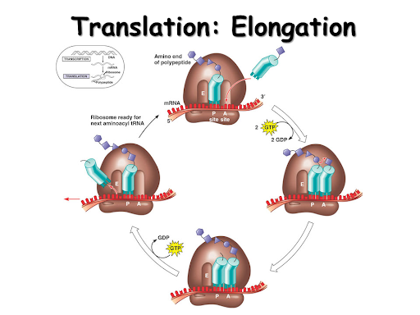
Termination
Polypeptides, like all good things, must eventually come to an end. Translation ends in a process called termination. Termination happens when a stop codon in the mRNA (UAA, UAG, or UGA) enters the A site.
Stop codons are recognized by proteins called release factors, which fit neatly into the P site (though they aren't tRNAs). Release factors mess with the enzyme that normally forms peptide bonds: they make it add a water molecule to the last amino acid of the chain. This reaction separates the chain from the tRNA, and the newly made protein is released.
After the small and large ribosomal subunits separate from the mRNA and from each other, each element can (and usually quickly does) take part in another round of translation.
Export of protein
Protein synthesis occurs on ribosomes. Most of the ribosomes are attached on the surface of the RER.The newly synthesized protein moved into ER, then moves toward Golgi apparatus. It packed into secondary vesicles or a lysosome. 