Mongol art:
Origin and background
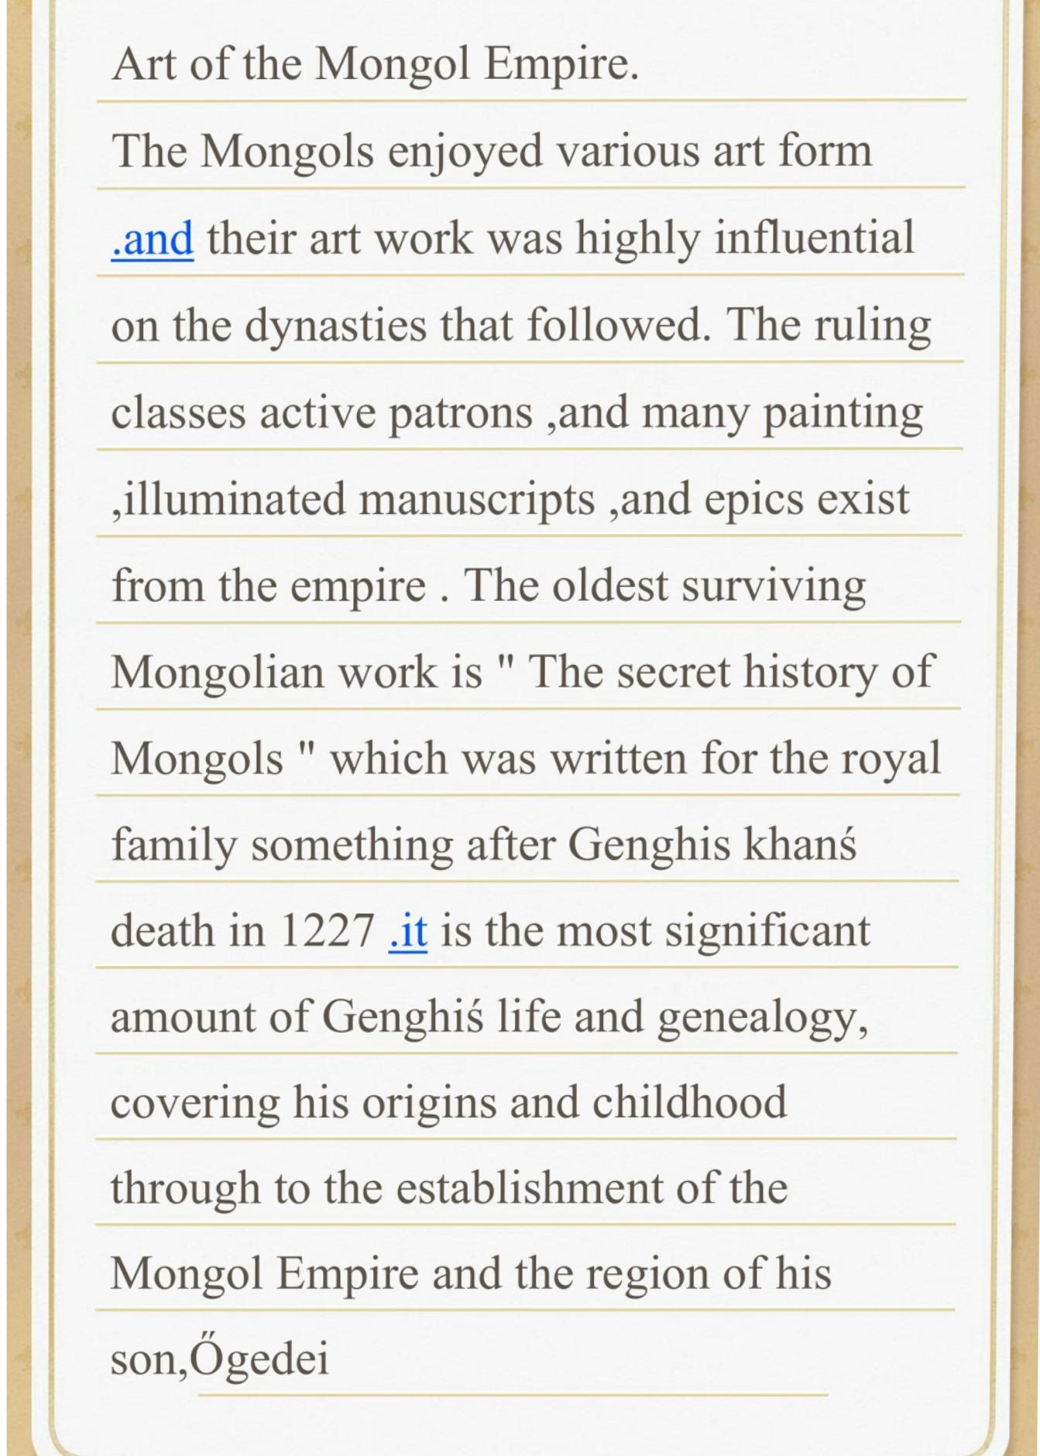
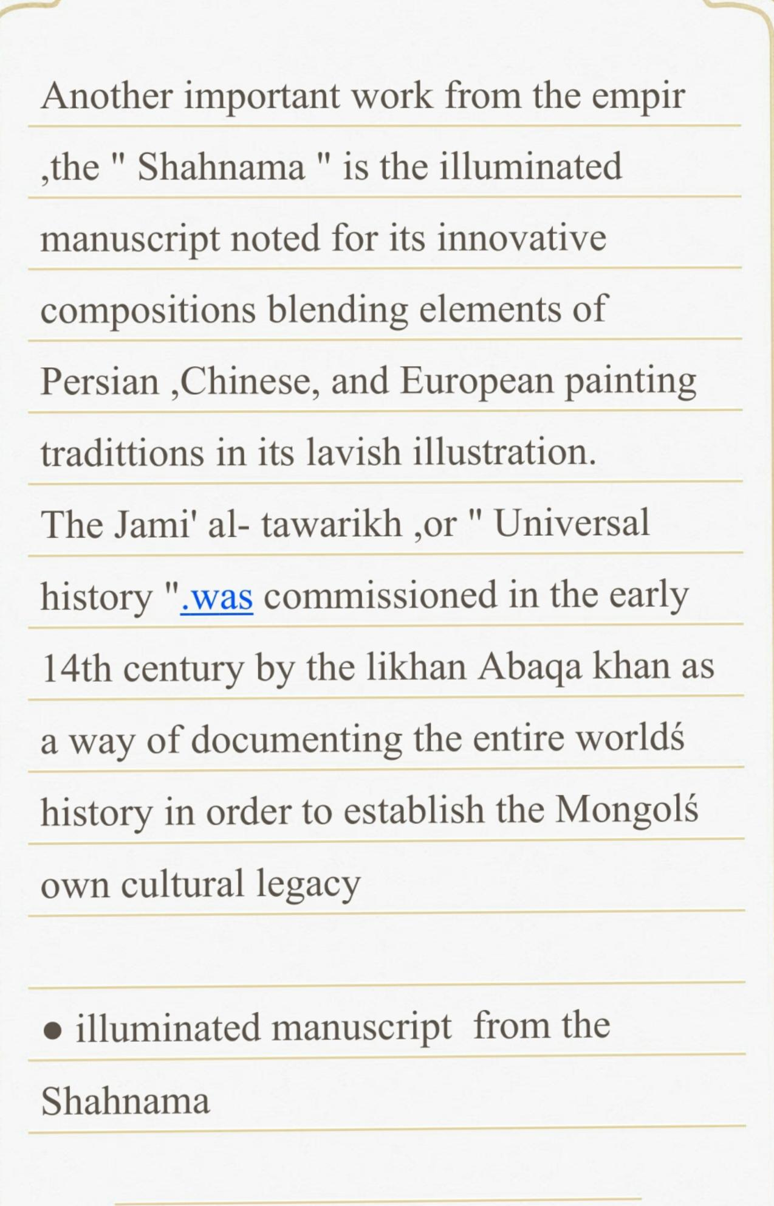
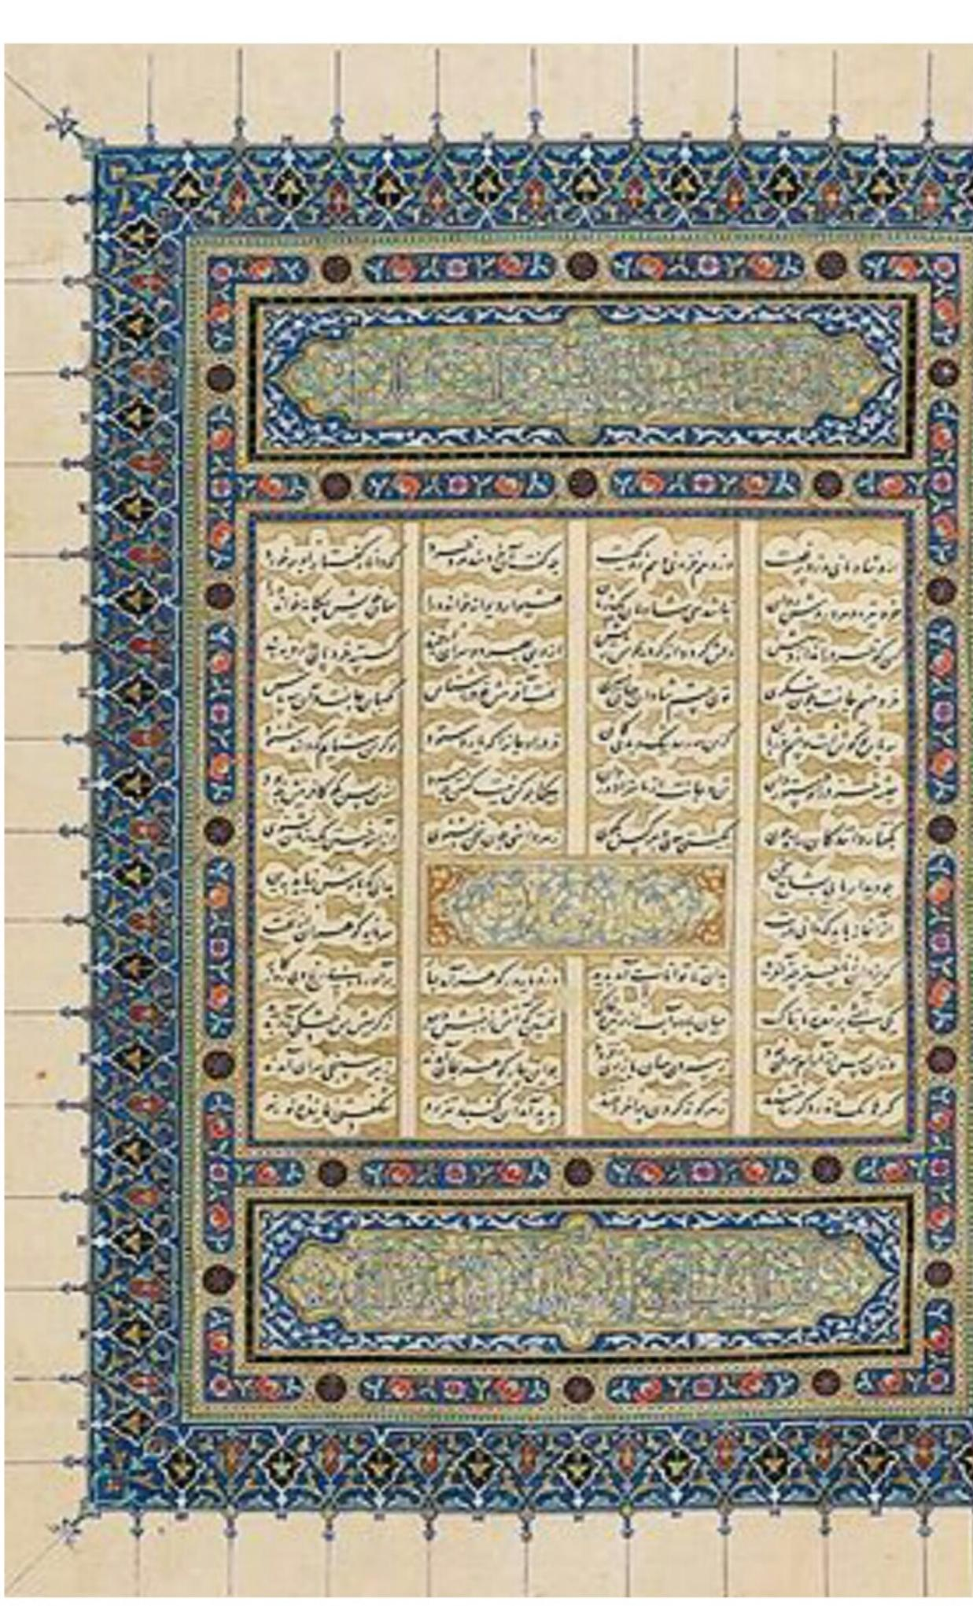
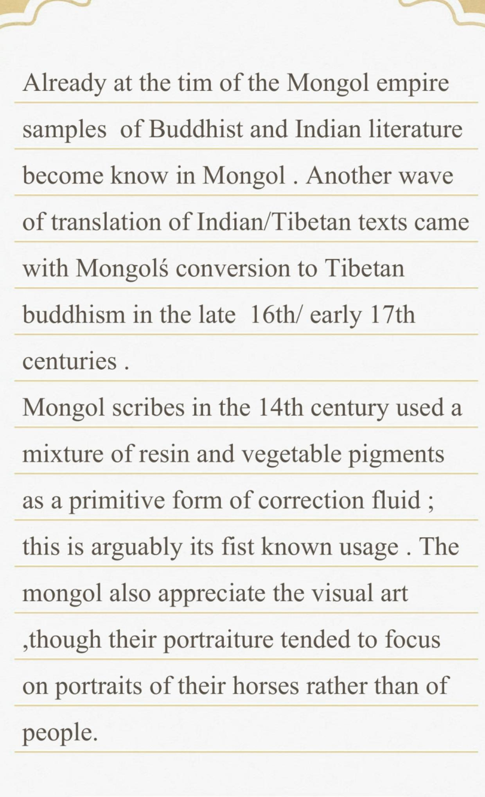
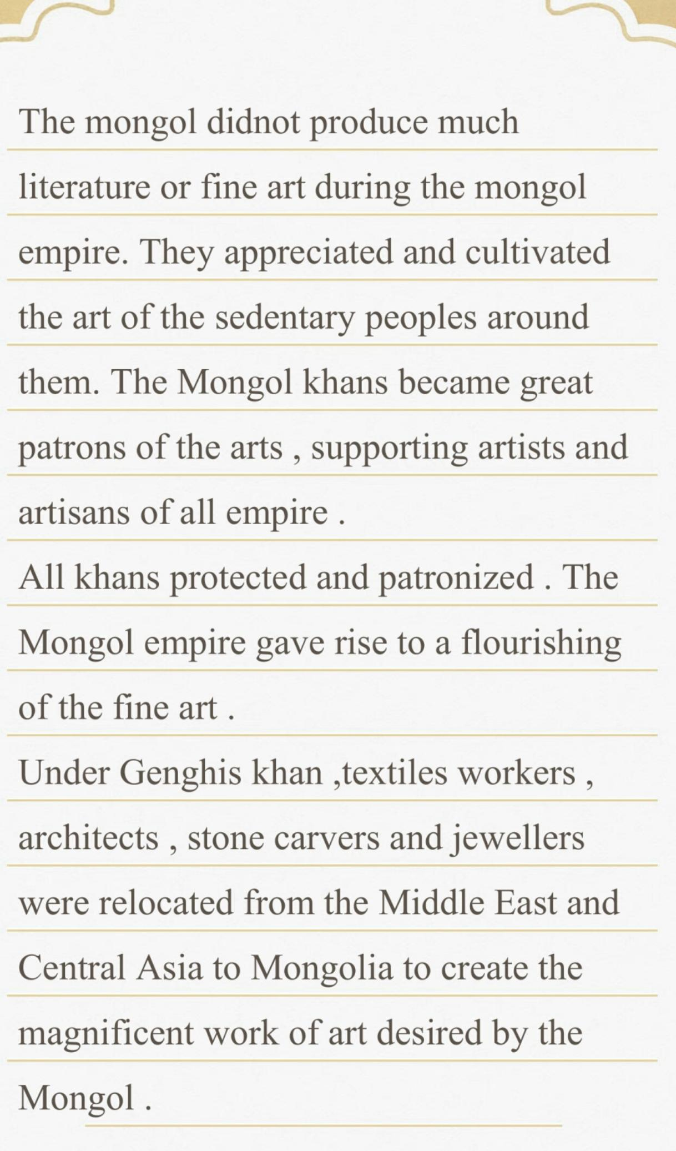
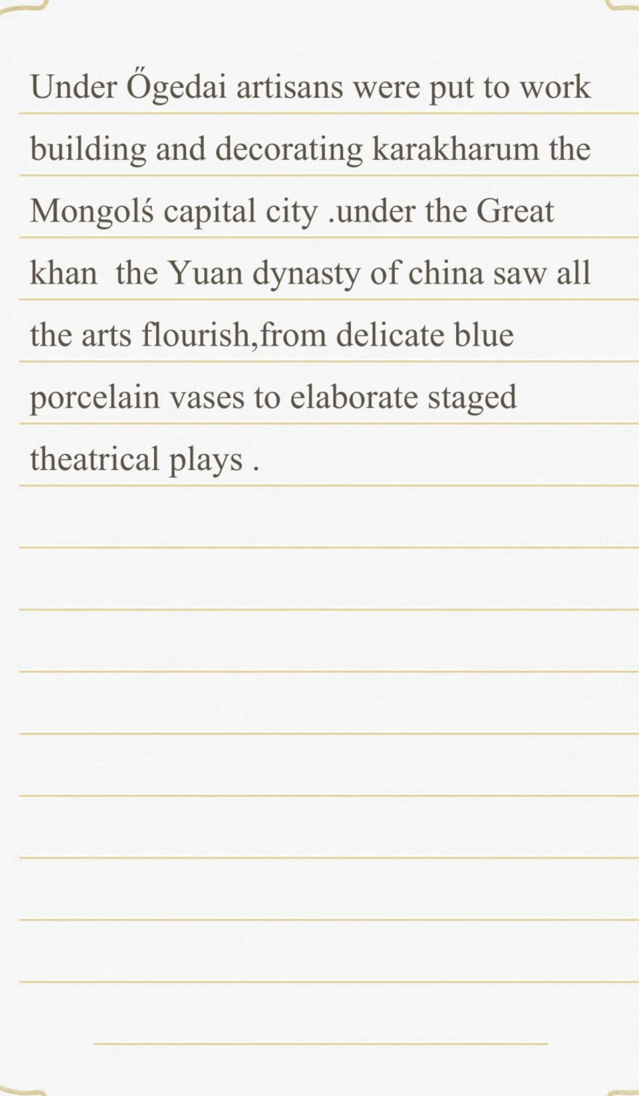

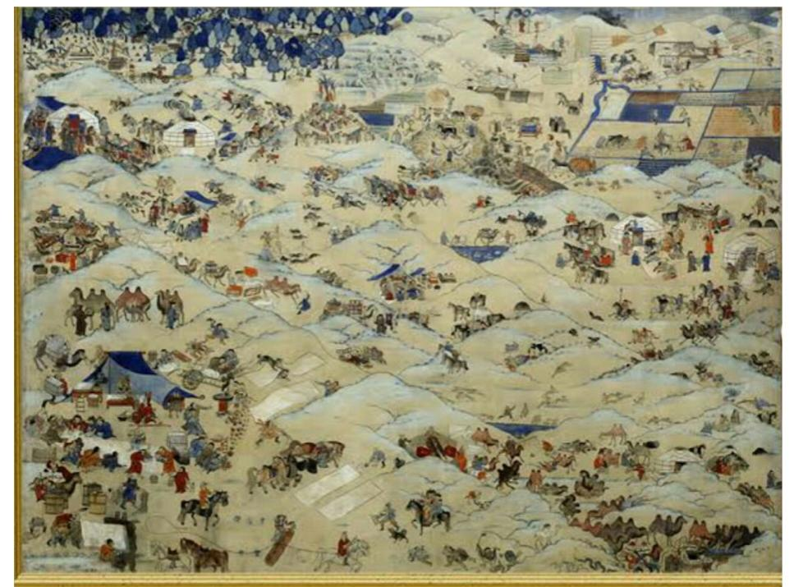

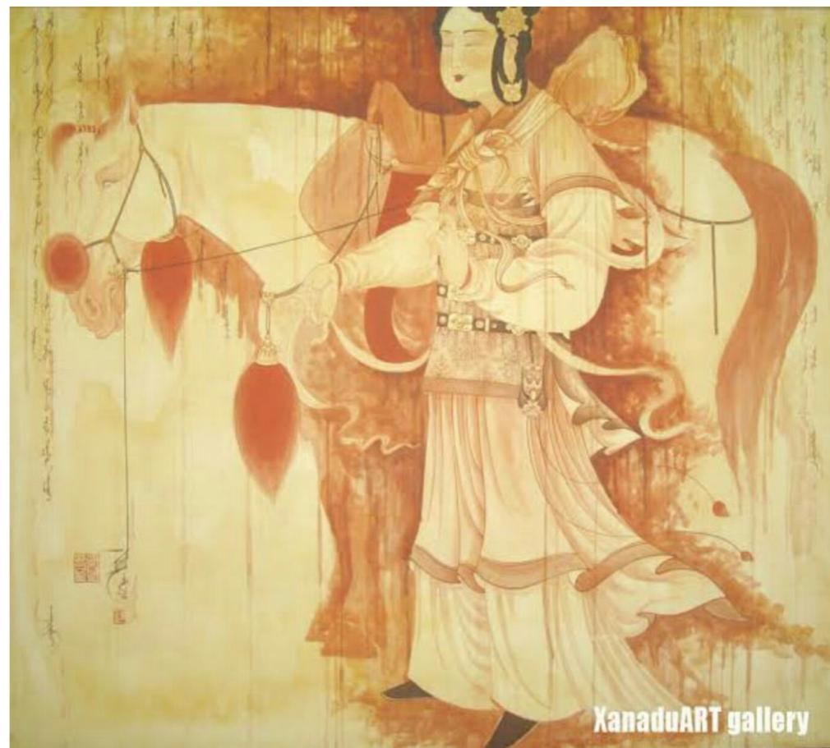
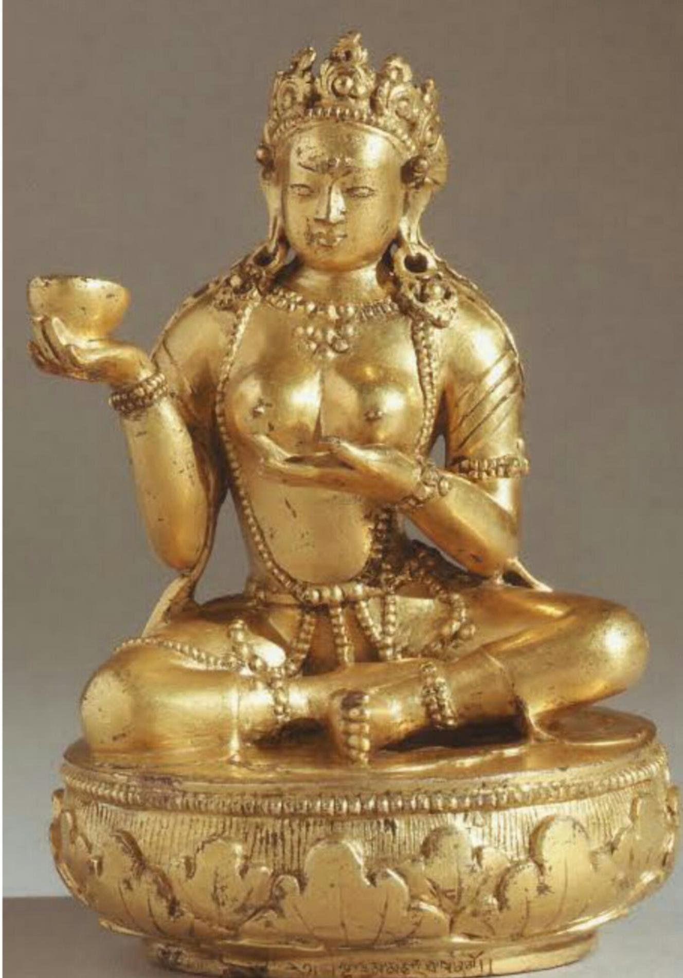
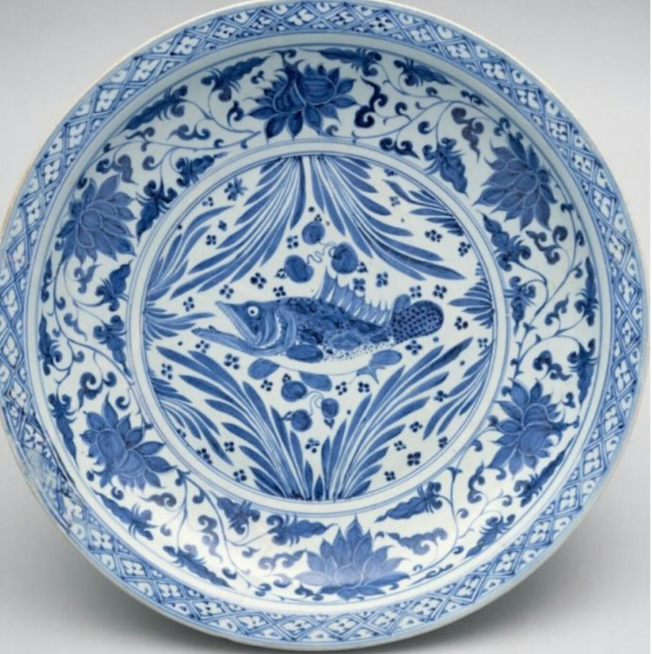
Mongolian painting began to develop more than two thousand years ago from simple rock drawings. Uighur paintings of the 8th century prove that this art was flourishing in Mongolia and Asia long ago. Buddhism was the main theme of the painting. and it developed into a fine art form.
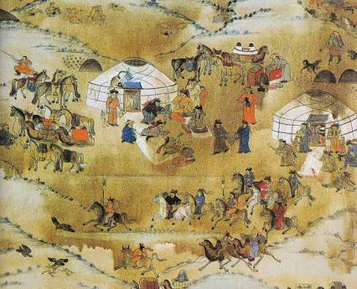
Mongolia's history is extremely long; it spans over 5,000. "The Mongols has little inclination to ally with other nomadic peoples of northern Asia and, until the end of the 12th century, the Mongols were little more than a loose confederation of rival clans, It was in the late 12th century that a 20-year-old Mongol named Temujin emerged and managed to unite most of the Mongol tribes. In 1189 he was given the honorary name of Genghis Khan, meaning 'universal king'. No Mongolian leader before or since has united the Mongolians so effectively."
Manchu controlled Mongolia from the year 1691 to 1911. Thanks to the fall of the Manchu dynasty that controlled stopped. A group of Mongol princes "proclaimed" the living Buddha of Urge to be ruler. "Mongolians have always taken wholeheartedly to Tibetan Buddhism and the links between Mongolia and Tibet are old and deep." In 1921 there were 110,000 lamas or monks in Mongolia living in 700 monasteries. In the 1930s thousands of monks were arrested. Some believed that by the year 1939 3% of Mongolia's population, at the time, was executed or out of 27,000; 17,000 were monks.
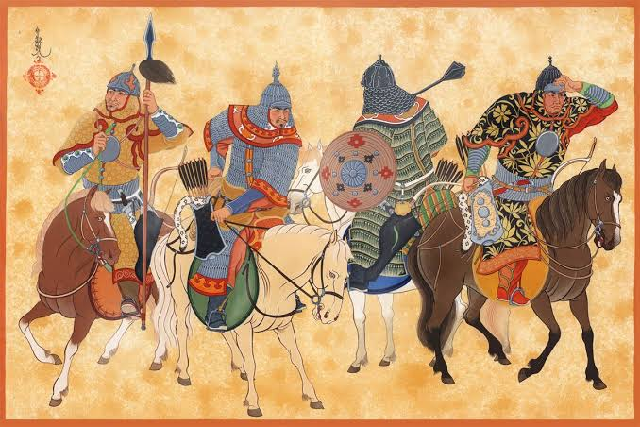
In the year 1990 the freedom of religion returned. Since then a revival of Buddhism and other religions has occurred. Mongolia won its independence in 1911. In 1921 the Mongolian People's Revolutionary Party government started. "When the last living Buddha died in 1924 ("with the rise of Tibetan Buddhism in the 16th century, a living Buddha would be named"), the Mongolian People's Republic was established. It took 22 years for China to recognize this. All subsequent Mongolians texts were written in script until Stalin forcibly replaced it with Russian Cyrillic in the 1940s. The text was written in scripts named SECRET HISTORY scripts. Since 1944 the Russian Cyrillic alphabet has been used to write Mongolian.

Mongol art
Background:
- Around 1200 year ago , The mangols moved out of center Asia to build one of the largest empire in the world.
- The Mangols also known as khalkh Mongals.
- In 13th CE the worlf mongol grew into an umbrella term for a long group og mangoles speaking tribes united under the rule of Genghis khan.
- Buddhism in mongolia began with the yuan emperor’s conversion to Tibetan buddhism.

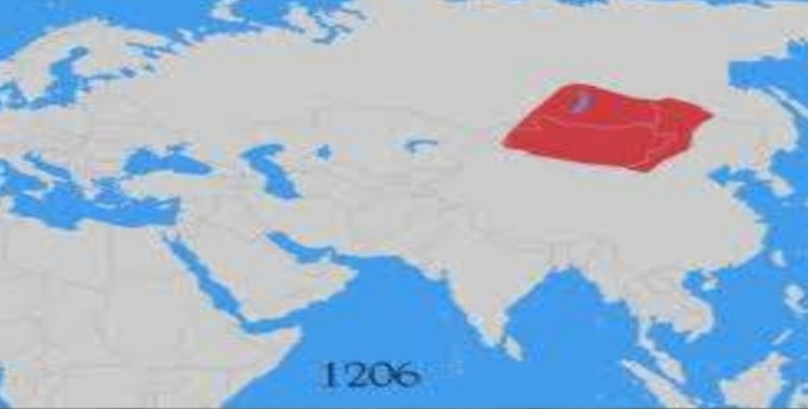
Map of Mongolia
- List of rulers
- Genghis khan
- Ogedei khan
- Guyuk khan
- Monke khan
- Kubalar khan
Toghan Temur khan
Rise of mongol empire
- The power that held in mongolia among the tribe were the Xiongnu.
- Confederated empire thet warred with young chines in state dissolving in 48CE
- In 1162- 1227 Genglish Khan come to power with in the Mangols league and was proclaimed khan in 1208
- He gained control on Mangols outside league between 1207 and 1227.
- He undertook military campain that extendes Russia and far as east as Northern China taking Beijing in 1215.

Genglish khan the mongols were divided into various tribe and ruled by chirgtain called KHAN tribe lived in barbaric customs patiring horse, cattle and sheep on dessert oases, fighting on another.
They had nonreligion writing literature art or science , they exccelled only in archery, horse viding and fighting .

