1. NITROGEN (N)
Importance
- First most important nutrient in the world.
- Also present in the form of gas as N₂.
- 79% N₂ is in the atmosphere (air).
- Also present in soil in the form of earth crust and soil parent material.
- 98% of nitrogen is present in lithosphere and remaining 2% in soil organic matter, from where it is supplied to plants in the form of nitrates (NO₃⁻) and ammonium (NH₄⁺).
- 99 kg/ha of nitrogen is fixed from the atmosphere annually by micro-organisms through BNF.
- Eutrophication is the enrichment of surface water with nitrogen and phosphorous. Due to this aquatic life will die.
- Transformation of nitrogen occurs in soil.
Losses of nitrogen
- Volatilization
- Leaching
- De-nitrification
- Fixation losses
- Immobilization: Conversion of nutrients form inorganic to organic form.
- Mineralization: Conversion of minerals form organic to inorganic form.
Immobilization is done by microbes as microbes uptake N etc. If immobilization is more than mineralization, there will be less availability of nutrient for plants. If mineralization is more than immobilization, there will be more availability of nutrient. At C: N ratio, 20:1 immobilization and mineralization are equal (critical point).
A) Available forms:
NO₃⁻ and NH₄⁺
B) Uptake:
Nitrogen demand in plants met by two ways:
- Assimilation of soil nitrate or ammonium
- Nitrogen fixation
NH₄⁺ is the most desirable form of N by plant.
NO₃⁻ occurs by NO₃⁻/2H⁺ symport (nitrate 2 protons symport) whereas the very minute quantity of ammonia uptake occurs through diffusion by roots. The NH₄⁺ or NH₃ uptake also occurs through diffusion. The NO₃⁻ uptake mechanism has been depicted in Figure 1(a & b).
C) Assimilation:
There are 5 major steps are:
- Reduction of NO₃⁻ to NO₂⁻ by nitrate reductase (NR) in cytosol of the root and leaf cells
- Reduction of Nitrite to NH₄⁺ by nitrite reductase (NiR) in plastids of the roots and leaf cells
- Fixation of ammonium into amino acid by glutamine synthase in plastids of roots and leaf cells
- Regeneration of glutamate by glutamate synthase or GOGAT in chloroplast of leaf cells
- Synthesis of other amino acids from glutamate in chloroplast of leaf cell
Assimilation is the conversion of inorganic components to organic components either structural or functional is called assimilation. The nitrogen assimilation has been shown in Figure 2.
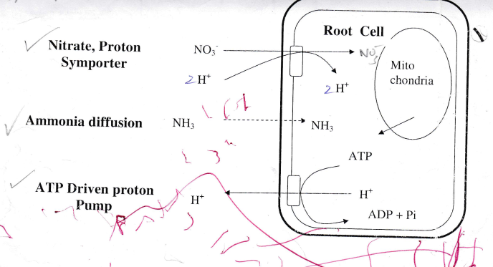
Figure 1(a): N-uptake
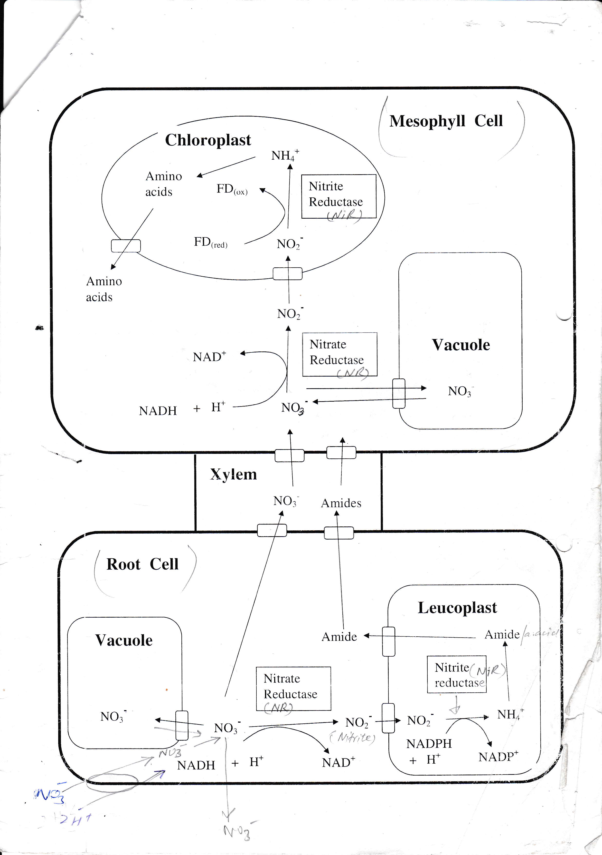
Figure 1(b): N uptake mechanism
It is very energy expensive reaction. If occur in root it uses Fd_{(red)} Fd_{(ox)} .
If occur in leaf it uses NADH + H⁺ NAD.
Nitrogenase reductase:
It was discovered in 1970 in many crops nitrate reductase enzyme was found to be in limited amount, therefore N assimilation was poor. But now most of the crops are not limited in it. Itis present in cytosol.
Co-factors:
1. FAD (Flavin D nucleotide)
2. Heme (Cytochrome B type)
3. M_{O}
Nitrite reductase:
Convert nitrites into ammonium. Present in plastids. Co-factors are 4 Fe-S clusters, and FAD modified heme (Siro-heme). It is high-energy process.
Amino acid:
First amino acid produced is glutamate.
Glutamate + NH₄⁺ Glutamin + α-Ketogluteric acid (2-oxoglutarate).
ATP ADP+PI
Glutamin + α-Ketogluteric acid GOGAT 2 Glumates
Fd _{(rd)} Fd_{(ox)}
D) Translocation and redistribution:
Translocation: Movement through xylem is called translocation whereas through phloem is called redistribution. After nitrate absorption by plant form soil solution, there are four fates of nitrate:
- Assimilation
- Stored in vacuole
- Pumping out of root cell
- Translocation to upper plants parts via xylem

A. Translocation
When nitrate becomes a part of transpiration stream it reaches, aerial parts everywhere in plants even through stomata. Most of the ammonium which is absorbed is assimilated in root. Then amino acid and amides may be loaded into xylem only traces of ammonium moves through xylem. In plants of BNF other compounds are also formed i.e. ureids, allantoins, asparagine is present. Xylem stream consist amino acid, amide, nitrate, ureids, asparagine and allantions and this is called translocation.
B. Redistribution /biological advantage
It occurs through phloem. Nitrate is absent in phloem. For the things which are loaded in phloem we use term re-distribution. After assimilation in cell redistribution of a compound occurs through phloem. Somethings are mobile that can move within the plants and other are immobile. Plants redistribution mobile elements to parts where there is active growth by sacrificing the older parts. Before leaf shedding all the compounds which are present in that leaf are hydrolyzed and then load into phloem which are then move to main stem. When there is deficiency of an element the older plant, parts will then sacrifice and translocate their compounds to younger parts. Nitrogen is very much mobile element.
The preferable from N is amino acid.
Protein amino acids phloem
Deficiency symptoms of N:
- Chlorosis of older leaves (loss of green color)
- Necrosis (death of tissue)
- Sometimes C: N ratio becomes high (when there is no assimilation)
- Excess carbohydrates are converted into anthocyanin and gives purple shade or purple coloration in plants.
Excess symptoms of N
- Dark green succulent leaves
- Abundant foliage
- Poorly develop root system
- High shoot to root ratio
- Delayed maturity
- Susceptible to disease and insect pest

