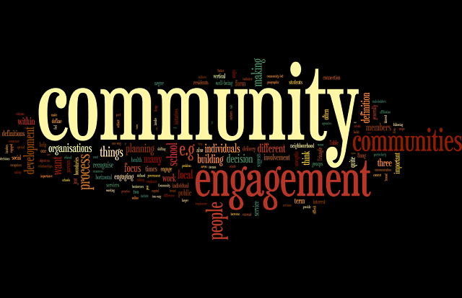
community engagement is the process of working collaboratively with community groups to address issues that impact the well being of those groups. ommunity engagement means different things to different people.

community engagement in three broad contexts:
- Community engagement in community development and community building – for example a community development project in caravan parks or large community art projects in marginalised communities

- Community engagement in service delivery – for example engaging parents and the local community in schools or a health promotion initiative encouraging healthy eating habits

- Community engagement in planning and decision making – for example a consultation about public transport options or planning for the constitutional recognition of Aboriginal and Torres Strait Islander people.

community engagement is both a process (how we do things e.g., ensuring that communities have a say in decision making) and an outcome (what we want to achieve e.g., community building or involving parents in a school). In planning and decision making, community engagement is largely used as a process, but in community development and service delivery, community engagement is often both a process and an outcome.

The Community Engagement Triangle ² helps us to think about the objectives of community engagement.
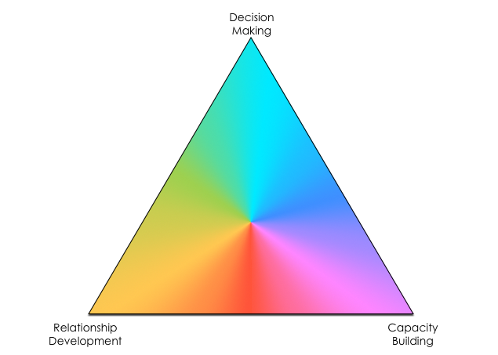

The Community Engagement Triangle identifies three overarching objectives:
- Decision making which provides opportunities for communities to contribute to improved decision making
- Relationship development which involves building new relationships and /or improving existing relationships with or within communities
- Capacity building which builds on community strengths so that communities and individuals can enhance their ability to influence their physical, social, natural, economic and cultural environments
By being a triangle, it acknowledges that community engagement can have more than one objective and encourages us to think about what we are hoping to achieve.
It can also be helpful to recognise there is a difference between vertical and horizontal community engagement.

Vertical community engagement is where organisations like government agencies, local councils, schools, businesses, health, community services or whatever, want to engage community members in planning and decisions, want to increase access to their services or want to involve communities in some other aspect of their work.
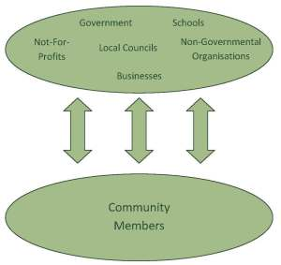Horizontal community engagement is where people are engaged in their local community as active community members. While this often happens as a result of community interactions without the involvement of any formal initiatives, at times organisations or programs work to increase community connection. For example an important component of community building and community development is often building connections between community members and there can be health and educational benefits with increased social capital.
A community is a dynamic whole that emerges when a group of people:
• Participate in common practices
• Depend on one another
• Make decisions together
• Identify themselves as part of something larger than the sum of the individual relationship
• Commit themselves for the long term to their own, one another’s and the group’s well-being.
Notice it is quite an idealistic vision of what we want communities to be. In reality there can be real divisions and power struggles within communities and it’s important we recognise that communities are not always harmonious and supportive of all members

