n this article we will discuss about the structure and replication of Tobacco Mosaic Virus (TMV).

Structure of Tobacco Mosaic Virus (TMV):
TMV is a simple rod-shaped helical virus (Fig. 13.20) consisting of centrally located single- stranded RNA (5.6%) enveloped by a protein coat (94.4%). The rod is considered to be 3,000 Å in length and about 180 Å in diameter.
The protein coat is technically called ‘capsid’. R. Franklin estimated 2,130 sub-units, namely, capsomeres in a complete helical rod and 49 capsomeres on every three turns of the helix; thus there would be about 130 turns per rod of TMV.
The diameter of RNA helix is about 80 Å and the RNA molecule lies about 50 Å inward from the outer-most surface of the rod. The central core of the rod is about 40 Å in diameter. Each capsomere is a grape like structure containing about 158 amino acids and having a molecular weight of 17,000 dalton as determined by Knight.

The ssRNA is little more in length (about 3300 Å) slightly protruding from one end of the rod. The RNA molecule consists of about 7300 nucleotides; the molecular weight of the RNA molecule being about 25,000 dalton.

Life-Cycle (Replication) of Tobacco Mosaic Virus (TMV):
Plant viruses like TMV penetrate and enter the host cells in toto and their replication completes within such infected host cells (Fig. 13.21). Inside the host cell, the protein coat dissociates and viral nucleic acid becomes free in the cell cytoplasm.
Although the sites for different steps of the viral multiplication and formation of new viruses have not yet been determined with absolute certainty, the studies suggest ha alter becoming free in the cell cytoplasm the viral-RNA moves into the nucleus (possibly into the nucleolus).
The viral-RNA first induces the formation of specific enzymes called ‘RNA polymerases’ the single-stranded viral-RNA synthesizes an additional RNA strand called replicative RNA.
ADVERTISEMENTS:
This RNA strand is complementary to the viral genome and serves as ‘template’ for producing new RNA single strands which is the copies of the parental viral-RNA. The new viral-RNAs are released from the nucleus into die cytoplasm and serve as messenger-RNAs (mRNAs). Each mRNA, in cooperation with ribosomes and t-RNA of the host cell directs the synthesis of protein subunits.
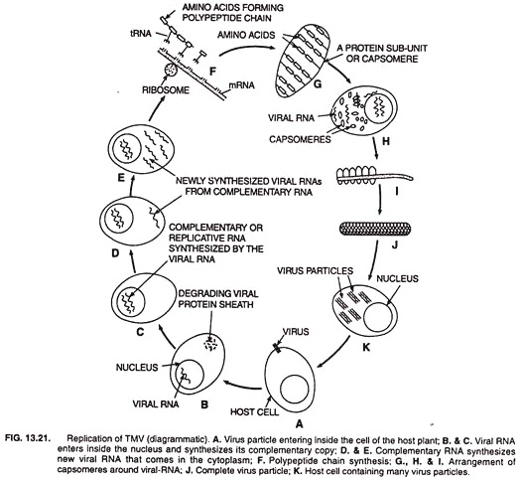
After the desired protein sub-units (capsomeres) have been produced, the new viral nucleic acid is considered to organize the protein subunit around it resulting in the formation of complete virus particle, the virion.
No ‘lysis’ of the host cell, as seen in case of virulent bacteriophages, takes place. The host ells remain alive and viruses move from one cell to the other causing systemic infection. When transmitted by some means the viruses infect other healthy plants.

